**Determining the causal effects of lipid levels on risk of dementia: a triangulation of new and existing evidence**



#### Luke A McGuinness

A dissertation submitted to the University of Bristol in accordance with the requirements for award of the degree of

*Doctor of Philosophy*

in the Faculty of Health Sciences December 2021

*Word count: 48,351*

*ii*

## Abstract

**Background:** Identification of causal relationships between modifiable targets and risk of dementia is central to the development of evidence-based prevention strategies. Blood lipid levels have been implicated in the aetiology of dementia by genetic linkage and functional cell biology studies, but current epidemiological evidence has yet to reach a consensus on their role in dementia risk. This thesis sought to triangulate the causal effects of lipid levels (total cholesterol, LDL-c, HDL- c, and triglycerides) on risk of incident dementia (all-cause dementia, Alzheimer’s disease, and vascular dementia) using existing and new evidence.

**Methods:** Four distinct analyses were conducted. Firstly, a systematic review of 81 published and preprinted studies was used to summarise the existing evidence base. Preprints were searched using a new research tool created as part of this thesis. The existing evidence was then supplemented via two primary studies: i) a cohort study of the association of lipid regulating agents and dementia incidence in the Clinical Practice Research Datalink (CPRD); and ii) an individual participant data meta-analysis of the association of blood lipids with dementia incidence in previously unanalysed cohorts accessed through the Dementia Platform UK. Finally, a novel quantitative triangulation framework was proposed, building on recent developments in risk-of-bias assessment and bias-/indirectness-adjusted meta- analyses. This framework was then used to quantitatively triangulate the evidence identified and produced by this thesis.

**Results:** The systematic review did not identify a consistent effect of blood lipids on any dementia outcome across study designs, through there was some suggestion of a protective effect of LDL-c lowering on all-cause dementia and Alzheimerâ€™s disease in observational studies of statin use. The analysis of lipid regulating agents in the CPRD provided weak evidence for a protective effect of statins on all-cause dementia and Alzheimer’s disease but suggested a harmful association with vascular dementia. However, the use of control outcomes illustrated this finding was likely due to confounding by indication related to vascular factors. The

individual participant data meta-analysis suffered from a low response rate to data access requests, but in the three cohorts analysed, there was some evidence only for the association of triglycerides and vascular dementia. Finally, the triangulation analysis integrating the results of the previous three studies did not provide strong evidence for the causal effect of blood lipids on dementia outcomes.

**Conclusions:** This thesis provides new evidence concerning the role of blood lipids as a modifiable risk factor for dementia and highlights the uncertainty that still remains in relation to this causal question. In addition, it has developed new evidence synthesis methods and tools, specifically around the inclusion of preprints in systematic reviews and the quantitative triangulation of evidence sources.

For Brendan McHugh

## Acknowledgements

There are many people without whose input and support this work would have been severely diminised:

First and foremost, I would like to thank my supervisors - Julian Higgins, Yoav Ben-Shlomo, Liz Coulthard and George Davey-Smith - for all their support over the past three years. Thanks also to Rupert Payne and Emma Anderson for their engaging discussion and useful feedback during my annual progress reviews. Sharen Hockey-O’Keffe helped me at numerous points throughout my PhD, and I was very lucky to receive her support. Similarly, Mark Newbury of the Dementia Platform UK worked tirelessly to support my applications for data access - I am extremely grateful for his help and commitment in chasing cohort owners.

Thanks must also go to those who contributed their time and energy to my research projects: Matthew Lee, Lena Schmidt, Alexandra McAleenan, and Vincent Cheng. Francesca Spiga kindly shared an advance copy of her review of tools to assess Mendelian randomisation studies, and Rebecca Turner shared her code for bias-

/indirectness-adjusted meta-analyses that underpins the quantitative triangulation framework presented in Chapter 7. Thanks to Vivienne for proof-reading.

A particular thank you to Emily Hennessy, with whom I co-wrote the guidance paper for preparing primary research for incorporation into systematic reviews. Similarly, thanks to Athena Sheppard for her support in assessing the impact of journal polices on open-data sharing.

Thanks also to all those who raised issues or otherwise provided feedback on the open source tools built as part of this thesis: [@abannachbrown,](https://github.com/abannachbrown) [@ailengt,](https://github.com/ailengt) [@AJFOWLER,](https://github.com/AJFOWLER) [@danielskatz,](https://github.com/danielskatz) [@earcanal,](https://github.com/earcanal) [@Jamesohare1,](https://github.com/Jamesohare1) [@jannisborn,](https://github.com/jannisborn) [@paulsharpeY,](https://github.com/paulsharpeY) [@rachaelm-](https://github.com/rachaelmburke) [burk](https://github.com/rachaelmburke)e, [@rdboyes,](https://github.com/rdboyes) [@seabbs,](https://github.com/seabbs) [@vanAmsterdam,](https://github.com/vanAmsterdam) [@yochannah,](https://github.com/yochannah) and [@zaddyzad.](https://github.com/zaddyzad) A special mention must go to Randall Boyes and Alex J Fowler for their input on the robvis tool.

I have been supported throughout my studies by an NIHR Doctoral Research Fellowship (DRF-2018-11-ST2-048). The views expressed in this thesis are my own and do not necessarily represent those of the NIHR or the Department of Health and Social Care.

On a personal note, there are several people without whom I would not have survived the process of writing a dissertation during COVID times. Thanks to Mum and Dad for your never-ending love and support (I promise I’ll get a real job now!). Thank also to Doug for introducing me to the joys of running, Ben for always being around to chat, and Christin for encouraging regular coffee-breaks.

Finally, deepest thanks to Ciara Gardiner: holder-of-forts, maker-of-spreadsheets, and all-round fiancee-extraordinaire. I can’t wait for the next adventure with you.

Canynge Hall, Bristol 1 December 2021

## Author’s declaration

I declare that the work in this dissertation was carried out in accordance with the requirements of the University’s Regulations and Code of Practice for Research Degree Programmes and that it has not been submitted for any other academic award. Except where indicated by specific reference in the text, the work is the candidate’s own work. Work done in collaboration with, or with the assistance of, others, is indicated as such. Any views expressed in the dissertation are those of the author.

SIGNED: ............................................................. DATE: ..........................

## Contents

List of Figures xiii

List of Tables xv

List of Abbreviations xvii

|  |  |  |
| --- | --- | --- |
| **1** | **Background, Theoretical framework, Aims & Objectives** | **1** |
|  | Lay summary . . . . . . . . . . . . . . . . . . . . . . . . . . . . . . . . . | 2 |
|  | 1.1 Introduction . . . . . . . . . . . . . . . . . . . . . . . . . . . . . . . | 2 |
|  | 1.2 Dementia . . . . . . . . . . . . . . . . . . . . . . . . . . . . . . . . | 3 |
|  | 1.2.1 Definition and underlying pathologies . . . . . . . . . . . . . | 3 |
|  | 1.2.2 Diagnostic criteria . . . . . . . . . . . . . . . . . . . . . . . | 4 |
|  | 1.2.3 Public health importance . . . . . . . . . . . . . . . . . . . . | 6 |
|  | 1.2.4 Treatments . . . . . . . . . . . . . . . . . . . . . . . . . . . | 6 |
|  | 1.2.5 Risk factors . . . . . . . . . . . . . . . . . . . . . . . . . . . | 7 |
|  | 1.3 Serum lipids . . . . . . . . . . . . . . . . . . . . . . . . . . . . . . . | 8 |
|  | 1.3.1 Lipid fractions . . . . . . . . . . . . . . . . . . . . . . . . . . | 8 |
|  | 1.3.2 Statins . . . . . . . . . . . . . . . . . . . . . . . . . . . . . . | 9 |
|  | 1.3.3 Other lipid regulating agents (LRA) . . . . . . . . . . . . . | 11 |
|  | 1.4 Evidence for the association between blood lipids and dementia . . | 13 |
|  | 1.4.1 Basic science . . . . . . . . . . . . . . . . . . . . . . . . . . | 13 |
|  | 1.4.2 Observational studies . . . . . . . . . . . . . . . . . . . . . . | 13 |
|  | 1.4.3 Randomised controlled trials . . . . . . . . . . . . . . . . . . | 14 |
|  | 1.4.4 Mendelian randomisation . . . . . . . . . . . . . . . . . . . . | 15 |

*Contents*

* 1. Theoretical framework: Evidence synthesis 16
     1. Inclusion of preprints 17
     2. Individual participant data meta-analysis 18
     3. Triangulating across study designs 19
  2. Thesis overview 20
     1. Aims and objectives 20
     2. Structure 21
  3. Outputs from this thesis 22
     1. Contributions to the scientific literature 22
     2. Presentations/Talks 24
     3. Software 25
  4. Summary 26

1. medrxivr: an R package for systematically searching biomedical preprints 27

Lay summary 28

* 1. Introduction 28
  2. Development 30
     1. Success criteria 30
     2. Alternative medRxiv/bioRxiv interfaces 30
     3. Early versions 31
     4. Package infrastructure 32
  3. Usage 32
     1. Installation 33
     2. Importing preprint metadata 33
     3. Performing a search 35
     4. Refining a search 36
     5. Exporting to a bibliography file 38
     6. Downloading the PDFs of relevant records 38
  4. Discussion 39

Contents

* + 1. Reception and future plans 39
    2. Use cases 39
    3. Limitations of medrxivr 40
    4. Role of open source tools in evidence synthesis 41
  1. Summary 42

1. Systematic review of existing evidence on the association between blood lipids and dementia outcomes: Methods 43

Lay summary 43

* 1. Introduction 44
  2. Methods 45
     1. Protocol 45
     2. Contributions 45
     3. Eligibility criteria 45
     4. Information sources and search strategy 47
     5. Study selection 49
     6. Validation of screening process 50
     7. Data extraction 51
     8. Risk-of-bias assessment 53
     9. Analysis methods 57
  3. Summary 62

1. Systematic review of existing evidence on the association between blood lipids and dementia outcomes: Results 63

Lay summary 63

* 1. Introduction 64
  2. Search results 64
     1. Initial search and validation of search filters 64
     2. Screening results 64
     3. Validation of screening 67
     4. Characteristics of included studies 68

Contents

* 1. Primary analyses 77
     1. All-cause dementia 77
     2. Alzheimer’s disease 82
     3. Vascular dementia 87
     4. Risk of bias 90
  2. Additional analyses 91
     1. Dose response meta-analysis of lipid levels 91
     2. Heterogeneity and publication bias 92
     3. Added evidential value of including preprints 93
  3. Discussion 94
     1. Summary of findings 94
     2. Comparison with previous reviews 97
     3. Inclusion of Mendelian randomisation studies 97
     4. Inclusion of preprints 101
     5. Open data sharing 103
     6. Strengths and limitations 104
  4. Summary 106

1. Primary analysis of lipid-regulating agents and dementia outcomes107

Lay summary 108

* 1. Introduction 108
  2. Methods 109
     1. Study protocol 109
     2. Data source 109
     3. Cohort definition 111
     4. Exposures 112
     5. Outcomes 113
     6. Covariates 113
     7. Missing data 116
     8. Estimation methods 117

*Contents*

|  |  |  |
| --- | --- | --- |
|  | 5.2.9 Immortal time bias and time-varying treatment indicators . | 117 |
| 5.2.10 Time axis . . . . . . . . . . . . . . . . . . . . . . . . . . . . | 119 |
| 5.2.11 Sensitivity analyses . . . . . . . . . . . . . . . . . . . . . . . | 119 |
| 5.3 | Results . . . . . . . . . . . . . . . . . . . . . . . . . . . . . . . . . . | 123 |
|  | 5.3.1 Patient characteristics . . . . . . . . . . . . . . . . . . . . . | 123 |
|  | 5.3.2 Missing data . . . . . . . . . . . . . . . . . . . . . . . . . . . | 128 |
|  | 5.3.3 Primary analysis . . . . . . . . . . . . . . . . . . . . . . . . | 129 |
|  | 5.3.4 Sensitivity analyses . . . . . . . . . . . . . . . . . . . . . . . | 131 |
| 5.4 | Discussion . . . . . . . . . . . . . . . . . . . . . . . . . . . . . . . . | 139 |
|  | 5.4.1 Summary of findings . . . . . . . . . . . . . . . . . . . . . . | 139 |
|  | 5.4.2 Interpretation of results . . . . . . . . . . . . . . . . . . . . | 139 |
|  | 5.4.3 Strengths and limitations . . . . . . . . . . . . . . . . . . . . | 144 |
|  | 5.4.4 Enabling easy synthesis of this analysis . . . . . . . . . . . . | 146 |
|  | 5.4.5 Summary . . . . . . . . . . . . . . . . . . . . . . . . . . . . | 146 |

1. Individual participant data meta-analysis of blood lipid levels and dementia outcomes 149

Lay Summary 150

* 1. Introduction 150
  2. Methods 151
     1. Eligibility criteria 151
     2. Applying for data access 152
     3. Primary analysis 154
  3. Results 157
     1. Data access 157
     2. Included data sources 159
     3. Covariate definition & missing data 161
     4. Analytical results 162
  4. Discussion 169
     1. Summary of findings 169

*Contents*

* + 1. Limitations 170
    2. Strengths 175
    3. Reflections on the process 175
    4. Future work 176
  1. Summary 177

1. Aetiological triangulation across new and existing evidence sources179

Lay summary 180

* 1. Introduction 180
  2. Data sources 182
  3. Qualitative (narrative) triangulation 184
  4. Quantitative triangulation 187
     1. Methods 187
     2. Results 198
  5. Discussion 204
     1. Summary of findings 204
     2. Limitations 205
     3. Strengths 208
     4. Future research 209
     5. Outputs 210
  6. Summary 211

1. Discussion 213
   1. Lay summary 214
   2. Introduction 214
      1. Chapter summary 214
   3. Summary of clinical findings 215
      1. Effect of blood lipids on dementia outcomes 215
      2. Comparison with new evidence 216
      3. Implications for clinical practice 217

*Contents*

|  |  |  |
| --- | --- | --- |
|  | 8.3.4 Implications for public health . . . . . . . . . . . . . . . . . | 217 |
| 8.4 | Summary of methodological contributions . . . . . . . . . . . . . . | 218 |
|  | 8.4.1 Inclusion of preprinted evidence . . . . . . . . . . . . . . . . | 218 |
|  | 8.4.2 Bias . . . . . . . . . . . . . . . . . . . . . . . . . . . . . . . | 219 |
|  | 8.4.3 Triangulation framework . . . . . . . . . . . . . . . . . . . . | 219 |
| 8.5 | Overall strengths and limitations . . . . . . . . . . . . . . . . . . . | 220 |
|  | 8.5.1 Strengths . . . . . . . . . . . . . . . . . . . . . . . . . . . . | 221 |
|  | 8.5.2 Weaknesses . . . . . . . . . . . . . . . . . . . . . . . . . . . | 221 |
| 8.6 | Lessons learned . . . . . . . . . . . . . . . . . . . . . . . . . . . . . | 222 |
| 8.7 | Future work . . . . . . . . . . . . . . . . . . . . . . . . . . . . . . . | 223 |
|  | 8.7.1 Generation of new RCT evidence . . . . . . . . . . . . . . . | 223 |
|  | 8.7.2 Evidence on vascular dementia . . . . . . . . . . . . . . . . . | 224 |
|  | 8.7.3 Preprinted evidence . . . . . . . . . . . . . . . . . . . . . . . | 225 |
|  | 8.7.4 Reviewing Mendelian randomisation studies . . . . . . . . . | 225 |
|  | 8.7.5 Systematic reviews and quantitative triangulation . . . . . . | 226 |
| 8.8 | Overall conclusions . . . . . . . . . . . . . . . . . . . . . . . . . . . | 226 |

1. Bibliography 229

**Appendices**

A Appendices by Chapter 259

* 1. Chapter 1 260
     1. Publications beyond the scope of this thesis 260
  2. Chapter 2 262
     1. Code for publication rate analysis 262
  3. Chapter 3 264
     1. Deviations from protocol 264
     2. Web of Science databases searched 265
     3. Search strategy 265
     4. Code to search preprints 277

*Contents*

* + 1. Calculating Gwet’s AC1 279
    2. Risk-of-bias assessment tool for Mendelian randomisation studies 280
  1. Chapter 4 283
     1. PRISMA Checklist 283
     2. Dose response plots by fraction 289
  2. Chapter 5 291
     1. Amendments to protocol 291
     2. Minimum follow-up period 291
  3. Chapter 6 293
     1. Covariate matrix 293
     2. Dementia definitions across cohorts 294
  4. Chapter 7 295
     1. Calculation of average adjustment values from previous expert elicitation exercise 295
     2. Comparison of two scenarios of bias 298
  5. Chapter 8 300
     1. Reproducible research 300
     2. Catalogue of failures 300

1. Other Appendices 303
   1. Software used to create this thesis 304
   2. Producing risk-of-bias visualisations with robvis 307
      1. Templates 307
      2. Data expectations 307
      3. Simple visualisations 309
   3. Copies of papers arising from this thesis 311

*xviii*

## List of Figures

1.1 Statin mechanism of action 10

* 1. Role of medrxivr in a systematic review workflow 29
  2. Overview of medrxivr data sources 35
  3. PRISMA flow diagram 66
  4. Geographical distribution of study cohorts 76
  5. Random-effects meta-analysis of hypercholesterolemia on all-cause dementia 78
  6. Random-effects meta-analysis of lipids and all-cause dementia 79
  7. Random-effects meta-analysis of statins on all-cause dementia in RCTs 80
  8. Random-effects meta-analysis of statins on all-cause dementia 81
  9. Random-effects meta-analysis of fibrates on all-cause dementia 82
  10. Random-effects meta-analysis of hypercholesterolemia on Alzheimer’s disease 83
  11. Random-effects meta-analysis of lipids on Alzheimer’s disease 84
  12. Summary of duplication across two-sample Mendelian randomisation studies 85
  13. Random-effects meta-analysis of statins on Alzheimer’s disease 86
  14. Random-effects meta-analysis of HMGCR inhibition on Alzheimer’s disease 87
  15. Random-effects meta-analysis of hypercholesterolemia on vascular dementia 88
  16. Random-effects meta-analysis of total cholesterol on vascular dementia 89
  17. Random-effects meta-analysis of statins on vascular dementia 90
  18. Dose-response meta-analysis of total cholesterol on Alzheimer’s disease 92

*List of Figures*

* 1. Study designs by year of publication 95
  2. Summary of the assumptions in Mendelian randomisation analyses . 98
  3. Growth of preprint repositories over time 102
  4. Decision tree for assigning dementia subtypes 113
  5. Immortal time bias 118
  6. Causal diagram for ideal negative outcome 121
  7. Attrition of CPRD participants 124
  8. Results from primary analyses of CPRD data 130
  9. Complete case vs. imputed data analysis 132
  10. Results of control outcome analysis 133
  11. Comparison of different combinations of covariates 134
  12. Sensitivity analysis: grouped year of entry 135
  13. Comparison of pregnancy analysis 137
  14. Analysis stratified by statin properties 138
  15. Confounding by indication causal diagram 141
  16. Comparison of code used in this analysis with those used in the Smeeth et al. 2010 paper 144
  17. Flowchart detailing sources of data for the IPD analysis 158
  18. IPD meta-analysis of all-cause dementia, stratified by lipid fraction 164
  19. IPD meta-analysis of all-cause dementia, stratified by lipid fraction 165
  20. Comparison of partially and maximally adjusted results 166
  21. Meta-analysis of age-lipid interaction terms for all-cause dementia . 167
  22. Meta-analysis of sex-lipid interaction terms for all-cause dementia . 168
  23. Meta-analysis of age-lipid interaction terms for vascular dementia . 169
  24. Comparison of results across the two analyses of the Whitehall II cohort 173
  25. Comparison of results across the two analyses of the Whitehall II cohort 174

*List of Figures*

* 1. Illustration of calculating the absolute direction of biases, based on

bias type 192

* 1. Bias direction plot example for a single study 199
  2. Bias direction plot for LDL-c/Alzheimer’s disease 201
  3. Random effects meta-analysis using unadjusted and bias-/indirectness- adjusted results. 202
  4. Bias direction plot for triglycerides/vascular dementia 203
  5. shortcap 204
  6. Dose-response meta-analysis of total cholesterol on all-cause dementia290
  7. Dose-response meta-analysis of low-density lipoprotein cholesterol on Alzheimer’s disease 290
  8. Illustration of minimum follow-up period in two study designs 292
  9. Sensitivity analysis of the CPRD data with a 10 year minimum period of follow-up. 293
  10. Comparison of bias-/indirectness-adjusted meta-analyses of LDL- c/Alzheimer’s disease, using two different scenarios for the relation-

ship of levels of bias. 299

* 1. Comparison of bias-/indirectness-adjusted meta-analyses under two different scenarios of prior distributions of bias. 299
  2. Example risk-of-bias summary barplot 309
  3. Example risk-of-bias traffic-light plot 310

## List of Tables

* 1. Overview of the DSM-5 criteria for dementia and vascular dementia. 5
  2. Classification of blood lipid levels . . . . . . . . . . . . . . . . . . . 9
  3. Overview of common statins 11
  4. Summary of available treatments for hyperlipidaemia. 12
  5. searchOverview 48
  6. Ranges for Gwet’s AC1 51
  7. Inter-rater agreement 67
  8. Inter-rater agreement 67
  9. Characteristics of included studies 69
  10. Example of CPRD Read code hierarchy 110
  11. Covariates adjusted for. 114
  12. Crude rates, stratified by outcome and drug class of interest. 126
  13. Patient characteristics by drug class 127
  14. Participants who stopped, switched or added treatements by initial treatment type 128
  15. Frequency of diagnoses by grouped year of cohort entry 136
  16. Summary of statin properties (lipophilicity vs hydrophilicity). 137
  17. Exclusion reasons for cohorts providing data 159
  18. Summary of characteristics of IPD cohorts 163
  19. Summary of research designs included in this thesis 183
  20. Mapping of risk-of-bias judgements across assessment tools 191

*List of Tables*

* 1. Prior distributions mapped to different extents of bias. 194
  2. Prior distributions mapped to different extents of bias. 196
  3. singleIndirect 200
  4. Publication status of medRxiv preprints 264
  5. Summary of Web of Science databases searched. 265
  6. searchOverviewAppendix 266
  7. Medline search strategy 266
  8. Embase search strategy 269
  9. PyscINFO search strategy 271
  10. CENTRAL search strategy 273
  11. Web of Science search strategy 275
  12. Mendelian randomisation risk-of-bias assessment tool 280
  13. PRISMA Checklist 283
  14. missingMatrix 294
  15. Definition of dementia outcomes in IPD meta-analysis 295
  16. addTable1 296
  17. addTable1 297
  18. addTable1 297
  19. turnerEstimates 298
  20. biasData 308
  21. biasDirectionData 308

*xxiv*

## List of Abbreviations

**AC** Agreement coefficient

**ACE** Acetylcholinesterase

**AD** Alzheimer’s disease

**ADGC** Alzheimer’s Disease Genetics Consortium

**API** Application programming interface

**ApoE** Apolipoprotein E

**BAS** Bile acid sequestrants

**BMI** Body mass index

**CAD** Coronary arterial disease

**CaPS** Caerphilly Prospective Study

**CBS** Coronary bypass surgery

**CCI** Charlson co-morbidity index

**CIND** Cognitive impairment not dementia

**CKD** Chronic kidney disease

**CPRD** Clinical Practice Research Datalink

**CRAN** Comprehensive R Archive Network

**CSV** Comma separated value

**CVD** Cardiovascular disease

**DOI** Digitial object identifier

**DPUK** Dementia Platform UK

**DSM** Diagnostic and Statistical Manual of Mental Disorders

**EHR** Electronic health record

**EPIC** European Prospective Investigation of Cancer

**FAGs** Fatty acid groups

**GLGC** Global Lipids Genetic Consortium

*xxv*

*List of Abbreviations*

**GWAS** Genome wide association studies

**HDL** High density dipoprotein

**HES** Hospital episode statistics

**HMG-CoA** *. .* 3-hydroxy-3-methylglutaryl-coenzyme-A

**HMGCR** HMG-CoA reductase

**HR** Hazard ratio

**ICD** International Classification of Diseases

**IGAP** International Genomics of Alzheimer’s Project

**IHD** Ischemic heart disease

**IMD** Index of multiple deprivation

**IPD** Individual participant data

**IV** Instrumental variable

**JUPITER** *. .* Justification for the Use of Statin in Prevention: An Intervention Trial Evaluating Rosuvastatin

**LDL-c** Low density lipoprotein cholesterol

**LRA** Lipid regulating agent

**MCI** Mild cognitive impairment

**MICE** Multiple imputation by chained equations

**MMSE** Mini Mental State Exam

**MoCA** Montreal Cognitive Assessement

**MR** Mendelian randomization

**NAG** Nicotinic acid groups

**NINDS-ADRA** National Institute of Neurological Disorders and Stroke - Alzheimer’s Disease and Related Disorders Association

**NINDS-AIREN** National Institute of Neurological Disorders and Stroke - Asso- ciation Internationale pour la Recherche en l’Enseignement en Neurosciences

**NOS** Newcastle-Ottowa Scale

**NRSE** Non-randomised studies of exposures

**NRSI** Non-randomised studies of interventions

**OR** Odds ratio

*xxvi*

*List of Abbreviations*

**PAD** Peripheral arterial disease

**PCSK9i** PCSK9 inhibitors

**PDF** Portable document format

**PR** Proportional hazards

**PROSPER** *. .* Prospective Study of Pravastatin in the Elderly

**PYAR** Participant-years-at-risk **RCT** Randomised controlled trial

**REML** Restricted maximum likelihood

**RoB-ME** Risk of bias due to missing evidence

**RR** Risk/rate ratio

**SD** Standard deviation

**SNP** Single nucleotide polymorphism

**TC** Total cholesterol

**TG** Triglycerides

**VaD** Vascular dementia

*Alles in allem genommen haben wir hier offenbar einen eigenartigen Krankheitsprozeß vor uns.*

*~*

*Considering everything, it seems we are dealing here with a special illness.*

— Alois Alzheimer, 19071,2

# 1

## Background, Theoretical framework,

Aims & Objectives

**Contents**

**Lay summary** **2**

* 1. **Introduction** **2**
  2. **Dementia** **3**
  3. **Serum lipids** **8**
  4. **Evidence for the association between blood lipids and****dementia** **13**
  5. **Theoretical framework: Evidence synthesis** **16**
  6. **Thesis overview** **20**
  7. **Outputs from this thesis** **22**
  8. **Summary** **26**

*1.1 - Introduction*

### Lay summary

Around 850,000 people in the UK live with dementia, and by 2040, nearly twice as many will have the condition. Despite many promising candidates, no cure for dementia currently exists, meaning the focus is on finding ways to prevent the condition. The best way to do this is to find risk factors (characteristics that influence a person’s chance of developing a disease) for dementia that we can easily change. Avoiding a risk factor does not guarantee that a person will not develop dementia but makes it less likely. A key risk factor for dementia may be the levels of lipids (fatty substances such as cholesterol) in a person’s blood, though not all existing research agrees. The aim of this thesis is to use all available evidence to assess whether blood lipid levels are in fact a risk factor for dementia.

This introductory chapter provides background information on both dementia and blood lipids, and on the potential link between them. It introduces the theory used to frame the research presented here, and then maps the formal aims and objectives of the research project to the relevant chapters of this thesis. Finally, it summarises the outputs (journal articles, presentations and software) that were created as part of this thesis.

### Introduction

This chapter provides an overview of the broad context of this thesis, introducing the core concepts used throughout and providing some background on each. It briefly discusses the underlying pathologies and diagnosis of dementia, its public health importance, and the current state of treatment and prevention research. It then provides background on blood lipids and lipid-modifying treatments, and summarises the types of evidence used to examine the effect of these exposures on dementia outcomes.

The chapter introduces evidence synthesis as the key framework used to guide the research presented in the remaining chapters. Finally, it outlines the aims, objectives and structure of this thesis, and briefly summarises the contributions to the scientific literature that arose from this research.

* 1. *- Dementia*

### Dementia

* + 1. Definition and underlying pathologies

Defined by the Diagnostic and Statistical Manual of Mental Disorders as a “major neurocognitive disorder”, dementia is a progressive disease which impairs cognitive functions including speech, memory and executive reasoning.3 At advanced stage, the condition causes severe behavioral and personality changes,4 culminating in reduced motor control that affects patients’ ability to swallow or breathe.5 The condition has several distinct underlying causes, including Alzheimer’s disease and vascular dementia.6

Alzheimer’s disease is the most common cause of dementia, accounting for approx- imately 60-80% of cases. Characterised by substantial cognitive impairment and difficulty with high level executive function, it is an insidious disease, with initial onset thought to occur up to 15 years prior to symptomatic presentation.7 Much remains unknown about Alzheimer’s pathogenesis, despite research implicating the “amyloid hypothesis”,7 as a potential mechanism of disease. Under this hypothesis, the build-up of amlyoid plaques (composed mainly of amlyoid-*β* peptide) and neurofibrillary tangles (composed mainly of tau protein) triggers a range of physiological changes, including inflammation and cell death, that result in cognitive impairment.7

Vascular dementia (VaD) is the second largest underlying pathology of dementia, accounting for ~10-25% of cases. Vascular dementia is caused by a range of cerebrovascular disorders, and as a result, presentation of symptoms can vary widely.8 Similarly, due to the varied underlying pathophysiology, vascular dementia can onset either quite rapidly following a cerebrovascular event such as a stroke or over a long time-frame due to a series of small infarcts.9 Vascular dementia regularly co-occurs in patients with Alzheimer’s disease.8 This presentation is described as “mixed” dementia,10 and occurs in approximately 25% of cases.6

*1.2 - Dementia*

The remaining 10-30% of cases are caused by other dementia subtypes (e.g. Lewy body or frontotemporal dementias) or other neurological diseases (e.g. Parkin- son’s disease).6

* + 1. Diagnostic criteria

Dementia is difficult to diagnose, primarily due to its slow onset, in addition to the confusion of initial symptoms with normal ageing.7 Dementia is diagnosed on the basis of behavioral and cognitive changes as assessed by an experienced clinician, using one of several diagnostic criteria.

One of the most commonly used sets of criteria for diagnosing dementia cases are the Diagnostic and Statistical Manual of Mental Disorders (DSM) criteria (Table 1.1).3 Outlined in Table 1.1, these form the broad definition of a dementia diagnoses, and are supported by a detailed patient history, evidence from carers and family members, and objective assessments of cognitive ability using neurocognitive tests.

Many cognitive assessment tools exist for the purpose of informing a diagnoses of dementia,11 with two of the best known of these being the Mini Mental State Exam (MMSE) and Montreal Cognitive Assessment (MoCA) scale. The distinction between these memory scales and diagnostic criteria presented above should be noted. For example, the MMSE is used to provide evidence for part A of the criteria presented in 1.1. Taken alone, it does not indicate the absence or presence of dementia, instead merely indicating cognitive impairment which could be due to another cause (for example, temporary delirium as a result of an infection or surgery).

*1.2 - Dementia*

**Table 1.1:** Overview of the DSM-5 criteria for dementia and vascular dementia.3

Criterion Major neurocognitive event (previously dementia)

* + - 1. Evidence of significant cognitive decline from a previous level of performance in one or more cognitive domains:*
         * Learning and memory
         * Language
         * Executive function
         * Complex attention
         * Perceptual-motor
         * Social cognition
      2. The cognitive deficits interfere with independence in everyday activities. At a minimum, assistance should be required with complex instrumental activities of daily living, such as paying bills or managing medications.
      3. The cognitive deficits do not occur exclusively in the context of a delirium.
      4. The cognitive deficits are not better explained by another mental disorder (eg, major depressive disorder, schizophrenia).

* From DSM: Evidence of decline is based on concern of the individual, a knowledgeable informant, or the clinician that there has been a significant decline in cognitive function and a substantial impairment in cognitive performance, preferably documented by standardized neuropsychological testing or, in its absence, another quantified clinical assessment.

Differentiating between the underlying causes of a dementia diagnosis is challenging but necessary, as whether the patient has Alzheimer’s disease or vascular dementia will affect expected progression and potential treatment options available (see Section 1.2.4). Cause-specific criteria exist for the diagnosis of dementia sub- types. For example, the NINCDS-ADRDA criteria are commonly used to assess patients for Alzheimer’s disease,12 while vascular dementia is diagnosed using the NINCDS-AIREN criteria.13

* + 1. Public health importance

*1.2 - Dementia*

Dementia is quickly becoming a critically important public health issue. Despite the age-specific incidence and prevalence of dementia remaining relatively constant over time,14 an ageing population is set to create a dementia epidemic, particularly in Westernised countries.15 While approximately 525,000 patients have received a dementia diagnosis, the true number of people currently living with dementia in the UK is thought to be closer to 850,000, with this figure expected to double by 2040.16 Globally, the prevalence of dementia is expected to reach 75 million by 2030.14 Dementia is a leading cause of death in the UK,17 and one of the few without a proven treatment.

Dementia also has a substantial economic impact. In 2015, the estimated total cost of dementia in England was £24.2 billion. Health care costs alone were

£3.8 billion, with the remainder being divided between unpaid care and social care costs.18 Globally, the cost of dementia care is expected to rise to $1tr by 2030.19 As such, the urgent need to reduce the burden of dementia, both at the personal and system level, is clear.

* + 1. Treatments

Developing treatments for dementia is regularly deemed to be one of the most challenging markets in the pharmaceutical world, with trials of seemingly promising therapeutics being regularly abandoned due to futility.20. At present, there are no known curative treatments for dementia, regardless of the underlying cause, though several available therapeutics can help alleviate the symptoms of Alzheimer’s disease. The most common of these are acetylcholinesterase (ACE) inhibitors, which inhibit the degradation of the neurotransmitter acetylcholine by competitively binding the ACE enzyme. Acetylcholine plays a key role in controlling the cholingeric synapses, which are highly concentrated in regions of the brain (such as the neocortex) that

* 1. *- Dementia*

control higher level brain functions such as memory and attention.21 Commonly prescribed ACE inhibitors include donepezil and galantamine.22 ACE inhibitors increase the availability of the neurotransmitter, and have shown clinical effect is easing the behavioural and memory-related symptoms of Alzheimer’s disease.23 ACE inhibitors represent only a stop-gap treatment, treating the symptoms rather than the underlying pathology which may continue to progress.24

* + 1. Risk factors

Given the substantial burden that dementia represents and the absence of any curative therapies, as detailed in the above sections, the assessment of easily modifi- able targets for their utility in the prevention of dementia should be prioritized.25 To date, a substantial amount of research has been produced examining putative risk factors for dementia.26–28

The benefits of a prevention-based approach based on addressing these risk factors are well-studied. Reducing the prevalence of the seven most important risk factors for dementia (obesity, hypertension,29 diabetes, smoking, physical inactivity, and low educational attainment) by 10-20% per decade is estimated to result in a reduction in dementia prevalence of 8-15% by 2050.30

In this context, lipid levels represent a promising target for preventative treat- ment, due to the ready availability of lipid-modifying treatments which could be repurposed.31 Determining whether variations in lipid levels are causative for dementia may prove critical in reducing the future burden of the condition.

This thesis will focus on blood lipids as the primary risk factor of interest. The next section provides an overview of blood lipid fractions and therapeutic interventions that modify them, while Section 1.4 provides an overview of the existing evidence for an association between lipids and dementia outcomes.

* 1. *- Serum lipids*

### Serum lipids

* + 1. Lipid fractions

The blood lipid profile contains a range of component parts, or fractions. However, this thesis will only consider the two most important fractions, trigylcerides (TG) and cholesterol, which are either absorbed from food (exogenous lipids) or produced internally (endogenous lipids).26

Triglycerides are the simplest and most common type of lipids found across the body. They are used to store unused calories from food, and to move energy around the body.32 In contrast, cholesterol is primarily used to create cell walls and certain sex hormones.33 As lipids are not water soluble, within the blood stream, cholesterol is transported in lipoprotein structures of varying densities. Low-density-lipoprotein cholesterol (LDL-c), commonly know as the “bad” cholesterol, transports fat to cells, acting as an energy conveyor. In contrast, High density-lipoprotein cholesterol (HDL-c), transports cholesterol to the liver to be broken down and excreted.26

In addition to the individual fractions, total serum cholesterol (TC) is a commonly- used summary measure to estimate the total amount of lipid present in the blood. The level of TC is derived from measurements of the individual HDL-c, LDL-c and TG levels using the Friedwald formula:34

*TC ≈ LDLc* + *HDLc* + *kTG* (1.1)

where *k* is 0.20 if measurements are in milligrams per decilitre (*mg/dl*) and 0.45 if measured in millimole per litre (*mmol/l*). Widely-used ranges for the acceptable levels of different types of lipids are based on the National Cholesterol Education Program (NCEP)35, and are outlined in Table 1.2.

Elevated LDL-c in the bloodstream, a condition also known as hypercholesterolaemia or hyperlipidaemia,36 can lead to atherosclerosis,37 the build-up of fatty deposits in the blood vessels. These deposits constrict blood flow and can lead to vascular

*1.3 - Serum lipids*

complications. Alternatively, part of the deposit can detach from the artery walls, forming a clot that can lead to a heart attack or stroke.37

**Table 1.2:** Classification of blood lipid levels according to the National Cholesterol Education Program guidelines.35

Fraction Measure (mg/dL) Classification

<100 Optimal

100-129 Near/above optimal

130-159 Borderline high

LDL cholesterol

160-189 High

>190 Very high

<40 Low

HDL cholesterol >60 High

<150 Normal

150-199 Borderline high

Triglycerides

Total cholesterol

200-499 High

>500 Very high

<200 Desirable

200-239 Borderline high

>240 High

* + 1. Statins

Statins are a commonly prescribed method of lipid regulation.38 Statins inhibit the conversion of 3-hydroxy-3-methylglutaryl-coenzyme-A (HMG-CoA) into mevalonate, by competitively binding with HMG-CoA reductase (HMGCR). This conversion is a key rate-limiting step in the cholesterol biosynthesis pathway (see Figure 1.1), enabling statins to reduce effectively the production of LDL cholesterol.

*1.3 - Serum lipids*

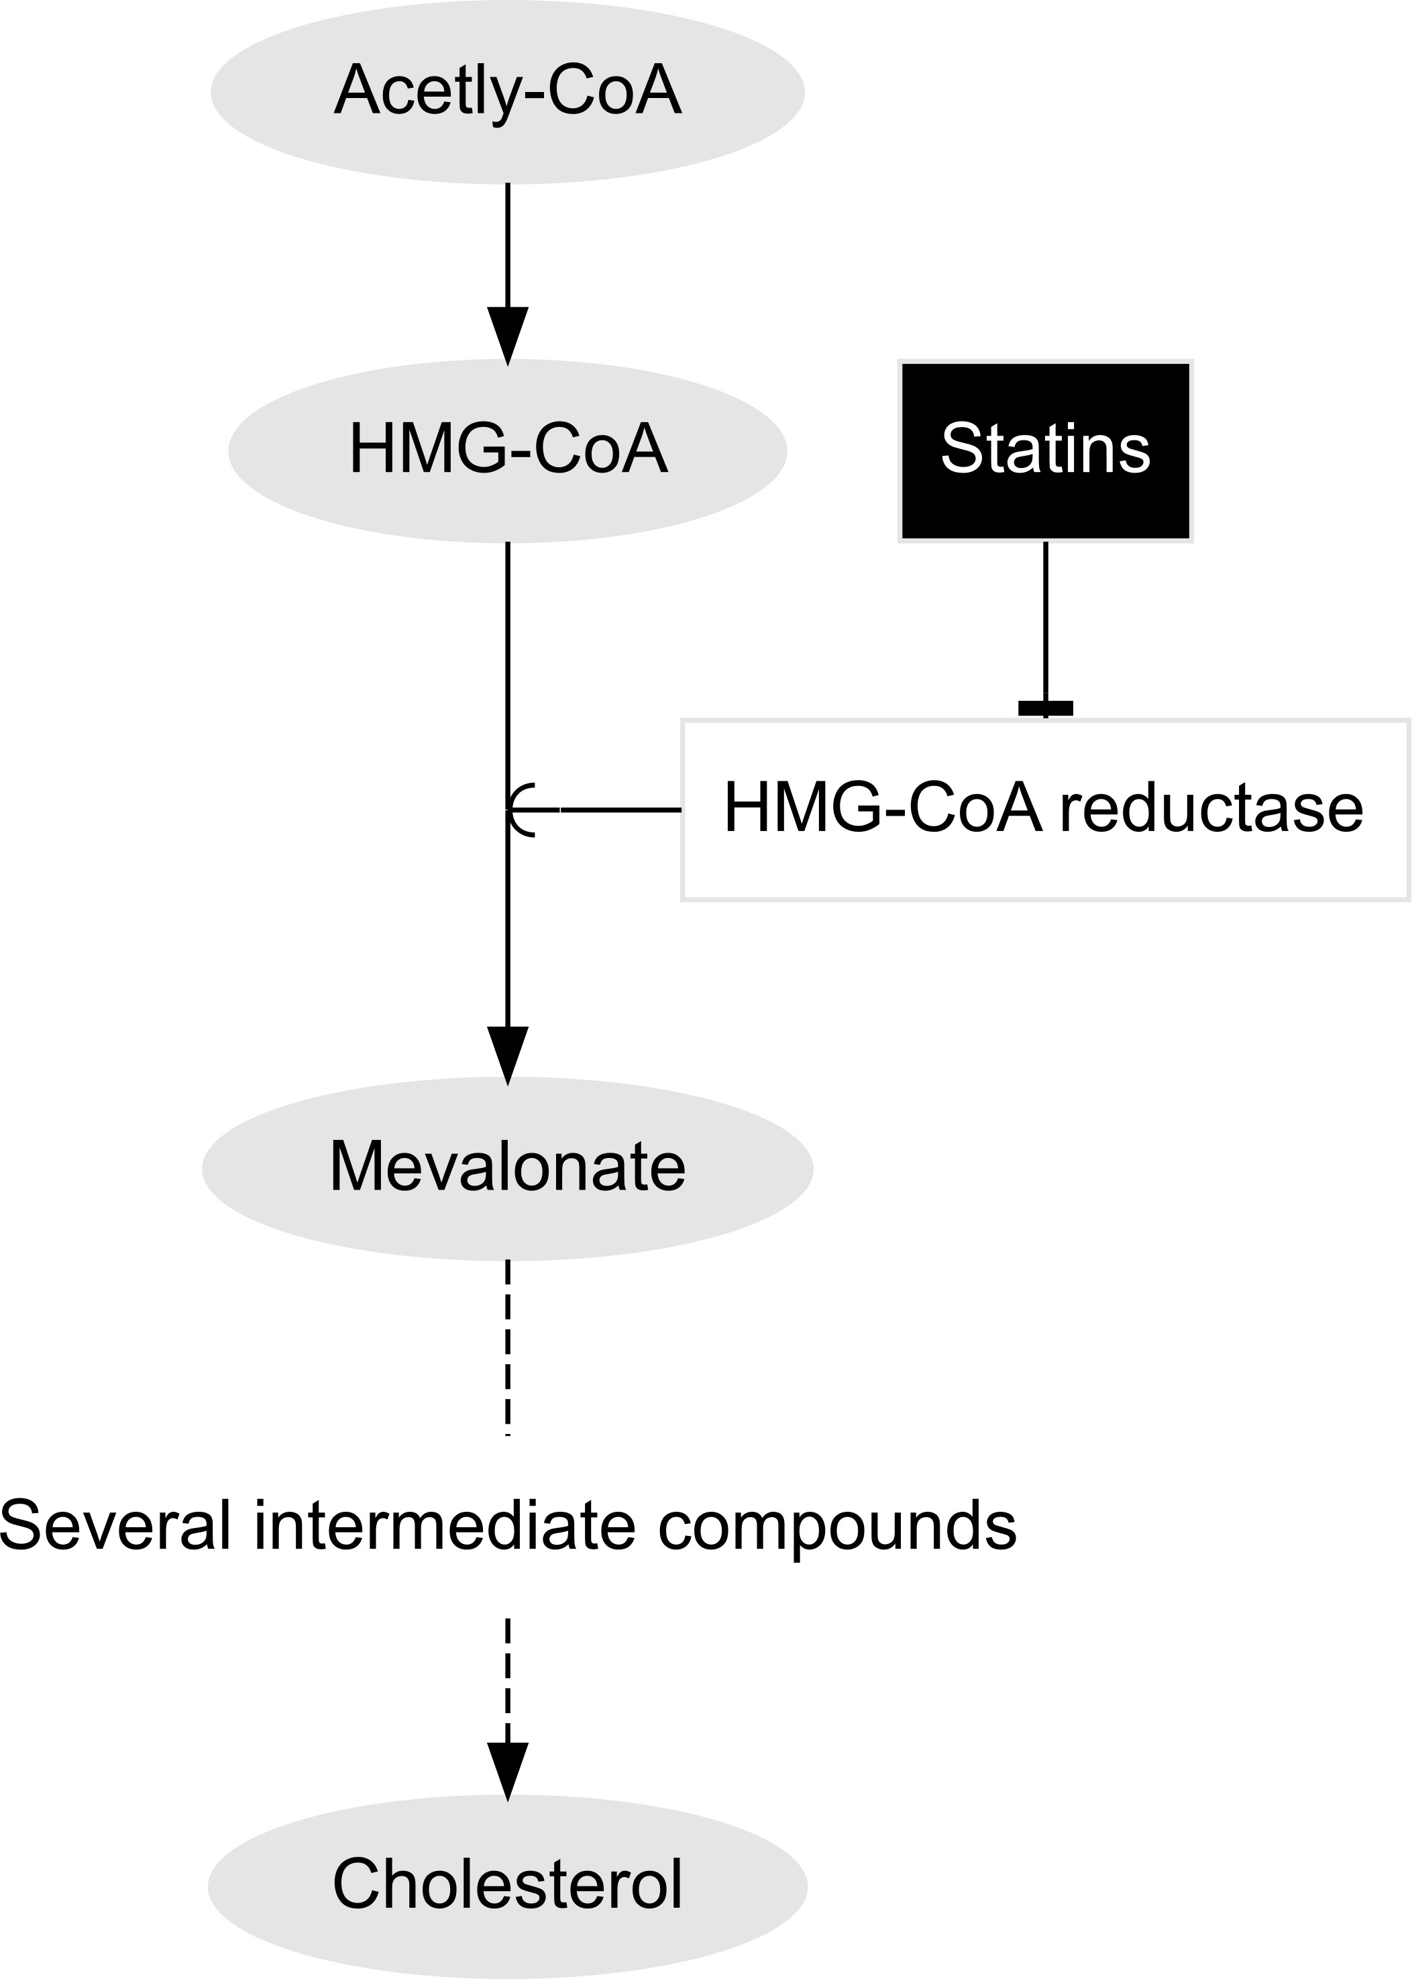

**Figure 1.1:** Overivew of statins mechanism of action, inhibiting HMG-CoA reductase which controls the conversion of HMG-CoA to mevalonate, the rate-limiting step in cholesterol biosynthesis.

Several statin treatments have been widely available for some time (see Table 1.3). Depending on the statin and dosage prescribed, the average reduction in LDL-c concentrations ranges from 15% with low-intensity regimen (e.g. ravastatin 5 mg/day) up to 60% with a high-intensity regimen (e.g. rosuvastatin 80 mg/day).38,39 Statins also vary with regard to their lipophilicity (the extent to which they are lipid soluble), affecting their localisation within the body, with hydophilic statins being concentrated in the liver and lipophilic statins circulating more widely.40 This may create a divide in the pleiotropic affects of statins with differing lipophilicity, particularly given the ability of lipophilic statins to permeate the blood brain barrier.41

* 1. *- Serum lipids*

**Table 1.3:** Overview of commonly-prescribed statins, summarising their approval date (US), properties and lipid-lowering effect.

|  |  |  |  |  |
| --- | --- | --- | --- | --- |
| **Name** | **Brand name** | **Year approved** | **Properties** | **Lipid-lowering effect** |
| **Atorvastatin** | Lipitor | 1996 | Lipophilic | +++ |
| **Pravastatin** | Lipostat | 1989 | Hydrophilic | + |
| **Rosuvastatin** | Crestor | 2003 | Hydrophilic | ++++ |
| **Simvastatin** | Zocor | 1992 | Lipophilic | ++ |

* + 1. Other lipid regulating agents (LRA)

There are several other interventions that can be used to modify a persons lipid profile, each of which act via different mechanisms. However, in general, these treatments are either used as adjunct (additional) treatments to statin therapy or are used in situations where statins are contra-indicated or not tolerated.

The most commonly used non-statin therapeutic is ezetimibe,42 which prevents intestinal absorption of cholesterol. However, when used alone, it has a limited LDL-c lowering effect, leading to the creation of combined statin/ezetimibe therapies (both compounds contained in a single pill, as opposed to complimentary treatments).43

Fibrates provide a second example of non-statin therapy. They are used to treat hypertriglyceridaemia by reducing production of triglyceride carrying compounds in the liver. They are commonly used in patients with mixed hyperlipidaemia if treatment with statins has failed to sufficiently control cholesterol levels.

Finally, PCSK9 inhibitors (or PCSK9i) are a relatively new treatment with strong lipid lowering effects, lauded as a potential alternative to statins.44 Their mechanism of action is to bind to and inhibit PCSK9, which breaks down LDL-c receptors on the surface of the liver, thus allowing more LDL-c to be internalised and broken down.

* 1. *- Serum lipids*

Other therapies targeting triglycerides exist, including nicotinic acids45 and omega- 3-fatty acids,46 but they far less effective in LDL-c lowering than the therapies described above.

**Table 1.4:** Summary of available treatments for hyperlipidaemia.

|  |  |  |  |
| --- | --- | --- | --- |
| **Treatment** | **Effect** | **Mechanism of** | **Examples** |
| **HMG CoA** | Lowers LDL-c & | Inhibits | Atorvastatin, |
| **reductase** | TG | cholesterol | Simvastatin, |
| **inhibitors** | Raises HDL-c | biosynthesis | Pravastatin |
| **(statins)** |  | pathway in the |  |
|  |  | liver |  |
| **Ezetimibe** | Lowers LDL-c | Prevents |  |
|  |  | absorption of |  |
|  |  | cholesterol from |  |
|  |  | diet |  |
| **Bile acide** | Lowers LDL-c | Prevent bile acid | Colestipol |
| **sequestrants** |  | reabsorption in |  |
|  |  | the |  |
|  |  | gastro-intestinal |  |
|  |  | tract, increasing |  |
|  |  | conversion of |  |
|  |  | cholesterol to bile |  |
|  |  | acids |  |
| **Proprotein** | Lowers LDL-c | Bind to PSCK9 | Evolocumab, |
| **convertase** |  | protein, | Alirocumab |
| **subtilisin kexin** |  | preventing it from |  |
| **9 (PCSK9)** |  | breaking down |  |
| **inhibitors** |  | LDL receptors on |  |
|  |  | heptatic cells, |  |
|  |  | increasing |  |
|  |  | cholesterol uptake |  |

action

* 1. *- Evidence for the association between blood lipids and dementia*

### Evidence for the association between blood lipids and dementia

This section provides an overview of the varying sources of evidence on the relationship between blood lipid levels and dementia risk.

* + 1. Basic science

A role for lipids in the aetiology of dementia is supported by both genetic linkage studies and functional cell biology studies. The generation of the amyloid plaques found in the brains of Alzheimer’s patients is cholesterol dependent„47,48 while the most established genetic risk factor for late-onset dementia, apolipoprotein E (*ApoE* ), is involved in cerebral cholesterol transport. Several other genes involved in cholesterol transport have also been found to be associated with increased AD susceptibility.49–51

Despite these results, evidence from the diverse range of epidemiological studies on this topic has been inconclusive.

* + 1. Observational studies

By far the largest source of evidence on the relationship between blood lipids and dementia outcomes comes from observational designs. Several studies have examined the relationships between concentrations of serum lipids (total cholesterol (TC), low density lipoprotein cholesterol (LDL-c), high density lipoprotein cholesterol (HDL-c) and triglycerides) and both Alzheimer’s disease and vascular dementia and reported extremely varied results. In some studies, a high serum cholesterol concentration has been found to be associated with an increase in susceptibility to AD,52–56 however others have shown no association,57–60 or a reduced susceptibility.61,62 With regard to vascular dementia, decreased levels of HDL-c appear to be associated

*1.4 - Evidence for the association between blood lipids and dementia*

with increased risk,62 while for LDL-c, studies have reported both positive and negative associations.62,63

* + 1. Randomised controlled trials

In terms of the central research of this thesis, RCTs of statin therapy can be used to provide indirect evidence for the effect of reducing blood LDL-c levels on dementia risk. However, RCTs may be infeasible if the outcome of interest is one with a long prodomal period, such as dementia (see Section 1.2.1), as they would require extremely long and costly follow-up.64 It is no surprise then that the two previous trials providing evidence on the effect of statins on dementia risk, identified by a recent Cochrane review,65 are in fact trials of statins for the prevention of coronary related outcomes.

While being widely cited, these studies have major limitations that reduce their utility as a source of evidence on the effect of statin treatment in assessing the impact of lipid-lowering treatment on dementia risk. Firstly, the criteria used to determine a dementia outcome are unclear. One of the trials, the Prospective Study of Pravastatin in the Elderly (PROSPER) trial,66 reported not on dementia outcomes but on the change in cognitive scores over a mean of 3.2 years. As highlighted in Section 1.2.2, a “change in score” alone is insufficient to diagnose a dementia outcome. The second trial, the Medical Research Council/British Health Foundation Protection Study,67 found no effect of simvastatin on dementia (OR: 1.00, 95%CI: 0.61-1.65), but did not report how the outcome was assessed/recorded within the trial.

Additionally, the two trials did not make any effort to assign an underlying pathology to each case, instead reporting an all-cause dementia outcome. As discussed in Section 1.2.1, the different underlying pathologies of dementia have different mechanisms of action, and so it is not gauranteed that the effect of statins would be consistent across them.

* 1. *- Evidence for the association between blood lipids and dementia*

Both trials were also limited by the relatively short follow-up period examined. This limited follow-up was expected, as the primary aim of both trials was to assess the effect of statins on short-term coronary-related outcomes.66,67 The PROSPER trial had a mean follow-up of 3.2 years, while the MRC/BHF Protection Study estimated risk at 5 years of follow-up. Given the long lag time between non-symptomatic onset of dementia and clinical presentation, it is likely that these durations are insufficient to fully capture the onset of dementia. Finally, as they included only patients at high vascular risk, their generalisability to other settings is limited.65

* + 1. Mendelian randomisation

Newer methodological approaches, such as Mendelian randomisation (MR),68 have also been used to examine the effect of varying lipid levels on dementia risk. Mendelian randomisation attempts to combat the risk of reverse causation and residual confounding inherent to observational studies by using natural random varation in participants genomes.69 In brief, MR uses genetic variants that are both strongly associated with the exposure of interest and are independent from potential confounders to strengthen causal inference.68 The analytic method relies on several assumptions about the instrumental variable (IV),70 namely that:

* + - 1. the IV is associated with the exposure of interest (the relevance assumption);
      2. the IV and outcome do not share a common cause (the independence assump- tion); and
      3. the IV does not affect the outcome other than via the exposure (the exclusion restriction assumption).

Recent MR studies indicated that genetically determined low levels of LDL-c may cause a reduction in AD risk.71,72 However, the effect was attenuated in sensitivity analysis that exclude the region surrounding the *ApoE* gene, the strongest known risk factor for Alzheimer’s disease.73 Inclusion of *ApoE* 4 variants invalidates the

* 1. *- Theoretical framework: Evidence synthesis*

exclusion restriction criteria (Assumption 3, above), as the risk reduction observed may be driven by variants in this region via a pathway independent of lipid levels. This was supported by further MR studies where *ApoE* 4 variants were intentionally excluded.74 Despite the increasing number of MR studies examining this topic, no systematic review of this study design as a source of evidence has been performed.

In summary, multiple sources of evidence exist on the relationship between statins and dementia. In the next section, I introduce the synthesis of diverse sources of evidence as the theoretical framework used in this thesis.

### Theoretical framework: Evidence synthesis

Evidence synthesis is the process of finding and integrating information from several sources to examine a research question.75 A common type of evidence synthesis is a systematic review, either with or without a meta-analysis.76

The results of an evidence synthesis exercise can be used to provide a more definitive answer to that question or, failing that, to highlight gaps in the existing evidence base. The ability to identify these gaps is particularly useful in guiding future research to address questions that have yet to be answered.

This thesis seeks to use an evidence synthesis framework to assess the effect of lipids, and treatments that influence lipid levels, on dementia outcomes. Specifically, this thesis considers three concepts within the umbrella term of evidence synthesis:

* + - Inclusion of preprints
    - Individual participant data meta-analysis
    - Triangulation across evidence sources

These three elements are expanded on below and are used to frame the research presented in the subsequent Chapters.

*1.5 - Theoretical framework: Evidence synthesis*

* + 1. Inclusion of preprints

The importance of including grey literature, defined as literature not published in peer-reviewed journals,77 in systematic reviews is widely acknowledged. Meta- research studies have demonstrated that systematic reviews excluding grey literature sources overestimate the effect of interventions.78–80 Common, well-accepted forms of grey literature include conference abstracts, government reports and theses.77,81

However, the role of preprints in evidence syntheses is less well defined. Defined by the Committee on Publication Ethics as ‘scholarly manuscript[s] posted by the author(s) in an openly accessible platform, usually before or in parallel with the peer review process’,82 preprints serve several purposes. They are used to establish primacy when submitting to a journal where the peer-review process may take several months.83 In addition, the allow for the rapid disseminate research findings, as occurred during the COVID-19 pandemic.84 Finally, they are a source of information on manuscripts that may not have been accepted elsewhere, helping to combat publication bias or the “file-drawer” effect.85

One of the major criticisms of using preprints as an evidence source is that they have not yet undergone formal peer review.86,87 However, this approach assigns substantial weight to peer-review as a indicator of “quality”, and is at odds with the acceptance of non-reviewed conference proceedings as an evidence source.81,88 The argument for including preprints as an evidence source is further strengthened by results that demonstrate preprinted studies seldom change following peer review. Meta-studies of the concordance between preprinted and published studies showed that results were broadly comparable between the two, indicating that while the numerical results may change, the overall interpretation of the results were consistent in the majority of cases.89–91 This indicates that preprints should be considered a reliable reflection of a given study.

In this thesis, preprints are considered an important source of evidence, in contrast to previous reviews on this topic. However, as with grey literature,88 there are several logistical problems with carrying out systematic searches in preprint repositories.

*1.5 - Theoretical framework: Evidence synthesis*

As such, to enable the inclusion of preprints in the systematic review described in Chapters 3, a new tool addressing these issues is presented in Chapter 2.

* + 1. Individual participant data meta-analysis

Individual participant data (IPD) meta-analyses are commonly considered to be the gold standard in evidence synthesis methodology.92,93 IPD methods seek to obtain the raw data from each study identified in a systematic review, rather than basing the meta-analysis on summary results extracted from the literature.92

In the context of this thesis, if lipids are found to have a causal role in development of dementia, evidence-based preventative strategies would be best informed by identifying the types of individuals who are most likely to receive benefit from treatment with lipid-modifying agents.94–96 However, if primary studies do not present results stratified by covariates of interest, meta-analyses of summary-level data on this topic often have limited ability to examine research questions related to exposure-covariate interactions.92 In terms of this thesis, participant age and sex are considered to be of particular interest.94,97

An IPD meta-analysis of lipid levels on dementia outcomes would overcome this limitation of summary-level data, as access to the raw data allows for an analysis that investigates these interactions.98 This approach has the added benefit of allowing a common set of inclusion criteria and a common statistical model to be applied across all datasets, potentially eliminating some important sources of heterogeneity.99

Despite their advantages, IPD meta-analysis are rarely performed.100 Factors limiting their uptake include the increased time and effort they require when compared to a summary-level analysis, and the low success rate associated with obtaining the raw data.101,102 The data underlying primary studies are frequently not publicly available,103,104 and the availability of data “available on request from authors” declines rapidly over time.105 Several systematic barriers to open data sharing have been identified106. Of particular concern for biomedical IPD analyses are legal

* 1. *- Theoretical framework: Evidence synthesis*

issues surrounding the sharing of medical data, motivated by concerns around patient privacy.107

In response to these limitations, new collaborative initiatives have developed to enable rapid access to relevant data in a secure supported workshop. The most import in relation to this thesis is the Dementia Platform UK (DPUK),108 which aims to provide access to several dementia-related datasets via a single simplified application process.

I will attempt to obtain the raw data from relevant primary studies identified by the systematic review in Chapters 3 & 4. Any data obtained will be combined with that available from the DPUK portal as part of an IPD meta-analysis in Chapter 6. This will enable the assessment of the effect of lipids on dementia stratified by key variables such as sex.

* + 1. Triangulating across study designs

As illustrated in Section 1.4, several diverse epidemiological methods have been used to examine the effect of varying blood lipid levels on dementia risk. However, each method is limited by its own biases. Aetiological triangulation is a developing evidence synthesis method that seeks to exploit these inherent differences in study design, and as a result, in biases.109 If several sources of evidence are available and point towards identical conclusions about an exposure-outcome relationship, and these sources are at risk of unrelated biases, this strengthens our confidence in the result. The ideal scenario is where predicted sources of bias are likely to be in competing directions, one to strengthen the effect of the exposure and the other to attenuate it.109 As such, triangulating these results can provide a middle-ground between the competing directions of bias. A triangulation approach can also prove useful in helping to prospectively design new studies that are at risk of different sources of bias to those already observed in the published literature.110 However, existing methods for triangulation are limited to a qualitative discussion of the

* 1. *- Thesis overview*

different identified results with respect to their biases,109 an approach which faces issues in interpretability when assessing many results.

To address this limitation, this thesis seeks to develop and apply a novel quantitative triangulation approach to answer causal questions on the effect of blood lipids on dementia outcomes. All existing evidence, regardless of study design, is first identified and assessed using domain-based tools by the systematic review presented in Chapters 3 & 4. The existing evidence base is then supplemented by two primary analyses, presented in Chapters 5 and 6. Finally all existing and new evidence is incorporated into the quantiatative triangulation framework in Chapter 7.

### Thesis overview

* + 1. Aims and objectives

The over-arching aim of this thesis is to explore the relationship between blood lipid levels, and by extension treatments that modify blood lipid levels such as statins, and the subsequent risk of dementia and related outcomes

The specific research objectives that this thesis seeks to address are:

* + - * To create a tool that allows for the inclusion of health related preprints in evidence syntheses in a systematic and reproducible manner
      * To review all available evidence across multiple diverse study designs to assess the effect of lipids and lipid regulating agents on dementia risk
      * To examine whether there is evidence for an effect of lipid-regulating agents on dementia and related outcomes in a large scale population-based cohort, the Clinical Practice Research Datalink (CPRD)
      * To produce evidence on lipid-covariate interactions as part of an IPD meta- analysis
  1. *- Thesis overview*
     + - * To propose a generalised framework for the quantitative triangulation across diverse evidence sources
     1. Structure

Chapters are self-contained, presenting the methods and results of that specific research project. They are bookended by introductory and discussion sections which place the methods and results in context. Each chapter is prefaced by a “lay” or plain English summary.

* + - * **Chapter** **1:**Background information on dementia and blood lipid levels. This chapter provides an introduction to the topics covered in this thesis to non-subject area experts, and discusses the motivation for the remainder of the thesis.
      * **Chapter** **2:**This chapter introduces a new tool, medrxivr, which was used to developed to allow for systematic searches of the health-related preprint repositories.
      * **Chapters** **3** **&** **4:**These chapters describe, respectively, the methods and results of a comprehensive systematic review and meta-analysis. This review examined all available evidence on the effect of blood lipids and interventions that modified blood lipids on dementia outcomes.
      * **Chapter** **5:**This chapter examines the relationship between lipid-regulating agent use and dementia outcomes in the Clinical Practice Research Datalink, a large primary care electronic health record database.
      * **Chapter** **6:**This chapter describes an individual participant data analysis of several longitudinal cohort studies to describe the relationship between blood serum lipids and dementia outcomes, stratified by important covariates such as sex.
  1. *- Outputs from this thesis*
* **Chapter** **7**: This chapter integrates the evidence identified and produced by the preceeding chapters as part of a quantitative triangulation framework.
* **Chapter** **8**: This chapter summarise the key clinical and methodological findings of the thesis and discusses their implications for practice. The overall strengths and weaknesses of this project are discussed in detail, and further avenues of research are suggested.

### Outputs from this thesis

The outputs of this thesis are detailed below, and include peer-reviewed papers, presentations, and open-source evidence synthesis tools.

* + 1. Contributions to the scientific literature

During the course of this thesis, I have made several contributions to the scientific literature. Those arising from or directly related to the contents of this submission are presented below.

***McGuinness L. A.****, Higgins J. P. T., Walker, V. M., Davies, N. M., Martin, R. M., Coulthard, E., Davey-Smith, G., Kehoe, P. G., and Ben-Shlomo, Y. (2021) Association of lipid-regulating drugs with dementia and related conditions: an observational study of data from the Clinical Practice Research Datalink. medRxiv* [*10.1101/2021.10.21.21265131*](https://doi.org/10.1101/2021.10.21.21265131)

Preprinted manuscript of the analysis of lipid-regulating agents and dementia outcomes in the CPRD, which is presented in Chapter 5.

*1.7 - Outputs from this thesis*

***McGuinness, L. A.****, and L Schmidt. (2020) medrxivr: Accessing and searching medRxiv and bioRxiv preprint data in R. Journal of Open Source Software 5.54 2651. DOI:* [*10.21105/joss.02651*](https://doi.org/10.21105/joss.02651)

A paper introducing the open-source preprint search tool described in Chapter 2. As is common for journal articles describing software, the paper is intentionally short providing only a broad overview of the tool while extensive documentation is available from the project website (see Section 2.1 for more details).

*Hennessy, E. A., Acabchuk, R., Arnold, P. A., Dunn, A. G., Foo, Y. Z., Johnson,*

*B. T., Geange, S. R., Haddaway, N. R., Nakagawa, S., Mapanga, W., Mengersen, K., Page, M., Sánchez-Tójar, A. Welch, V.,* ***and McGuinness L. A.*** *(2021). Ensuring Prevention Science Research is Synthesis-Ready for Immediate and Lasting Scientific Impact. Prevention Science . DOI:* [*10.1007/s11121-021-01279-8*](https://doi.org/10.1007/s11121-021-01279-8)

The experience of extracting data for the systematic review in Chapters 3 & 4 inspired a practical guide for researchers. This piece was co-written with Dr. Emily Hennessy (see Author Declarations in the front materials).

***McGuinness, L. A.****, and Higgins J. P. T. (2020) “Risk-of-bias VISualization (robvis): An R package and Shiny web app for visualizing risk-of-bias assessments.” Research Synthesis Method). DOI:* [*10.1002/jrsm.1411*](https://doi.org/10.1002/jrsm.1411)

The tool used to visualise the risk-of-bias assessments in Chapters 3 & 4 has been published in Research Synthesis Methods. See Appendix B.2 for more details on this tool. Note that this publication does not describe the recently-developed functionality for producing bias direction plots, as described in Chapter 7.

***McGuinness, L. A.****, and Sheppard A. L. 2020. “A Descriptive Analysis of the Data Availability Statements Accompanying Medrxiv Preprints and a Compar-*

* 1. *- Outputs from this thesis*

*ison with Their Published Counterparts.” PLOS ONE 16(5): e0250887. DOI:* [*10.1371/journal.pone.0250887*](https://doi.org/10.1371/journal.pone.0250887)

Using the tool described in Chapter 2, I led a “research-on-research” study to assess the concordance between the openness of data availability statements accompanying a sample of medRxiv preprints and their published counterparts.

For information on additional contributions to the scientific literature not directly related to this thesis, see Appendix A.1.1.

* + 1. Presentations/Talks

*“Identifying and triangulating all available evidence on the effect of blood lipids and statins on dementia outcomes”* : Poster presentation, Alzheimer’s Association International Conference 2021.

*“medrxivr: A new tool for searching for and retrieving records and PDFs from the medRxiv preprint repository”* : Accepted oral presentation abstract, Cochrane Colloquium 2020 (note: event was cancelled due to the COVID-19 pandemic).

*“On the shoulders of giants”: advantages and challenges to building on established evidence synthesis packages, using the {robvis} package as a case study"*: Oral presen- tation, Evidence Synthesis and Meta-Analysis in R Conference (ESMARConf) 2021.

*“RoB 2.0: A revised tool to assess risk of bias in randomised trials”* : Webinar, co-presented with Dr. Theresa Moore as part of the Evidence Synthesis Ireland Methods Series.

* + 1. Software
  1. *- Outputs from this thesis*

medrxvir

An R package that allows users to search and retrieve bibliographic data from the medRxiv111 and bioRxiv112 preprint repositories. See Chapter 2 for more details. Install a stable version of the package from the Comprehensive R Archive Network (CRAN), or alternatively install the development version from GitHub, using:

*# CRAN version*

install.packages("medrxivr")

*# Development version*

devtools::install_github("ropensci/medrxivr")

triangulate

An R package containing function to implement the quantitative triangulation approach detailed in Chapter 7. At present, only the development version of the package is available, which can be installed from GitHub using:

*# Development version*

devtools::install_github("mcguinlu/triangulate")

robvis

An R package and associated shiny web application that allows users to visualize the results of the risk-of-bias assessments performed as part of a systematic review. See Appendix B.2 for more details. Install a stable version of the package from CRAN, or alternatively install the development version from GitHub, using:

* 1. *- Summary*

*# CRAN version*

install.packages("robvis")

*# Development version*

devtools::install_github("mcguinlu/robvis")

### Summary

* In this introductory chapter, I provided background information on the core elements of the central research question and framed the research presented in the context of a theoretical framework of evidence synthesis. I outlined the central aim of the thesis and provided an overview of the individual analyses performed.
* I also described the contributions of this thesis to the scientific literature. Finally, I discussed the research tools and software developed to support the analyses in this thesis, one of which (the preprint search tool) is introduced more fully in the following chapter.

*Why are open source statistical programming languages the best?*

*Because they R.*

— Chris Beely, 2013113

# 2

## medrxivr: an R package for systematically searching biomedical preprints

**Contents**

**Lay summary** **28**

* 1. **Introduction** **28**
  2. **Development** **30**
  3. **Usage** **32**
  4. **Discussion** **39**
  5. **Summary** **42**

*2.1 - Introduction*

### Lay summary

Preprints are copies of academic manuscripts that are posted online in advance of being formally published by an academic journal. They represent an important source of scientific literature. A new software program called medrxivr was created as part of this thesis to allow researchers to find preprints related to their research in a transparent and reproducible way. Development of this tool was an essential part of this thesis, as preprints represent a key source of information needed for the research reported in future chapters.

### Introduction

Preprints represent an increasingly important source of scientific information (see Section 1.5.1). As a result, repositories of preprinted articles should be considered a distinct but complementary information source when reviewing the evidence base as part of a systematic review. The two key repositories in the health science are bioRxiv, established in 2013,112 and medRxiv, which launched in 2019 and was designed to replace the “Epidemiology” and “Clinical Trial” categories of bioRxiv.111

Searching these preprints as part of the systematic review described in Chapters 3 & 4 was a necessity, as many of the existing reviews on the topic of lipids and dementia have not considered this important source of evidence. At the time of writing, how- ever, the bioRxiv and medRxiv websites allow only simple search queries as opposed to the complex searches containing Boolean logic operators (AND/OR/NOT) that information specialists use to query other major databases.114,115 Additionally, the best available extraction mechanism for obtaining references for all records returned by a search involved going through each record and downloading individual citations one-by-one. As the scale of these preprint databases increase, particularly in light of the massive expansion of the medRxiv repository as a result of COVID, this already time-consuming and error-prone method is no longer feasible.

This chapter outlines the development and key functionality of medrxivr (version 0.0.5), a tool I created to facilitate the systematic searching of medRxiv and

* 1. *- Introduction*

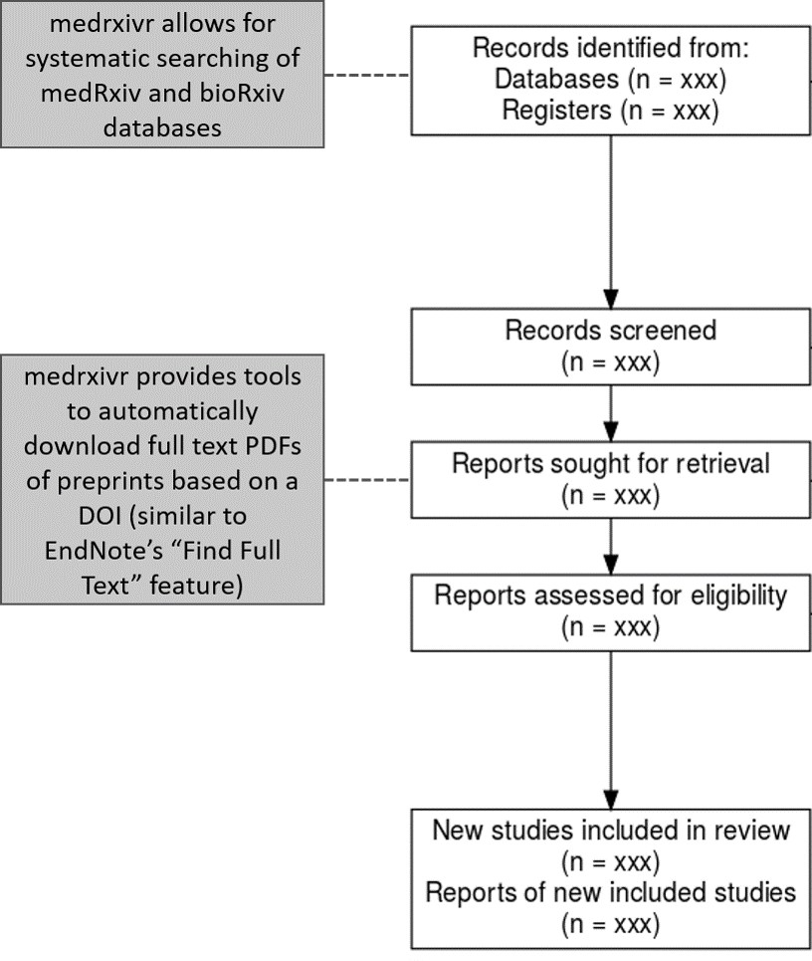

**Figure 2.1: Role of medrxivr in a systematic review workflow** - medrxivr allows for systematic searching of biomedical preprints as part of the initial literature searching. Following title and abstract screening, reviewers can then programmatically retrieve a copy of the PDF of included records to facilitate the full-text screening stage (similar to Endnote’s “Find Full Text” feature).

bioRxiv preprints. The factors that necessitated the development of this tool in the context of this thesis are outlined, and the use of medrxivr in my own projects and by other researchers is discussed. As the majority of work on this aspect of my thesis is represented by lines of code or online documentation (available at <https://github.com/ropensci/medrxivr>and [https://docs.ropensci.org/](https://docs.ropensci.org/medrxivr/) [medrxivr/](https://docs.ropensci.org/medrxivr/) respectively), this chapter is an intentionally short, high-level summary of my work on this project. The GitHub repository for the medrxivr contains a complete record of the development of this tool, including discussion with other members of the systematic review community.116

* 1. *- Development*

### Development

* + 1. Success criteria

I developed the tool to meet three success criteria,117 influenced both by the functionality required to perform systematic searches as part of the review presented in the subsequent chapters, discussion with information specialist colleagues, and an informal survey of the evidence synthesis and health librarian communities on Twitter. The criteria were as follows:

* + - 1. reliable, reproducible and transparent search functionality, allowing for Boolean (AND/OR/NOT) operator logic;
      2. support for bulk export of references returned by the search to a file type that can be readily imported into a reference manager (e.g., *.bib* or *.ris*); and
      3. automated retrieval of the full-text PDFs of relevant records, similar to the Find Full Text feature offered by EndNote.
    1. Alternative medRxiv/bioRxiv interfaces

Prior to development of this tool, I conducted an audit of existing tools for accessing medRxiv and bioRxiv metadata. While none addresses the success criteria described above, two of these tools are useful to consider to highlight the additional functionality that medrxivr contributes.

The first, a platform called Rxivist118, allows users to search preprints using keywords. However, the core functionality of the Rxivist platform is focused around exploring the number of times a preprint has been downloaded and/or shared on Twitter, to allow researchers to find the most popular papers related to their topic. The search interface119 does not allow for complex search strategies using Boolean operators and there is no option to batch-export the results of a search.

* 1. *- Development*

The second tool, search.bioPreprint, allows users to search for terms across a range of preprint servers, including medRxiv and bioRxiv, but also journals which use a post-publication peer-review process such as F1000Research.120 However, similar to the Rxivist platform, this tool is designed for researchers aiming to keep up to date with recent developments in their fields rather than systematically assess the entirety of the available literature. As such, the platform only returns the most recent 1,000 records by publication date.

Finally, neither tool provides an easy way to programmatically download a copy of the PDF of relevant preprints as part of the preparation for the full-text screening stage of a systematic review.

* + 1. Early versions

Work on the medrxivr tool began in Summer 2019, and initially consisted of a development of set of R scripts to allow for searching medRxiv and bioRxiv as part of the systematic search outlined in Chapter 3. Following interest from other researchers in using the *ad-hoc* web-scraping scripts, additional development work took place in 2019/2020, allowing for improved searching and exporting functionality and I released the initial version of the medrxivr R package in February 2020.

Early versions of the tool had a reliance on scraping data directly from the repository website. Web-scraping is a fragile mechanism for extracting data, as it is entirely dependent on consistent website design and underlying code structure remaining unchanged.121,122. In the case of medrxivr, as the medRxiv/bioRxiv websites are regularly updated, ensuring the web-scraping performed as expected required that I regularly update or fix the script.

However, an application programming interface (API) for the medRxiv and bioRxiv repositories was made public in early 2020 by the institution responsible for managing these preprint repositories, the Cold Springs Harbor Laboratory. This allowed for newer versions of the medrxivr package to engage in active “fault

* 1. *- Usage*

prevention” and provide a more robust interface to the data by removing the reliance of web-scraping.122

* + 1. Package infrastructure

I wrote the medrxvir package in R using RStudio,123 and followed development best-practice, including detailed documentation, a robust unit testing framework (99% of all code lines within the package are formally tested across multiple platforms including Windows, MacOS, and Linux), and in-depth code review by two experienced, independent reviewers.

### Usage

The medrxivr R package is split into two component parts:

* + - an interface to the Cold Springs Harbor Laboratory API, which imports medRxiv and bioRxiv metadata into R; and
    - a collection of functions for working with the imported metadata, with an explicit focus on searching this data as part of a systematic review or evidence synthesis project.

The standard workflow is to download a copy of all metadata contained in the repository, and then to perform searches on this local copy. This is a workaround as the Cold Springs Harbor Laboratory API does not provide any functionality to search the database.

While the package allows users to interact with and search both medRxiv and bioRxiv metadata, as the process is identical for both, searching the medRxiv database is used as an illustrative example throughout this chapter.

* + 1. Installation

*2.3 - Usage*

medrxivr has been released to the Comprehensive R Archive Network (CRAN), and can be installed with the following code:

install.packages("medrxivr")

Alternatively, the development version of the package can be installed from GitHub:

*# install.packages("devtools")*

devtools::install_github("ropensci/medrxivr")

* + 1. Importing preprint metadata

Prior to searching the metadata, it must first be imported in R. In medrixvr, I have provided two separate but related methods for users to import the data (Figure 2.2). The first of these methods, accessed via the mx_api_content() function, creates a local copy of all data available from the medRxiv API at the time the function is run.

*# Get a copy of the database from the live medRxiv API endpoint*

mx_data <- mx_api_content()

This provides an up-to-the-minute reflection of the medRxiv preprint repository. However, this approach has two limitations. Firstly, as the API returns results as a series of pages limited to 100 records per page, downloading the entire database requires a time-intensive process of cycling through each page. Secondly, the API can become unavailable, either during peak usage times or planned maintainence windows. To address these limitations, I provide a second method of accessing

*2.3 - Usage*

medRxiv data, called via the mx_snapshot() function, which allows users to access a maintained static snapshot of the database.

*# Import a copy of the medRxiv data from the snapshot*

mx_data <- mx_snapshot()

This snapshot is created each morning at 6am using a process known as “git- scraping”,124 whereby the entire database is downloaded using the mx_api_content() function and saved as a comma separated value (CSV) file in an online repository (Figure 2.2). Calling mx_snapshot() imports this CSV into R, and has the advantage of both faster loading of the data into R (as it is imported as a single file and does not require cycling through the output of the API) and an absence of any reliance on the API. The one limitation of this approach is that the snapshot (by its nature) will not contain details of records added to the database since it was taken. However, given that the number of records added each day is relatively low, this should pose minor issues.

*2.3 - Usage*

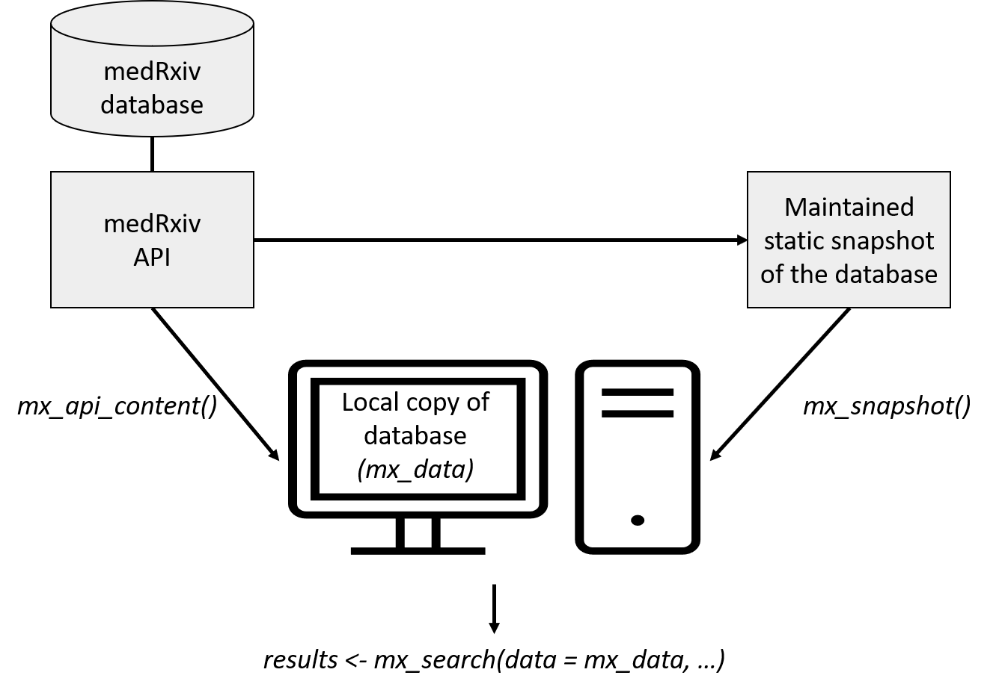

**Figure 2.2: Overview of medrxivr data sources** - Users can either access the API directly via mx_api_content(), or can import a maintained snapshot of the database, taken each morning at 6am, via the mx_snapshot() function. Note: due to the size of bioRxiv, only a maintained snapshot of the medRxiv repository is available via mx_snapshot().

* + 1. Performing a search

Once a local copy of the metadata is created, the first step in searching it is to create a search strategy. Search terms to be combined with the OR operator are contained in vectors (c(...)), while topics to be combined with the AND operator are contained in lists (list(...)).

*2.3 - Usage*

*# Create the search query*

topic1 <- c("dementia","alzheimer's") *# Combined with OR*

topic2 <- c("lipids","statins") *# Combined with OR*

myquery <- list(topic1, topic2)

*# Combined with AND*

For example, when written in standard syntax, the search contained in the myquery object above would be: “((dementia **OR** alzheimer’s) **AND** (lipids **OR** statins))”. There is no limit to the number of search terms that can be included in each topic, nor in the number of topics that can be searched for. Search terms can also contain common syntax used by systematic reviewers and health librarians, including the NEAR operator for the identification of co-localised terms and wild-cards which allow for alternate spellings (e.g. “randomi*s*ation” vs “randomi*z*ation”).

Once a strategy has been defined, it is passed along with the local copy of the database to the mx_search() function.

*# Run the search*

results <- mx_search(mx_data,

myquery)

* + 1. Refining a search

An important argument of the mx_search() is report, which outputs a structured table with each search strategy presented on an individual line and the number of records associated with this strategy.125

*2.3 - Usage*

results <- mx_search(mx_data,

myquery, report = TRUE)

***## Found 1 record(s) matching your search. ##***

***## Total topic 1 records: 224***

***## dementia: 224***

***## alzheimer's: 0 ##***

***## Total topic 2 records: 119***

***## lipids: 90***

***## statins: 33***

This allows users to discover which terms in their search are contributing most to the total number of results returned. This is important as part of developing a search strategy,114 as it allows for the key terms related to each topic to be discovered. It also aids in identifying misspelled or case-sensitive search terms, which will frequently return no results. As an example, in the search presented above, the term “alzheimer’s” returns no records. This is expected, as “Alzheimer’s” is a proper noun and so should be capitalised, but serves to illustrate the usefulness of the reporting function.

In hindsight, the decision to make the search case-sensitive was a poor one as users reported being unaware of this setting when searchin. However, changing the default behaviour of mx_search() to be case-insensitive is problematic, as it could result in different numbers of hits based solely on which version of the package the user has installed. To address this, mx_search() now contains an autocaps argument, which when set to TRUE will automatically search for both capitalised and uncapitalised versions of the search term.

* + 1. Exporting to a bibliography file
  1. *- Usage*

In line with my second success criteria (Section 2.2.1), one of the key features of the medrxivr is the ability for users to export easily the results of their systematic search to a reference manager. While it is a seemingly simple request, this is is one of the key ways in which medrxivr is set apart for other preprint search tools, including the native medRxiv/bioRxiv website search functionality.

For example, the results of our simple search above can be exported to the

"medrxiv_export.bib" file using the following code:

mx_export(results,

file = "medrxiv_export.bib", report = TRUE)

* + 1. Downloading the PDFs of relevant records

medrxivr also allows users to download the full text papers for records that are deemed eligible for full-text screening (see Figure 2.1). mx_download() takes the list of included records and saves the PDF for each to a folder specified by the user. This functionality is similar to the “Find Full Text” feature offered by EndNote.

mx_download(results, *# Search results, less excluded records*

"pdf/") *# Directory to save PDFs to*

* 1. *- Discussion*

### Discussion

* + 1. Reception and future plans

The tool has been well received by the community (as of December 2021, medrxivr has been downloaded more than 6100 times), and several use cases have been reported. It has been used to investigate the role of preprints in the response to the 2019 coronavirus outbreak,126 perform searches of preprints as part of a systematic review,127,128 and examine how data-sharing behaviour is affected by journal policies (see 1.7).129

The package has been accepted into the rOpenSci suite of packages, a collection of “carefully vetted, staff- and community-contributed R software tools that lower barriers to working with scientific data sources on the web”.130 As part of this process, following rigorous peer-review, an associated article introducing the tool was published by the Journal of Open Source Software.131 The entire review discussion is publicly available and can be viewed online.132 The tool has also been well received by the open-source community, demonstrated by the engagement of other developers in contributing to important new functionality and suggesting bug-fixes.

Lobbying of the Cold Springs Harbor Laboratory to develop the API to allow for direct searching of the database has been ongoing. This would negate the current need to download a local copy of the relevant preprint database before searching it, which is currently the rate limiting step for performing searches. For example, as of January 2021, downloading a copy of the bioRxiv database takes approximately an hour.

* + 1. Use cases

In addition to being used to search systematically health-related preprint servers, as illustrated in the systematic review presented in Chapters 3 & 4, medrxivr has other uses.

*2.4 - Discussion*

For example, I led a descriptive analysis of the change in data availability statements between preprinted and published versions of the same manuscript, stratified by journal data sharing policy access, underpinned by preprint meta-data provided by medrixvr. By comparing the preprinted and published versions of the data availability statement, I could examine the same manuscript - same content, authors and funders - under two different publication policies (preprint server vs peer- review journal). This comparison provides evidence on whether stricter policies which require data sharing as a condition of publication result in increased data availability. The analysis found some evidence that data availability statements more frequently described open data on publication when the journal mandated data sharing, compared to when the journal did not mandate data sharing. This study has since been published,129 and a copy is included in Appendix B.3.

Secondly, using medrxivr, an analysis of the publication rate for medRxiv preprints was performed (see Appendix A.2.1). 87 of the 129 records (67.4%) posted on medRxiv in July 2019 were published by 30th July 2021 (i.e. allowing for a two- year lag between preprint posting and publication). This finding agrees with previous work demonstrating that two-thirds of bioRxiv preprints are published in a peer-reviewed journal within two years of posting.133 This analysis further illustrates that a subtantial number of preprints are never formally published but remain accessible as preprints.

In summary, the meta-research/methodological analyses described above illustrate that easy access to medRxiv/bioRxiv metadata has applications beyond the inclusion of preprints in systeamtic review.

* + 1. Limitations of medrxivr

While searching of the medRxiv and bioRxiv databases was crucial for the systematic review element of my thesis, there are some important limitations to note here. A key example is that the tool only searches the available metadata of preprint records

* 1. *- Discussion*

(the title, abstract and keywords), rather than the full text of preprints, and so some relevant records might be missed. However, this approach echoes that used by other search platforms such as OvidSP, and while some relevant records may be missed (reduced sensitivity), limiting the search to the metadata fields prevents non-relevant records from being returned (high specificity). A key example of the reduced specificity when searching the full text, identified during development of medrxivr, is that a search for “dementia” would return a record where the only occurrence of this term is in the title of one of the references.134

There is also the potential that the cross-section of literature posted on medrxiv/bioRxiv is substantially different to those suffering from publication bias (studies or analyses that are not published for a range of reasons including results that are not deemed “novel” or are not statistically significant).135 This is because simply lowering the barriers to publication may well encourage authors to published “null” results, but due to the effort involved in writing up a distributable manuscript, it is unlikely

to completely address the “file drawer” effect.85

It is probably too early (and likely too methodologically difficult) to tell whether the increased popularity and acceptance of preprint repositories will have any effect of the availability of research that was not considered “publishable” at other venues.

* + 1. Role of open source tools in evidence synthesis

Part of the motivation for creating the medrxivr tool was a belief that the develop- ment and distribution of open source scripts and tools should be a fundamental part of evidence synthesis research.136,137 In the case of medrxivr, it is likely that several other evidence synthesists had written personal scripts that have a similar, or related, functionality - in fact, following development of the tool, I identified one other researcher that has done so (Nicholas Fraser, author of the rbiorxiv package, which allows for importing medRxiv metadata into R but does not provide search functionality).138 If these scripts continue to be developed in

* 1. *- Summary*

private and are never shared or publicised, this will inevitably hamper the efforts of the evidence synthesis community, not only in terms of duplication of time and effort but also due to lost opportunities for collaboration.137 Creating and sharing well-documented packages, the recognised standard for sharing code in R, represents one way to reduce this inefficiency.139

### Summary

* + - In this Chapter, I have introduced a new tool, medrxivr, for performing complex systematic searches of the medRxiv and bioRxiv preprint repositories.
    - I have outlined the motivation for developing this tool in relation to this thesis

- more specifically, that it was used to perform systematic and reproducible searches of key literature sources used in the comprehensive systematic review described in Chapters 3 & 4.

* + - I have contrasted medrxivr with other available interfaces to medRxiv/bioRxiv data to highlight the added functionality it offers. I have also discussed the tools reception to date, its limitations, and the important role of open-source tools like medrxivr in evidence synthesis.

*“It is surely a great criticism of our profession that we have not organised a critical summary by speciality or sub-speciality, up-dated periodically, of all relevant RCTS.”*

— Archibald Cochrane, 2000140

# 3

## Systematic review of existing evidence on the association between blood lipids and dementia outcomes: Methods

Contents

**Lay summary** **43**

* 1. **Introduction** **44**
  2. **Methods** **45**
  3. **Summary** **62**

*3.1 - Introduction*

### Lay summary

Systematic reviews are a type of research study that aim to collect and combine all existing evidence to provide the best possible answer to an important research question. Well-performed reviews involve multiple steps including: searching for existing studies; assessment of the studies against predefined inclusion criteria; collection of data from each study; and assessment of each study’s method and results.

This chapter presents the methods used to perform a systematic review of primary studies that have examined the relationship between the levels of blood lipids (such as cholesterol and triglycerides) and dementia outcomes. In addition, the review examined the relationship between treatments that change blood lipid levels, such as statins, and dementia outcomes. The results of this systematic review are then presented in Chapter 4.

### Introduction

In this chapter, I describe a comprehensive systematic review of the relationship between blood lipid levels (and treatments that modify them) and the subsequent risk of dementia and related outcomes.

This analysis sought to address two specific aims. Firstly, as discussed in the introduction to this thesis (Section 1.4), several diverse forms of evidence on the relationship between lipids and dementia exist. These include randomised controlled trials, observational studies of different design, and Mendelian randomisation studies. However, based on a scoping review of existing literature, no previous evidence synthesis exercise has attempted to examine the association of lipids/statins with dementia outcomes across these distinct evidence types. Collating these diverse evidence sources is important, as, if the observed association between lipids and dementia is constant across them, it increases our confidence in the association. As such, the primary aim of this analysis was to systematically review all available literature describing prospective analyses, regardless of study design.

* 1. *- Methods*

Secondly, I explicitly sought to include health-related preprint servers as a potential evidence source in this review, as they are infrequently considered by evidence synthesists but can report relevant unpublished analyses. As a sensitivity analysis to the review presented in this chapter, I sought to quantify the additional evidential value of including preprints, making use of the preprint search tool presented in Chapter 2.

Given the size of the review, I have separated the methods and results into two chapters for ease of reading. This chapter details the methodology used, while Chapter 4 presents the results.

### Methods

* + 1. Protocol

A pre-specified protocol for this analysis was registered on the Open Science Framework platform and is available for inspection.141 Deviations from the protocol are summarised in Appendix A.3.1.

* + 1. Contributions

In line with best-practice guidance, secondary reviewers were used to check the accuracy of screening, data extraction and risk-of-bias assessment processes. Due to the scale of the project, this review was performed in conjunction with a team of secondary reviewers (see Acknowledgements and Author Declaration in the front matter).

*3.2 - Methods*

* + 1. Eligibility criteria

Inclusion criteria

I sought to include studies that examined blood lipid levels as a risk factor for dementia outcomes, defined either as binary hypercholesterolemia variable or by category/1-standard-deviation increase in a specific lipid fraction (total cholesterol, high- and low-density lipoprotein cholesterol and triglycerides). I also aimed to include studies examining the effect of lipid-regulating agents (LRA) as a source of indirect evidence. LRA are treatments used to modify blood lipids levels, and common examples include statins, fibrates, and ezetimibe.

Eligible study designs were randomised controlled trials of LRA, cohort studies examining blood lipids or LRA, and genetic instrumental variable studies (more commonly known as Mendelian randomisation studies) examining the effect of genetically increased/decreased blood lipid levels.

Eligible studies screened participants for dementia at baseline and excluded any prevalent cases. Alternatively, where no baseline screening was employed, partic- ipants were assumed to be dementia free if less than 50 years of age at baseline. Studies of any duration were included to allow for exploration of the effect of length of follow-up on the effect estimate. No limits were placed on the sample size of included studies. Eligible studies defined dementia outcomes according to recognised criteria. Examples of acceptable criteria included the International Classification of Diseases (ICD),142 National Institute of Neurological Disorders and Stroke Association-Internationale pour la Recherche en l’Enseignement en Neurosciences (NINDS-AIREN),13 or Diagnostic and Statistical Manual of Mental Disorders (DSM) criteria.3 Studies utilising electronic health records were the sole exception to this, as it was assumed that health care professionals employed their own expertise when entering the outcome into the EHR.

Conference abstracts with no corresponding full-text publication were eligible, and where required, I contacted authors to obtain relevant additional information

*3.2 - Methods*

not available from the abstract. No limitations were imposed on publication status, date, venue or language.

Exclusion criteria

Due to the significant impact of a memory-related outcome such as dementia on exposure recall, case-control studies were excluded, though case-control studies where historical records are used to determine the exposure status were eligible for inclusion. Cross-sectional studies, qualitative studies, case reports/series and narrative reviews were also excluded, as were studies that measure change in continuous cognitive measures (e.g. MoCA score) without an attempt to map these scores to ordinal groups (e.g. no dementia/dementia).143 Previous systematic reviews were not eligible for inclusion, but their reference lists were screened to identify any potentially relevant articles.

Studies with outcomes not directly related to the clinical syndrome of dementia (e.g., neuroimaging) and studies where there was no screening for dementia at baseline were excluded. An exception to the latter criteria was made if the sample was initially assessed in mid-life (i.e. below the age of 50) were excluded. Additionally, studies implementing a “multi-domain intervention” where a lipid-regulating agent is included in each arm were excluded. For example, a study examining exercise + statins versus statins alone would be excluded, but a study examining exercise + statins vs exercise alone would be eligible as the effect of statins can be estimated. Finally, studies using a dietary intervention, for example an omega-3 fatty acid enriched diet, were excluded as it is difficult to disentangle the effect of other elements contained within the diet. Note that this is distinct from studies which delivered a simple tablet-based omega-3 intervention, which would have been eligible for inclusion.

* + 1. Information sources and search strategy
  1. *- Methods*

I systematically searched several electronic bibliographic databases to identify potentially relevant entries (hereafter referred to as “records”). The following databases were searched in June 2019 from inception onwards: Medline, EMBASE, Psychinfo, Cochrane Central Register of Controlled Trials (CENTRAL), and Web of Science Core Collection. As the contents of the Web of Science Core Collection can vary by institution,115 the specific databases and date ranges for each database searched via this platform are listed in Appendix A.3.2. The search strategy used in each database was developed in an iterative manner using a combination of free text and controlled vocabulary (MeSH/EMTREE)81 terms to identify studies which have examined the relationship between blood lipids levels and dementia, incorporating input from an information specialist. The strategy included terms related to lipids, lipid modifying treatments, and dementia, and was designed for MEDLINE before being adapted for use in the other bibliography databases listed. A high-level outline of the strategy is presented in the Table 3.1 below and the full search strategies for each database are presented in Appendix A.3.3.

*3.2 - Methods*

**Table 3.1:** Summary of systematic search by topic. The full search strategy including all terms and the number of hits per term is included in Appendix A.3.3.

**No. Concept**

* + 1. Dementia
    2. Lipids
    3. Lipid-modifying treatments
    4. 1 AND 2
    5. 1 AND 3
    6. 4 OR 5
    7. Animals NOT (Animals AND Humans)
    8. 6 NOT 7
    9. Observational filter
    10. Randomised controlled trial (RCT) filter
    11. Mendelian randomisation/Instrumental variable filter 12 OR/ 9-11

13 8 AND 12

For all topics, search queries were comprised of relevant free text & controlled vocabulary terms.

When searching the bibliographic databases, study design filters (Lines 9-11 in Table 3.1) were employed to try to reduce the screening load. To ensure that the study design filters were not excluding potentially relevant records, a random sample of 500 records identified by the main search but excluded by the filters (defined as “8 NOT 12” in Table 3.1) was screened.

I also searched clinical trial registries, for example ClinicalTrials.gov, to identify relevant randomised controlled trials. In addition, I searched the bioRxiv and medRxiv preprint repositories using the tool developed in Chapter 2 to identify potentially relevant preprinted studies (see Appendix A.3.4 for the code used to search these preprint repositories).

Grey literature was searched via ProQuest, OpenGrey and Web of Science Conference Proceedings Citation Index, while theses were accessed using the Open Access Theses

*3.2 - Methods*

and Dissertations portal. In addition, the abstracts list of relevant conferences (e.g. the proceedings of the Alzheimer’s Association International Conference, published in the journal Alzheimer’s & Dementia) were searched by hand. Finally, the reference lists of included studies were searched by hand, while forward and reverse citation searching (“snowballing”) was performed using Google Scholar.144,145

* + 1. Study selection

Records were imported into Endnote and de-duplicated using the method outlined in Bramer et al. (2016).146 In summary, this method uses multiple stages to identify potential duplicates. The initial step involves automatic deletion of records matching on multiple fields (“Author” + “Year” + “Title” + “Journal”), and is followed by manual review of articles with less overlap (e.g. those identified as duplicates based on the “Title” field alone).

Following de-duplication of records, screening (both title/abstract and full-text) was performed using a combination of Endnote and Rayyan. Endnote is a citation management tool,147 and Rayyan is a web-based screening application.148 Title and abstract screening to remove obviously irrelevant records was performed, with a random ~10% sample of excluded records being screened in duplicate to ensure consistency with the inclusion criteria. Additionally, I re-screened the same ~10% sample with 3 month lag to assess intra-rater consistency.

Similarly, I completed all full-text screening, with a random ~20% being screened by a second reviewer. Additionally, any records I identified as being difficult to assess against the inclusion criteria were also screened by the second reviewer. Reasons for exclusion at this stage were recorded. Disagreements occurring during either stage of the screening process were resolved through discussion with a senior colleague. A PRIMSA flow diagram was produced to document how records moved through the review.149

* + 1. Validation of screening process

*3.2 - Methods*

Inter- and intra-rater reliability during the screening stages were assessed for a 10% sub-sample of records. Intra-rater reliability involved a single reviewer applying the inclusion criteria to the same set of records while blinded to their previous decisions (i.e. assessment of consistency), while inter-rater reliability involved two reviewers independently screening the same set of records (i.e. assessment of accuracy).

Rater reliability was assessed using Gwet’s agreement coefficient (AC1).150 This measure was chosen over other methods such as percent agreement (number of agreements divided by total number of assessments), as it accounts for chance agreement between reviewers but does not suffer from bias due to severely imbalanced marginal totals in the same way that Cohen’s *kappa* value does.150 Given the small number of included studies in this review as a proportion of the total number screened, this is a useful characteristic. The formulae used to calculate the coefficient are given in Appendix A.3.5.

Interpretion of agreement coefficients is a widely debated topic, and while arbitrary cut-off values may mislead readers,153 they provide a useful rubric by which to assess inter-rater agreement. Here, I used guidelines based on a stricter interpretation of the Cohen’s *kappa* coefficient,154 presented in Table 3.2.

**Table 3.2:** Suggested ranges to aid in interpretation of Gwet’s AC1 inter-rater reliability metric154

Kappa Interpretation

0 – 0.20 None

0.21 – 0.39 Minimal

0.40 – 0.59 Weak

0.60 – 0.79 Moderate

0.80 – 0.90 Strong

> 0.90 Almost perfect

*3.2 - Methods*

Intra- and inter-rater reliability was assessed against these cut-offs. If this assessment demonstrates an issue with the screening process (defined as an AC1 of less than 0.9), it indicates the need for a larger proportion of records to be dual-screened.

* + 1. Data extraction

Data extraction was performed using a piloted data extraction form. I extracted all data in the first instance, which was subsequently checked for accuracy by a second member of the review team. Extracted items included:

* Article metadata: year of publication, author, journal)
* Study characteristics: study location, data source, exposure, outcomes, diagnostic criteria used)
* Patient characteristics: age, sex, baseline cognition scores, baseline education scores
* Results: exposure, outcome, effect measure, effect estimate, error estimate, p-value).

Grouping multiple reports into studies

As part of the data extraction process, multiple records resulting from a single analysis were included and grouped into single units, hereafter called studies. This was most common in cases where multiple records reported on the same analysis but at different time points. In this case, the result corresponding to the longest follow- up was used. Grouping records into studies builds out the most comprehensive account of a given analysis by incorporating information from all available records.

*3.2 - Methods*

This was particularly relevant to preprints and published papers reporting the same study, which were not considered to be duplicate records but instead different reports of the same study. This decision was taken due to the potential for the published version to offer some information that the preprint did not, and vice versa.

Combining across groups

In line with best practice, where summary data was presented across two groups (e.g. age at baseline stratified by hypercholesterolemia status), the following approach was used to combine the groups:155

*N* = *N*1 + *N*2 (3.1)

*M ean* =

(*N*1*M*1 + *N*2*M*2) (3.2)

(*N*1 + *N*2)

= 1�1 (*N*1 *−* 1)*SD*2 + (*N*2 *−* 1)*SD*2 + *N*1*N*2 (*M* 2 + *M* 2 *−* 2*M*1*M*2)

*SD*

1

2

*N*1+*N*2

1

2

*N* 1 + *N* 2 *−* 1

(3.3)

where *Ni*, *Mi* and *SDi* denote the number of participants, mean and standard deviation in the *i*th subgroup. This approach was implemented in a systematic manner, with the raw group data being extracted and a cleaning script employed to combine the groups for analysis.

Harmonisation of cholesterol measures

Where necessary, lipid levels reported in *mmol/L* were converted in *mg/dL* using the following formula:

*3.2 - Methods*

*mg/dL* = *mmol/L × Z* (3.4)

where *Z* = 38*.*67 for total cholesterol, LDL-c and HDL-c, and *Z* = 88*.*57 for triglycerides.156 The choice of *mg/dL* was influenced by the widely-used categories of lipids levels on the *mg/dL* scale, as shown in Table 1.2 in Section 1.3.1.

Following up with authors

Where additional data, not included in the report of an analysis, were required either for data extraction or risk-of-bias assessment, the corresponding author of the study was contacted. This approach was taken due to the potentially large impact of additional information obtained through contact with study authors on the results of the review.157

* + 1. Risk-of-bias assessment

A key aim of the review presented here is to identify different sources of evidence at risk of a diverse range of biases, and to contrast and compare findings across them (see Section 7.1 for an overview of triangulation and Chapter 7 for the results of this analysis). To enable this triangulation exercise, detailed and structured risk-of-bias assessment formed an important part of this review.

There has been a recent movement within the evidence synthesis community away from examining *methodological quality* to assessing *risk of bias*,158,159 and thus directly evaluating the internal validity of a study. Internal validity is defined here as the absence of systematic error (or bias) in a study, which may influence its results.160,161

This move was prompted by an unclear definition of methodological quality which could include facets such as unclear reporting, in addition to challenges in the

*3.2 - Methods*

comparison of results from different tools. As part of this shift, the focus moved from checklist or score based tools towards domain-based methods, in which different potential sources of bias in a study are assessed in order. Finally, the new tools tools move from assessing bias at the study level to considering separately each individual numerical result reported. For example, a study may report on the efficacy of an intervention at six months and two years follow-up. In this case, the proportion of missing outcome data may not be an issue at six months but may introduce bias after two years of follow-up. In this case, assigning a single risk-of-bias judgement to the study as a whole masks the different biases applicable to each unique result.

In this review, domain-based tools were used to assess the risk of bias for each result in each included study. The study design-specific tools are introduced and discussed in more detail in the following sections.

Randomised controlled trials

Randomised controlled trials were assessed using the RoB 2 tool.162 The tool assesses the risk of bias across five domains:

* + - * bias arising from the randomisation process,
      * bias due to deviations from intended intervention,
      * bias due to missing outcome data,
      * bias in measurement of the outcome,
      * bias in selection of the reported result.

Acceptable judgements for each domain include: “low risk”, “some concerns”, “high risk”. Each of the five domains contains a series of signaling questions or prompts which guide the user through the tool. Once a domain-level judgement for each domain has been assigned, an overall judgement, using the same three levels of risk of bias, is assigned to the result.

*3.2 - Methods*

Non-randomised studies of interventions/exposures

For non-randomised studies of interventions (NRSI), I used the ROBINS-I (Risk Of Bias In Non-randomised Studies - of Interventions) tool.159 This tool assess the risk of bias across seven domains:

* bias due to confounding,
* bias due to selection of participants,
* bias in classification of interventions,
* bias due to deviations from intended interventions,
* bias due to missing data,
* bias in measurement of outcomes, and
* bias in selection of the reported result.

Similar to RoB 2, it has a number of signaling questions which inform the domain- level judgement, with acceptable judgements including “low”, “moderate”, “serious” and “critical”. In the context of the tool, observational studies are assessed in reference to an idealised randomised controlled trial. Under this approach, the (rare) overall judgement of “low” indicates that the results should be considered equivalent to that produced by a randomised controlled trial.

While a risk-of-bias tool for non-randomised studies of exposures (NRSE) is currently under development,163 it was insufficiently developed at the time the risk-of-bias assessments for this review were performed. Instead, I used a version of the ROBINS- I tool informed by the preliminary ROBINS-E tool (Risk of Bias In Non-randomised Studies – of Exposure), which I had previously applied in a published review.164 The version had no signaling questions and so judgements, using the same four levels of risk of bias as ROBINS-I, were made at the domain level. The motivation for using this tool above other established tools such as the Newcastle-Ottowa scale (NOS)165 was two-fold. In the first instance, as mentioned in the introduction to this section, using a domain-based tool has distinct advantages over better-developed checklist-type tools including the NOS. Additionally, using a domain-based tool for

*3.2 - Methods*

non-randomised studies of exposures enabled better comparison with risk-of-bias assessments performed for the other study designs as part of this review.

Mendelian randomisation studies

At present, no formalised risk-of-bias assessment tool for Mendelian randomisation studies is available. Assessment of the risk of bias in Mendelian randomisation studies was informed by the approach used in a previous systematic review of Mendelian randomisation,166 as identified by a review of risk-of-bias assessments in systematic reviews of Mendelian randomisation studies.167 Advanced results from this review were obtained from contact with the review authors. A copy of this tool is available in Appendix A.3.6, but in summary, results were assessed for bias arising from weak instruments, genetic and other confounding, pleiotropy and population stratification. Acceptable judgements for each of the five domains in the tool were “low”, “moderate” and “high” risk of bias.

Risk of bias due to missing evidence

In addition to assessing the risk of bias within each result contributing to a synthesis, I also assessed risk of bias due to missing evidence at the analysis level. This assessment examines evidence missing due to selective non-reporting as distinct from the selective reporting of a single result from multiple planned analyses. The assessment was performed using the forthcoming RoB-ME (Risk of Bias due to Missing Evidence in a synthesis) tool.168 The tool is in development stages, and as part of this review, I piloted the tool and provided feedback to the developers.

* + 1. Analysis methods
  1. *- Methods*

An initial qualitative synthesis of evidence was performed, summarising the data extracted from studies stratified by study design. Where individual studies were deemed comparable, they were incorporated into a quantitative analysis or “meta- analysis”.

Analysis overview

Results were not combined across different study designs (i.e. RCTs were not combined in a meta-analysis with results from observational studies). The summary effect estimates produced across individual study designs are discussed, but are compared and contrasted more fully as part of the triangulation exercise presented in Chapter 8. Similarly, analyses are presented separately for each dementia outcome of interest (all-cause dementia, Alzheimer’s disease, vascular dementia).

The range of effect measures presented by studies (odds ratios, risk ratios, hazard ratios, etc.) are not directly interchangeable in the context of systematic review. As such, different reported effect estimates can be one potential problem that precludes a meta-analysis of all studies.169 However if the outcome is rare, as is the case for dementia outcomes, the estimated odds, risk and hazard ratios will approximate each other.170 As such, I did not stratify the analyses by reported effect measure.

Random-effects meta-analysis

I used a random-effects model in all meta-analyses.171,172 Random-effects meta- analysis does not assume one true underlying effect, but rather allows for a distribution of true effects with variance *τ* 2. The result in the *i*th study is denoted as *yi*. The weight assigned to this result is then given as the inverse of the variance of that result (*vi*) plus the estimate of between-result variance (*τ* 2):

*3.2 - Methods*

*wi* =

*vi*

1 (3.5)

*τ*

+ 2

Once the weights are calculated for each result, the overall estimate (*y*ˆ) and variance (*V ar*(*y*ˆ)) can be estimated:

*y*ˆ = *yiwi*

*wi*

(3.6)

*V ar*(*y*ˆ) =

1

*wi*

(3.7)

Results included in each meta-analysis were stratified into subgroups on the basis of the overall risk of bias judgement, and summary estimates for each subgroup, in addition to an overall effect estimate, are displayed in each forest plot. Additional descriptive statistics are presented, while prediction intervals are shown as a dotted line banding the overall effect estimate. Finally, where at least 10 results are available, a test of subgroup differences between studies at different levels of risk of bias was performed (see subsequent Section 3.2.9).173 All models were implemented using the metafor R package.174

Dose-response analyses

Several of the included studies presented data on multiple categories of lipid levels, but provided an overall effect estimate based on a comparison of only two of these categories (e.g. for example, highest vs lowest quartile). While this allows for easy interpretation of the resulting effect estimate, it ignores any potential non-linear relationships between the exposure and outcome, in addition to discarding useful information contained in the interim groups. In order to address this limitation,

* 1. *- Methods*

I performed a dose-response meta-analysis in those studies reporting more than two categories of lipid levels.

Studies were excluded from this analysis if the number of categories was less than three or if the necessary information for synthesis (cut-off points, number of participants and number of events per category) was not available. When the highest reported category was open ended (e.g LDL-c ); 200 mg/dL), I calculated the category midpoint by assuming the width of the highest category was the same as the one immediately below it. Similarly, when the lowest category was open-ended (e.g LDL-c � 100 mg/dL), I set the lower boundary for this category to zero (though this is unlikely to occur naturally).

I took a two-stage dose-response meta-analysis approach, where study-specific trends are estimated before being pooled across studies.175 To estimate within-study trends, a restricted cubic spline model was fitted within each study. This approach allows for a non-linear relationship between lipid levels and dementia, for example a U or J-shaped relationship, where low and high levels of a lipid fraction can have different effects versus the “normal” reference dose.176,177 Reference doses were defined *a priori* as the cut-off of the “Normal”/“Optimal” categories for each fraction, as detailed in Table 1.2. Under this approach, the reference dose was defined as 200 mg/dL for total cholesterol, 100 mg/dL for LDL-c, 40 mg/dL for HDL-c, and 150 mg/dL for triglycerides.

Restricted cubic spline models use “knots” to separate the data into subsets or “windows”, in which the trend is modelled. Further restrictions are then imposed, in that the curves in each window must join up “smoothly” at the knot location, and that the trend is assumed to be linear before the first knot and after the last knot.178 The locations of the knots in the model were identified using fixed percentiles (5th, 50th, 95th) of the exposure data.176 Once the within-study trends had been estimated, they were combined in a multivariate random-effects meta-analysis using the restricted maximum likelihood (REML) method.177,179,180 All dose-response analyses were implemented using the dosresmeta R package.181

* 1. *- Methods*

Additional analyses

Where there was evidence of heterogeneity between results included in a meta- analysis, I investigated this further using meta-regression against reported charac- teristics. *A priori*, I was interested in the effect that the age at baseline, sex and risk-of-bias judgement had on the results. Syntheses with greater than 10 results were assessed for heterogeneity across these covariates.173

Finally, I investigated the potential for small study effects, which may be caused by publication bias, both visually using funnel plots and formally using Egger’s regression test.182

Visualisation of results

Evidence maps are useful way to explore the distribution of research cohorts included in a systematic review.183 As part of the initial descriptive synthesis, the location of each individual study contributing to the evidence base was visualised on a world map.

One of the limitations of current risk-of-bias assessment practice in systematic reviews is that they are often divorced from the results to which they refer, and are infrequently incorporated into the analysis.184,185 In response to this criticism, I developed a new visualisation tool which was designed to allow for the production of “paired” forest plots - a risk-of-bias assessment is presented alongside it’s corresponding numerical result - as recommended by the ROB2 publication.162 In addition, the risk of bias due to missing evidence in each synthesis is shown beside the overall summary diamond. This tool was developed as an adjunct to this thesis to aid in creating standardised risk-of-bias figures.186 A summary of this tool is contained in Appendix B.2, and all forest plots presented in this Chapter

* 1. *- Summary*

were created using this tool. Unless otherwise stated in the figure caption, only a single effect measure (hazard ratio/odds ratio/etc) is represented in the forest plot.

Assessment of added value of including preprints

Preprints are considered a valuable evidence source within this thesis (see Introduc- tion, Section 1.5.1). As an adjunct analysis to this review, meta-analyses including a preprint result were re-analysed using a fixed effect model. The weight assigned to the preprinted result was extracted and used to assess the additional evidential value provided by the preprint. In addition, in meta-analysis including at least one preprinted result, I assessed the impact of including the preprinted results on the summary estimate using a leave-one-out approach.

Additionally, I performed a follow-up analysis, allowing for a a two-year lag, to investigate whether identified preprints had been subsequently published (in which case preprints provided a snapshot into the future, and a systematic review update would capture the published version of the preprint) or not (in which case preprints provide a distinct evidence source to conventional bibliographic databases).

### Summary

* + - In this chapter, I have presented the methods underpinning a comprehensive systematic review of the existing literature on the association of dementia incidence with blood lipids and lipid-regulating agents.
    - I have detailed how this review will find, extract, critically assess and synthesize the results of existing studies. Additionally, I have highlighted how this review will examine the impact of including preprinted results, as enabled by the research tool presented in the previous chapter.

*3.3 - Summary*

* + - * In the following chapter, I present the results of this review, and detail how the identified evidence is used throughout the remainder of the thesis.

*Hold*

— Hold

# 4

## Systematic review of existing evidence on the association between blood lipids and

dementia outcomes: Results

**Contents**

**Lay summary** **63**

* 1. **Introduction** **64**
  2. **Search results** **64**
  3. **Primary analyses** **77**
  4. **Additional analyses** **91**
  5. **Discussion** **94**
  6. **Summary** **106**

*4.1 - Introduction*

### Lay summary

Using the methods outlined in the previous chapter, here I present the results of a systematic review of primary studies that have examined the relationship between the levels of blood lipids (such as cholesterol and triglycerides) and dementia outcomes. In addition, it examined the relationship between treatments that change blood lipid levels, such as statins, and dementia outcomes.

My review included 81 primary studies. I found that statins appear to reduce the risk of all-cause dementia and Alzheimer’s disease, but were not associated with risk of vascular dementia. Lipid levels were not associated with any dementia outcome. However, problems with the methods used in some studies included in the review meant that I was less confident in their results. In addition, I found that several results were missing from my analysis as authors decided not to report them.

### Introduction

Following the methods outlined in the previous chapter, I present the results of the comprehensive systematic review here. The use of the evidence identified by the review in future chapters is discussed. Finally, I make recommendations for future methodological work around the inclusion of preprints and Mendelian randomisation studies in evidence synthesis exercises.

### Search results

* + 1. Initial search and validation of search filters

The database search identified 23,447 records, of which 7,338 were duplicated records. To ensure the accuracy of the study design filters, a random sample of 500 records removed by the filters were screened, and no eligible records were identified. As expected, many of those excluded by the filters were commentaries/educational articles, or described basic science studies.

*4.2 - Search results*

* + 1. Screening results

Following de-duplication, the titles and abstracts of 16,109 records were assessed for eligibility. Of these, 387 were deemed potentially eligible. The full text records for these records were then accessed and screened.

The PRISMA flow diagram presented in Figure 4.1 illustrates the movement of articles through the review. To highlight the contribution of preprint archives to the review, the flow diagram delineates between those records captured through databases searches (presented on the left of the diagram) and those captured by the search tool described previously (presented in grey on the right of the diagram).

Common reasons for exclusion at the full-text stage included studies reporting on ineligible exposures (Number of studies (N) = 70 ; most commonly an ineligible lipid fraction) or outcomes (N = 67; e.g. change in cognitive scores), or the use of an ineligible study design (N = 56).

*4.2 - Search results*

*68*

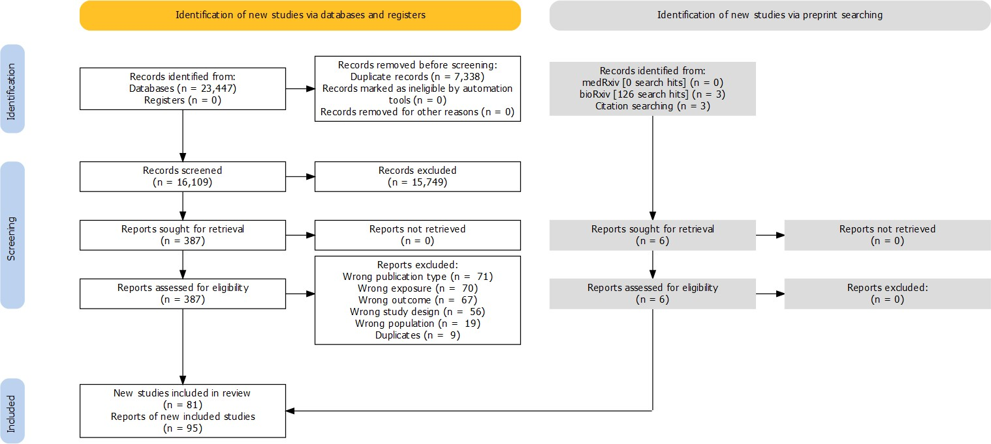

**Figure 4.1: PRISMA flow diagram** - The diagram illustrates how records moved through the systematic review process. Note that the different contributions of standard bibliographic databases (left) and preprint servers (right) to the review are indicated.

* + 1. Validation of screening

*4.2 - Search results*

For the assessment of the intra-/inter-rater reliability, the estimated values of Gwet’s agreement coefficinet, *AC*1, were interpreted against the categories presented in Table 3.2. For the inter-rater reliability, agreement was “almost perfect” (*AC*1 = 0.97, *kappa* = 0.54, Table 4.1). Similarly for intra-rater reliability, agreement was “almost perfect” (*AC*1 = 0.99, *kappa* = 0.65, Table 4.2). The discrepancy between the *AC*1 and *kappa* coefficients illustrates the sensitivity of *kappa* to imbalanced marginals, caused in this sample by a large imbalance towards exclusion.187

**Table 4.1: Inter-rater agreement** - For a subset of records, the decisions between two independent were compared. Gewt’s *AC*1 was calculated from this data to assess inter-rater reliability, indicating high accuracy (*AC*1 = 0.97).

Initial screening decision

|  |  |  |  |  |  |
| --- | --- | --- | --- | --- | --- |
|  | | **Exclude** | **Include** | **Total** |  |
|  | **Exclude** | 1244 | 9 | 1253 |  |
| **Second reviewer** | **Include** | 26 | 22 | 48 |  |
| **decision** | **Total** | 1270 | 31 | 1301 |  |

**Table 4.2: Intra-rater agreement** - For a subset of records, the decisions between the same reviewer with 3 month lag were compared. Gewt’s *AC*1 was calculated from this data to assess intra-rater reliability, indicating high consistency (*AC*1 = 0.99).

Initial screening decision

|  |  |  |  |  |  |
| --- | --- | --- | --- | --- | --- |
|  | | **Exclude** | **Include** | **Total** |  |
|  | **Exclude** | 1266 | 14 | 1280 |  |
| **Same reviewer decision** | **Include** | 4 | 17 | 21 |  |
| **(with 3 month lag)** | **Total** | 1270 | 31 | 1301 |  |

Those records which were excluded in the initial screening, but were included by the second reviewer (N =26, Table 4.1) were investigated. This discrepancy

* 1. *- Search results*

between the two reviewers was explained in all cases by differing interpretations of the inclusion criteria, most commonly around the definition of cognitive decline versus dementia and of eligible lipids fractions.

* + 1. Characteristics of included studies

Following full-text screening, 81 unique studies (described across 95 reports) met the criteria for inclusion in this review.53–62,67,71,72,74,188–254 Table 4.3 presents a summary of the characteristics of each study.

The majority of included studies described non-randomised analyses, with the only two included randomised controlled trials (the Heart Protection Study/British Heart Foundation trial67 and the JUPITER trial188) both reporting on the effect of statin use on incidence of all-cause dementia in older adults. A similarly small number of Mendelian randomisation studies were identified, several of which employed a two-sample approach using summary statistics from the same published genome wide association studies (GWAS), leading to complications in the synthesis of these estimates due to the potential for double-counting (see Section 4.3.2).

Of the 31 non-randomised studies examining treatments that modify lipid levels, all examined statin use (N = 31; 100%), while a small number also reported on other non-statins agents such as fibrates (N = 2; 6.5%). In the 43 non-randomised studies of exposure, hypercholesterolemia (N = 19; 44.2%) and total cholesterol levels (N = 21; 48.8%) were the most frequently reported risk factors.

In terms of outcomes, the vast majority of studies examined either all-cause dementia (N = 59; 72.8%) or Alzheimer’s disease (N = 51; 63%), with only a small proportion examining vascular dementia (N = 15; 18.5%). Some other outcome classifications such as vascular-component or mixed dementia were also investigated, but were much rarer.

*4.2 - Search results*

*71*

**Table 4.3: Characteristics of included studies** - The characteristics of studies included in this review, stratified by study design, are presented below. Note that three studies reported on multiple analytical designs within a single study report (Beydoun 2011,192 Reitz 2010,212 and Benn 201774), and these have been duplicated across the relevant sub-sections. Preprinted studies are denoted using an asterik.

**Study Location N Age at baseline Female (%) Exposures Outcomes Diagnostic criteria**

|  |  |  |  |  |  |  |  |
| --- | --- | --- | --- | --- | --- | --- | --- |
| **Randomised controlled trials** | | | | | | | |
| HPS 200267 | United Kingdom | 20536 | >70 | 24.8 | Simvastatin | Dementia | NR |
| JUPITER 2009188 | Multiple | 17902 | 66 (median) 60-71 (range) | 38 | Rosuvastatin | Dementia | NR |
| **Non-randomised studies of interventions** | | | | | | | |
| Ancelin 2012189 | France | 7056 | NR | 67 | Fibrate; Statin | Dementia; AD | DSM-IV; NINCDS-ADRDA |
| Arvanitakis 2008190 | United States | 929 | 74.9 (NR) | 68.7 | Statin | AD | Consortium to Establish a Registry for Alzheimer’s Disease (CERAD) |
| Bettermann 2012191 | United States | 3069 | 78.6 (3.3) | 46.2 | Non-statin LRA ; Statin | Dementia; AD; Vascular component | Consensus panel - criteria not reported |
| Beydoun 2011192 | United States | 1604 | 57.6 (18.4) | 38.5 | Statin | Dementia | DSM-III-R |
| Chao 2015193 | Taiwan | 256265 | 73.2 (7.4) | 50.3 | Statin | Non-vascular dementia | ICD-9 |
| Chen 2014194 | Taiwan | 18100 | 67 (8.6) | 47.9 | Statin | Dementia; AD; Non-AD | ICD-9 |
| Chitnis 2015195 | United States | 8062 | 74.47 (9.21) | 53.04 | Statin | Dementia | ICD-9 |
| Chou 2014196 | Taiwan | 33398 | >60 | 53.9 | Statin | Dementia; AD; VaD; Non-vascular dementia | ICD-9 |
| Chuang 2015197 | Taiwan | 123300 | 54 (13) | 49.1 | Statin | Dementia | ICD-9 |
| Cramer 2008198 | United States | 1674 | 70 (6.8) | 58 | Statin | Dementia/CIND | DSM-IV |
| Gnjidic 2016199 | Sweden | 2056 | >60 | NR | Statin | Dementia | DSM-IV |
| Haag 2009200 | Netherlands | 6992 | 69.4 (9.1) | 60 | Non-statin LRA ; Statin | AD | NINCDS-ADRDA |

*4.2 - Search results*

*72*

**Table 4.3: Characteristics of included studies** - The characteristics of studies included in this review, stratified by study design, are presented below. Note that three studies reported on multiple analytical designs within a single study report (Beydoun 2011,192 Reitz 2010,212 and Benn 201774), and these have been duplicated across the relevant sub-sections. Preprinted studies are denoted using an asterik. *(continued)*

**Study Location N Age at baseline Female (%) Exposures Outcomes Diagnostic criteria**

|  |  |  |  |  |  |  |  |
| --- | --- | --- | --- | --- | --- | --- | --- |
| Hendrie 2015201 | United States | 974 | 76.6 (4.9) | 69.7 | Statin | Dementia; AD | DSM-IV; Consortium to Establish a Registry for Alzheimer’s Disease (CERAD) |
| Hippisley-Cox 2010202 | United Kingdom | 2004692 | 46 (14) | 51 | Statin | Dementia | EHR codelist |
| Jick 2000203 | United Kingdom | 1364 | 50-89 | 61 | Non-statin LRA ; Statin | Dementia | EHR codelist |
| Li 2004205 | United States | 2356 | 75.1 (6.1) | 59.8 | Non-statin LRA; Statin | Dementia; AD | DSM-IV; NINCDS-ADRDA |
| Li 2010204 | United States | 3392 | 75 (6.2) | 59 | Statin | AD | NINCDS-ADRDA |
| Liao 2013206 | NR | 5221 | NR | NR | Statin | Dementia | NR |
| Liu 2019207 | Taiwan | 2012 | 74 (7.5) | NR | Statin | Dementia | ICD |
| Pan 2018208 | Taiwan | 14807 | 65 (13) | 43 | Statin | Dementia | ICD-9 |
| Parikh 2011209 | United States | 377838 | 75.53 (6.07) | 2 | Statin | Dementia | ICD-9 |
| Rea 2005210 | United States | 2798 | NR | NR | Non-statin LRA ; Statin | Dementia; AD; Mixed; VaD | NINCDS; NINCDS-ADRDA;  Combination; State of California Alzheimer’s Disease Diagnostic and Treatment Centers |
| Redelmeier 2019211 | Canada | 28815 | 76 (NR) | 61.3 | Statin | Dementia | ICD-9 |
| Reitz 2004212 | United States | 1168 | 78.4 (6.2) | 68.3 | Statin | VaD; AD | Cohort criteria; NINCDS-ADRDA |
| Smeeth 2009213 | United Kingdom | 729529 | 50 (NR) | 40-81 | Statin | Dementia; AD; Non-AD | EHR codelist |
| Solomon 2010214 | Finland | 17597 | 68 (5.8) | 57 | Statin | Dementia | EHR codelist |

*4.2 - Search results*

*73*

**Table 4.3: Characteristics of included studies** - The characteristics of studies included in this review, stratified by study design, are presented below. Note that three studies reported on multiple analytical designs within a single study report (Beydoun 2011,192 Reitz 2010,212 and Benn 201774), and these have been duplicated across the relevant sub-sections. Preprinted studies are denoted using an asterik. *(continued)*

|  |  |  |  |  |  |  |  |
| --- | --- | --- | --- | --- | --- | --- | --- |
| **Study** | **Location** | **N** | **Age at baseline** | **Female (%)** | **Exposures** | **Outcomes** | **Diagnostic criteria** |
| Sparks 2008215 | United States | 2068 | 75 (3.8) | 54 | Statin | AD | NINCDS-ADRDA |
| Szwast 2007216 | United States | 1416 | 77.3 (5.3) | 69.3 | Statin | Dementia | DSM-IV |
| Yang 2015217 | Taiwan | 45973 | 82 (5.3) | 48 | Fibrate; LRA (exlc. statin + fibrates); Statin | Dementia | ICD-9 |
| Zamrini 2004218 | United States | 3397 | 73 (NR) | 0 | Statin | AD | ICD-9 |
| Zandi 2005219 | United States | 3308 | NR | NR | Non-statin LRA; Statin | Dementia; AD | DSM-III-R; NINCDS-ADRDA |
| **Non-randomised studies of exposures** | | | | | | | |
| Ancelin 2013220 | France | 7053 | 74 (5.3) | 61.1 | Hypercholesterolemia | AD; Dementia | NINCDS-ADRDA; DSM-IV |
| Batty 2014221 | United Kingdom | 103764 | 47.3 (18.1) | 55 | Non-HDL-c; Hypercholesterolemia | Dementia | ICD |
| Benn 201774 | NR | 111194 | 56 (median) 46-66 (range) | 55 | LDL-c | AD; VaD; Dementia | ICD; ICD-10 |
| Beydoun 2011192 | United States | 1604 | 57.6 (18.4) | 38.5 | TC | Dementia | DSM-III-R |
| Bruce 2017222 | Australia | 217 | 63.6 (8.4) | 45.6 | HDL-c; TC; TG | Dementia | NR |
| Chiang 2007223 | Taiwan | 785 | 58 (7.4) | 41.4 | TC; TG | Dementia; AD; VaD | ICD-9; NR |
| Dodge 2011224 | United States | 822 | 71.6 (4.7) | 64.4 | Hypercholesterolemia | Dementia; AD | DSM-III-R;  Consortium to Establish a Registry for Alzheimer’s Disease (CERAD) |
| Forti 2010225 | Italy | 749 | 73 (6.1) | 53 | Hypercholesterolemia; TG | Dementia; AD; VaD | DSM-IV;  NINCDS-ADRDA; NINCDS-AIREN |
| Gottesman 2017226 | United States | 15407 | 54.2 (5.8) | 55 | TC | Dementia | Combination |

*4.2 - Search results*

*74*

**Table 4.3: Characteristics of included studies** - The characteristics of studies included in this review, stratified by study design, are presented below. Note that three studies reported on multiple analytical designs within a single study report (Beydoun 2011,192 Reitz 2010,212 and Benn 201774), and these have been duplicated across the relevant sub-sections. Preprinted studies are denoted using an asterik. *(continued)*

**Study Location N Age at baseline Female (%) Exposures Outcomes Diagnostic criteria**

|  |  |  |  |  |  |  |  |
| --- | --- | --- | --- | --- | --- | --- | --- |
| Gustafson 2012227 | Sweden | NR | NR | 100 | TC | AD | NR |
| Hayden 2006228 | United States | 3308 | 74.0 (6.4) | 58.2 | Hypercholesterolemia | Dementia; AD; VaD | DSM-III-R; NINCDS-ADRDA; NINCDS-AIREN |
| Kimm 2011229 | South Korea | 848505 | 53 (9.3) | 42.2 | TC | AD; VaD; Dementia | ICD-10 |
| Kivipelto 2001230 | Finland | 1499 | 50.4 (6.0) | 62 | Hypercholesterolemia | AD | NINCDS-ADRDA |
| Kivipelto 200553 | Finland | 1449 | 50.6 (6.0) | 62 | Hypercholesterolemia | Dementia | DSM-IV |
| Kuo 2015231 | Taiwan | 67066 | 62.1(11.4) | 48.4 | Hypercholesterolemia | Dementia | ICD-9 |
| Li 200557 | United States | 2141 | 74.9 (5.9) | 60.5 | HDL-c; TC | Dementia; AD | DSM-IV; NINCDS-ADRDA |
| Mainous 200558 | United States | 6558 | NR | NR | Hypercholesterolemia | Dementia; AD | ICD-9 |
| Mielke 200559 | Sweden | 382 | NR | 70 | TC; TG | Dementia | DSM-III-R |
| Mielke 201061 | France | 1460 | 38-60 (range) | 100 | Hypercholesterolemia; TC | Dementia; AD | DSM-III-R; NINCDS-ADRDA |
| Mielke 2012232 | United States | 99 | 74 (2.5) | 100 | HDL-c; TC; TG | Dementia; AD | DSM-IV; NINCDS-ADRDA |
| Muller 2007233 | United States | 542 | NR | NR | HDL-c; TG | Dementia; AD | DSM-IV; NINCDS-ADRDA |
| Noale 2013234 | Italy | 5632 | 71.3(5.3) | 56.3 | Hypercholesterolemia; TG | Dementia | DSM-III-R |
| Notkola 1998235 | Finland | 444 | 40-59 (range) | 0 | Hypercholesterolemia | AD | Combination |
| Peters 2009236 | Mutliple | 3336 | >80 | 60.4 | HDL-c; TC | Dementia | DSM-IV |
| Raffaitin 2009237 | France | 7087 | 73.4 (4.9) | 61 | Hypercholesterolemia; TG | Dementia; AD; VaD | DSM-IV;  NINCDS-ADRDA;  Combination |
| Rantanen 2017238 | Finland | 3309 | 42 (median) 39–46 (range) | 0 | TC;  Hypercholesterolemia | Dementia; AD; VaD | NR |

*4.2 - Search results*

*75*

**Table 4.3: Characteristics of included studies** - The characteristics of studies included in this review, stratified by study design, are presented below. Note that three studies reported on multiple analytical designs within a single study report (Beydoun 2011,192 Reitz 2010,212 and Benn 201774), and these have been duplicated across the relevant sub-sections. Preprinted studies are denoted using an asterik. *(continued)*

**Study Location N Age at baseline Female (%) Exposures Outcomes Diagnostic criteria**

|  |  |  |  |  |  |  |  |
| --- | --- | --- | --- | --- | --- | --- | --- |
| Reitz 2004212 | United States | 1168 | 78.4 (6.2) | 68.3 | HDL-c; LDL-c;  Non-HDL-c; TC; TG | VaD; AD | Cohort criteria; NINCDS-ADRDA |
| Reitz 201062 | United States | 1130 | 75.7(6.3) | 65.7 | HDL-c; LDL-c; TC | AD | NINCDS-ADRDA |
| Ronnemaa 2011239 | United States | 2268 | 49.6 (0.6) | 0 | Hypercholesterolemia | AD; VaD; Dementia | NINCDS-ADRDA; ADDTC; DSM-IV |
| Schilling 201754 | France | 9294 | 73.8 (5.3) | 61 | HDL-c; LDL-c; TC; TG | Dementia; AD; Mixed | DSM-IV;  NINCDS-ADRDA; NINCDS-AIREN |
| Solomon 2007240 | Finland | 1449 | 50.4 (6.0) | 62.1 | Hypercholesterolemia | Dementia | NR |
| Solomon 200955 | United States | 9844 | 43 (1.7) | 54 | TC | AD; VaD | ICD-9 |
| Strand 2013241 | Norway | 48793 | 42.6 (4.3) | 49 | TC | Dementia; AD | ICD |
| Su 2017242 | United Kingdom | 212085 | NR | NR | NR | NR | NR |
| Svensson 2019243 | Japan | 781 | 54.1 (5.6) | NR | HDL-c;  Hypercholesterolemia | Dementia | DSM-IV |
| Tan 200360 | United States | 1026 | 76.1 (5.3) | 63 | HDL-C; TC | AD | NINCDS-ADRDA |
| Tynkkynen 2016244 | Finland | 13725 | 48.4 (13.3) | 51.6 | HDL-c | Dementia; AD | ICD-10 |
| Tynkkynen 2018245 | Multiple | 22623 | 57 (9.2) | 47 | HDL-c; LDL-c; TC; TG | Dementia; AD | ICD-10 |
| Wang 2012246 | Taiwan | 1230400 | 60 (13) | 52 | Hypercholesterolemia | AD | ICD-9 |
| Whitmer 200556 | United States | 8845 | 68 (2.6) | 53.7 | Hypercholesterolemia | Dementia | ICD-9 |
| Yamada 2009247 | Japan | 1637 | >60 | 100 | NR | NR | NR |
| Yoshitake 1995248 | Japan | 828 | 74 (5.9) | 59.5 | HDL-c; LDL-c; TC; TG | VaD; AD | NINCDS-AIREN; NINCDS-ADRDA |
| Zimetbaum 1992249 | United States | 350 | 79 (median) 75-85 (range) | 64.5 | HDL-c; LDL-c; TC; TG | Dementia | DSM-III-R |

*4.2 - Search results*

*76*

**Table 4.3: Characteristics of included studies** - The characteristics of studies included in this review, stratified by study design, are presented below. Note that three studies reported on multiple analytical designs within a single study report (Beydoun 2011,192 Reitz 2010,212 and Benn 201774), and these have been duplicated across the relevant sub-sections. Preprinted studies are denoted using an asterik. *(continued)*

**Study Location N Age at baseline Female (%) Exposures Outcomes Diagnostic criteria**

**Mendelian randomisation studies**

|  |  |  |  |  |  |  |  |
| --- | --- | --- | --- | --- | --- | --- | --- |
| Andrews 2019250,255 * | Multiple | 54162 | NR | NR | HDL-c; LDL-c; TC; TG | AD | NR |
| Benn 201774 | Multiple | 111194;  54162 | NR | NR | HMGCR; LDL-c; PCSK-9 | AD; VaD; Dementia | NR |
| Burgess 2017251 | Multiple | 21165 | NR | NR | HDL-c; LDL-c; TG | AD | NR |
| Larsson 201771 | Multiple | 54162 | NR | NR | LDL-c | AD | NR |
| Mukherjee 2013252 | Multiple | 54162 | NR | NR | HDL-c; LDL-c; TG | AD | NR |
| Ostergaard 201572 | Multiple | 54162 | NR | NR | HDL-c; LDL-c; TC; TG | AD | NR |
| So 2017253 * | Multiple | 54162 | NR | NR | HMGCR | AD | NR |
| Zhu 2018254,256 * | Multiple | 54162 | NR | NR | HDL-c; LDL-c; TG | AD | NR |

* Denotes preprinted study.

*Abbreviations:* AD - Alzheimer’s disease; DSM - Diagnostic and Statistical Manual (Roman numerals indicate edition); EHR - Electronic code list; ICD - International Classification of Diseease (numbers indicate edition); HDL-c - high density lipoprotein cholesterol; LDL-c - low density lipoprotein cholesterol; NINCDS-ADRDA - National Institute of Neurological and Communicative Disorders and Stroke and the Alzheimer’s Disease and Related Disorders Association; NINCDS-AIREN - National Institute of Neurological Disorders and Stroke and Association Internationale pour la Recherché et l’Enseignement en Neurosciences; NR - Not reported; TC - total cholesterol; TG - triglycerides; VaD - vascular dementia.

* 1. *- Search results*

Three included reports were preprinted (denoted in the Table 4.3 using an asterisk),253,255,257 one of which had subsequently been published and was captured by the primary literature search.254 All three included preprints were obtained from the bioRxiv preprint server and all described a Mendelian randomisation analysis.

As illustrated in Figure 4.2, the majority of reports described studies conducted in high-income countries, with the most highly represented region being North America. Of interest, several of the included studies were conducted in Taiwan (N

= 10; 12.35%), all but one of which made use of the Taiwan National Health Insurance database.

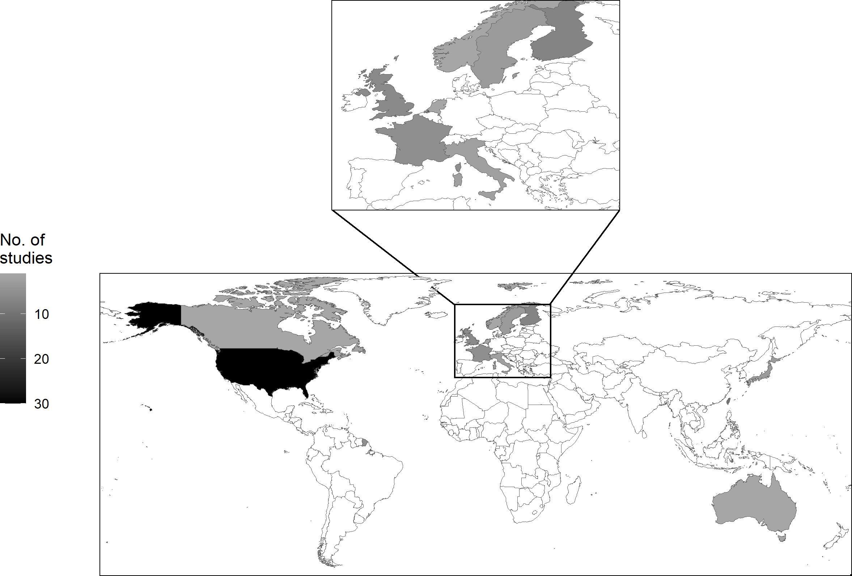

**Figure 4.2: Geographical distribution of study cohorts** - The country or countries of origin for the studies include in the review are shown below. Note that the majority of included studies were performed in the Western world, predominantly in Europe and North America.

* 1. *- Primary analyses*

Finally, there were several eligible studies reported as conference abstracts that did not present numerical results. These reports were included in the analysis to enable assessment of risk of bias due to missing evidence (see Section 3.2.8).

### Primary analyses

In the following sections, analyses are grouped first by outcome (all-cause dementia, Alzheimer’s disease and vascular dementia) and are then further stratified by exposure category (lipids, lipid regulating agents).

* + 1. All-cause dementia

Lipids

Across all outcomes, lipid levels were categorised in a number of ways. The most common categorisation was hypercholesterolemia at baseline, defined most frequently as a total cholesterol measurement of greater than 6.5 mmol/L.

Eleven studies reported on the association of hypercholesterolemia with all-cause de- mentia and provided weak evidence for an effect (HR: 1.11, 95%CI: 0.98-1.25, Figure 4.3).

*4.3 - Primary analyses*

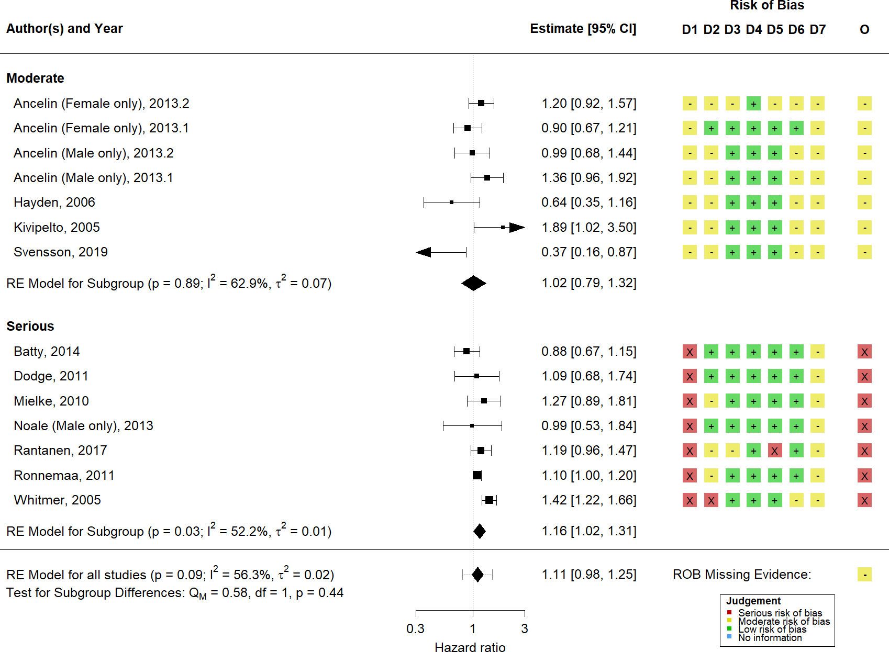

**Figure 4.3: Random-effects meta-analysis of hypercholesterolemia on all- cause dementia** - Non-randomised studies examining the association of hypercholes- terolemia with all-cause dementia were synthesised using a random-effects meta-analysis. Subgroup estimates, stratified by overall risk-of-bias level, are also presented. D1-D7 and O refer to the seven risk-of-bias domains and single overall judgement in the ROBINS-E tool, while the risk of bias due to missing evidence is shown beside the overall summary diamond.

Several studies analysed individual lipid fractions by estimating the risk of dementia per 1 standard deviation increase in that fraction (Figure 4.4). Weak evidence for an effect on all-cause dementia was found for total cholesterol (N = 5; HR: 0.97, 95%CI: 0.88-1.07), LDL-c (N = 2; HR: 0.97, 95%CI: 0.86-1.08), HDL-c (N = 4; HR:

1.05, 95%CI: 0.96-1.14) and triglycerides (N = 3; HR: 0.90, 95%CI: 0.74-1.09).

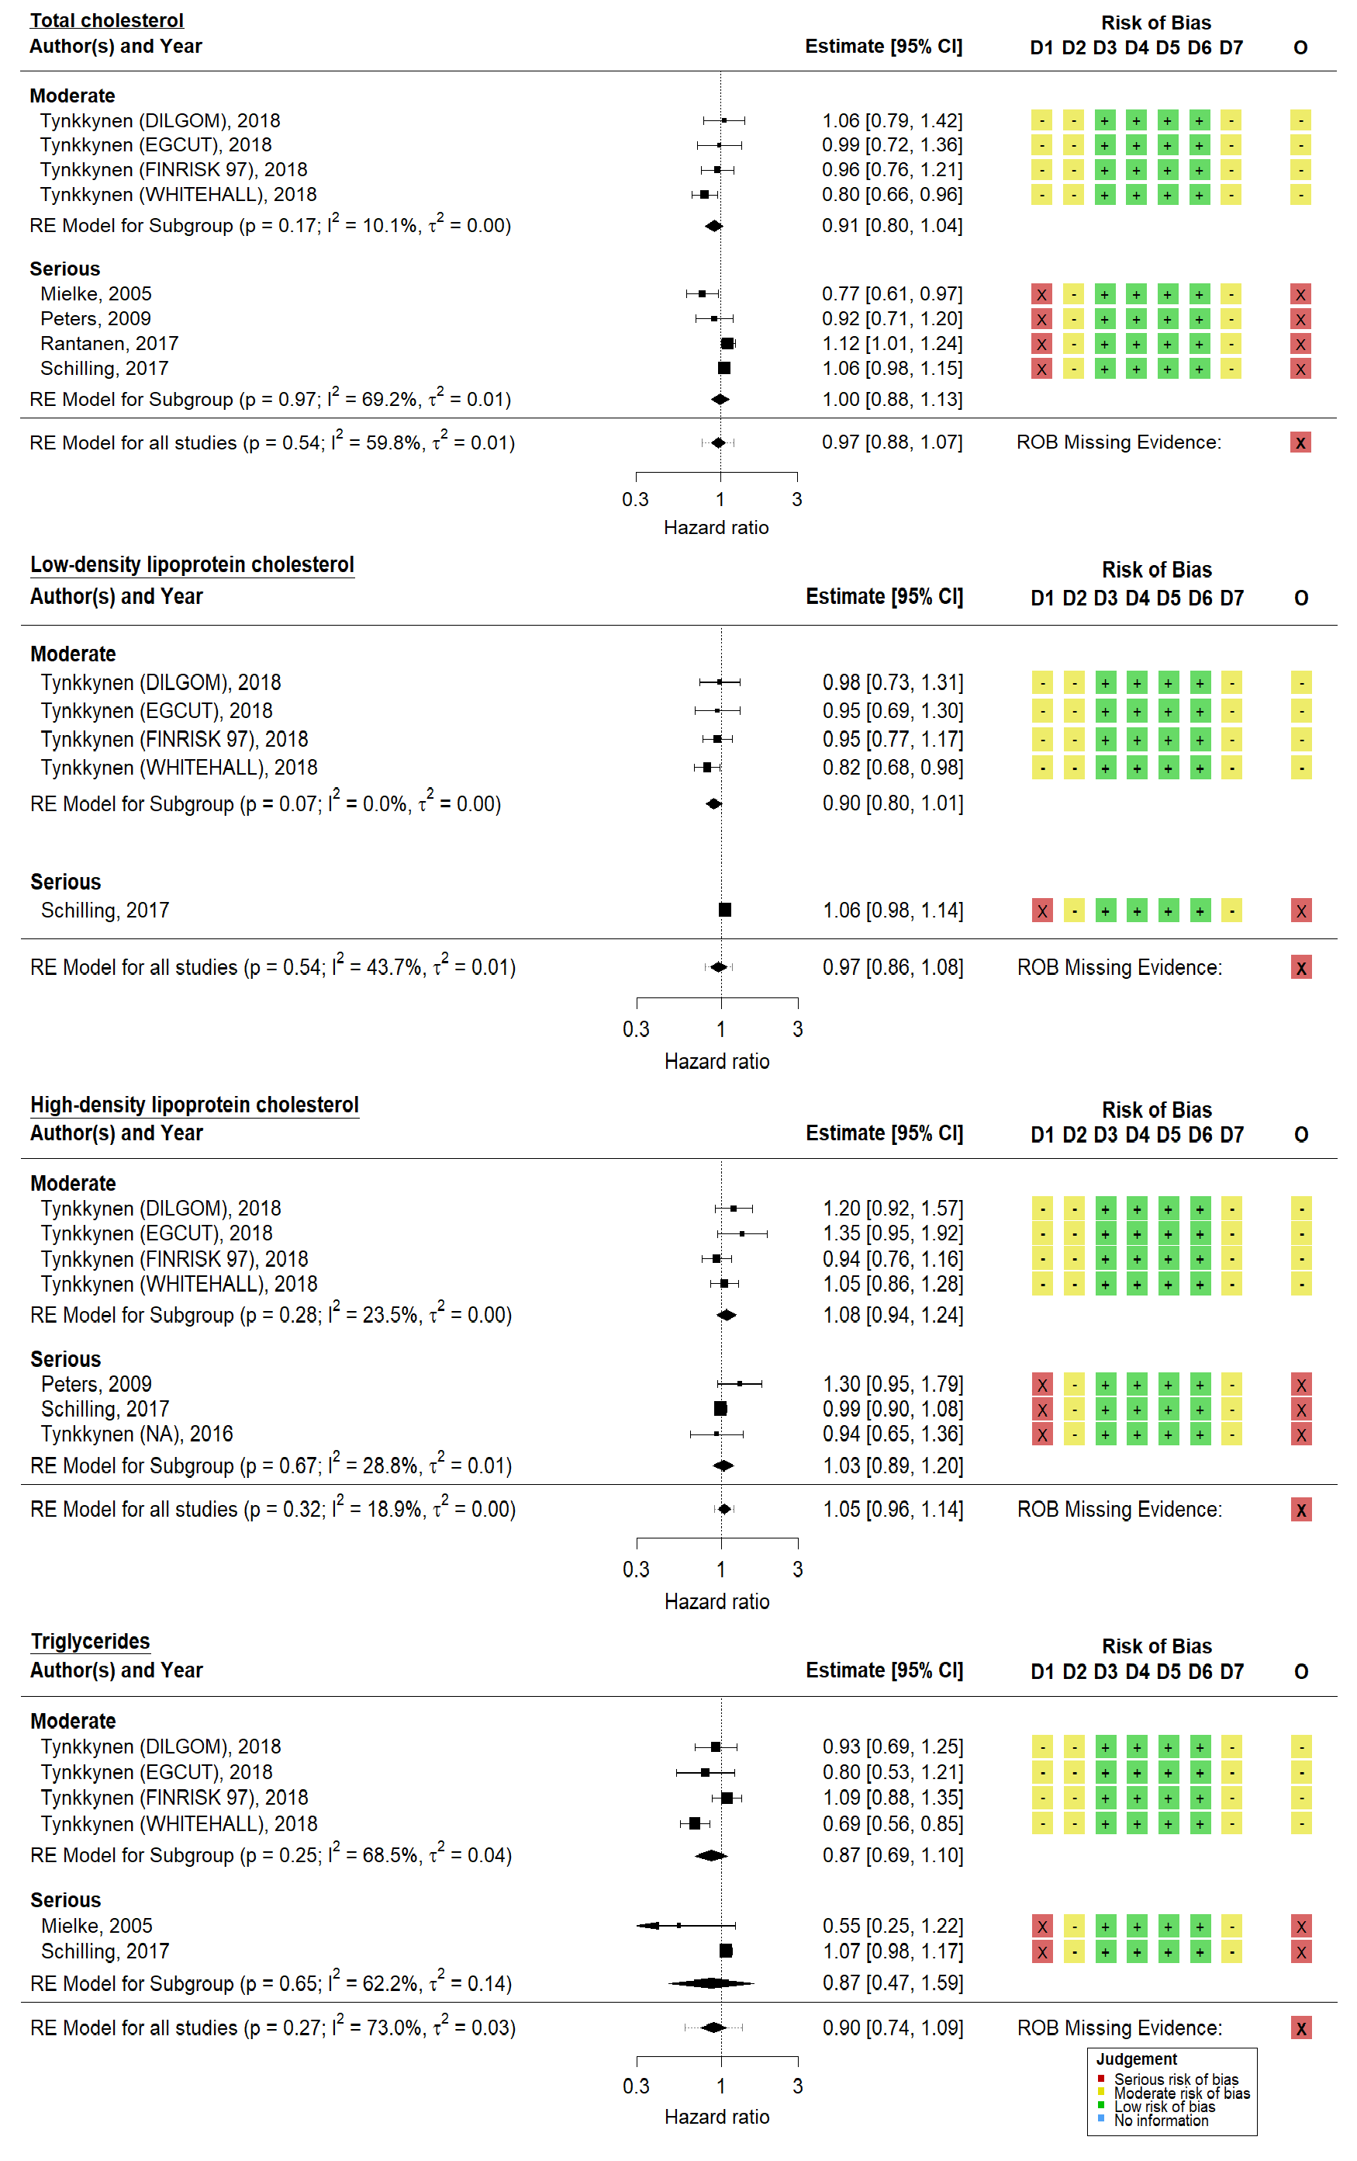

**Figure 4.4: Random-effects meta-analysis of lipids on all-cause dementia** - Non-randomised studies examining the association of four lipid fractions (total cholesterol, HDL, LDL, and triglycerides) with all-cause dementia risk, standardised per 1-SD increase, were synthesised using a random-effects meta-analysis. D1-D7 and O refer to the seven risk-of-bias domains and single overall judgement in the ROBINS-E tool, while the risk of bias due to missing evidence is shown beside the overall summary diamond. Note that Tynkkyen *et al*245 reported results from multiple cohorts and these are presented separately.

*4.3 - Primary analyses*

Finally, there were no identified Mendelian randomisation analysis examining the effect of lower lipid levels, as determined by any genetic instrument, on all- cause dementia risk.

Statins

The two randomised controlled trials provided weak evidence (OR: 1.07, 95%CI: 0.70-1.66) of an effect on statin use on all-cause dementia risk (Figure 4.5).

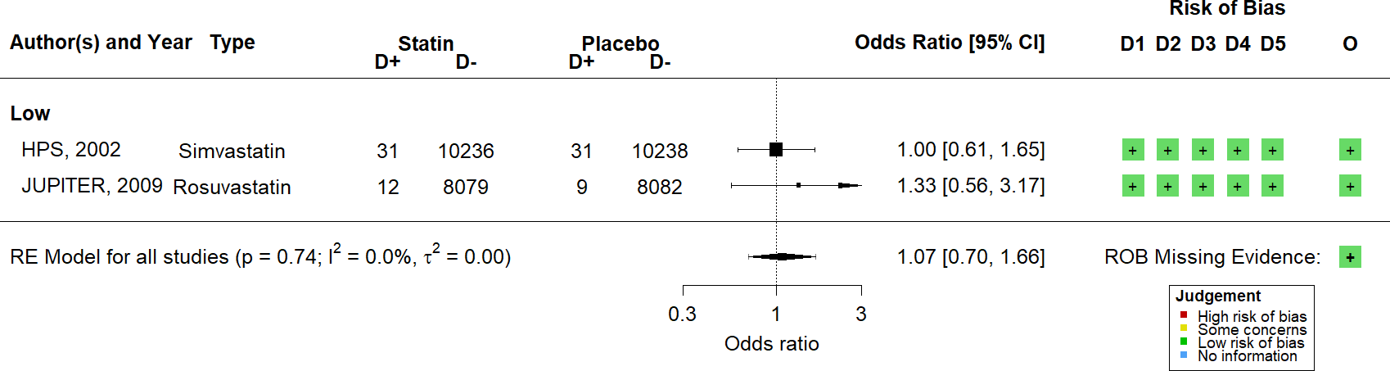

**Figure 4.5: Random-effects meta-analysis of statins on all-cause dementia in RCTs** - Randomised controlled trials examining the effect of statin use on all-cause dementia risk were synthesised using a random-effects meta-analysis. D1-D5 and O refer to the five risk-of-bias domains and single overall judgement in the RoB2 tool, while the risk of bias due to missing evidence is shown beside the overall summary diamond.

In contrast, a meta-analysis of 15 prospective observational studies provided some evidence of a protective effect of statins use on all-cause dementia risk (HR: 0.77, 95%CI: 0.69-0.87, Figure 4.6).

*4.3 - Primary analyses*

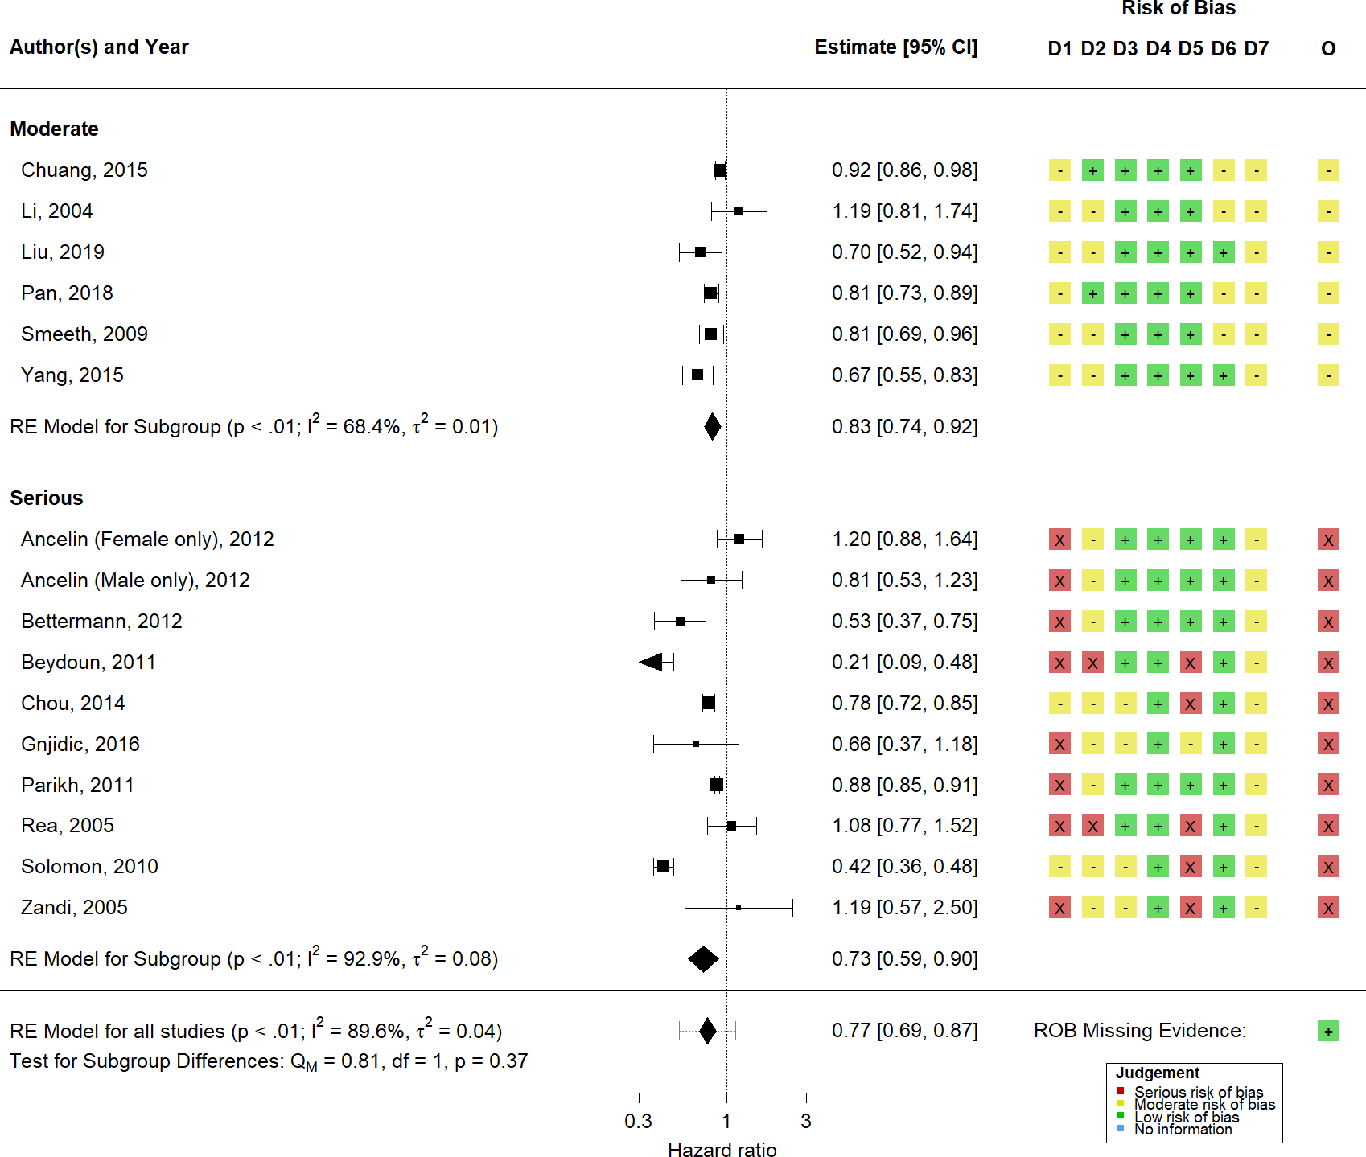

**Figure 4.6: Random-effects meta-analysis of statins on all-cause dementia** - Non-randomised studies examining the association of statin use with all-cause dementia were synthesised using a random-effects meta-analysis. Subgroup estimates, stratified by overall risk-of-bias level, are also presented. D1-D7 and O refer to the seven risk-of-bias domains and single overall judgement in the ROBINS-I tool, while the risk of bias due to missing evidence is shown beside the overall summary diamond.

Finally, a single Mendelian randomisation analysis was identified examining the effect of lowered LDL-c levels on the risk of all-cause dementia via genetic inhibition of the 3-hydroxy-3-methylglutaryl-coenzyme A reductase (HMGCR), emulating statin treatment (see Section 1.3.2 for more details of the statin mechanism of action). This analysis provided weak evidence of an effect (RR: 0.90, 95%CI: 0.29-2.81).

*4.3 - Primary analyses*

Fibrates

Two studies examined the effect of fibrate use on all-cause dementia and found weak evidence for an effect (HR: 0.89, 95%CI: 0.75-1.07, Figure 4.7).

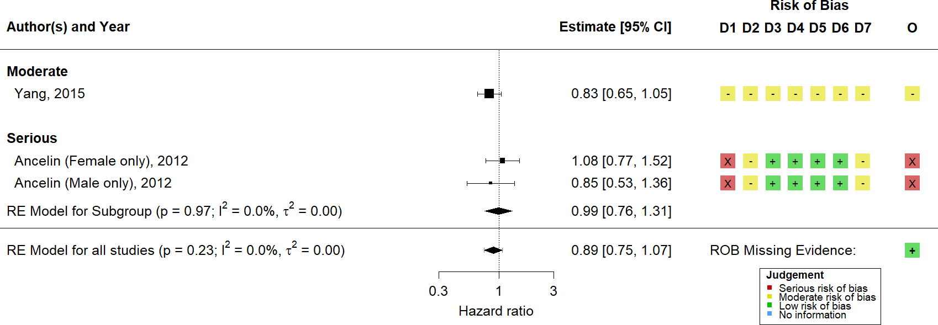

**Figure 4.7: Random-effects meta-analysis of fibrates on all-cause dementia** - Random-effects meta-analysis of non-randomised studies examining the effect of fibrate use on all-cause dementia. D1-D7 and O refer to the seven risk-of-bias domains and single overall judgement in the ROBINS-I tool, while the risk of bias due to missing evidence is shown beside the overall summary diamond.

* + 1. Alzheimer’s disease

Lipids

Nine studies reported on the association of hypercholesterolemia with Alzheimer’s disease and provided weak evidence for an effect (HR: 0.99, 95%CI: 0.78-1.25, Figure 4.8)

*4.3 - Primary analyses*

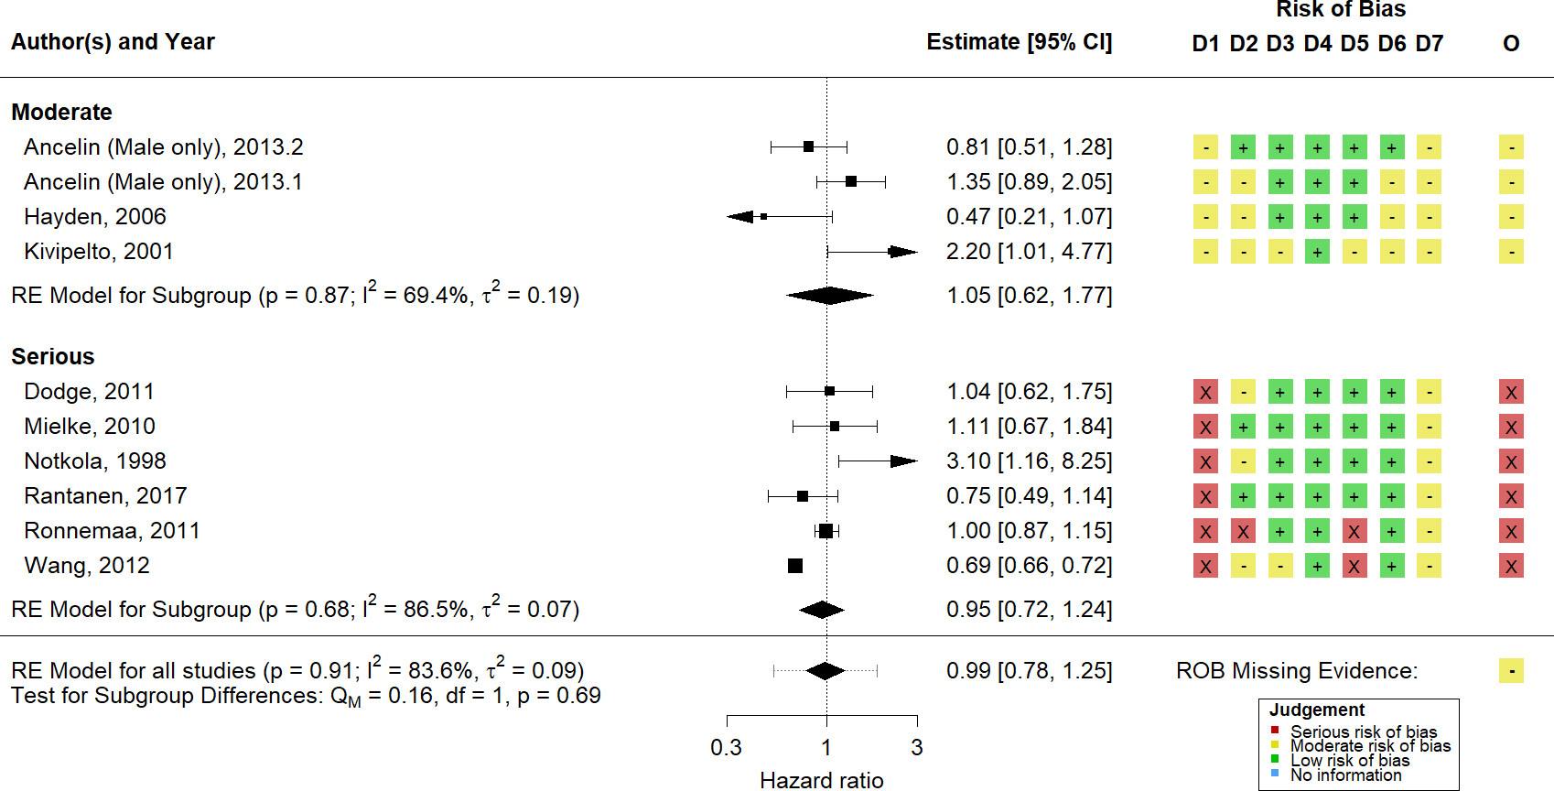

**Figure 4.8: Random-effects meta-analysis of hypercholesterolemia on Alzheimer’s disease** - Non-randomised studies examining the association of hypercholes- terolemia with Alheimer’s disease were synthesised using a random-effects meta-analysis. Subgroup estimates, stratified by overall risk-of-bias level, are also presented. D1-D7 and O refer to the seven risk-of-bias domains and single overall judgement in the ROBINS-E tool, while the risk of bias due to missing evidence is shown beside the overall summary diamond.

Similarly to all-cause dementia, several studies analysed individual lipid fractions by estimating the risk of dementia per 1 standard deviation increase in that fraction (Figure 4.9). Weak evidence for an effect on all-cause dementia was found for total cholesterol (N = 5; HR: 1.00, 95%CI: 0.94-1.06), LDL-c (N = 3; HR: 1.06,

95%CI: 0.98-1.16), HDL-c (N = 4; HR: 0.99, 95%CI: 0.91-1.07) or triglycerides

(N = 3; HR: 1.00, 95%CI: 0.84-1.18).

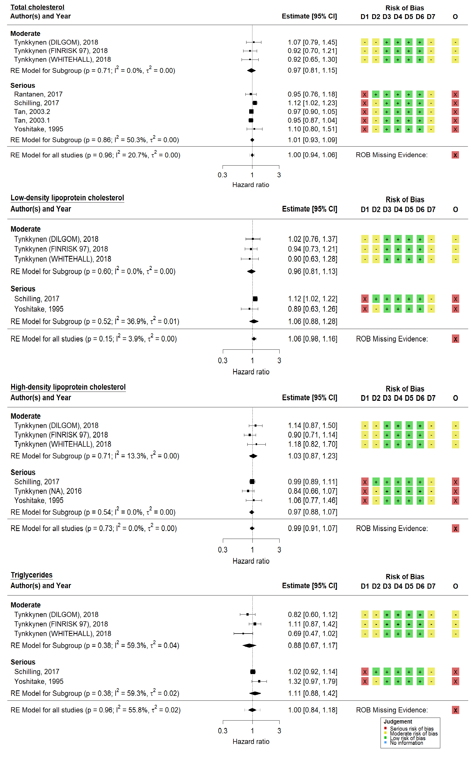

**Figure 4.9: Random-effects meta-analysis of association of lipid fractions with Alzheimer’s disease** - D1-D7 and O refer to the seven risk-of-bias domains and single overall judgement in the ROBINS-E tool, while the risk of bias due to missing evidence is shown beside the overall summary diamond. Note that Tynkkyen *et al*245 reported results from multiple cohorts and these are presented separately.

*4.3 - Primary analyses*

Finally, there were several identified Mendelian randomisation studies examining the effect of genetically lowered LDL-c on Alzheimer’s disease risk (Figure 4.10). However, all of these studies took a two-sample approach, making use of summary statistics from the Global Lipid Genetics Consortium (GLGC) and International Genomics of Alzheimer’s Project (IGAP) consortia. Synthesis of these results would would result in a falsely precise estimate caused by multiple counting of the same participants,and as a result, no meta-analysis of these studies was performed. However, across each analysis using varying number of SNPS, no evidence for an effect was observed (Figure 4.10).

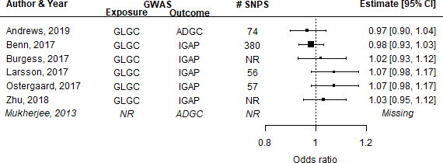

**Figure 4.10: Summary of duplication across two-sample Mendelian randomi- sation studies** - Several Mendelian randomisation studies used summary statistics from the Global Lipid Genetics Consortium (GLGC) and the International Genomics of Alzheimer’s Project (IGAP). Note that the Alzheimer’s Disease Genetics Consortium (ADGC) is a sub-cohort within IGAP.

Statins

There were no randomised trials of the use of statins or any other lipid regulating agents on Alzheimer’s disease, though several observational studies reported on this outcome and provided evidence for a protective effect (N = 11; HR: 0.83, 95%CI: 0.69-0.99; Figure 4.11).

*4.3 - Primary analyses*

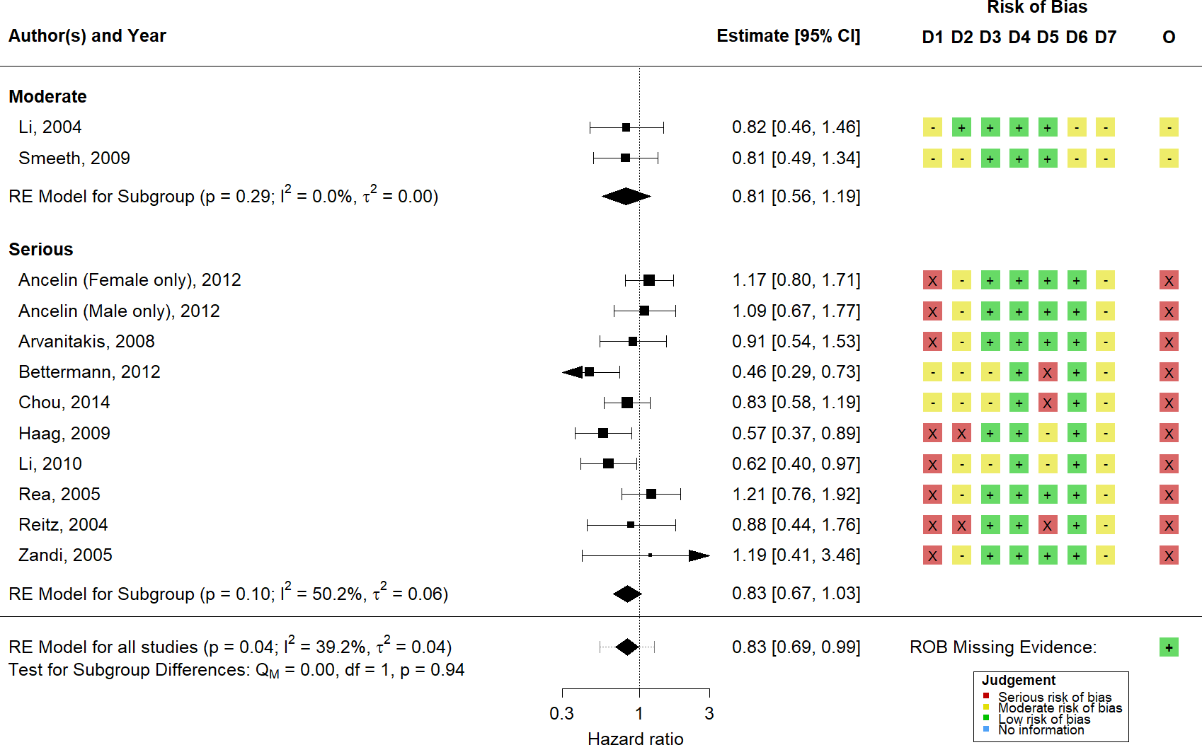

**Figure 4.11: Random-effects meta-analysis of statins on Alzheimer’s disease** Non-randomised studies examining the association of statin use with Alzheimer’s disease were synthesised using a random-effects meta-analysis. Subgroup estimates, stratified by overall risk-of-bias level, are also presented. D1-D7 and O refer to the seven risk-of-bias domains and single overall judgement in the ROBINS-I tool, while the risk of bias due to missing evidence is shown beside the overall summary diamond.

Two Mendelian randomisation studies looked at lipid-lowering specifically as a result of HMGCR inhibition, mediated by SNPs in the gene (rs172338484 and rs12916).74,253 The first used a one sample approach (SNP-exposure and SNP- outcome associations are estimated using the same dataset) in a large Copenhagen- based cohort, while the second made use of summary level data obtained from the GLGC (SNP-exposure) and the IGAP (SNP-outcome). Meta-analysis of these estimates provided weak evidence of an effect (RR: 0.76, 95%CI: 0.51- 1.14, Figure 4.12).

*4.3 - Primary analyses*

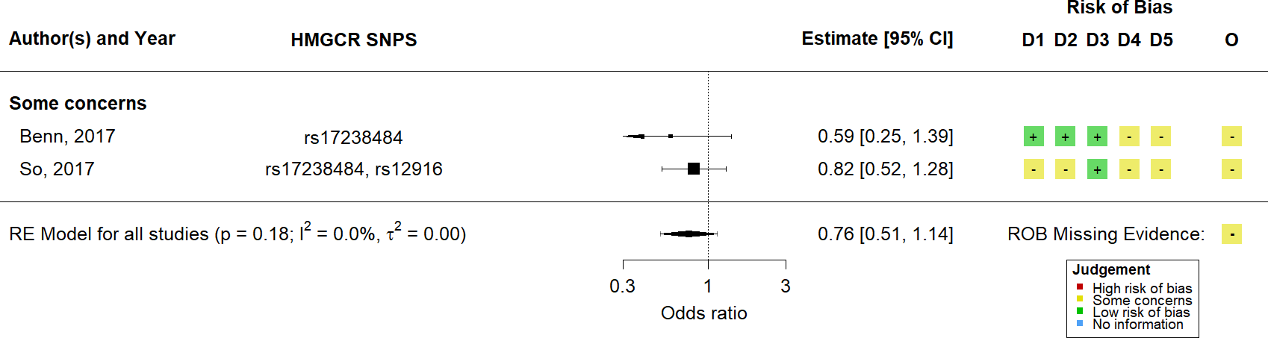

**Figure 4.12: Random-effects meta-analysis of HMGCR inhibition on Alzheimer’s disease** - Mendelian randomisation studies examining the association of genetically lowered LDL-c via HMGCR inhibition with Alzheimer’s were synthesised using a random-effects meta-analysis. D1-D5 and O refer to the five risk-of-bias domains and single overall judgement in the Mamluk *et al* tool, while the risk of bias due to missing evidence is shown beside the overall summary diamond.

* + 1. Vascular dementia

Lipids

Three studies reported on the association of hypercholesterolemia with vascu- lar dementia and provided weak evidence for an effect (HR: 1.20, 95%CI: 1.00- 1.44, Figure 4.13)

*4.3 - Primary analyses*

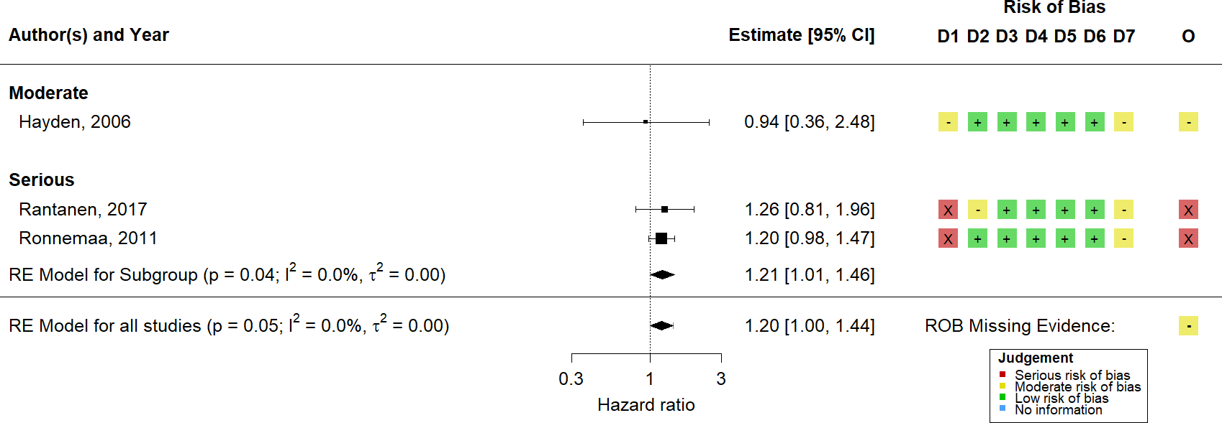

**Figure 4.13: Random-effects meta-analysis of hypercholesterolemia on vascu- lar dementia** - Non-randomised studies examining the association of hypercholesterolemia with vascular dementia were synthesised using a random-effects meta-analysis. Subgroup estimates, stratified by overall risk-of-bias level, are also presented. D1-D7 and O refer to the seven risk-of-bias domains and single overall judgement in the ROBINS-E tool, while the risk of bias due to missing evidence is shown beside the overall summary diamond.

Few studies investigated the effect of individual lipid fractions. Only for total cholesterol was there greater than one result reported (Figure 4.14), and a meta- analysis of these found weak evidence for an effect (N = 2; HR: 1.05, 95%CI: 0.79-1.41). A single study provided evidence on the other three fractions,248 and similarly found minimal evidence of an effect LDL-c (HR: 1.12, 95%CI: 0.83-1.51), HDL-c (HR: 0.83, 95%CI: 0.60-1.14) or triglycerides (HR: 1.00, 95%CI: 0.75-1.34).

*4.3 - Primary analyses*

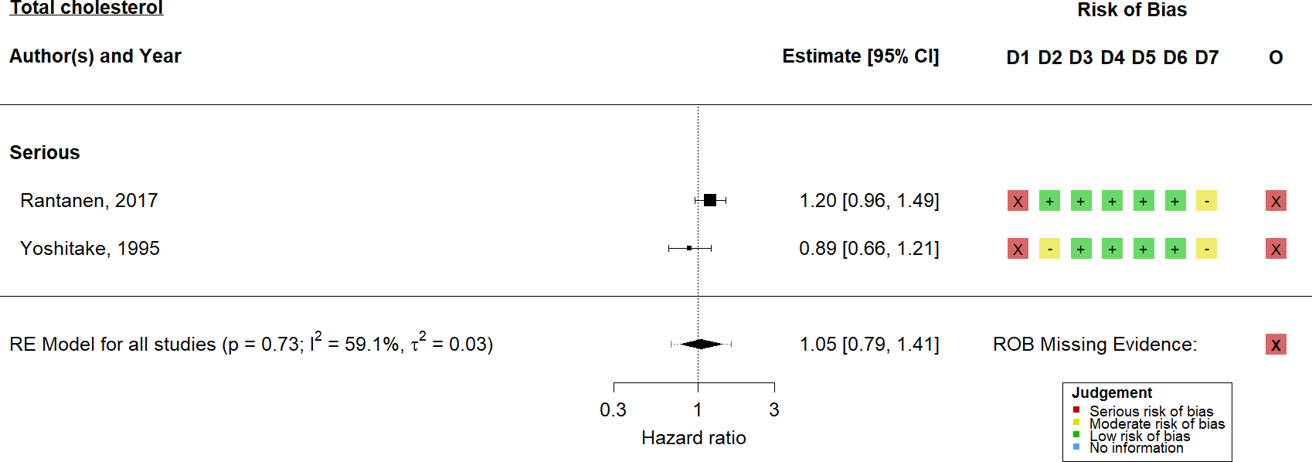

**Figure 4.14: Random-effects meta-analysis of total cholesterol on vascular dementia** - Non-randomised studies examining the association of total cholesterol with vascular dementia risk, standardised per 1-SD increase in the lipid fraction, were synthesised using a random-effects meta-analysis. D1-D7 and O refer to the seven risk-of- bias domains and single overall judgement in the ROBINS-E tool, while the risk of bias due to missing evidence is shown beside the overall summary diamond.

Finally, no Mendelian randomisation analyses examining the effect of genetically determined lipid levels on vascular dementia risk were identified.

Statins

As noted in Section 4.2.4 above, there was substantially less literature available on the association of my risk factors of interest and vascular dementia. There were no available randomised trials for this outcome. Three prospective cohort studies examined statin use and vascular dementia, though meta-analysis of these studies provided weak evidence for an effect (N = 3; HR: 0.99, 95%CI: 0.79- 1.25; Figure 4.15).

* 1. *- Primary analyses*

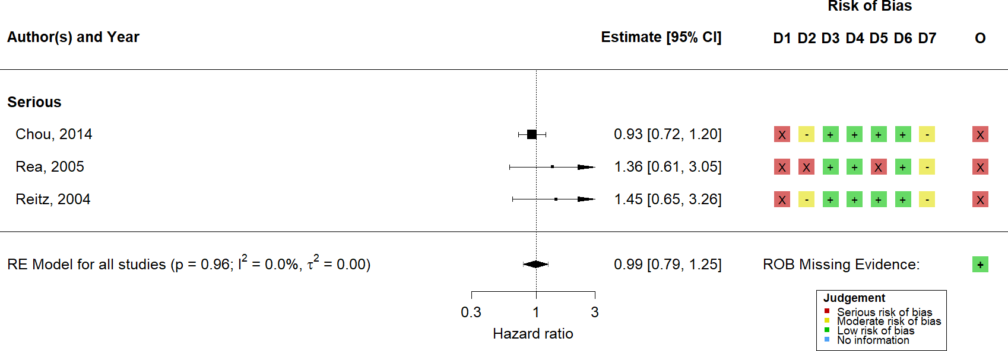

**Figure 4.15: Random-effects meta-analysis of statins on vascular dementia** - Non-randomised studies examining the association of statin use with vascular dementia were synthesised using a random-effects meta-analysis. Subgroup estimates, stratified by overall risk-of-bias level, are also presented. D1-D7 and O refer to the seven risk-of-bias domains and single overall judgement in the ROBINS-I tool, while the risk of bias due to missing evidence is shown beside the overall summary diamond.

A single Mendelian randomisation analysis was identified that examined the effect of genetically lowered LDL-c levels via HMGCR inhibition on the risk of vascular dementia, which provided some evidence for an effect (RR: 0.44, 95%CI: 0.21-0.91).

* + 1. Risk of bias

As shown in the forest plots in the above sections, the risk-of-bias assessments are presented alongside their corresponding numerical result. This section presents only a brief summary of the biases observed in each study design, as s detailed discussion of the sources and directions of bias in each result is presented in Chapter 7.

For the two randomised controlled trials, both were judged to be at low risk of bias. In contrast, many of the non-randomised studies of statin use were at serious risk of bias primarily due to poor controlling for confounding, immortal time bias, and missing outcome data. Similarly, non-randomised studies of exposures suffered from incomplete adjustment for potentially important confounders, and concerns over the selection of the reported result from among several analyses

* 1. *- Additional analyses*

(e.g. examination of lipids as a binary or continuous variable). Finally, bias was introduced into Mendelian randomisation studies via the potential for hoziontal pleiotropy and population stratification.70

Following best practice, any result judged to be at critical risk of bias should be excluded from any quantitative analysis.159 Three observational studies were excluded on this basis, predominantly due to a lack of adjustment for any potentially important confounders (i.e. the study reported unadjusted estimates).58,231,235

The risk of bias due to missing evidence in each synthesis is shown beside the overall summary diamond in each forest plot presented above. For randomised controlled trials and non-randomised studies of interventions, the risk of bias due to missing evidence was assessed to be minimal. However, there was substantial evidence that results were selectively reported in studies examining the effect of lipid fractions on dementia outcomes (Figures 4.4, 4.9 and 4.14).

### Additional analyses

* + 1. Dose response meta-analysis of lipid levels

There were 13 studies initially considered eligible for the dose-response meta- analysis, as they appear to provide data on risk of dementia outcomes across several categories of lipid exposure. However, following data extraction, five were excluded as they did not report the relevant information needed (most commonly, the cut-off measures for each category).

Across the remaining eight studies, a sufficient number of results (n ); 3) were identified only for the total cholesterol-Alzheimer’s, LDL-Alzheimer’s, and total cholesterol-dementia strata. This analysis provided weak evidence for a non-linear effect of lipid levels on dementia outcomes, and Figure 4.16 illustrates this for the total cholesterol-Alzheimer’s strata. Similar figures for the other analysed lipid-outcome strata are presented in Appendix A.4.2.

*4.4 - Additional analyses*

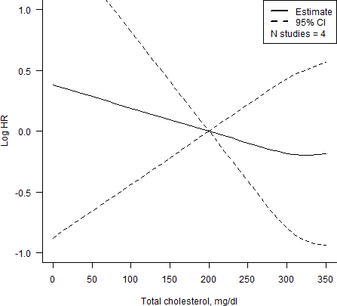

**Figure 4.16: Dose-response meta-analysis of total cholesterol on Alzheimer’s disease** - Non-randomised studies examining the association of lipids levels with Alzheimer’s disease across several categories or “doses” of exposure were synthesised using a dose response meta-analysis. The reference dose was defined *a priori* as 200 *mg/dL*, the cut-off of the “Normal”/“Optimal” category for total cholesterol as detailed in Table 1.2.

* + 1. Heterogeneity and publication bias

Investigation of potential sources of heterogeneity was complicated by two factors. In the first instance, a minority of meta-analysis (4 out of 18, 22%) included more than 10 results, the recommended minimum required for meta-regression. Secondly, poor reporting of study characteristics of interest including education level and baseline cognitive ability precluded the use of several results in a meta-regression analysis.

Age and gender were assessed as potential causes of heterogeneity in the meta- analyses of statin use and hypercholesterolemia on all cause dementia and Alzheimer’s

* 1. *- Additional analyses*

disease, but I found weak evidence for variation in the observed effect estimates due to these factors.

Similarly, assessment of small-study effects, for which publication bias could be one potential reason, was hindered by the relatively small number of results included in a given meta-analysis. However, all analyses assessed provided weak evidence of small-study effects.

* + 1. Added evidential value of including preprints

As show in the PRISMA flow diagram (Figure 4.1), the number of hits returned by preprint searching was not substantial (bioRxiv = 256, medRxiv = 0). From these hits, three preprinted reports of eligible studies were included in the review, of which two described unique studies not captured by the main search.253,255

One preprint (So *et al*253) provided additional evidential value in a single meta- analysis (5.6% of the 18 meta-analyses performed in this chapter). This meta- analysis of Mendelian randomisation studies examined the effects of lipid-lowering via HMGCR mutations on incidence of Alzheimer’s disease (Figure 4.12). To assess the evidence added to the meta-analysis through inclusion of the preprint, the data was re-analysed using a fixed-effect model. Examination of the weight assigned to each result in the analysis illustrates that a large proportion (78%) of the weight is given to the preprinted result. However, the inclusion of the preprinted study did not have a substantial impact on the result of the meta-analysis (RR: 0.76, 95%CI: 0.51-1.14) compared with that reported by the single published study (RR: 0.59, 95%CI: 0.25-1.39), other than a slight increase in precision.

The other two preprints identified255,257 reported on the effect of LDL-c on Alzheimer’s disease using data from GLCC and IGAP consortia. As illustrated in Figure 4.10, these consortia were previously analysed in several published reports, and so these preprints did not add to new information to the evidence base.

* 1. *- Discussion*

For one of the three preprints identified, the published version of the preprint was captured by the main search. Investigation of the publication status of the two unpublished preprints found that, allowing for a two-year lag (i.e. up to July 2021), only one had been subsequently published.250,255

### Discussion

This review presented a summary of the available evidence on the association between lipids, and treatments that modify lipids such as statins, and the subsequent risk of dementia. This discussion seeks to summarise the key findings in terms of literature sources and results as reported. A detailed comparison across the evidence sources, exposure measures and sources of bias reported here is presented as part of the triangulation exercise in Chapter 7.

* + 1. Summary of findings

There was some indication of a protective effect of statins on all-cause and Alzheimer’s disease dementia when looking solely at observational studies. This finding was not supported by evidence from the two available RCTs, or by studies that emulated statin treatment using a genetic proxy, suggesting that these findings may be a result of differing exposure windows (e.g. mid-life lipid lowering in non-randomised studies versus life-course lipid exposure in Mendelian randomisation studies and late-life lipid reduction in RCTs) or alternatively due to biases within the non-randomised studies.

Across dementia outcomes, the majority of studies were non-randomised studies of lipids or lipid regulating agents. This distribution of evidence between analytical designs is to be expected. Randomised controlled trials of dementia are particularly challenging, as the follow-up made necessary by the long latent period of the condi- tion makes trials logistically difficult and financially expensive. Similarly, Mendelian

*4.5 - Discussion*

randomisation is a comparatively new study design, and studies employing it in relation to dementia outcomes only appear in the evidence base in recent years, as illustrated in Figure 4.17. This recent increase is likely driven by the availability of summary genome wide association studies (GWAS) that form the basis of the two-sample Mendelian randomisation approach.

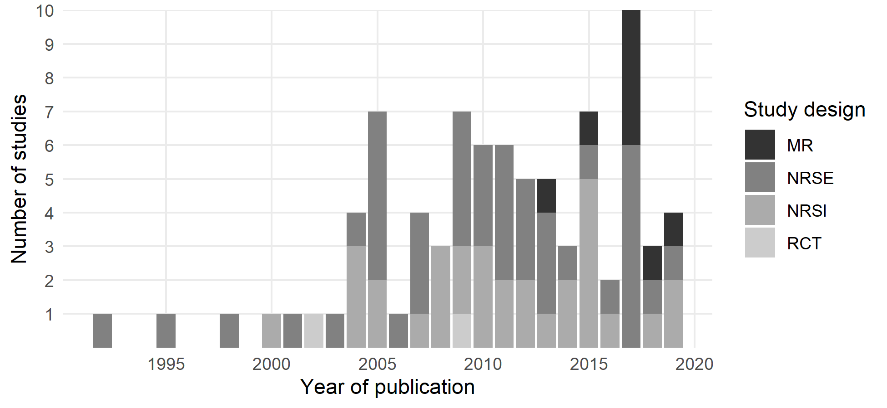

**Figure 4.17: Study designs by year of publication** - Included studies across all dementia outcomes are shown grouped by study design and year of publication. Note that Mendelian randomisation studies only begin to appear in the evidence base much later than other study designs.

A central finding of this review is the absence of studies examining vascular dementia as an outcome, most noticeable when comparing the evidence base for statins in dementia/Alzheimer’s (Figures 4.6 & 4.11) with that available for vascular dementia (Figure 4.15). This is particularly interesting given that lipids and statins are strongly related to the prevention of vascular disease. A potential explanation for this observation may be publication bias or the “file-drawer effect”,85 though there was weak evidence of a small-study effects for this outcome (of which publication bias is one potential cause).182 Similarly, only one Mendelian randomisation study examined this outcome, likely due to the absence (until recently) of vascular dementia GWAS which precludes a two-sample approach.

*4.5 - Discussion*

Of note, this review did not include the commonly cited PROSPER RCT, which examined the effect of pravastatin on cardiovascular disease risk and reported on cognitive outcomes as one of several secondary outcomes.258 While widely cited in relation to the effect of statins on dementia risk and included in the Cochrane review of RCTs on this topic,65 the trial reported solely on the change in a range of cognitive measures (MMSE, Stroop test, Picture-Word Learning test and others) over follow-up. Though a useful indicator of general cognitive decline, it is not equivalent to a dementia diagnosis using recognised criteria, as cognitive tests should feed into a broader diagnostic pathway (see Section 1.2.2). As such, this trial did not meet the inclusion criteria for this review.

Risk of bias across the individual results was generally high. The causes and expected impact of these biases on the results are discussed in more detail in Chapter 7. Of particular interest to this chapter, however, was the high risk of bias due to missing evidence observed for observational studies of lipid levels. In many cases, estimates were known to be missing from meta-analyses due to preferential reporting of significant results, leading to high risk of bias due to missing evidence. These missing estimates were most commonly identified through differing descriptions of the same analysis in conference abstract versus the final publication.247,259 In addition, some authors stated outright that non-significant results were not reported (e.g. “The other lipid variables not significantly associated with dementia and Alzheimer’s disease . . . were not reported in the table.”220). However, as all identified missing results are likely to be non-significant, they would not be expected to have a substantial impact on their respective meta-analysis (which provided weak evidence of an effect), other than increasing the precision of the summary estimate.

Finally in terms of generalisability, despite a large proportion of the included studies being conducted in the Western world (Figure 4.2), the applicability of the results to other populations is aided by the inclusion of several studies which made use of data from the Taiwan health insurance database.

* + 1. Comparison with previous reviews

*4.5 - Discussion*

While conducting this review, I identified several previous systematic reviews of this topic.260–265 However, to my knowledge, this review is the first to use established domain based assessments tools (for example, the RoB 2 tool for randomised controlled trials)162 to assess the risk of bias in included studies. The majority of the highly cited reviews on this topic either do not formally consider risk of bias in the observational studies they include,260,266 or used a non-domain-based assessment tool (e.g. the Newcastle-Ottowa Scale).263

I identified one previous review of Mendelian randomisation studies examining risk factors for Alzheimer’s disease. However, this review was conducted prior to the majority of Mendelian randomisation studies included in this review being published. In addition this previous review extracted the results of analyses which did not account for SNPs in the *ApoE* 4 genetic region (see the following section for a discussion of the bias this introduces).

Despite these differences in time scales and methodology, the duplication of work across systematic reviews (including this one) is substantial. In retrospect, an alternative approach to conducting a further systematic review from scratch, known as an umbrella review or review-of-reviews,267,268 could have been employed. This study design uses other systematic reviews rather than primary studies as the unit of analysis. Furthermore, it would have enabled more efficient identification of relevant primary studies to which the methods which sets this review apart could have been applied.

* + 1. Inclusion of Mendelian randomisation studies

One of the particular strengths of this review is the inclusion and critical assessment of Mendelian randomisation studies as a source of evidence.

*4.5 - Discussion*

Mendelian randomisation is a powerful analytical technique, using natural variation in participants’ genomes to identify causal links between a genetically determined risk factor and an outcome, given that the three core assumptions detailed in Figure

4.18 are valid. These assumptions are namely that:

* the genetic variant associates with the risk factor of interest (relevance assumption);
* the variant-exposure association has no unmeasured confounders (indepen- dence assumption);
* the variants affect the outcome only through their effect on the risk factor of interest (exclusion restriction assumption).

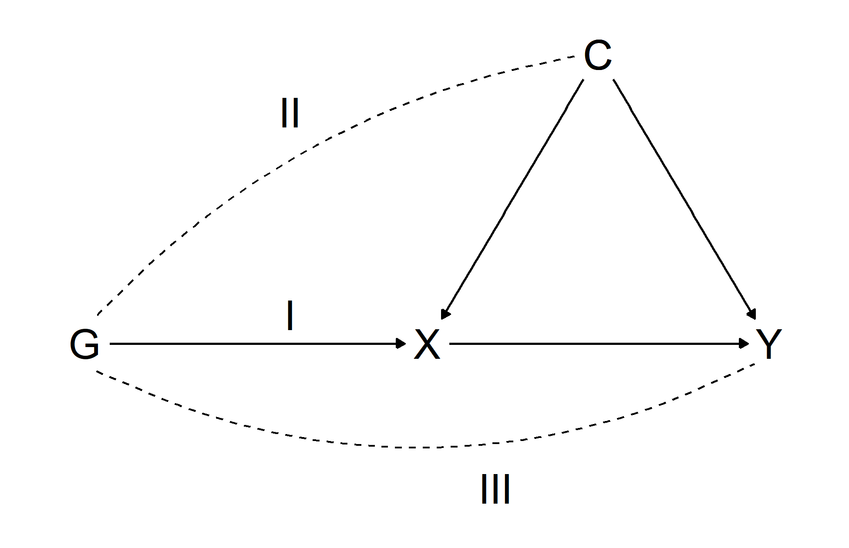

**Figure 4.18: Summary of the assumptions in Mendelian randomisation analyses** - Mendelian randomisation analyses make three key assumptions: (I) *relevance* - the genetic variant associates with the risk factor of interest; (II) *independence* - the variant- exposure association has no unmeasured confounders; and (III) *exclusion restriction* - variants affect the outcome only through their effect on the risk factor of interest (i.e. there is no horizontal pleiotropy).

However, inclusion of Mendelian randomisation as an acceptable study design in this review was complicated by a number of factors. Firstly, this study design is relatively new, particularly when compared to randomised trials or cohort studies. Figure 4.17 demonstrates that Mendelian randomisation studies only begin to appear in the

*4.5 - Discussion*

evidence base much later than NRSE/NRSI, likely due to the limited availability of large scale GWAS datasets needed for two-sample Mendelian randomisation analyses. As such, the process and tools for systematically assessing this study design are not as well developed. A key example of this is the absence of validated search filters for Mendelian randomisation studies. This limitation is further complicated by the varying terminology used to describe the method, particularly in the early years of its application, which led to me including general terms for instrumental variable analyses in my search.

Additionally, there is currently no widely used risk-of-bias assessment tool for Mendelian randomisation studies. While a recent commentary provided a checklist for interpreting Mendelian randomisation studies, this guide includes reporting items in their quality checklist.70 Reporting quality is an important consideration for Mendelian randomisation studies, as reflected by the recent release of the STROBE MR reporting guidelines,269 but it is a separate consideration to bias, as discussed in Section 3.2.8. Similarly, a previous review of Mendelian randomisation studies used the Q-Genie tool which was designed to assess the quality of GWAS included in a meta-analysis.270 While this tool assesses the underlying GWAS used, it does not address the additional methodological considerations of the Mendelian randomisation analysis itself. For this review, I used the best available author-devised tool, sourced from a recent review of systematic reviews of Mendelian randomisation studies.167

As a further stumbling block, Mendelian randomisation lends itself to the analysis of multiple exposure-outcome comparisons as part of a single study, particularly when using a two-sample summary data design. This is particularly relevant to the consideration of bias due to missing evidence. As an example, through snowballing and other measures, I identified at least one relevant Mendelian randomisation study that had not been captured by the search strategy.71 This study examined lipid fractions as one of many risk factors for Alzheimer’s disease, though the search would not have been expected to find it given the absence of any lipid-related keywords in the title or abstract. Studies examining multiple risk factors such as this can introduce bias into a systematic review, as it is commonly only those risk

*4.5 - Discussion*

factors with a statistically significant result that are reported in the abstract and so are captured by a systematic search. These studies are described as “unknown unknown’s” in the context of the RoB-ME tool, and are considered to be particularly challenging (as opposed to an analysis that was insufficiently reported to be included in the statistical analysis, or the “known unknown’s”).

Useful future work to improve the methodology for inclusion of Mendelian ran- domisation studies in systematic reviews should involve the development of a validated search filter for this study design.271,272 Alternatively, in better-resourced reviews, a broader search (e.g. “risk factor” AND “dementia” AND “Mendelian randomisation”) followed by manual review of studies that examined multiple risk factors would be advisable. This was not feasible in the context of this review, given the large number of records to be screened even when using study design filters (N

= 16,109). Additionally, the value of methods that support traditional bibliographic database searches, such as snowballing (forwards and backwards citation chasing) and communication with relevant topic experts, should not be underestimated. Finally, development of a risk-of-bias assessment tool for this study design by a panel of methodologists and analysts would be of substantial benefit.

One item of particular interest is the attenuation of any effects identified by Mendelian randomisation studies following the adjustment for/exclusion of genetic variation in the *ApoE* 4 gene region. As discussed in the introduction (see Section 1.4.1), an increasing number of *ApoE* 4 alleles is a major independent risk factor for Alzheimer’s disease and so violates the exclusion restriction criteria of Mendelian randomisation studies (Figure 4.18). In all cases, excluding variants in the *ApoE* region attenuates the observed effect to the null. A clear example of this is Benn *et al* (2017), where *ApoE* variants were not sufficiently identified and excluded, leading the published paper to report a protective effect of LDL-c on Alzheimer’s (RR: 0.83, 95%CI: 0.75-0.92).74 Following several rapid responses, the data was re-analysed to exclude a larger area around *ApoE* which attenuated the finding to the null.273

*101*

* + 1. Inclusion of preprints

*4.5 - Discussion*

As highlighted in Section 1.5.1, this review explicitly sought to synthesize all available evidence, irrespective of publication status (preprinted vs. published). Using the tool described in Chapter 2.1, two preprint servers related to health and biomedical sciences were searched as part of this review. The small number of studies returned by the preprint searches (or the absence of any relevant hits in the medRxiv database - see Figure 4.1) is largely due to the timing of the preprint searches. The searches for this review were performed in mid-July 2019, but the medRxiv repository, an offshoot of the Epidemiology and Clinical Trials categories of the bioRxiv preprint server, only registered its first preprint 25th June 2019. As such, at the point it was searched, the medRxiv database contained only a very small number of records (N = 148; Figure 4.19).

*102*

*4.5 - Discussion*

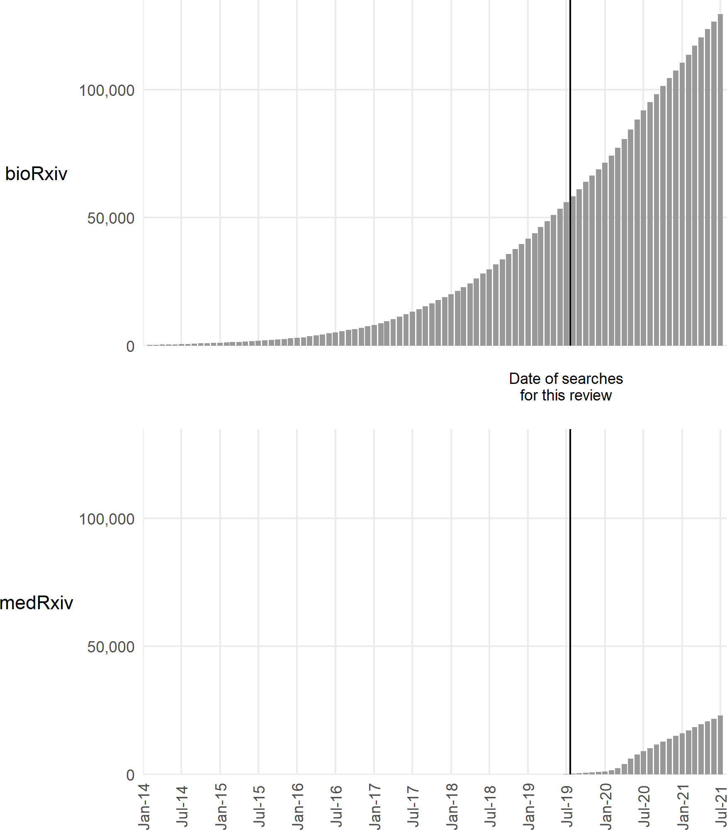

**Figure 4.19: Growth of preprint repositories over time** - Given the relative sizes of the preprint repositories at the time the searches for this review were conducted (bioRxiv N = 56,007, medRxiv N = 148), the number of hits returned by each is expected.

Three relevant preprints from bioRxiv were identified. Of note, all three described a Mendelian randomisation study, potentially indicating that more biologically- focused study designs are over-represented in the bioRxiv repository. The added evidential value of including these preprints was described in Section 4.4.3 and indicated that results available only via preprinted reports can contribute additional evidence to a meta-analysis. However, the scale of this contribution is questionable. Preprinted evidence was incorporated into only a single meta-analysis in this review, and inclusion of the preprinted result did not substantially impact the summary effect estimate.

*103*

*4.5 - Discussion*

Of the three identified preprints, two were subsequently published as of September 2021. This fits well with the analysis presented in Chapter 2 that, allowing for a two-year lag, approximately two-thirds of preprints are published. It also illustrates the dual advantages of preprinted reports to evidence syntheses. Firstly, preprints provide an advance snapshot of the literature, capturing articles that will eventually be published but were not available at the time of the main search. For example one eligible preprint in this review was initially posted on bioRxiv in July 2019255 and was subsequently published in 2021 following peer-review.250 Secondly, inclusion of preprints allows for results that may never be formally published to be included in an evidence synthesis exercise, as is the case with a second preprint included in this review.253 Both of these aspects illustrate that inclusion of preprints is a necessity if the aim is to find all relevant literature on a topic at the time of searching.

Recently, inclusion of preprints in systematic reviews has become significantly more widespread. This is largely due to the role of preprint servers, in particular medRxiv, as a key evidence dissemination venue during the early stages of the COVID-19 pandemic.84 How well this adoption of preprints will transfer to other less-urgent topics, where the speed of research does not put the same focus on preprinted articles, is currently unknown.

* + 1. Open data sharing

As discussed in Section 4.4.1, many primary studies did not report important information required for the dose-response meta-analysis, and so could not be included in the synthesis. This limitation was compounded by the expected low response rate to requests for further information from primary authors. Contacting authors is worthwhile, as it can substantially change the conclusion of a systematic review274 and is not too costly to systematic reviewers,275 though a preferable option is that the authors of primary studies readily deposit all relevant study data at the point of publication.

*104*

*4.5 - Discussion*

Based on my experience of extracting data for this review, I co-authored a guidance article to aid primary prevention scientists in preparing and sharing their data so that it can easily be incorporated into a evidence synthesis exercise, using a trial of mindfulness interventions as a case study.276 A copy of this publication is available in Appendix B.3. In an attempt to apply my own guidance, I have invested a substantial amount of time and effort into making the data obtained by this review openly available to other researchers, via a GitHub repository.

* + 1. Strengths and limitations

Strengths

There are several aspects where this review is distinct from those already available in the published literature. While several reviews of this research topic exist,260–263 the overlap between the list of studies included in each is not complete. As part of this review, I have not only performed an original search of primary literature databases, but have also screened the reference lists of comparable reviews to ensure no relevant study has been omitted.

Secondly, this review employed a structured approach to risk-of-bias assessment using a domain-based tool. This represents an important strength of this review, as the detailed risk of bias assessments are used in inform the quantitative triangulation analysis presented in Chapter 7.

Thirdly, as discussed at length in the section above, in contrast to other available reviews and enabled by the tool described in Chapter 2, this review systematically searched preprinted health-related preprints. Finally, as a secondary element, I used this review to pilot new research synthesis methodologies, in particular a new visualisation approach for risk-of-bias assessments and a forthcoming tool for assessing the risk-of-bias due to missing evidence.

*105*

*4.5 - Discussion*

Limitations

The primary limitation of this review is that several included studies used data from EHR databases, which come with serious concerns regarding validity.277–279 Relatedly, several studies which made use of electronic health record databases did not report the specific code lists used, potentially introducing substantial heterogeneity into the analysis. An empirical example of the effect of differing EHR code lists is presented as part of the analysis in Chapter 5 (see Section 5.3.4).

In addition, the fact that only a sample of records were dual screened at the title/abstract and full-text stages is a potential limitation, as there is a chance that some eligible records could have been excluded. However, evidence from assessments of inter- and intra-rater reliability indicate that this is not a major concern.

One particular limitation with regards to the risk-of-bias assessment is the fact that the ROBINS-E assessments were performed using an adapted version of the ROBINS-I tool. This meant that there were no signaling questions to guide the domain-level risk-of-bias assessments, which may have influenced the accuracy with which the judgements were assigned. However, there is no published empirical evidence supporting the need for signaling questions and assessment of inter-rater reliability across the different tools did not indicate a specific problem with the ROBINS-E assessments. In fact, low agreement was common across the tools, though this is expected based on the available literature.280

A final limitation is the potential for missing evidence on the basis of the results. Evidence for this limitation came from the ROB-ME assessments and was supported by empirical evidence that some studies containing relevant results were missed by the search (see Section @Ref(rev-discussion-MR) above for a fuller discussion of this issue with respect to Mendelian randomisation studies). Unfortunately, this is probably a common limitation across all systematic reviews, based on the way in which increased search sensitivity must be balanced with a manageable workload.

*106*

### 4.6 Summary

* 1. *- Summary*
     + In this chapter, I presented the results of a comprehensive systematic review of existing evidence on the association between lipid levels and dementia use. The review included both direct (studies that examined lipid levels directly) and indirect (studies examining lipid regulating agents such as statins) forms of evidence. In contrast to previous reviews, I also included preprinted evidence, facilitated by the research tool introduced in Chapter 2.
     + I found no consistent relationship between lipids or lipid-regulating agents and dementia across different evidence sources. However, there was some indication of a protective effect of statins on all-cause and Alzheimer’s disease dementia in non-randomised studies of interventions.
     + The findings from this review are used throughout the subsequent chapters. In Chapter 5, this summary of the evidence guided the choice of analysis approach, ensuring that the new analysis was at risk of a different source of bias and provided evidence on an under-studied outcome (vascular dementia). In Chapter 6, prospective cohorts identified by the review were contacted in an attempt to obtain individual participant data. Finally, the results identified here are used as a key source of evidence for the triangulation exercise presented in Chapter 8.

*When dealing with human beings controlled experi- ments frequently prove to be impracticable, so for a scientific basis for our assumptions we turn to past history to reconstruct the suspected causal chain of events - and then our statistical troubles may begin.*

— Harold F. Dorn, 1953281

# 5

## Primary analysis of lipid-regulating agents

and dementia outcomes

Contents

**Lay summary** **108**

* 1. **Introduction** **108**
  2. **Methods** **109**
  3. **Results** **123**
  4. **Discussion** **139**

*5.1 - Introduction*

### Lay summary

Electronic health record (EHR) databases are large collections of medical data, used to manage patient administration and care. Under these systems, whenever a patient attends their GP, their clinical data is recorded in a central database using a standardised coding system. These databases have several advantages over traditional methods of data collection, including the number of people they contain and the relatively low cost of data collection via routine care. This is particularly important when studying diseases such as dementia, which may begin to develop in patients long before symptoms are seen.

This analysis makes use of the Clinical Practice Research Datalink (CPRD), which contains the electronic medical records of more than 3 million people from general practices across England. Using this data, the analysis presented in this chapter examined whether treatments which lower cholesterol levels (also known as lipid-regulating agents or LRA) of which statins are a prime example, affect the risk of all-cause dementia and related outcomes (Alzheimer’s disease, vascular dementia and other dementias).

Little evidence for an effect of lipid-regulating agents effect on the risk of Alzheimer’s disease was found, with the exception of a slightly increased risk in those prescribed a certain type of lipid-regulating agent called fibrates. In contrast, I found an increased risk of vascular and other (i.e. non-Alzheimer’s) dementia was associated with lipid-regulating agent use.

This increased risk in outcomes with a vascular element (e.g. vascular dementia) is unexpected, and is very likely to be due to the presence of bias in the analysis. This bias, called “confounding by indication”, is caused when those who are prescribed a statin are more at risk of vascular dementia for a range of reasons, which makes it appear as if statins are harmful. Despite this limitation, the analysis presented provides an important source of information which will be used in later chapters.

### Introduction

In this chapter, I present an analysis of a large population-based electronic health record dataset to investigate the relationship between lipid-regulating agent (LRA) use and dementia outcomes. The analysis aims to address two important limitations

*110*

*5.2 - Methods*

of the current evidence base as identified by the systematic review presented in Chapters 3 & 4.

Firstly, it explicitly examines vascular dementia as an outcome. The systematic review presented in the previous chapter identified an evidence gap around the effect of lipid-regulating agents on the risk of vascular dementia. As triangulation exercises require as many diverse sources of evidence as possible, this analysis provides a source of information on this outcome.

Secondly, and in a similar vein, the analysis intentionally takes a different analytical approach to that most commonly used to examine the effect of statins on dementia as identified by the systematic review. Specifically, this involved a concerted effort to address immortal time bias through use of a Cox proportional hazards analysis, incorporating a time-varying treatment indicator.282 By employing this approach, the analysis provides an evidence source at risk of a distinct bias. The results from this analysis will be incorporated into the triangulation exercise presented in Chapter 8.

This chapter represents an extended version of a preprinted manuscript, a copy of which is available in Appendix B.3.

### Methods

* + 1. Study protocol

An *a priori* protocol for this study was published,283 and amendments to this are recorded in Appendix A.5.1.

* + 1. Data source

Previously known as the General Practice Research Database, the Clinical Practice Research Datalink (CPRD) is a large population-based EHR database.284 The

*111*

*5.2 - Methods*

database has been collecting primary care data from participating practices across England since 1987.285,286 It contains the primary care records for more than 10 million primary care patients in England, and is broadly representative of the UK population in terms of age, sex and ethnicity.284,287

To avoid the ambiguity of interpreting free-text clinical notes and to allow for easy analysis of the resulting data, the CPRD primarily collects data using a predefined coding system known as Read codes.288 All clinical events, including clinical test results and diagnoses, can be identified by a specific Read code. The codes use a nested approach (see Table 5.1), with the initial characters defining broad diagnostic topics (e.g. Eu. . . - Mental and behavioural disorders), while subsequent characters provide additional information on the specific condition diagnosed (e.g. Eu001 - Dementia in Alzheimer’s disease with late onset).

**Table 5.1:** Example of CPRD Read code hierarchy, showing how “Dementia in Alzheimer’s disease with late onset” (*Eu001* ) is nested under the top-level of “Mental disorders” (*Eu. . .* ). Broad topics are specified using the initial two alpha-numeric characters of the Read code, while subsequent characters are used to define specific conditions and context.

Level Read code Term

|  |  |  |
| --- | --- | --- |
| 1 | E.... | Mental disorders |
| 2 | Eu... | Mental and behavioral disorders |
| 3 | Eu0.. | Organic mental disorder |
| 4 | Eu00. | Dementia in Alzheimer’s disease |
| 5 | Eu001 | Dementia in Alzheimer’s disease with late onset |

The index events, exposures and outcomes used in this analysis were identified using predetermined code lists, which are available for inspection from the archived reposi- tory accompanying this analysis (data/code availability is discussed in Section 5.4.4).

*112*

* + 1. Cohort definition
  1. *- Methods*

This analysis included all participants registered at a participating practice between 1 January 1995 and 29 February 2016 who had a flag for “research quality” data (as defined by the CPRD). Records pre-dating the 1995 cut-off were included in the original CPRD extract obtained for this analysis. However, these older records were excluded from the analysis as data quality and reliability are thought to be higher after this date.289 Additionally, individuals with less than 12 months of continuous records prior to cohort entry were excluded, making the effective start date of the cohort 1 January 1996.

Participants were included in the study cohort if their record contained any of the following index events:

* + - a Read code for a diagnosis of hypercholesterolemia or related condition;
    - a Read code for prescription of a lipid-regulating agent (such as statins);
    - a total cholesterol test result of >4 mmol/L;
    - an LDL-c test result of >2 mmol/L.

The blood lipid cut-offs were based on NIHR-recommended levels at the time the protocol was written. These index events allowed me to define a population of participants who were either at risk of hypercholesterolemia, as indicated by the elevated total or LDL cholesterol test results, or had already been diagnosed with it, as indicated by a diagnostic code/related prescription.

The index date for a participant was defined as the date where the first relevant code or test result was recorded on their clinical record, and participants were followed up until the earliest of:

* + - an outcome of interest;
    - death;
    - end of follow-up (29 February 2016);
    - last registration date with their GP practice;

*113*

*5.2 - Methods*

* the last CPRD collection date for their practice.

Participants were ineligible for the cohort if they were less than 40 years of age (as these patients are less likely to be prescribed a LRA), had less than 12 months of “research quality” data, were simultaneously prescribed more than one lipid- regulating agent (due to the difficult of assigning these to a single exposure group), or were diagnosed with an outcome of interest before or on the date of the index event (i.e. had less than one full day of follow-up).

* + 1. Exposures

I considered seven lipid-regulating drug classes based on groupings in the British National Formulary,290 namely: statins, fibrates, bile acid sequestrants, ezetimibe, nicotinic acid groups, ezetimibe and statin (representing one treatment containing both drugs, rather than the two classes being prescribed concurrently), and omega-3 fatty acid groups.

A participants drug class was assigned based on their first recorded prescription, and any drug switching was ignored in an effort to mimic an intention-to-treat approach. We did however examine how often the initial drug class altered according to one of three criteria:

* **stopped**: defined as the last prescription of the primary class being followed by at least six months of observation;
* **added**: defined as a second drug class being prescribed before the last prescription of the initial class; and
* **switched**: defined as a second drug class being prescribed after the last prescription of the initial class.

*114*

* + 1. Outcomes

*5.2 - Methods*

I considered five outcomes as part of this analysis: probable Alzheimer’s disease, possible Alzheimer’s disease, vascular dementia, other dementias, and a composite all- cause dementia outcome. When two or more outcomes were coded in a participant’s clinical record, a decision tree was used to differentiate between them (Figure 5.1). The diagnosis date of the outcome was determined by the first record of a relevant code.

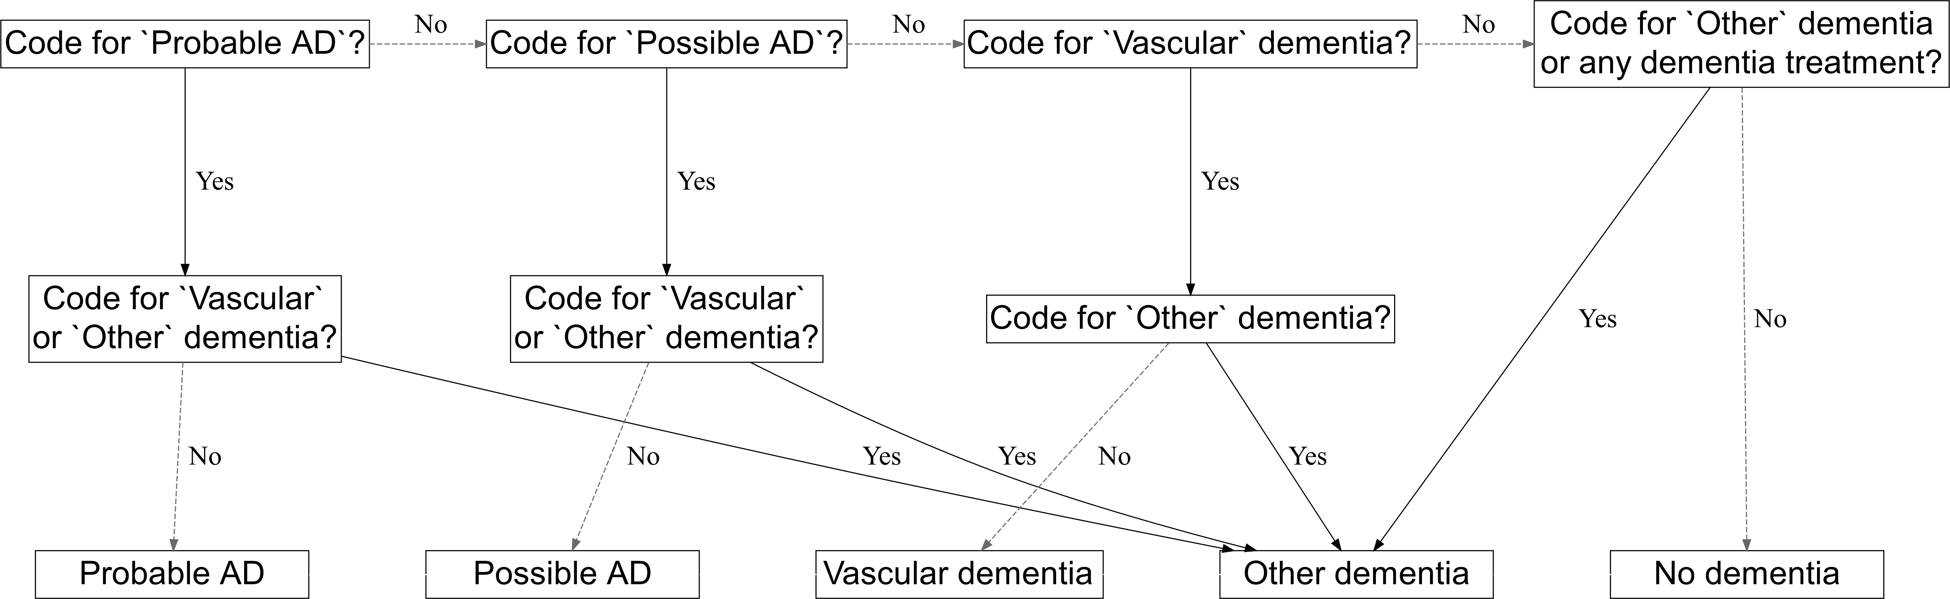

**Figure 5.1: Decision tree for assigning dementia subtypes** - Based on the presence of specific Read codes in the patient’s record, a decision tree was used to classify dementia subtypes (“Probable” or “Possible” Alheimer’s disease, vascular dementia, and other dementia). Note that an outcome of “probable” or “Possible” Alzheimer’s disease (AD) requires the absence of any vascular outcome codes.

* + 1. Covariates

A range of additional variables were included in the analysis. These were intended to address the different distributions of potential confounding factors between those who were prescribed a lipid-regulating agent and those who were not. These are discussed in detail below and summarised in Table 5.2.

*115*

*5.2 - Methods*

Charlson index implemented using Read code lists.292 Code lists based on those by Taylor et al.293

**Table 5.2:** Definition of covariates adjusted for in the full-adjusted model. The code lists used to define the majority of these covariates were originally created for use in a previously published analysis.291 while others were built on or adapted from previous published work,292–294.

**Covariate How was the covariate defined?**

Previous history of coronary arterial disease

Previous history of coronary bypass surgery

Previous history of cerebrovascular disease (including stroke)

Chronic illness, including cancer and arthritis

Presence of one or more relevant Read codes on record. Presence of one or more relevant Read codes on record. Presence of one or more relevant Read codes on record.

Charlson index implemented using Read code lists.292 Code lists based on those by Taylor et al.293

Socioeconomic position 2010 English Index of Multiple Deprivation (IMD) at the

twentile level, where 1 represents the least deprived and 20 the most deprived.

Consultation rate Calculated by dividing the total number of clinic visits by the length of the patient record prior to the index

date to give an average annual rate.

Alcohol status Recorded value (current, former or never). Smoking status Most recent of recorded value (current, former or never)

or Read code indicating a recorded value. Code lists based on those by Wright et al.294

Body Mass Index Recorded value if available, or a calculated value using the last recorded height and weight measurements.

Measurements taken before the age of 25 were excluded to ensure adult measurements were used.

Peripheral arterial disease Presence of one or more relevant Read codes on record.

Hypertension Presence of one or more relevant Read codes on record.

Baseline total cholesterol Continuous value recorded as test result ("enttype==163

& test_data1==3")

Baseline LDL cholesterol Continuous value recorded as test result ("enttype==177

& test_data1==3")

Chronic kidney disease Presence of one or more relevant Read codes on record. Type 1 Diabetes Presence of one or more relevant Read codes on record.

Type 2 Diabetes Presence of one or more relevant Read codes on record.

*116*

*5.2 - Methods*

Demographic covariates adjusted for included age and gender. Age in years was calculated at date of entry into the cohort, using the 1st of January of a patient’s birth year (the exact date of birth was not provided by CPRD), and was adjusted for via its use as the time axis for the Cox model (see Section 5.2.10). Socioeconomic status was proxied using the Index of Multiple Deprivation (IMD) 2010. The IMD draws on seven domains (income; employment; education, skills and training; health and disability; crime; barriers to housing and services; living environment) to create an overall deprivation score for each of 32844 statistical geography areas in England. To help preserve patient privacy, IMD score is only available from the CPRD in twentiles, with 1 indicating the least deprived and 20 indicating the most deprived. Smoking and alcohol use was determined at index, and was categorised as current, former, or never use.

Body mass index (a summary measure calculated as *weight/height*2), baseline total cholesterol and baseline LDL cholesterol measures were obtained, using the last recorded value prior to the index date. A variable indicating grouped year of entry into the cohort (<=2000, 2001-2005, 2006-2010, >2010) was included to allow for changes in prescribing trends across the lifetime of the cohort. To assess healthcare utilisation, I adjusted for the average annual number of consultations between the beginning of a patient’s data and their entry into the cohort.

Finally, presence of a range of related conditions at baseline were accounted for, including cardiovascular disease, coronary bypass surgery, coronary artery disease, peripheral arterial disease, hypertension, chronic kidney disease, and Type 1 and Type 2 diabetes. In addition to adjusting for these covariates individually, a Charlson co-morbidity index (CCI) score was calculated for each participant. The CCI is a weighted index that uses presence and severity of a number of conditions to enable adjustment for the general health of a participant in terms of their mortality risk.295 The conditions considered under the index are: AIDS; cancer; cerebrovascular disease; chronic pulmonary disease; congestive heart disease; dementia; diabetes; diabetes with complications; hemiplegia; metastatic tumour; mild liver disease; moderate liver disease; myocardial infarction; peptic ulcer disease;

*117*

*5.2 - Methods*

peripheral vascular disease; renal disease; and rheumatological disease. Inclusion of this index allowed me to attempt to adjust for the general health of patients included in the analysis.

code lists for all covariates can be found in the archived data repository accompanying this analysis (see Section 5.4.4).

* + 1. Missing data

Missing data are a recognised problem in electronic health records databases.296 These databases are created from administrative data, collected primarily for the purposes of patient management and care rather than academic research.

In this analysis, missing data was handled using a multiple imputation approach.297 Variables with missing observations were identified for inclusion in the imputation model. Nominal variables with missing values were modelled using multinomial logistic regression, while continuous variables were modelled using linear regression. As per best practice, all variables used in the analytic model, including the outcome, were included in the imputation model.298 Using the MICE (Multiple Imputation by Chained Equations) command in STATA16, 20 imputed datasets were created.

Missing data was only considered problematic for variables where a numerical test result was expected (e.g. BMI), or where a code existed for the absence of the condition (e.g. categorical smoking status). This approach was necessary, as absence of a code for other treatments or conditions (e.g. statin use or dementia) was assumed to indicate absence of the treatment/condition rather than being considered missing.296

*118*

* + 1. Estimation methods
  1. *- Methods*

A Cox proportional hazards (PR) model was used to estimate the effect of statins on dementia outcomes. Cox PR models are defined in general terms as:

where:

*h*(*t*) = *ho*(*t*) *× exp*(*b*1*x*1 + *b*2*x*2 + *...* + *bpxp*) (5.1)

* + - *t* is the survival time;
    - *h*(*t*) is the hazard function; and
    - *x*1*, x*2*, ..., xp* are the covariates which determine the hazard function, while

*b*1*, b*2*, ..., bp* are the coefficients for each covariate.

* + - *ho*(*t*) is the baseline hazard - when all *xi* are zero, the *exp*() function resolves to 1.

A Cox PR model was chosen for this analysis as it inherently accounts for the length of time participants spend in each exposure group. Using this approach, time-at-risk can be properly attributed to the appropriate exposure group, thus mitigating the impact of immortal time bias. This is discussed in detail in the following section.

* + 1. Immortal time bias and time-varying treatment in- dicators

Immortal time bias describes two distinct but related types of bias, considered here in relation to statin use. The first presentation, the selection bias aspect (Panel A, Figure 5.2), occurs when time prior to statin initiation is excluded leading to the statin and control groups being followed up from different time points.299 Following the example displayed in the figure, the unexposed group are followed from the date of an index event (e.g. diagnosis of hypercholesterolemia), while the statin group is followed from date of a statin initiation. In this scenario, the time between the index

*119*

*5.2 - Methods*

event and statin initiation is missing, and any events that occur in the exposed group prior to the prescription will be inappropriately excluded from the analysis.

The second presentation of immortal time bias is as a type of misclassification bias (Panel B, Figure 5.2). It occurs when the exposure time prior to statin initiation, and any events occurring within it, is inappropriately assigned to the exposed group.

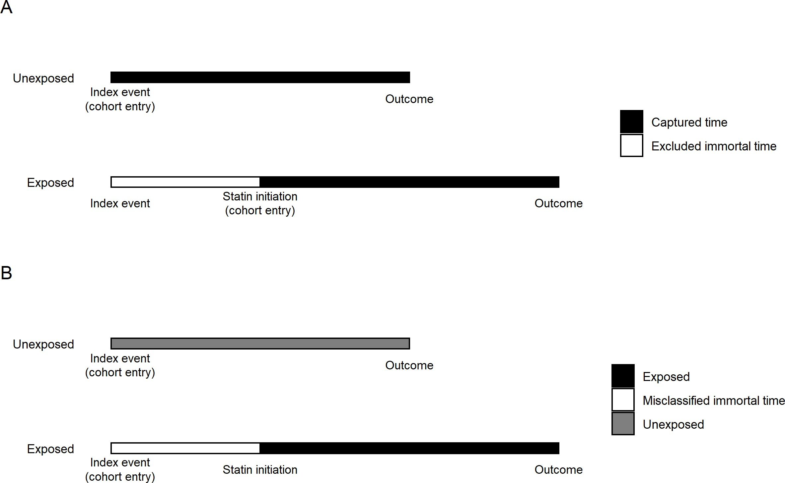

**Figure 5.2: Immortal time bias** - The two presentations of immortal time bias are illustrated. Panel A shows the selection bias presentation, where time prior to a statin exposure is excluded from the analysis and outcomes in this time period are lost. Panel B shows the misclassification presentation, there time (and events) prior to statin exposure is incorrectly assigned to the exposed group.

This second presentation appears to be common in the existing literature on the relationship of statins and dementia, as several of the studies included in the systematic review performed as part of this thesis were identified as being at risk of immortal time bias following formal risk of bias assessment using the ROBINS-I tool (see Section 4.3.4).

*120*

*5.2 - Methods*

Following a recommended approach to addressing the second form of immortal time bias, I employed a time-varying indicator of treatment status to correctly allocate time-at-risk to the exposed and unexposed groups.299 Under this approach, all patients are followed from a common index date, defined as earliest of: (a) date of raised cholesterol test results; (b) hypercholesterolemia diagnosis; or (c) LRA prescription. Patients start in the unexposed group and contribute time-at-risk until they are prescribed a lipid-regulating agent, at which point they move into the exposed group. Note, patients for whom prescription of a lipid-regulating agent was the index event only contribute time to the exposed group (i.e. they enter the cohort and move into the exposed group on the same day).

* + 1. Time axis

As part of a Cox proportional hazard model, there is the option to use either absolute time in cohort or participants age as the time scale of interest.300–302 A model using age as the time axis inherently accounts, or adjusts, for participants age as a potential confounder of the exposure-outcome relationship. As such, the main analyses presented all used age as the time axis.

* + 1. Sensitivity analyses

The primary analysis examined the effect of a lipid-regulating agent on dementia risk, stratified by outcome and drug class. To assess the robustness of the results, a number of sensitivity analyses were performed. These are described in the following sections.

*121*

*5.2 - Methods*

Complete case vs imputed data

Using multiple imputation to handle missing data is an alternative to a “complete case” approach,303 where participants missing any covariate are dropped from the dataset. As a recommended sensitivity analysis,304 I performed and compared the results of both methods, to investigate the impact of multiple imputation on the results.

Control outcomes

In addition to the primary outcomes of interest (described in Section 5.2.5), I extracted data on three additional control outcomes. The inclusion of control outcomes in observational analyses are a useful technique to assess the strength of uncontrolled confounding,305 and these outcomes are usually classed as either “negative” or “positive” outcomes.

Negative outcomes are defined as those without a likely causal path between the exposure and outcome (see Figure 5.3 for a directed acyclic graph, or DAG, describing an ideal negative outcome). Conversely, positive control outcomes are those with a known causal association with the exposure of interest, ideally sourced from large well conducted randomised controlled trials. Positive control outcomes are useful in observational epidemiology, as if the analysis can reproduce a known result for the control outcome, confidence in the result for the outcome of interest is increased. Due to the wealth of data available on statins as a lipid-regulating agent, I chose three control outcomes in reference to this drug class: back pain (negative control), ischaemic heart disease (positive protective control), and Type 2 diabetes (positive harmful control).

*122*

*5.2 - Methods*

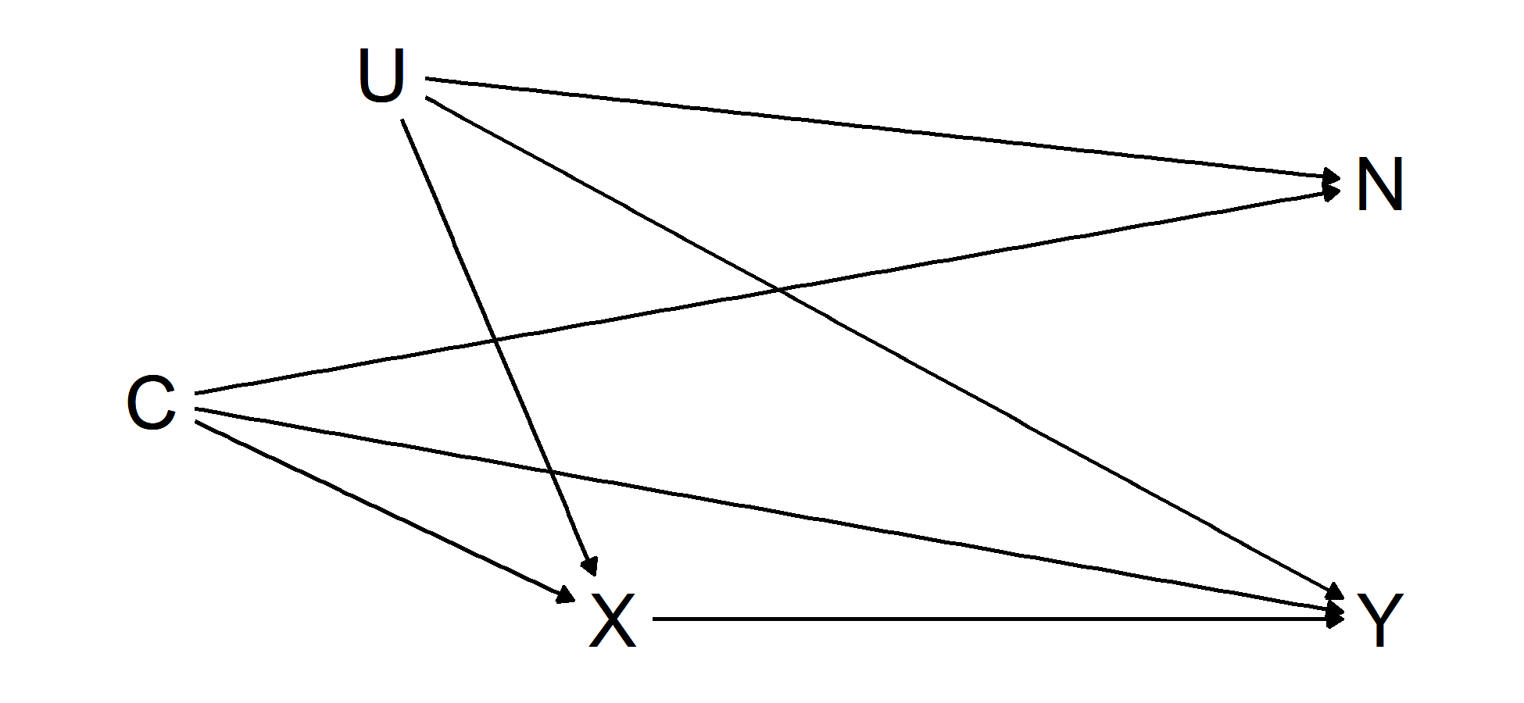

**Figure 5.3: Causal diagram for ideal negative outcome** - The directed acyclic graph shows the relationship between the exposure *X*, outcome *Y* , confounders (measured *C* and unmeasured *U* ) and an ideal negative outcome *N* . Note the absence of any arrow between *X* and *N* . In this scenario, any association observed between *X* and *N* is due to the presence of uncontrolled confounders *U* (assuming *C* has been adjusted for).

Despite observational analyses suggesting a link between statins and muscular pain (as opposed to more serious complications such as myopathy),306 systematic reviews of the adverse events of statin use38 and N-of-1 trials explicitly exploring the association of statin use with muscle pain307 have found little evidence supporting an effect. This suggests that muscular backpain would be suitable for use as a negative control outcome in this analysis. Under this approach, if statin use is found to be associated with muscular backpain in this analysis, this suggests the presence of residual confounding and reduces my confidence in the results for the dementia outcomes.

Similarly, incident ischemic heart disease and Type 2 diabetes were included as a protective and harmful positive control outcome, respectively. The protective effect of lipid-lowering treatment, via statins, on the risk of ischemic heart disease is well-established,38 while there is growing evidence for an increased risk of Type 2 diabetes with statin use.38,308,309 Similar to the negative outcome, if the analysis strategy can reproduce these known associations, this will provide evidence that potential confounders have been sufficiently adjusted for.

*123*

* 1. *- Methods*

Impact of additional covariates

To observe the effect of adjusting for additional covariates, I ran two additional models unadjusted except for: (a) age; and (b) age and gender. The results of these models was then compared the results with the fully adjusted model.

Sensitivity cohorts

Two sensitivity cohorts were also created. The first stratified by year of entry into the cohort in an attempt to assess for time period effects. The second removed participants who may have been pregnant (coded as under 55) to assess the robustness of the estimates, as statins are contraindicated in pregnancy.310

Statin properties

As detailed in the introduction, the properties of statins may be important due to the ability of lipophilic statins to cross the blood brain barrier (see Section 1.3.2).41 As such, I expected that any effects of statins on dementia outcomes would be stronger in the lipophilic as compared to the hydrophilic statin subgroup. To investigate this, I further stratified the statin exposure group into lipophilic (Atorvastatin, Lovastatin, Simvastatin, Cerivastatin) and hydrophilic (Pravastatin, Rosuvastatin, Fluvastatin) statins.

Impact of using different code lists for defining dementia outcomes

As part of an exploratory analysis of the effect of the choice of code lists on the analysis, I created an alternative Alzheimer’s disease and non-Alzheimer’s

*124*

*5.3 - Results*

dementia outcome using code lists from a published study by Smeeth *et al*.213 The intended purpose of this analysis was to assess the robustness of my results to the choice of code list.

This published analysis used a propensity matching approach to estimate the association of statins with a range of outcomes in The Health Improvement Network database, an alternative source of English electronic health records which has substantial overlap with the CPRD.311 The code lists used in this analysis were obtained through correspondence with the authors of that study, and are available for inspection (see Section 5.4.4).

### Results

* + 1. Patient characteristics

Of the 3,179,733 participants included in the extract, 1,684,564 met the inclusion criteria (Figure 5.4), with a total follow-up of 10,835,685 patient years at risk.

*125*

*5.3 - Results*

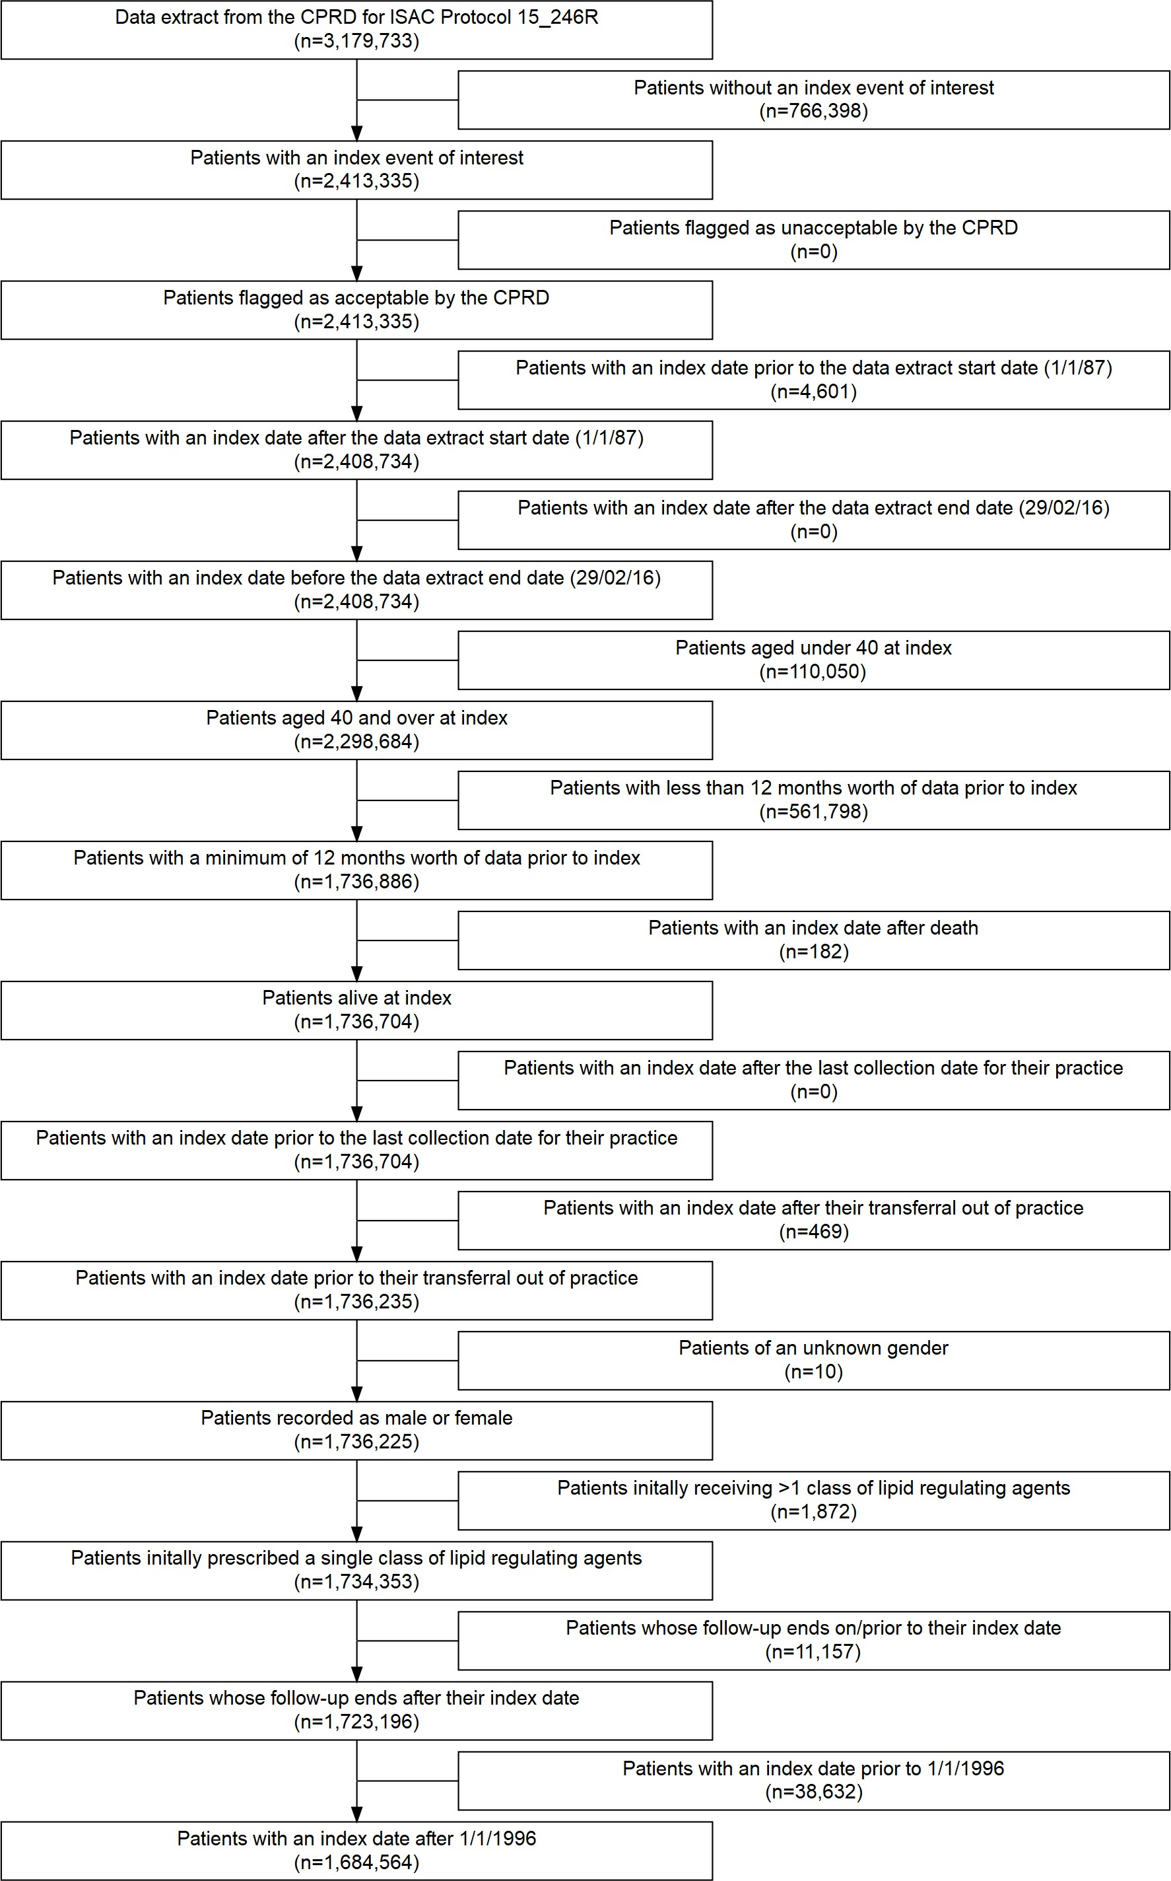

**Figure 5.4: Attrition of CPRD participants** - Patients were excluded from the study cohort for several reasons, and the number of patients excluded as each eligibility criterion was applied is shown above. Note that the largest cause of attrition was the absence of an index event of interest.

*126*

*5.3 - Results*

The median participant age at index was 57 years (inter-quartile range (IQR):48- 67years ) and participants were followed up for a median of 5.9 years (IQR:2.7- 9.7years ). During follow-up, an all-cause dementia diagnosis was recorded for 41,830 patients (12,647 probable AD, 9,954 possible AD, 8,466 vascular dementia,

10,763 other dementias).

The number of events, time-at-risk and crude rates for each drug class, tabulated by dementia outcome, are shown in Table 5.3. A substantial majority (98.1%) of participants prescribed a lipid-regulating agent were prescribed a statin. I excluded the “Ezetimibe and statins” (N =127) and “Nicotinic acid groups” (N = 165) classes from subsequent class-based subgroup analyses based on the extremely small number of participants in these groups. Note that the “Ezetimibe and statins” treatment group represent those prescribed a single treatment containing both ezetimibe and statins, rather than those where the two treatments were prescribed concurrently.

*127*

**Table 5.3:** Summary of number of events, years at risk and crude rates per 100,000 participant-years-at-risk stratified by dementia outcome and drug class of interest.

**Any dementia Possible AD Probable AD Vascular dementia Other dementia**

|  |  |  |  |  |  |  |  |  |  |  |
| --- | --- | --- | --- | --- | --- | --- | --- | --- | --- | --- |
| **Exposure Group** | **Events PYAR** | **Rate \*** | **Events PYAR** | **Rate \*** | **Events PYAR** | **Rate \*** | **Events PYAR** | **Rate \*** | **Events PYAR** | **Rate**  **\*** |

|  |  |  |  |  |  |  |  |  |  |  |  |  |  |  |  |
| --- | --- | --- | --- | --- | --- | --- | --- | --- | --- | --- | --- | --- | --- | --- | --- |
| **No LRA (unexposed) By drug class**  Statins  Omega-3 FAGs Fibrates Ezetimibe  BAS  Ezetimibe + Statins †  NAG | 18,608 | 5,872,717 | 317 | 6,368 | 5,818,047 | 109 | 2,637 | 5,800,964 | 45 | 4,813 | 5,811,594 | 83 | 4,790 | 5,808,285 | 82 |
| 22,920 | 4,871,568 | 470 | 6,190 | 4,758,526 | 130 | 5,773 | 4,753,437 | 121 | 5,871 | 4,755,258 | 123 | 5,086 | 4,747,237 | 107 |
| 19 | 8,034 | 236 | 4 | 7,927 | 50 | 7 | 7,950 | 88 | 4 | 7,938 | 50 | 4 | 7,925 | 50 |
| 141 | 38,003 | 371 | 49 | 37,102 | 132 | 21 | 36,835 | 57 | 36 | 37,001 | 97 | 35 | 36,983 | 95 |
| 32 | 6,604 | 485 | 8 | 6,429 | 124 | 7 | 6,425 | 109 | 12 | 6,444 | 186 | 5 | 6,393 | 78 |
| 106 | 36,370 | 291 | 28 | 35,808 | 78 | 19 | 35,726 | 53 | 26 | 35,768 | 73 | 33 | 35,808 | 92 |
| 0 | 986 | - | 0 | 986 | - | 0 | 986 | - | 0 | 986 | - | 0 | 986 | - |
| 4 | 1,403 | - | 0 | 1,379 | - | 2 | 1,391 | - | 1 | 1,389 | - | 1 | 1,382 | - |

**Total**

41,830 10,835,686 386

12,647 10,666,205 119

8,466 10,643,714 80

10,763 10,656,378 101

9,954 10,644,999 94

* Crude rate per 100,000 participant-years-at-risk

*5.3 - Results*

*128*

† One treatment containing both drugs, rather than the two classes being prescribed concurrently

**Abbreviations:** AD - Alzheimer’s disease; BAS - Bile acid sequestrants; LRA - Lipid regulating agent; NAG - Nicotinic acid groups; Omega-3 FGs - Omega-3 Fatty acid groups; PYAR - Participant-years-at-risk.

*5.3 - Results*

*129*

**Table 5.4:** Patient characteristics by drug class. Summary statistics are presented as “% (N)” unless otherwise specified in the variable name.

|  |  |  |  |  |  |  |  |
| --- | --- | --- | --- | --- | --- | --- | --- |
|  | **Whole Sample** | **None** | **Statins** | **Bile acid sequestrants** | **Ezetimibe** | **Fibrates** | **Omega-3 Fatty Acid Groups** |
| **Sample size (N)** | 1,684,564 | 1,087,704 | 585,528 | 5,396 | 763 | 3,889 | 992 |
| **Year of cohort entry (median)** | 2006 | 2007 | 2004 | 2005 | 2004 | 2001 | 2005 |
| **Female** | 53.0% (893174) | 56.2% (610950) | 47.1% (276043) | 66.4% (3585) | 54.5% (416) | 38.6% (1500) | 52.6% (522) |
| **Age at cohort entry (median)** | 57 | 54 | 62 | 57 | 60 | 58 | 56 |
| **CAD** | 0.4% (7133) | 0.1% (589) | 1.1% (6465) | 0.1% (6) | 0.9% (7) | 1.4% (53) | 1.3% (13) |
| **CBS** | 0.3% (5699) | 0.1% (682) | 0.8% (4926) | 0.1% (4) | 0.4% (3) | 2.0% (78) | 0.6% (6) |
| **CVD** | 2.1% (34899) | 1.1% (11619) | 3.9% (22977) | 1.6% (86) | 2.6% (20) | 4.4% (170) | 1.7% (17) |
| **Charlson (ever > 0)** | 30.6% (516135) | 25.1% (272642) | 40.7% (238403) | 42.5% (2292) | 41.7% (318) | 50.8% (1976) | 40.4% (401) |
| **IMD-2010 (median)** | 9 | 8 | 9 | 8 | 9 | 10 | 10 |
| **Consultation rate (mean/SD)** | 5.4 (5.4) | 5.0 (5.0) | 6.2 (6.1) | 8.6 (7.4) | 7.4 (6.6) | 7.1 (6.2) | 8.0 (8.0) |
| **Alcohol (ever)** | 85.9% (1447151) | 86.6% (941648) | 84.7% (496110) | 82.8% (4468) | 84.0% (641) | 82.9% (3223) | 82.0% (813) |
| **Smoking (ever)** | 51.1% (861355) | 47.1% (511826) | 58.6% (343074) | 55.2% (2978) | 57.5% (439) | 60.2% (2341) | 53.7% (533) |
| **BMI (mean/SD)** | 27.0 (5.3) | 26.7 (5.2) | 27.7 (5.3) | 26.8 (5.8) | 28.1 (5.7) | 29.0 (5.2) | 26.9 (5.5) |
| **PAD** | 0.7% (12613) | 0.4% (4039) | 1.4% (8424) | 0.9% (47) | 0.9% (7) | 1.9% (75) | 1.0% (10) |
| **Hypertension** | 16.0% (269804) | 11.5% (124604) | 24.4% (143101) | 12.8% (692) | 23.9% (182) | 25.8% (1002) | 15.7% (156) |
| **Total cholesterol (mean/SD)** | 5.7 (10.1) | 5.5 (6.4) | 6.2 (15.3) | 5.3 (1.3) | 7.1 (26.5) | 6.4 (5.6) | 5.6 (1.6) |
| **LDL cholesterol (mean/SD)** | 3.6 (4.9) | 3.4 (5.3) | 4.0 (3.7) | 3.1 (1.0) | 3.9 (1.1) | 3.3 (1.8) | 3.2 (1.0) |
| **CKD** | 0.1% (1295) | 0.1% (740) | 0.1% (545) | 0.1% (6) | 0.1% (1) | 0.0% (0) | 0.3% (3) |
| **Type 1 Diabetes** | 0.2% (4037) | 0.1% (785) | 0.5% (3196) | 0.3% (14) | 1.0% (8) | 0.8% (31) | 0.1% (1) |
| **Type 2 Diabetes** | 2.9% (48557) | 1.1% (11797) | 6.1% (35941) | 2.3% (123) | 5.4% (41) | 15.8% (614) | 2.8% (28) |

*Note:* The ’Nicotinic acid groups’ (n=165) and ’Ezetimibe and Statins’ (n=127) subgroups are not shown, but are included in the whole sample column

**Abbreviations:** BMI - Body mass index; CAD - Coronary arterial disease; CBS - Coronary bypass surgery; CKD - Chronic kidney disease; CVD - Cardiovascular disease; IMD - Index of multiple deprivation; LRA - Lipid regulating agent; PAD - Peripheral arterial disease; SD - Standard deviation.

*5.3 - Results*

The distribution of baseline characteristics across the remaining seven drug classes can be seen in Table 5.4. Note due to the experimental design, the median year of entry is expected to be later for those not prescribed an LRA, as this exposure group is more likely to include those who entered into the cohort towards the end of study window (as these people had less follow-up time in which to be prescribed an LRA).

The stopping, addition and switching of drug classes was common across all drug classes (Table 5.5).

**Table 5.5:** Participants who stopped, switched or added treatments by initial treatment type.

|  |  |  |  |  |  |  |  |  |
| --- | --- | --- | --- | --- | --- | --- | --- | --- |
|  | **Whole Sample** | **Statins** | **Bile acid seques- trants** | **Ezetimibe** | **Ezetimibe &**  **Statins** | **Fibrates** | **Nicotinic acid groups** | **Omega- 3 Fatty Acid Groups** |
| **Stopped** | 6.9% | 19.1% | 56.1% | 19.7% | 12.6% | 12.3% | 44.8% | 35.8% |
|  | (115899) | (111798) | (3028) | (150) | (16) | (478) | (74) | (355) |
| **Added** | 1.6% | 4.4% | 3.6% | 19.0% | 3.9% (5) | 21.6% | 3.6% (6) | 26.4% |
|  | (27441) | (25990) | (192) | (145) |  | (841) |  | (262) |
| **Switched** | 0.9% | 2.0% | 11.3% | 34.6% | 64.6% | 44.0% | 45.5% | 19.5% |
|  | (14935) | (11996) | (612) | (264) | (82) | (1713) | (75) | (193) |

**Defintions:** Stopped - last prescription of the primary drug class followed by at least six months of observation with no further prescriptions; Added - second drug class prescribed before the last prescription of the initial class; Switched - second drug class being prescribed after the last prescription of the initial class.

* + 1. Missing data

Full covariate information was available for 450,234 participants (26.7%). Six key variables had some missing data: IMD 2010 score was missing for 625,788 participants (37.1%), because it is only recorded for English practices; alcohol status was missing for 269,526 participants (16%); smoking status was missing for 84,424 participants (5%); BMI, or a calculated BMI from height and weight measurements, was missing for 266,672 participants (15.8%); baseline total cholesterol was missing for 119,675 participants (7.1%); and baseline LDL cholesterol was missing for 787,289 participants (46.7%).

*130*

*5.3 - Results*

* + 1. Primary analysis

The results of the primary analysis using the fully adjusted Cox proportional hazards model with participant age as the time scale are presented for each drug/outcome combination in Figure 5.5.

For each outcome, the overall “Any drug” estimate was driven by the statin subgroup, based on its large size relative to the other drug classes.

*131*

*5.3 - Results*

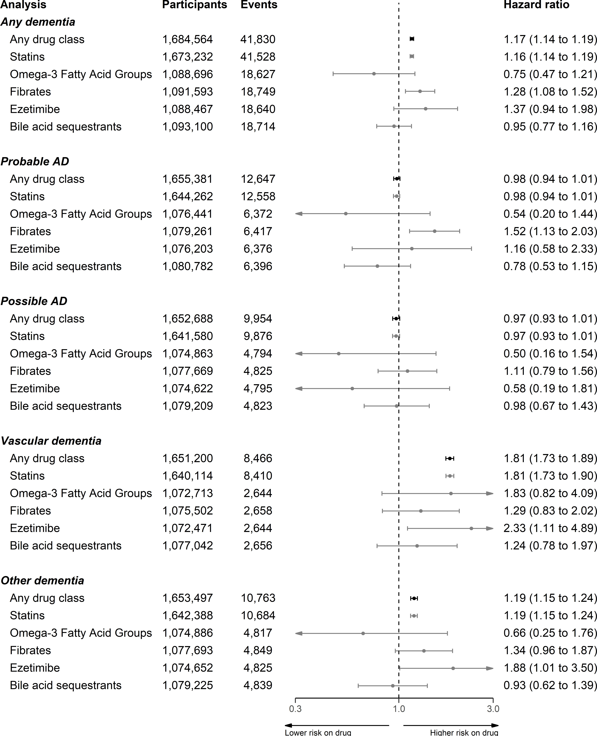

**Figure 5.5: Results from primary analyses of CPRD data** - Effect estimates obtained from the fully-adjusted time-varying model with participant age as the time scale, stratified by lipid-regulating agent and dementia outcome.

*132*

*5.3 - Results*

Alzheimer’s disease

My results show litte evidence was found for an effect of lipid-regulating agents on probable (HR:0.98, 95%CI:0.94-1.01) and possible (HR:0.97, 95%CI:0.93-1.01)

Alzheimer’s disease when compared to no treatment, with the sole exception of fibrates on probable Alzheimer’s disease (HR:1.52, 95%CI:1.13-2.03).

Non-Alzheimer’s disease dementias

In contrast to the findings for Alzheimer’s disease outcomes, an association between lipid-regulating agents and an increased risk of a subsequent diagnosis of vascular dementia (HR:1.81, 95%CI:1.73-1.89) or other dementias (HR:1.19, 95%CI:1.15-1.24) was observed. Again this effect was driven mainly by the statin subgroup, but there was some evidence that ezetimibe was associated with an increased risk of vascular (HR:2.33, 95%CI:1.11-4.89) and other (HR:1.88, 95%CI:1.01-3.5) dementia.

All-cause dementia

For the composite all-cause dementia outcome, I found treatment with a lipid- regulating agent was associated with a slightly increased risk (HR:1.17, 95%CI:1.14- 1.19), which lies between the associations for the Alzheimer and non-Alzheimer dementia outcomes as would be expected. There was also some evidence that fibrates were associated with increased risk of all-cause dementia (HR:1.28, 95%CI:1.08-1.52).

* + 1. Sensitivity analyses

The results of the series of sensitivity analyses performed are described in the following sections.

*133*

*5.3 - Results*

Complete case versus imputed data

In almost all cases, the use of imputed data resulted in a marginal attenuation of the effects observed when using a complete cases analysis. It should be noted that due to the large amount of missing data (e.g. 787,289 participants (46.7%) were missing a baseline LDL cholesterol measure), the number of participants included in the complete case analysis was substantially smaller than that included when using imputed data. In this case, though the overall position of the effect estimates does not change substantially when using the imputed dataset, there is a noticeable gain in power.297

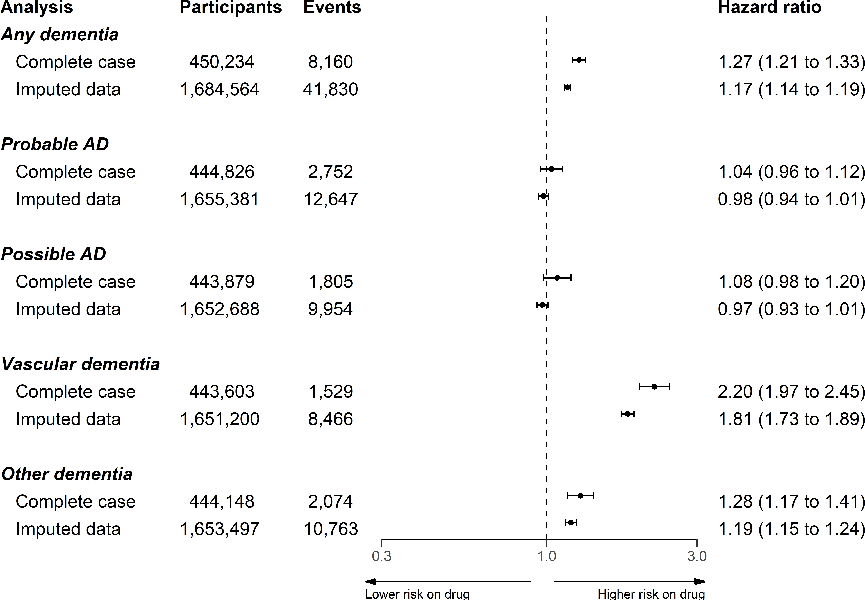

**Figure 5.6: Complete case vs. imputed data analysis** Comparison of analyses using the complete case versus imputed cohorts, indicating broad agreement between the two approaches. Note that the analyses using imputed data gave more precise estimates due to the low proportion of patients with complete covariate data.

*134*

*5.3 - Results*

Control outcomes

Following the primary analysis, the fully adjusted model was used to estimate the effect of treatment with a statin on the two control outcomes of back pain (negative) and ischemic heart disease (positive). The results of this analysis are presented in Figure 5.7.

For the negative control, there was some evidence that treatment with a statin was associated with an increased risk of back pain (HR: 1.04, 95%CI: 1.03-1.05), suggesting there may be some residual confounding. However, statin prescription was also associated with a substantially increased risk of ischemic heart disease (HR: 1.62, 95%CI: 1.59-1.64) and Type 2 diabetes (HR: 1.50, 95%CI: 1.48-1.51).

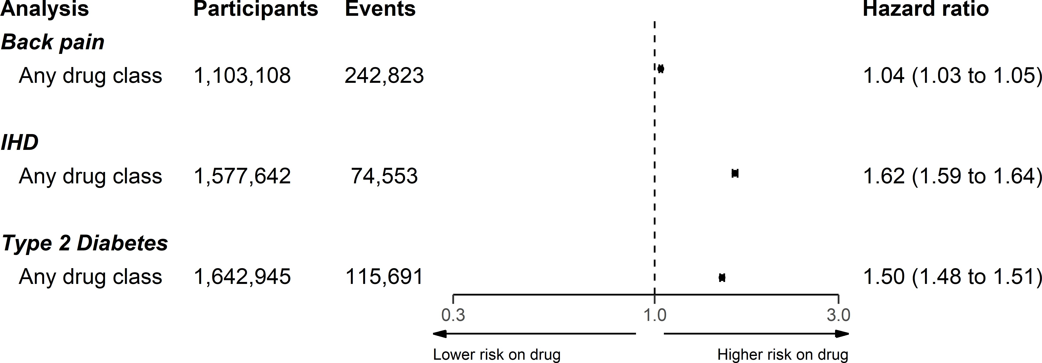

**Figure 5.7:** Results of control outcome analysis.

Impact of additional covariates

The results of three models adjusted for age only, age and sex, and the full covariates respectively, are presented in Figure 5.8. These models were used to estimate the impact of adjustment for additional covariates. Note that obtaining a completely unadjusted model is not possible, as age was used in the Cox model as the time scale.

*135*

*5.3 - Results*

Adjustment for additional covariates beyond age and sex had a limited impact on the observed effect estimates, with the exception of the probable AD outcome. In this case, adjustment for the full set of covariates attenuated to the null the protective effect observed when adjusting only for age and sex.

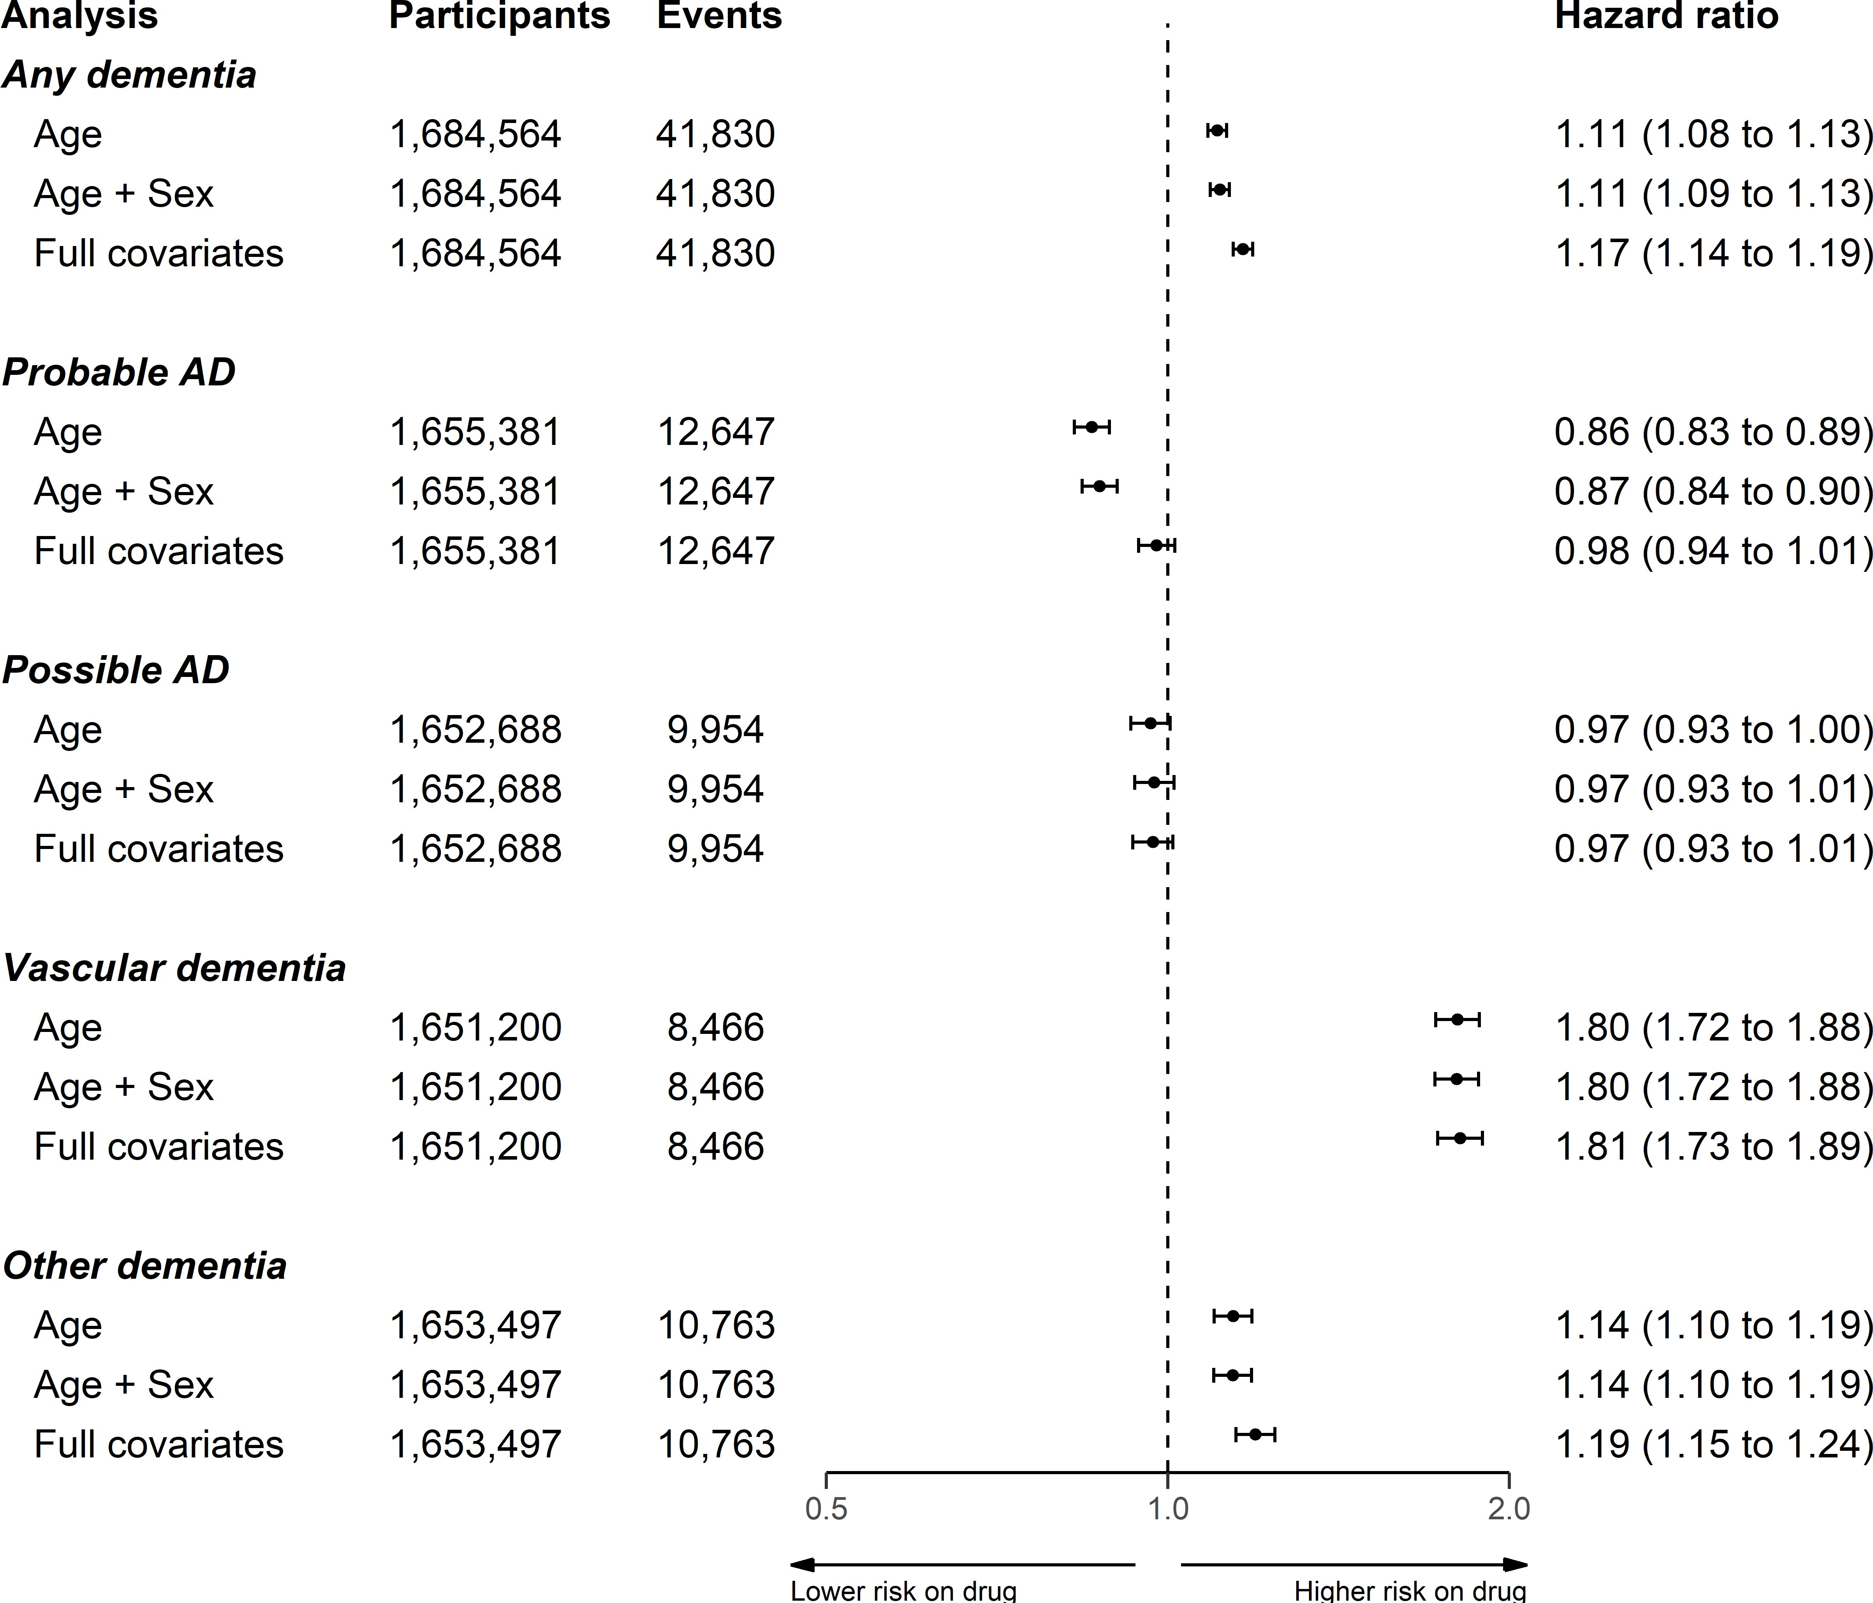

**Figure 5.8:** Results of three models adjusting for a different set of covariates. Note that the x-axis cutoffs (0.5,2) are different compared to other plots (0.3,3) to enable greater comparison between the different models.

Sensitivity cohorts: Entry year

When stratifying based on year of entry to the cohort, I observed no variation in risk by time period in any subgroup except for probable Alzheimer’s disease (Figure 5.9).

*136*

*5.3 - Results*

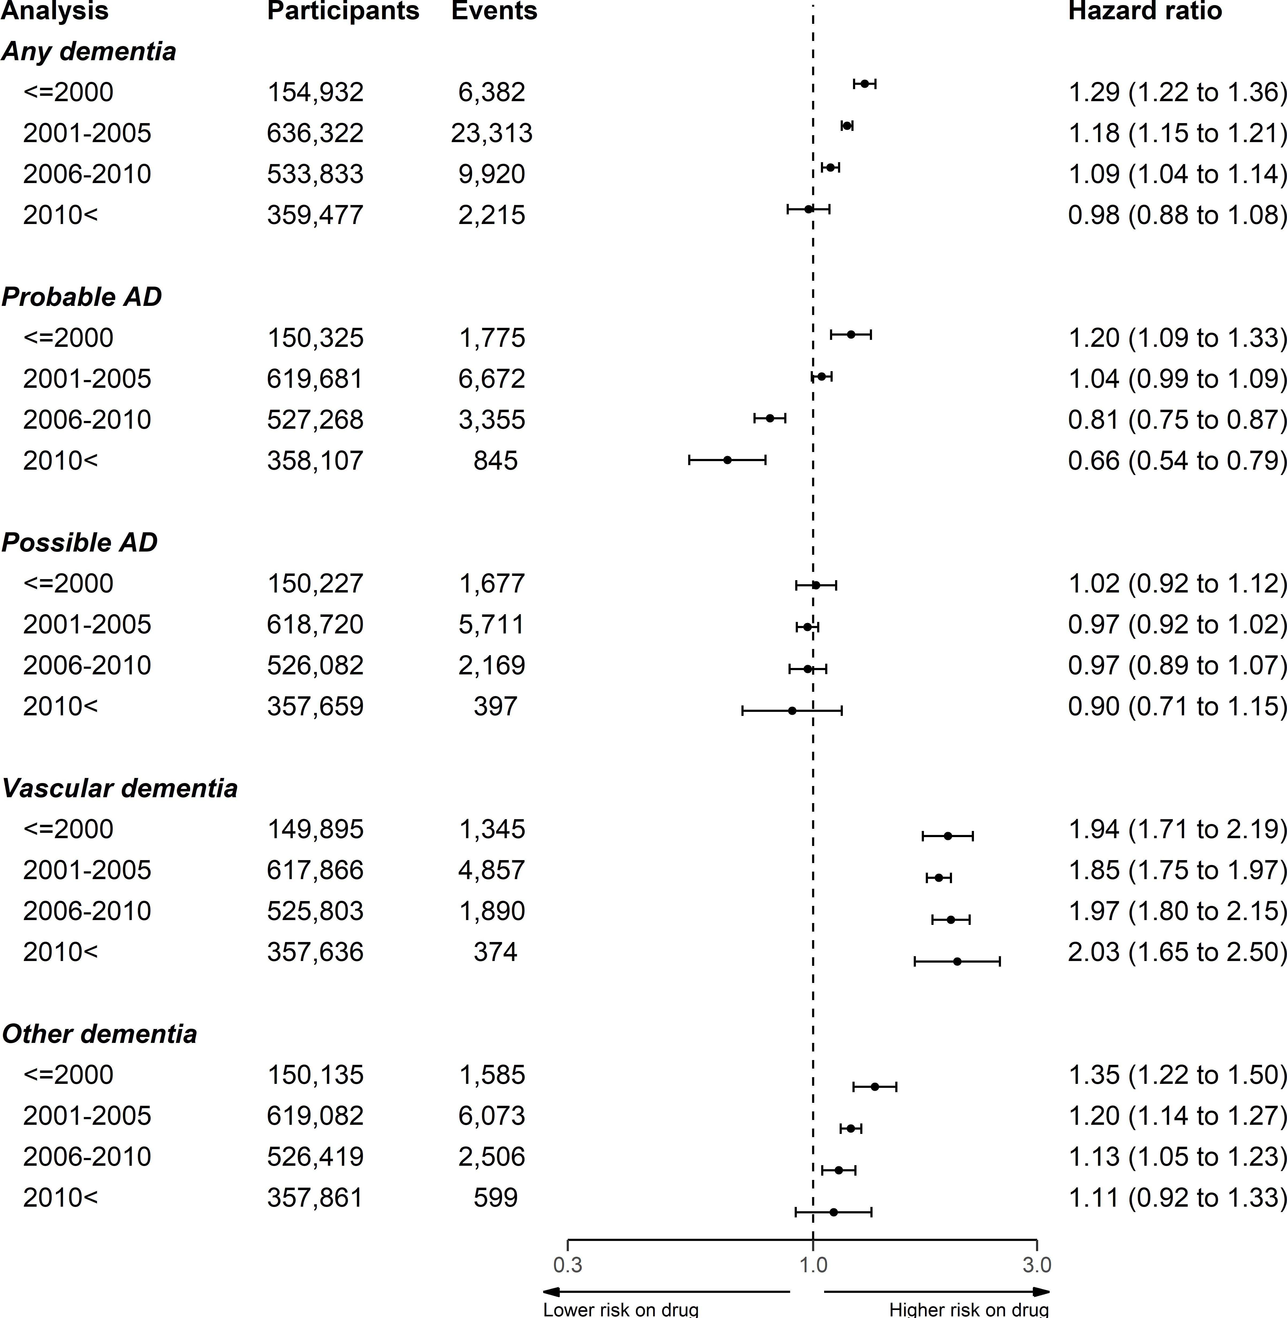

**Figure 5.9:** Analysis of any lipid-regulating agent on probable AD outcome, stratified by grouped year of cohort entry.

On the assumption that this variation could be caused by changes in the frequency of probable AD diagnoses in the cohort over time, I performed a *post-hoc* investigation of the frequency of each dementia outcome by year of entry (Table 5.6). While the frequency of outcomes declines in more recent strata, likely due to the limited follow-up inherent to these groups, this decline in frequency is relatively constant

*137*

*5.3 - Results*

across the dementia subtypes.

**Table 5.6:** Frequency of diagnoses by grouped year of cohort entry

|  |  |  |  |  |  |  |
| --- | --- | --- | --- | --- | --- | --- |
| **Year of cohort entry** | **No dementia** | **Probable AD** | **Possible AD** | **Vascular dementia** | **Other dementia** | **Total** |
| <=2000 | 148550 | 1775 (1.1%) | 1677 (1.1%) | 1345 (0.9%) | 1585 (1.0%) | 154932 |
|  | (95.9%) |  |  |  |  |  |
| 2001-2005 | 613009 | 6672 (1.0%) | 5711 (0.9%) | 4857 (0.8%) | 6073 (1.0%) | 636322 |
|  | (96.3%) |  |  |  |  |  |
| 2006-2010 | 523913 | 3355 (0.6%) | 2169 (0.4%) | 1890 (0.4%) | 2506 (0.5%) | 533833 |
|  | (98.1%) |  |  |  |  |  |
| 2010< | 357262 | 845 (0.2%) | 397 (0.1%) | 374 (0.1%) | 599 (0.2%) | 359477 |
|  | (99.4%) |  |  |  |  |  |
| Total | 1642734 | 12647 | 9954 (0.6%) | 8466 (0.5%) | 10763 | 1684564 |
|  | (97.5%) | (0.8%) |  |  | (0.6%) |  |

Sensitivity cohorts: Pregnancy

In the second sensitivity cohort, removing patients who may have been pregnant (coded as aged 55 and under at index) from the analysis had minimal effect on the effect estimates (Figure 5.10).

*138*

*5.3 - Results*

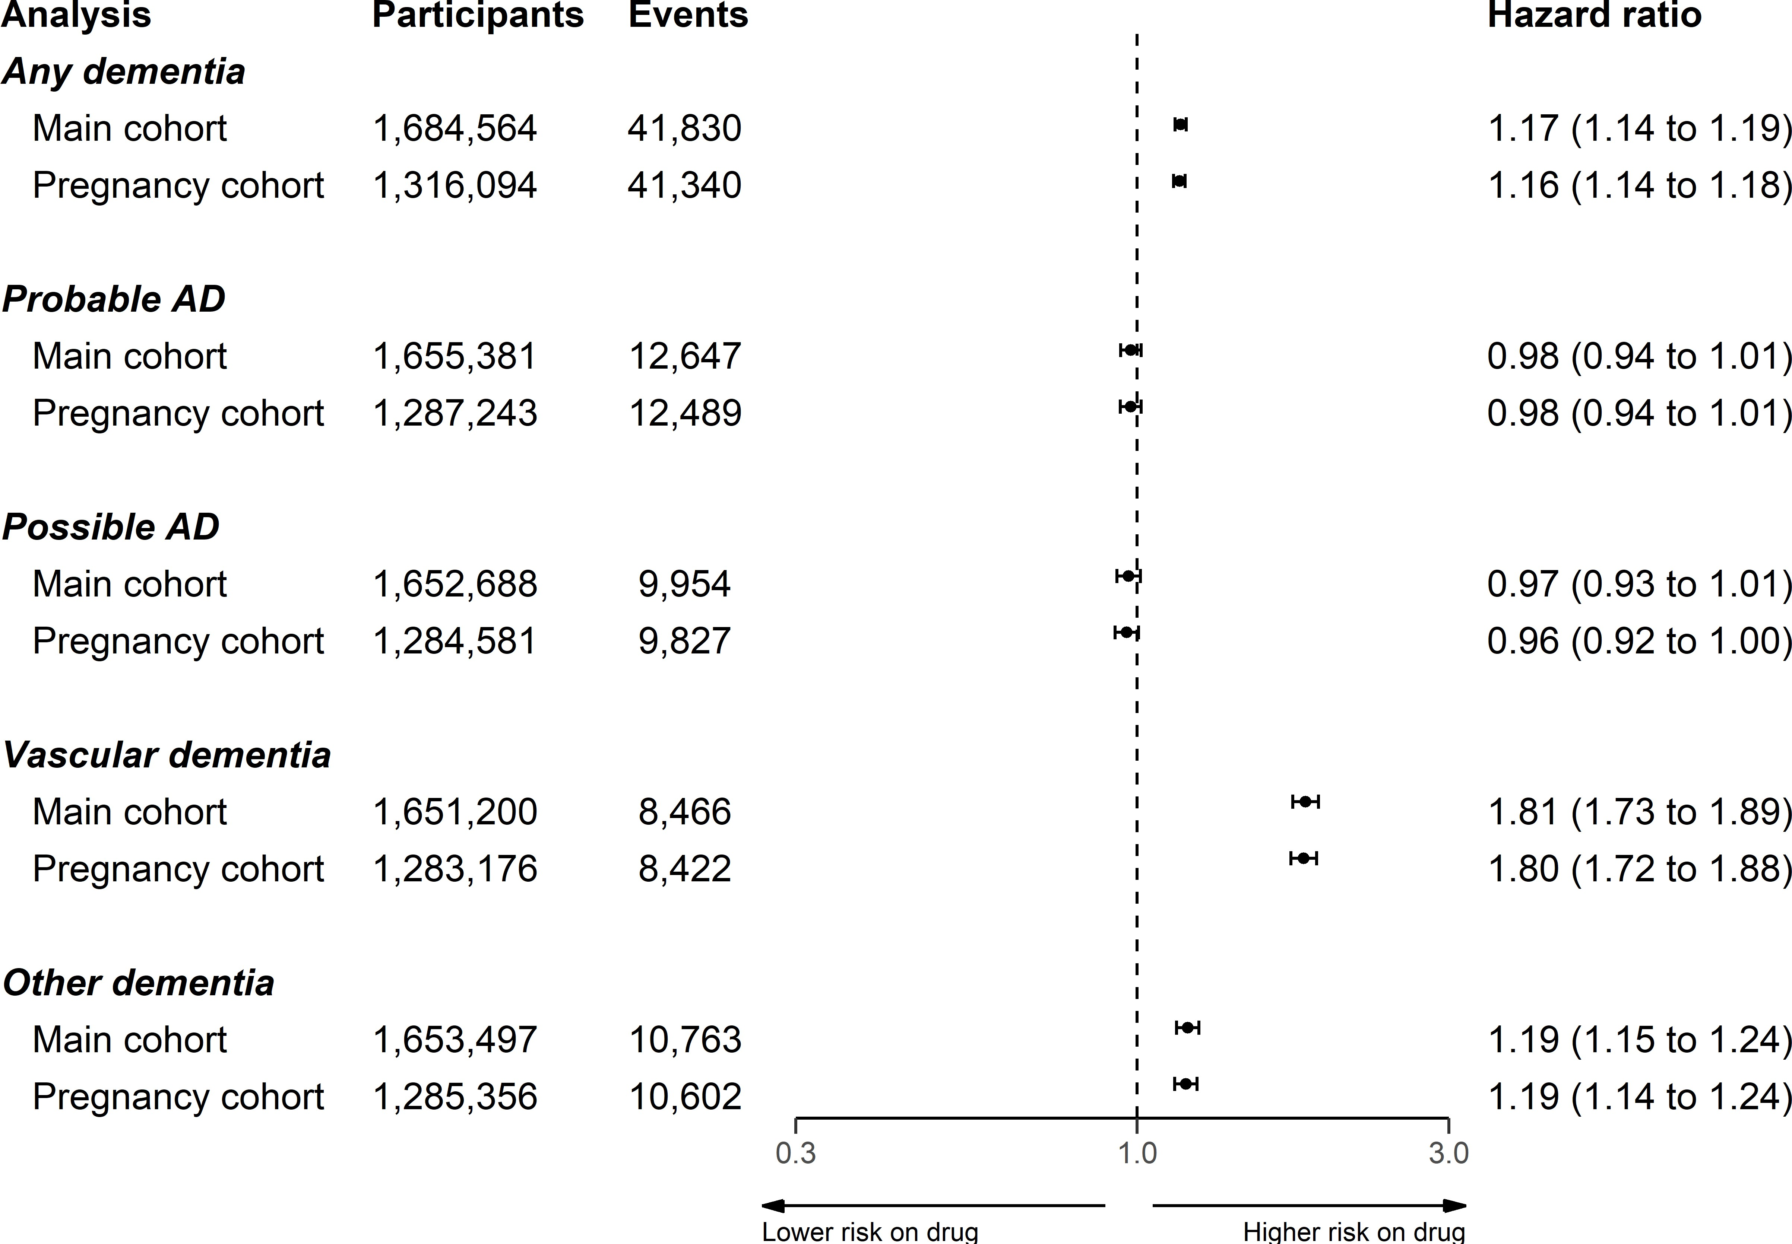

**Figure 5.10:** Comparison of analysis using main cohort and a cohort with potentially pregnany women removed.

Statin properties

In the cohort, statins with lipophilic properties were much more frequently prescribed than hydrophilic statins (Table 5.7). Additionally, there is evidence for an increasing tendency to favour hydrophilic statins in recent years with the proportion of lipophilic statins prescribed falling from 18.2% in 1996-2000 to <1% in 2011-2016.

**Table 5.7:** Summary of statin properties (lipophilicity vs hydrophilicity) by grouped year of prescription.

|  |  |  |  |
| --- | --- | --- | --- |
| **Prescription Year Group** | **Hydrophilic** | **Lipophilic** | **Total** |
| <=2000 | 7037 (18.2%) | 31531 (81.8%) | 38568 |
| 2001-2005 | 21427 (10.3%) | 187018 (89.7%) | 208445 |
| 2006-2010 | 3566 (1.6%) | 217726 (98.4%) | 221292 |
| 2010< | 1115 (0.9%) | 119035 (99.1%) | 120150 |

*139*

* 1. *- Results*

When stratifying by statin properties, hydrophilic statins were less harmful in the any, vascular and other dementias outcomes compared to lipophilic statins (Figure 5.11). Additionally, in the AD outcomes, hydrophilic statins were associated with a small reduction in risk, compared to the weak evidence for an effect for lipophilic statins.

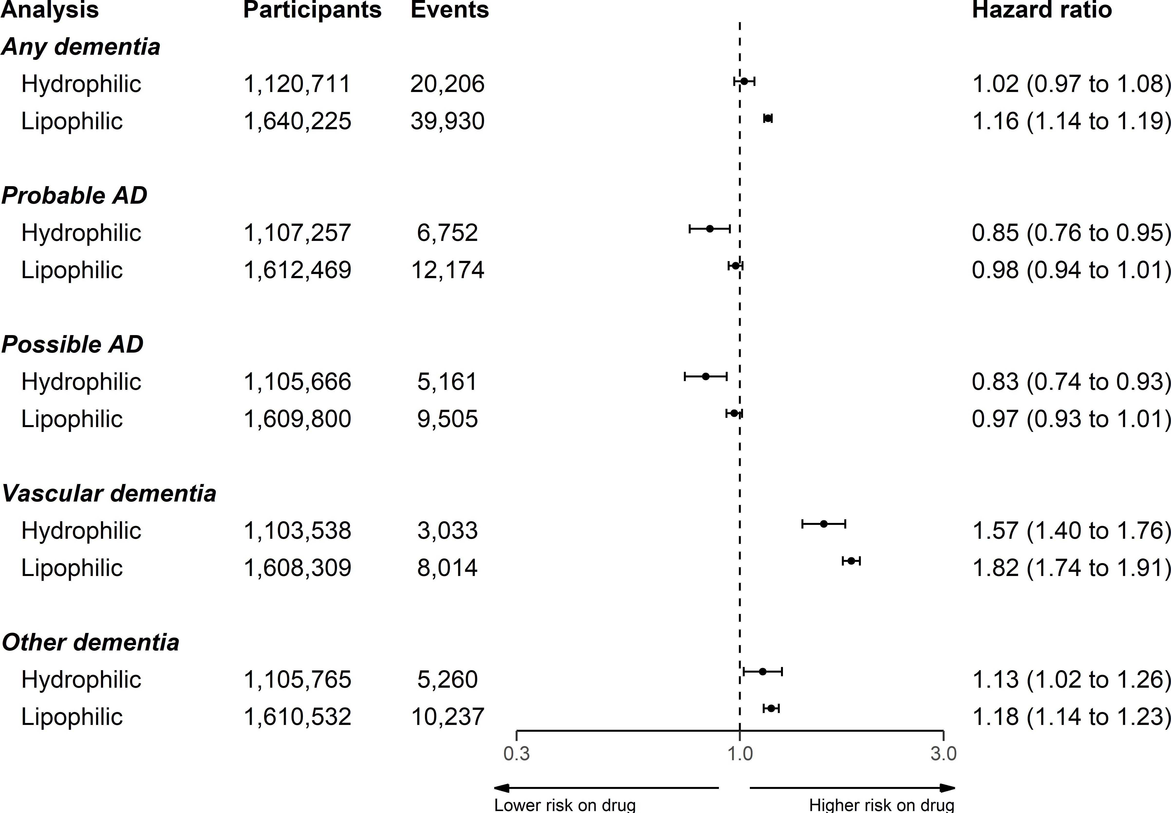

**Figure 5.11:** Analysis stratified by statin properties (hydrophilic vs lipophilic)

Impact of dementia code lists

When using the Smeeth *et al.* code lists to define dementia outcomes, effect estimates of HR: 1.19 (95%CI: 1.07-1.32) and HR: 1.33 (95%CI: 1.26-1.42) were obtained

for the Alzheimer’s disease and non-Alzheimer’s (“other”) dementia outcomes, respectively. While direct mapping to the outcomes used in this analysis was

*140*

*5.4 - Discussion*

not possible, the most comparable are probable Alzheimer’s disease (HR:0.98, 95%CI:0.94-1.01) and other dementia (HR:1.19, 95%CI:1.15-1.24).

### Discussion

* + 1. Summary of findings

Lipid-regulating agents showed little evidence of an association with probable and possible Alzheimer’s disease when compared to no treatment, but were associated with increased risk of an all-cause dementia, vascular dementia and other dementias diagnosises. The estimate observed in each case was driven by the effects observed statin subgroup, as a substantial majority of participants prescribed an LRA were presribed a statin. For the other drug classes, no association was found with any outcome, with two exceptions. Ezetimibe was associated with increased risk of vascular and other dementias, while fibrates were associated with increase risk of all-cause dementia and probable Alzheimer’s disease.

The effect estimates were robust to the exclusion of potentially pregnant participants, and for all outcomes except probable AD, no variation across grouped year of entry was observed. When looking at the statin subgroup alone, statin properties appeared to have a modifying effect, with hydrophilic statins being less harmful in the any, vascular and other dementias outcomes compared to lipophilic statins.

* + 1. Interpretation of results

This section will expand on a potential explanation for the observed results detailed above. However, as the comparison of evidence across different sources is the aim of the triangulation exercise presented in later chapters, a detailed comparison with other published literature will not be provided here, except where needed to illustrate

*141*

*5.4 - Discussion*

a methodological point. For a detailed comparison of the result presented above with the existing evidence base identified by the systematic review, see Chapter 7.

Confounding by indication

A likely explanation for the observed increased risk of dementia outcomes with a vascular component (e.g. vascular and other dementias) with lipid-regulating agent use, and an important limitation of this analysis, is residual “confounding by indication”. While the term has been used to describe different sources of bias in epidemiological analyses,312 it is used here to described the role of risk factors that both prompt treatment and increase the risk of the outcome, thus causing a distorted positive association between the treatment and outcome (see Figure 5.12). In causal inference nomenclature, statins and dementia are said to be *d*-connected, as there is an open “backdoor” path between them via the uncontrolled confounders.313 In the context of this analysis, this means a confounding variable (or, more likely, variables) both prompts prescription of statins and also represents a risk factor for the development of the vascular dementia. A similar confounding structure likely exists for ezetimibe, another hypercholesterolemia treatment, providing an explanation for the association of vascular/other dementia but not Alzheimer’s disease with this drug.

*142*

*5.4 - Discussion*

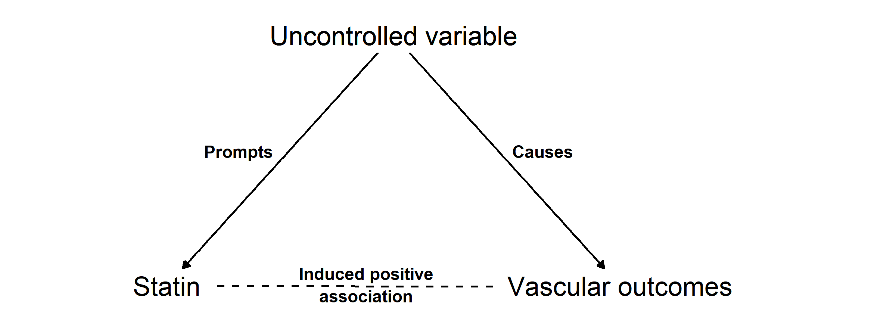

**Figure 5.12:** Causal diagram (directed acyclic graph) illustrating how confounding by indication could induce a positive association between statins and vascular dementia.

Conditioning entry into the study on being either “at-risk” or already diagnosed with hypercholesterolemia was employed in a pre-emptive attempt to mitigate confounding by indication, but evidence from the control outcomes suggests this was unsuccessful. The slight harmful effect for the backpain outcome is substantially smaller than that observed for the ischemic heart disease outcome, indicating that the majority of the uncontrolled confounding is likely related to vascular factors. The slight effect observed for the negative control of backpain could be due to incomplete control for socioeconomic status, as deprivation data was provided in twentiles to preserve patient privacy.314,315

In line with this, an increasingly harmful effect is observed when moving from the probable and possible Alzheimer’s disease outcomes to the other dementia outcome, and finally to the vascular dementia outcomes. This pattern suggests that the strength of the residual confounding by indication increases as the proportion of cases with a vascular component in an outcome definition increases. Given confounding related to vascular factors, this pattern is also expected given the decision tree for assigning outcomes in the presence of greater than one dementia code. Under this system, the Alzheimer’s disease outcomes require a “pure” condition and the presence of any vascular or other dementias codes excludes participants from this group (Figure 5.1).

*143*

*5.4 - Discussion*

A review of other available literature suggests that this observation (a harmful effect of lipid-regulating agents on vascular-related outcomes) is not unusual. Using a conventional epidemiological technique, a previous analysis also found an increased risk of coronary heart disease (analogous to the ischemic heart disease outcome used in this analysis) in those taking statins (HR: 1.31, 95%CI: 1.04-1.66).316 Controlling for confounding by indication in that study through the use of a trial emulation analysis gave an estimate of 0.89 (95%CI: 0.73-1.09), a comparable though less precise estimate to that observed in RCTs of statin use (0.73, 95%CI: 0.67-0.80).317

Given the absence of vascular dementia in the published literature, as highlighted in the previous chapter, the unexpected increase in vascular dementia risk with statin use is particularly interesting. It is possible that this finding reflects publication bias if previous research encountered similar methodological issues to this analysis, and these results did not make it into the evidence base as unexpected or assumedly incorrect results are less likely to be submitted or accepted for publication.

Statin properties

This analysis found that hydrophilic statins were less harmful in the any, vascular and other dementias outcomes compared to lipophilic statins, and were associated with a small reduction in the risk of the probable and possible AD outcomes. The relative precision of the estimates in each group is expected, as the two most commonly prescribed statins are lipophilic (simvastatin and atorvastatin).318

A widely discussed concept in the literature surrounding statin use and cognitive outcomes is the fact that lipophilic statins are more likely to be able to cross the blood brain barrier, and so have a more potent protective effect by directly lowering brain cholesterol.319 My findings that hydrophilic statins appear to be more protective/less harmful than their lipophilic counterparts runs counter to this assertion.

An initial interpretation of the different associations observed in the two groups was that the lipophilic statins may be more potent, and so are prescribed to patients with

*144*

*5.4 - Discussion*

a higher underlying vascular load, leading to increased confounding by indication in this group. However, the statin with the strongest lipid lowering effect that is available via the NHS, rosuvastatin, is hydrophilic.

Impact of code lists

As part of a sensitivity analysis exploring the impact of outcome code-lists, I used definitions for Alzheimer’s disease and other dementias obtained from a previously published paper (Smeeth *et al.*).213 Using these lists in my analytical set-up, I found a harmful association of statin use with both outcomes.

This finding disagrees with the results of the original analysis, which found evidence for a protective effect of statin use on all-cause dementia (HR: 0.81, 95%CI: 0.69- 0.96) and non-AD dementia (HR: 0.82, 95%CI: 0.69-0.97), but little evidence of an effect on AD (HR: 0.81, 95%CI: 0.49-1.35).

However, comparison of the results obtained using the two sets of code lists was deemed less useful following a detailed comparison of the codes used. While all of the codes used to define Alzheimer’s in the Smeeth *et al.* paper are included in the probable Alzheimer’s code-list (see Figure 5.13), I included several additional codes used to define this outcome (including, for example, “Eu00013: [X]AD disease type 2”). Additionally, several of the codes used to define “Possible Alzheimer’s” in this analysis are included in the “Other dementia” code list used by Smeeth.

*145*

*5.4 - Discussion*

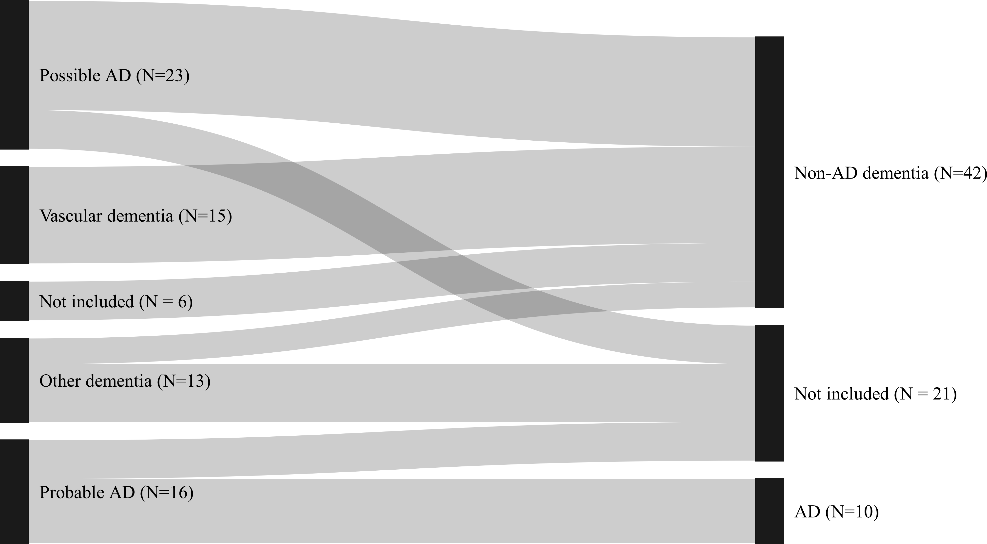

**Figure 5.13:** Sankey diagram comparing the codes used in this analysis with those used in the Smeeth *et al* paper.213 The outcomes and number of codes contributing to each are presented (the Smeeth *et al* outcomes are on the right hand side of the figure). The joining lines showing the overlap between the categories in the two analyses.

This analysis serves to illustrative the importance of the code lists chosen to define the outcomes of interest, particularly if they are used to define competing outcomes (e.g. AD vs non-AD dementia). This different codes used by Smeeth *et al.*, in addition to an analytical approach that adjusted for covariates defined after the index date, may go some way to explaining why my analysis obtained different results despite the substantial overlap in the data sources used.

* + 1. Strengths and limitations

The primary strength of this analysis is the relative size of the CPRD and length of follow-up. Having reviewed the existing literature, as identified by the systematic review element of this thesis, this analysis of 1,684,564 participants is one of the largest available studies of this research question. Additionally, this analysis followed LRA users and non-users from a common index date, using a time-updating

*146*

*5.4 - Discussion*

treatment indicator to correctly assign time-at-risk to the exposed and unexposed groups. This approach has been less commonly used in the literature and allows for the mitigation of potential immortal time bias. Finally, it is one of the few that provide evidence on the association of lipid-regulating agent use and vascular and other dementias, and used negative and positive controls to assess the potential for residual confounding.

However, the findings of this analysis are subject to several limitations in addition to the confounding by indication discussed above. There is a strong possibility of differential misclassification of dementia-related conditions based on the exposure.320 As an illustrative example, those with memory complaints may be more likely to be classified as vascular dementia than Alzheimer’s disease if their medical records contain prescriptions for lipid-regulating agents. Further, there is potential for general non-differential misclassification of the outcome due to the varying positive predictive value of electronic health record code lists to identify dementia cases.278,279

Misclassification of outcomes is not the only issue introduced by the use of EHR codes to define outcomes. Comparing and contrasting between different studies is particularly difficult because of the impact that the use of different code lists can have on the analysis. This problem is illustrated by the discrepancy between the results when using the code lists defined for this study and those used by Smeeth *et al*. This presents a particular challenge in comparing research across different time-periods and coding systems, particularly the unexpected results I obtained for the vascular and other dementias outcomes.

A further limitation stems from the possibility of uncontrolled confounding due to genetic factors. The number of *ApoE* 4 alleles represents the strongest genetic risk factor for Alzheimer’s disease, but also substantially increases LDL cholesterol levels,321 potentially prompting treatment with a statin or other lipid regulating agent. I was unable to control for *ApoE* genotype in this analysis as I did not have access to genetic data on participants. As a result, any protective association

*147*

*5.4 - Discussion*

between LRA use and the Alzheimer’s disease outcomes may be masked by residual negative confounding by *ApoE* .

Finally, as with many studies of dementia, there is a risk of reverse causation in my analysis. Dementia and associated conditions have a long prodromal period, during which preclinical disease could cause indications for the prescription of a lipid-regulating agent. Enforcing a minimum period of follow-up would address this limitation, but the use of a time-varying treatment indicator in this analysis prevents the use of this approach (see Appendix A.5.2 for a fuller discussion of this topic).

* + 1. Enabling easy synthesis of this analysis

The raw data supporting this analysis is not publicly available, as access to the CPRD data is controlled by a data monitoring committee. However, when data are not readily available, sharing the analysis code and summary statistics represents a way for readers to validate the findings.136

In light of this and my own experiences in attempting to extract information for papers assessing preventative treatments, as documented in Section 4.5.5, the outputs from this analysis have been made readily available. All code, Read code lists and summary statistics (namely the tables presented in this chapter plus summary tables of effect estimates) can be downloaded in a machine readable format from the archived repository for this project (Zotero DOI: **TBC**). This open approach should enable easy inclusion of this analysis in future evidence synthesis exercises, allowing new work to build on that presented here.

* + 1. Summary
* In this chapter, I produced new evidence on the association of lipid-regulating agents with incidence of all-cause dementia, Alzheimer’s disease, vascular

*148*

*5.4 - Discussion*

dementia, and other dementia.

* + I found little evidence for an effect of lipid-regulating agents on probable or possible Alzheimer’s disease. However, lipid-regulating agent use was associated with an increased risk of all-cause, vascular and other dementias. In all cases, the estimated associations for the any LRA analysis were largely due to those those observed in the large statin subgroup.
  + I attempted to account for important sources of bias through use of time- varying treatment indicator, though the control outcomes included in the analysis provided evidence for only partially controlled confounding by indi- cation related to vascular factors. Additionally, there was the potential for differential misclassification of dementia subtype on the basis of the exposure. Combined, these biases reduce the confidence in my findings, in particular the unexpected increase in risk of vascular dementia associated with statin use.
  + Findings from this analysis are used as an additional source of evidence in the triangulation exercise presented in Chapter 8.

*These particular systematic reviews [individual partic- ipant data reviews] remain yardsticks against which the quality of other reviews continues to be judged.*

— Ian Chalmers, 1993322

# 6

## Individual participant data meta-analysis of blood lipid levels and dementia

outcomes

**Contents**

**Lay Summary** **150**

* 1. **Introduction** **150**
  2. **Methods** **151**
  3. **Results** **157**
  4. **Discussion** **169**
  5. **Summary** **177**

*6.1 - Introduction*

### Lay Summary

Individual participant data (IPD) meta-analyses are a special type of meta- analysis in which the authors of relevant studies are contacted with requests to access the raw data on each participant in the original study. This approach is different to the meta-analyses presented in the previous chapter, which used published summary results.

In order to examine the relationship between lipid levels and dementia risk, I applied for access to 37 unique data sources containing information on these variables. However, only a small proportion of these data sources (n = 3, 8.1%) provided the requested access.

The resulting analysis of these data sources did not suggest a relationship between any blood lipid and any dementia outcome. The sole exception was an increased risk of vascular dementia in those with higher triglyceride levels. In addition, the participants age and sex did not appear to influence the relationship of lipid fractions and dementia outcomes.

The reasons for the low response rate to requests for data are explored in this chapter. Finally, I suggest future studies to investigate how data access rates could be improved.

### Introduction

Individual participant data (IPD) meta-analyses are considered to be the gold standard form of evidence synthesis, allowing for the application of a common selection model and analytical approach across all identified cohorts.92 They are particularly useful when investigating the impact of participant-level characteristics, something that is not possible with aggregate data unless the results are stratified by the characteristic of interest.92,323 Knowledge of which groups a treatment will benefit most (or harm least) is a core aim of the move towards personalised medicine.98,324 IPD analyses also offer a mechanism by which previously unanalysed datasets can be incorporated into an analysis, thus expanding the evidence base for a particular research question.

*152*

*6.2 - Methods*

Previous work has suggested a difference in the effect of lipids on dementia risk based on participant age and sex,59,220 though the systematic review presented in Chapters 3 & 4 did not identify strong evidence for an effect of sex or age at lipid measurement on the relationship between lipids and dementia. However, the number of included studies in the lipid fraction meta-analyses was small, due to both the relatively small number of studies reporting on the lipids exposure and the poor reporting of summary statistics of participant characteristics in those that did. Additionally, best practice guidance recommends against basing the decision to perform an IPD meta-analysis on the between-study heterogeneity in a summary data meta-analysis, as similar distributions of participant covariates across studies may mask a true effect.98

As such, the aims of this analysis are two fold: firstly, to perform an IPD meta- analysis across identified cohorts to examine the impact of participant age-at- measurement and sex on the relationship between lipids and dementia risk; and secondly, to expand the evidence base for the effect of lipids on dementia outcomes by obtaining estimates from previously unanalysed cohorts available via the Dementia Platform UK, a large consortium of dementia cohorts.

### Methods

* + 1. Eligibility criteria

Study design

Eligible data sources for this analysis were prospective cohort studies (see Section

* + 1. for details on how these studies were identified). Data sources which were cross-sectional, either by design or due to the available data (e.g. a study recorded data on participants at multiple time-points or “waves”, but only data from a single wave could be accessed) were excluded. Similarly, due to the time and cost

*153*

*6.2 - Methods*

restraints within the scope of my thesis project, studies making use of population- level electronic health records were ineligible. These studies are problematic in that they often require extensive project proposals in order to gain access to the data.

No restrictions were put on the number of participants or the length of follow-up, though it was a requirement that participants were dementia free (or assumed to be dementia free, based on age at entry) at baseline.

Exposures/outcome definition

I considered four blood lipid fractions as part of this analysis, namely: total choles- terol (TC), low-density lipoprotein cholesterol (LDL-c), high-density lipoprotein cholesterol (HDL-c) and triglycerides (TG). Cohorts were eligible for inclusion if they contained data on at least one of these recorded as a continuour variable (i.e. studies with binary “hypercholesteromemia” would be excluded).

In line with the analyses presented in other chapters, eligible cohorts were those containing data on at least one outcome of interest, namely: all-cause dementia, Alzheimer’s disease, or vascular dementia.

* + 1. Applying for data access

Potentially eligible data sources as defined above were identified via two mechanisms, each with a distinct focus. For both approaches, the number of cohorts responding to the request for data access and, where applicable, the reasons given for a refusal were recorded.

*154*

*6.2 - Methods*

Cohorts identified by the systematic review

The first approach focused on previously analysed observational prospective cohort studies examining the effect of blood lipid levels on dementia outcomes, as identified by the systematic review presented in Chapters 3 & 4. The data sources used in each of these cohort analyses were screened against the criteria listed in the previous section, and eligible cohorts were approached for data access. In the first instance, the first/corresponding author of the publication was emailed in Autumn 2020. If this approach did not elicit a response within two months, the last author was contacted, on the basis that the first/corresponding author may have been a more junior member of the research group who had moved to a different institution.

Cohorts contained in Dementia Platform UK

The second approach focused on incorporating relevant, previously-unanalysed data into the analysis, thus providing additional evidence on the relationship between blood lipids and dementia risk. This was achieved through the Dementia Platform UK (DPUK), a collaborative grouping of existing dementia cohorts established by the MRC which works with data owners to make their data readily accessible for secondary analysis.108 It provides access to 42 cohorts with over 3 million participants, and makes use of a central streamlined application process for all cohorts with the intent of making it easier to access data from existing data sources.

Cohorts included in the DPUK were assessed against the eligibility criteria, and in Autumn 2020, an application for access to a subset of 17 cohorts was made via the common-access procedure.

*155*

*6.2 - Methods*

* + 1. Primary analysis

Data cleaning and harmonisation

Where data on one of the exposures (TC, LDL-c, HDL-c, TG) was missing, it was inferred from the other three fractions (where available) using the Friedwald formula (Equation (1.1)). Lipids levels were retained as continuous variables rather than dichotomising into a binary hypercholesterolemia exposure, given the additional statistical power this adds to the meta-analysis.98,325 Where lipid measurements were reported in *mg/dL*, these were converted to *mmol/L*.

Across all cohorts, data cleaning was performed in a similar manner, standardizing to commonly named variables so that a single model could be applied using functional programming.326 The advantage of this approach is that it reduces the likelihood of errors in model mis-specification if changes are required in variables names from cohort to cohort. Following data cleaning, summary statistics for each data source were calculated and compared with publicly available statistics to ensure no errors were introduced in the data cleaning process, in line with best practice.327

Covariate definition

A range of additional variables were included in the analysis, intended to address the potential for confounding. With an awareness that discrepancies in available covariates is a common issue in IPD studies, I defined an idealised set of covariate domains to be age, sex, education, BMI, *ApoE* 4 status, smoking/alcohol status, ethnicity, and prevalent diabetes or cardiovascular disease. This set covers key risk factors for dementia/Alzheimer’s disease in addition to general cardiovascular risk factors. Details on how these variables were coded, given the available data, are presented in Section 6.3.3.

*156*

*6.2 - Methods*

Missing data

Missing data in this analysis was classified as either relating to missing values (a data on a variable of interest was available in a cohort, but some values were missing) or missing variables (a cohort did not collect data on a variable of interest). Variables with missing values were identified, and 20 imputed datasets were created.297 Imputation was performed using the MICE (Multiple Imputation by Chained Equations) using the mice package in R.

Missing variables were originally intended to be addressed using a previously published method.328 Here, the correlation between the fully-adjusted and partially- adjusted estimate in cohorts with the full set of covariates is used to estimate the fully-adjusted effect in those cohorts missing covariates. However, this method requires several large cohorts to contain the full set of covariates, a condition this analysis failed to meet given the very low response rate. As such, two other common approaches were employed.328 In the primary analysis, all cohorts were adjusted for the set of common covariates across cohorts (Model 1: age, sex, smoking, alcohol, diabetes). As a sensitivity analysis, cohorts with the full complement of covariates (Whitehall II and EPIC) were analysed using a maximally-adjusted model (Model 2: Model 1, further adjusted for education, ethnicity, prevalent ischemic heart disease (IHD) and BMI). Results between the common-set-adjusted (Model 1) and maximally-adjusted (Model 2) models were then compared.

IPD analysis

In terms of the analytic approach taken, a two-stage IPD analysis was used. Under a two-stage approach, estimates for the effect of each lipid fraction on incident dementia were first calculated for each data source. More specifically, a logistic regression model adjusted for relevant covariates as detailed in the above section was used to quantify the effect of a 1 *mmol/L* increase in each lipid fraction on each dementia outcome.

*157*

* 1. *- Methods*

Results were expressed as odds ratios (OR). Examination of the data available via the DPUK indicated that the common time-to-event approach used in studies of dementia outcomes would be precluded by the absence of detailed time-to-event data. An overall effect estimate was then produced by combining data-source- specific estimates in a random-effects meta-analysis (see Section 3.2.9 for a broader discussion of meta-analysis methods).

A two-stage IPD approach was employed for a number of reasons. Firstly, and most importantly, a two-stage approach allows for siloed data, enabling researchers who are unwilling/unable to provide their data to btain the effect estimates themselves, following a specified analysis plan, and share these with the IPD team.92 Secondly, it allows for the production of forest plots of within-cohort estimates, something which is useful for the triangulation exercise in Chapter 7. Finally, a two-stage approach is simpler to model, as it uses standard well-documented summary effect estimate meta-analysis techniques, and automatically accounts for methodological issues such as clustering within cohorts329 and the potential for ecological bias.330

Investigating the effect of participant-level covariates

In order to investigate the interaction of participant-level characteristics (age and sex) with lipid levels, lipid-covariate interaction terms were extracted and synthesised using a fixed effects meta-analysis.331 All interaction analysis were performed using the common-set-adjusted model (Model 1). To avoid ecological bias, where the between-study association does not reflect the within-study associations, cohorts where there was no within-study variation in the covariate of interest were excluded from the interaction analysis for that covariate.330 As an example, it is impossible to estimate the impact of sex on the lipid/dementia relationship in a study which contains only female participants.

*158*

*6.3 - Results*

### Results

* + 1. Data access

Of the 37 studies to which I applied for data access, only three (8.1%) were included in the final analysis. Figure 6.1 details whether the cohorts eventually included in the review were identified by the systematic review or via the DPUK portal. In addition, the reasons for cohorts not being included in the analysis are presented, where available, stratified by application approach.

In summary, the requests for data from cohorts identified by the systematic review were characterised by a very low response rate (N = 5, 25%). For the minority who did respond, common reasons given by authors for not sharing the data included that they: no longer worked with the same group and did not know if the data was available or how to obtain it; no longer had access to the data; or were currently performing, or intended to perform, a similar analysis as the one proposed.

With respect to the application to DPUK cohorts, where a dedicated project manager liaises with data owners on the applicants’ behalf, the overall response rate was higher. However, even using this streamlined approach, a positive response was obtained for approximately half (N =9, 53%) of the approached cohorts.

*159*

*6.3 - Results*

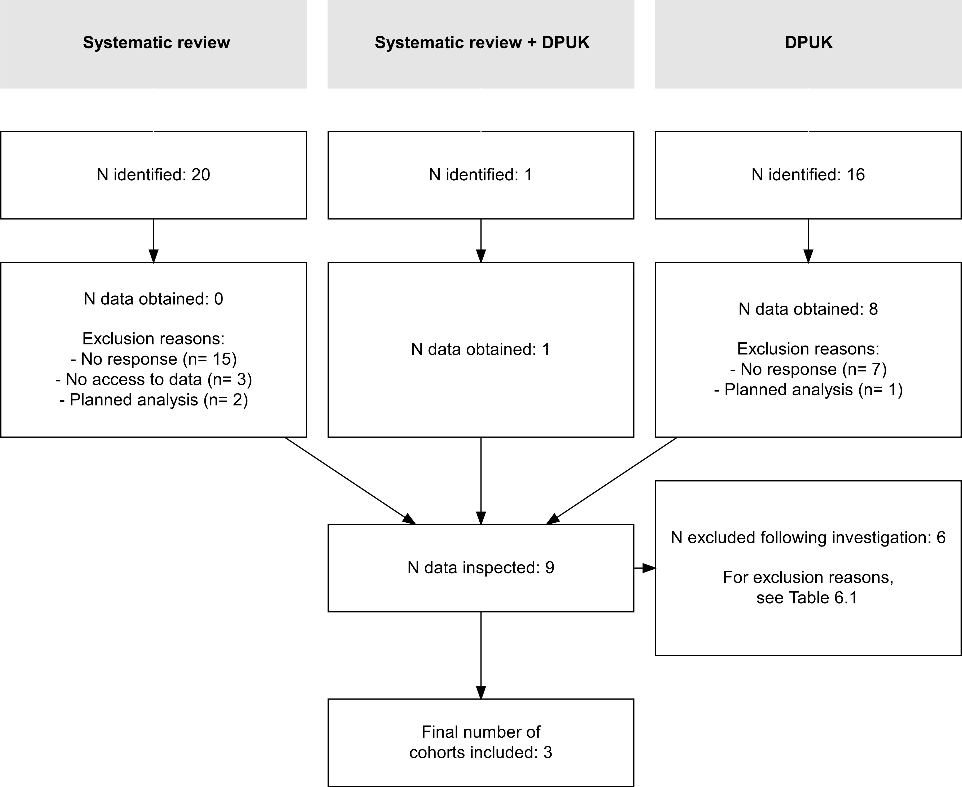

**Figure 6.1: Flowchart detailing sources of data for the IPD analysis** The number of cohorts approached and the reasons for exclusion are summarised, stratified by identification method (systematic review vs DPUK).

As highlighted in Figure 6.1, there was little overlap between cohorts identified by the systematic review and those contained in the DPUK (1), indicating that the DPUK is a useful source of unanalysed data with respect to this question. A single cohort (Whitehall II) was identified by the systematic review and was also present in the DPUK.

Nine cohorts (8 DPUK only, 1 Systematic review + DPUK) responded positively to requests for data access. However, on inspection of data provided, six of these cohorts were excluded and the reason for exlcusion in each case is summarised in Table 6.1. In summary, two cohorts contained were memory-complaint cohorts, containing participants unlikely to be free of dementia at baseline (BRACE, MEMENTO). Two cohorts, despite being designed as multi-wave studies, only shared data related

*160*

*6.3 - Results*

to a single wave and so represented cross-sectional data (Generation Scotland, NICOLA). Finally TRACK HD is a genetic cohort where cohort owners advised me that dementia will inevitably develop in mid-life driven by the Huntington’s (HTT gene) mutation and that this effect would likely far outweigh the effect of lipids. Finally, the ELSA study was excluded based on the dichotomous definition of the exposure variable.

**Table 6.1:** Exclusion reasons for cohorts providing data

Cohort Reason

BRACE Memory complaint cohort - unlikely to be dementia free at baseline

ELSA Lipid exposure reported as a binary variable Generation Scotland Cross-sectional - only one wave of data

available

MEMENTO Memory complaint cohort - unlikely to be dementia free at baseline

NICOLA Cross-sectional - only one wave of data available

TRACK HD HTT gene carriers (i.e. premanifest Huntington’s Disease)

* + 1. Included data sources

The three data sources used in this analysis are described in detail in the following sections. Of note, all included data sources were based in the United Kingdom. This is due to the majority of included datasets being identified via the Dementia Platform UK route (Figure 6.1), which as implied by the name, has a narrow geographical focus.108

*161*

*6.3 - Results*

Caerphilly Prospective Study

The Caerphilly Prospective Study (CaPS) is a longitudinal study of men in South Wales, UK.332,333 Blood lipids (TC, LDL-c, HDL-c and TG) were measured at baseline in 1979-1983, and from Phase III (1989-1993) onwards, a battery of cognitive tests were introduced. A dementia was derived using data obtained during Phase V (2002-2004), giving between 19-25 years of follow-up. The cohort contains data on dementia outcomes sub-classified as vascular and non-vascular dementia. Data was available for all covariates of interest except for education, BMI and *ApoE* 4 status.

Epic Norfolk

The European Prospective Investigation of Cancer (EPIC) - Norfolk is a population- based cohort, containing men and women recruited from 35 general practices in Norfolk between 1993 and 1998.334,335 Data provided by this cohort for the analysis, dementia was ascertained at at the 5th Health Checkup (2016-2018), providing between 18-25 years of follow-up. The added evidential value of the EPIC cohort is small, given the fact that the data obtained contains only 8 dementia events. The cohort contains no information on dementia subtype, while all covariates of interest bar *ApoE* 4 were available.

Whitehall II

The Whitehall II study is a prospective cohort study of men and women recruited between 1985 and 1989 from the civil service in London.336 Lipids measurements were available from the third wave of the study, conducted between 1991-1993. The cohort is linked with the Hospital Episode Statistics (HES) database, a database containing details of participant events at NHS hospitals in England, which was used to define covariates at baseline and dementia outcomes.337 HES data for

*162*

*6.3 - Results*

dementia outcomes was available up to March 2015, providing between 22-24 years of follow-up. Information was available on dementia type, which was classified as all-cause dementia, Alzheimer’s disease or vascular dementia. This data source contained details on all covariates of interest except for *ApoE* 4 status.

Of note, the Whitehall II cohort was analysed in one of the included studies identified by the systematic review presented in Chapters 3 & 4,245 meaning that a comparison between the published result and the analysis reported here was possible.

* + 1. Covariate definition & missing data

Based on available data across cohorts, smoking was classified as never/ever/current, while alcohol consumption was classified as never/ever. Education was categorised into 4 levels (None, O-levels, A-levels, Degree). BMI was treated as a continuous variable while presence of vascular co-morbidities was treated as dichotomous.

A key consideration in the definition of covariates across cohorts was the classification of age. The Whitehall II study, the largest cohort to which I had access, only shared age data in five-year age bands (e.g. 40-44, 45-49, etc.). To ensure comparability across the cohorts, I created identical categories in the CaPS and EPIC data. This grouped age variable was then used in all subsequent analyses.

Missing values in collected variables was common across the cohorts. A matrix of covariates, and whether they were not available or contained missing values for each included cohort, can be seen Appendix A.6.1. The Whitehall II and EPIC cohorts contained data on all but one covariates of interest, while three missing covariates were identified in the CaPS cohort, namely education, prevalent ischemic heart disease, BMI and ethnicity. No included cohort provided information on the *ApoE* 4 status of participants, and so this variable could not be adjusted for in the analysis.

*163*

*6.3 - Results*

* + 1. Analytical results

Descriptive statistics

Across the three cohorts, 11,835 participants were included in this analysis (White- hall II = 8208, EPIC = 1115, CaPS = 2512). All cohorts contained data on the four exposure variables of interest (or sufficient data from which to calculate them) and on all-cause dementia outcomes. The only other dementia outcome examined across cohorts was vascular dementia, which was reported in the CaPS and Whitehall II studies. The definitions of dementia outcomes used across cohorts can be seen in Appendix A.6.2. Cumulatively, there were 542 cases of all-cause dementia, with 114 further classified as vascular dementia. Summary statistics for each cohort are provided in Table 6.2.

*164*

*6.3 - Results*

**Table 6.2:** Summary of characteristics for cohorts included in the IPD analysis

|  |  |  |  |
| --- | --- | --- | --- |
|  | **Whitehall II** | **Epic** | **CaPS** |
| N | 8208 | 1115 | 2512 |
| Age group, Median | 45-49 | 50-54 | 50-54 |
| Male, N (%) | 5679 (69.2) | 495 (44)% | 2512 (100) |
| BMI, Mean (SD) | 25.3 (3.75) | 25.8 (3.58) | - |
| Education >18 yrs, N (%) | 2576 (31.4) | 252 (22.6) | - |
| Smoke ever, N (%) | 2678 (32) | 490 (43) | 2110 (83.9) |
| Alcohol ever, N (%) | 6612 (80.6) | 37 (3.3) | 2235 (89) |
| Ethnicity (white), N (%) | 7387 (90) | 1107 (99.3) | - |
| IHD, N (%) | 7 (0.1) | 63 (5.7) | - |
| TC, Mean (SD) | 6.49 (1.16) | 5.93 (1.08) | 5.93 (1.15) |
| LDL-c, Mean (SD) | 4.40 (1.04) | 3.77 (0.96) | 3.74 (1.12) |
| HDL-c, Mean (SD) | 1.43 (0.414) | 1.43 (0.41) | 1.37 (0.41) |
| TG, Mean (SD) | 1.49 (1.14) | 1.67 (1.04) | 1.83 (1.21) |
| Dementia, N (%) | 287 (3.5) | 8 (0.7) | 247 (9.8) |
| Alzheimer’s, N (%) | 92 (1.1) | - | - |
| Vascular dementia, N (%) | 37 (0.5) | - | 77 (3.1) |
| Non-vascular dementia, N (%) | - | - | 170 (6.8) |

**Abbreviations:** BMI - Body mass index; IHD - Ischemic heart disease; HDL - Low-density lipoprotein cholesterol; LDL - Low-density lipoprotein cholesterol; TG - Triglycerides.

Main effects

The results from the main effect analysis across the varying lipid fractions on each dementia outcome considered can be seen in Figures 6.2 & 6.3, respectively. There was weak evidence for an association of any lipid level with either all-cause or vascular dementia, with the exception of a harmful association between raised triglycerides and vascular dementia (OR: 1.25, 95%CI: 1.01-1.54). For the sole

*165*

*6.3 - Results*

cohort containing data on the Alzheimer’s disease outcome (Whitehall II), there was weak evidence for an association of this outcome with any lipid fraction (results shown in comparison with previous analysis of this cohort in Figure **??**)

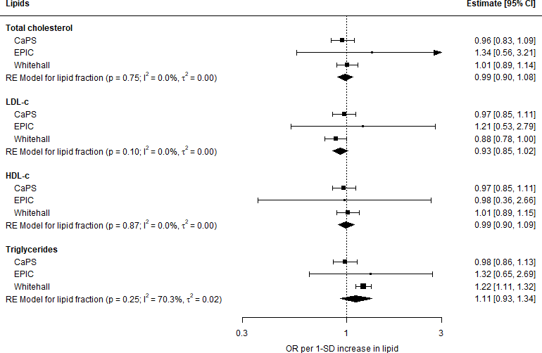

**Figure 6.2:** IPD meta-analysis (Model 1) of all-cause dementia outcomes, stratified by lipid fraction

*166*

*6.3 - Results*

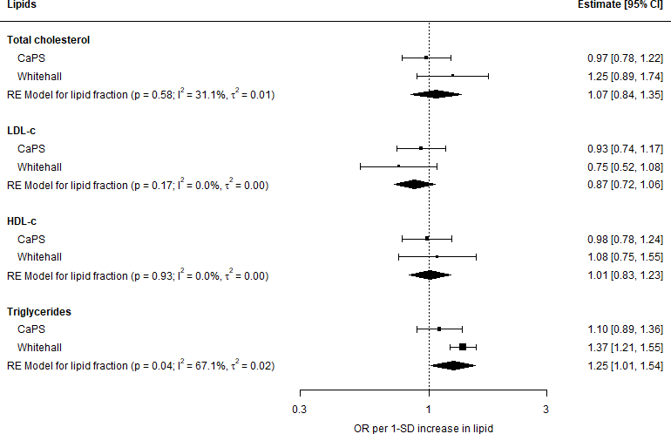

**Figure 6.3:** IPD meta-analysis (Model 1) of vascular dementia outcomes, stratified by lipid fraction. Note that the vascular dementia outcome was only available in the CaPS and Whitehall II cohorts.

Estimates from the common-set-adjusted model (Model 1: adjusted for age, sex, smoking, alcohol, and diabetes) were comparable to the fully-adjusted model (Model 2: Model 1 further adjusted for ethnicity, prevalent ischemic heart disease, education and BMI) for the effect of lipids on all-cause dementia in cohorts reporting all covariates of interest (Figure 6.4).

*167*

*6.3 - Results*

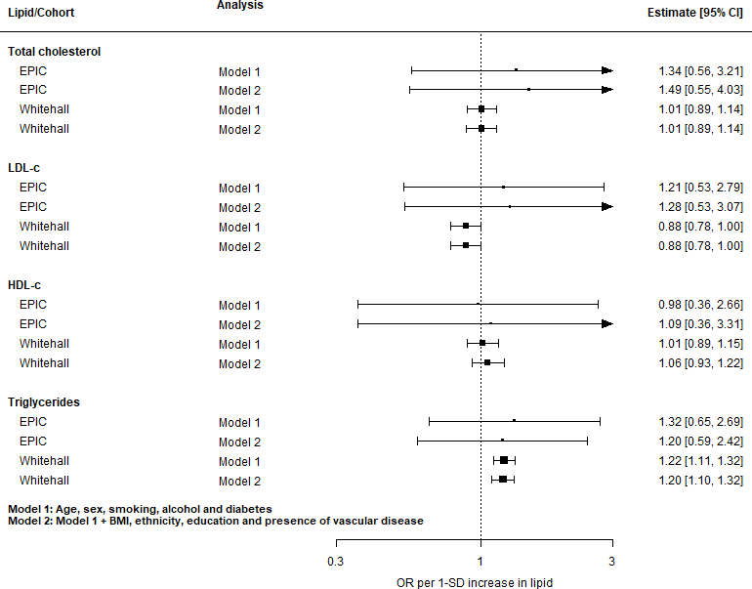

**Figure 6.4:** Comparison of results from the common-set-adjusted (Model 1) and fully- adjusted (Model 2) analyses for the all-cause dementia outcome.

Interaction effects

Given the minimal effect of further adjustment in the maximally-adjusted model, the common-set-adjusted model (Model 1) was used to perform the interaction analyses.

The maximally-adjusted model (Model 2) could have been employed in the analysis of the effect of sex, as the CaPS cohort contains only men and had to be excluded from this analysis, leaving the EPIC and Whitehall cohorts, both of which had a full complement of covariates. However, I decided to employ the same underlying

*168*

*6.3 - Results*

model across the interaction analyses to aid comparability between the age and sex interaction estimates.

For all-cause dementia, there was no evidence of an interaction of lipid levels with either age group or sex (Figures 6.5 & 6.6). Note that for the sex interaction analysis, the CaPS cohort was excluded as it contains only a single sex and therefore provides no information on exposure-sex interaction.

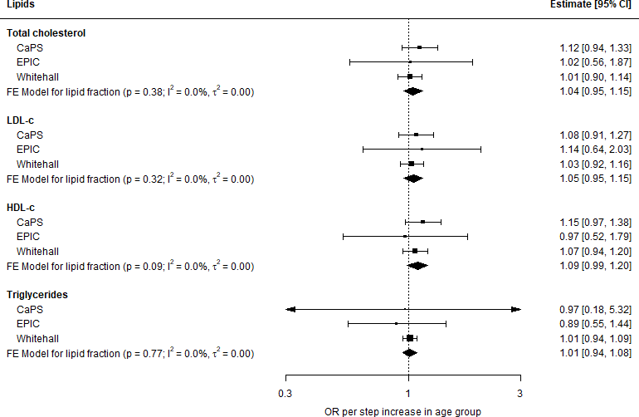

**Figure 6.5: Meta-analysis of age-lipid interaction terms for all-cause dementia**

* Age was grouped into 5-year age bands, and the effect estimatse presented represent the OR per 1-step increase in age group. Estimates were obtained using the common-set- adjusted model (Model 1: age, sex, smoking, alcohol, diabetes).

*169*

* 1. *- Results*

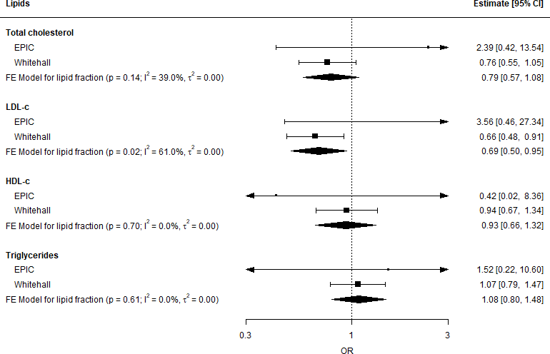

**Figure 6.6: Meta-analysis of sex-lipid interaction terms for all-cause dementia** Estimates were obtained using the common-set-adjusted model (Model 1: age, sex, smoking, alcohol, diabetes) and refer to the effect of male gender on the lipid/all-cause dementia association.

For the consideration of vascular dementia, I was only able to explore the effect of age, as only the CaPS and Whitehall cohorts contained details on vascular dementia as an outcome. As discussed above, the CaPS data contained a single sex excluding it from a exposure-sex analysis, leaving Whitehall II as the sole eligible study.

*170*

*6.4 - Discussion*

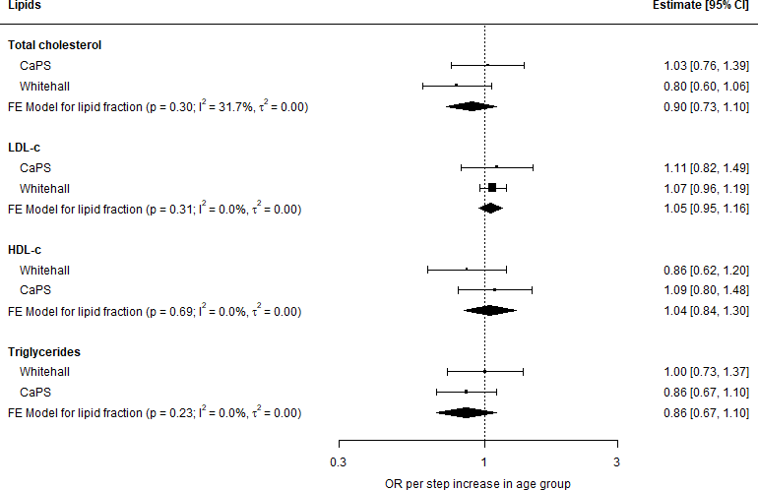

**Figure 6.7: Meta-analysis of age-lipid interaction terms for vascular dementia**

* Age was grouped into 5-year age bands, and the effect estimatse presented represent the OR per 1-step increase in age group. Estimates were obtained using the common-set- adjusted model (Model 1: age, sex, smoking, alcohol, diabetes).

### Discussion

* + 1. Summary of findings

This analysis requested data from 37 data sources, but only obtained data from three, all of which were based in the United Kingdom. No evidence for an effect of lipids on the risk of dementia or related outcomes was identified, except for a harmful association of raised triglycerides with risk of vascular dementia. Similarly, there was weak evidence for an interaction of the effect of lipid levels on dementia outcomes with participants’ age, grouped into 5 year bands, or sex.

*171*

*6.4 - Discussion*

A detailed comparison of the findings presented above with the existing evidence base identified by the systematic review (Chapters 3 & 4), is presented as part of the triangulation exercise in Chapter 7. As such, this discussion will not provide a detailed comparison of the results of this analysis with other published literature, except to compare between this analysis and previously published results using the same data source.

* + 1. Limitations

Low response rate to request for data

The obvious key limitation of this analysis is the very low response rate to requests for data access, which may bias the results if there are systematic differences in the association of lipids with dementia outcomes between cohorts that share data and those that do not.338 Whether or not to press ahead with an IPD analysis in the absence of all (or even most) data is a personal decision, and some previous analyses have highlighted where they decided not to pursue an IPD analysis.339 For the purposes of this thesis, the decision was made to conduct the IPD analysis, as it provided training in application of the methods in addition to providing new evidence that will be incorporated into the triangulation exercise detailed in Chapter 7.

A low response rate is not unexpected, given that a review of IPD studies published between 1987 and 2015 found that fewer than half managed to obtain data from greater than 80% of studies, and that in many cases, the exact percentage of studies for which data was obtained was not accurately reported.101 However, it is assumed that the ~10% response rate encountered in this analysis is at the lower end of the scale.

There are many likely reasons for this low response rate to requests for data access. In general terms, there are several well-documented barriers that prevent data from being made readily available, including concerns regarding participant privacy, fear

*172*

*6.4 - Discussion*

of “scooping” or “parasitic” behaviour, and a lack of trust between primary and secondary researchers.106 More specific to this analysis, IPD meta-analysis including studies other than randomised controlled trials have less success in obtaining IPD from previous published studies.101 Additionally, while no evidence is available on whether the characteristics of the researcher who is requesting data access influences the response rate and eventual decision, there is the possibility that my position as a PhD student meant I was less likely to elicit a positive response than a well-known senior academic might. The timing of the requests for data access, coinciding with a global pandemic, may also have affected the response rate as researchers prioritised COVID-related work.

Finally, in investigating the potential reasons for the low response rate, I discovered that the method of contact used (email) has been shown to be less successful in eliciting responses from authors when compared with telephoning (which was not used in this analysis).340 One of the reasons for this may be that the email addresses reported on publications are more likely to be out of date for older publications. Anecdotally, post-hoc investigation of a subset of cohorts revealed that several corresponding/first authors were no longer at the same institution as when the study was reported, and as a result, were unlikely to have access to the institutional email address listed on the study publication. Despite attempts to track authors as they move between institutions, out-of-date contact details may have contributed to the low response rate.

The obstacles to data access described above are in theory what the DPUK was built to address. However, even with the help of the streamlined application process afforded by the DPUK, accessing sufficient data was a challenge. The response rate among DPUK cohorts a year after application was just 50%. In addition, some cohorts responded saying that the proposed study question was already under investigation by another group, and that they would not share the data on this basis. In light of this, a centralised database of ongoing analyses being performed using DPUK data would be of enormous help, reducing research waste and providing opportunities for collaboration. Finally, the DPUK process would be aided by a

*173*

*6.4 - Discussion*

clearer distinction between those cohorts that are “DPUK native” (i.e. where a copy of the data is already held on DPUK servers) versus externally hosted, as the response time for externally hosted cohorts is likely to be much longer.

Uncontrolled confounding

A key limitation of this analysis is the potential for uncontrolled confounding. Across all cohorts, adjustment for *ApoE* 4 was not possible as I did not have access to genetic data on participants. *ApoE* 4 is a strong risk factor for both increased LDL-c levels and Alzheimer’s disease,321,341 and failing to adjust for this factor means residual confounding in the LDL-c fraction results is likely.

More generally, systematically missing variables required a trade-off between inclusion of cohort data and appropriate control for confounding. The final choice of the common-set-adjusted model for use in the interaction analyses mean there is the potential for residual confounding. However, sensitivity analysis comparing the common-set-adjusted (Model 1) and fully-adjusted (Model 2) models in cohorts with a full complement of covariates indicated that further adjustment for BMI, ethnicity, education and prevalent IHD had minimal impact on the effect estimates. Of note, this is comparable with the analysis of the CPRD data presented in the previous chapter, where adjustment for variable beyond age and sex had a limited impact on the observed effect estimates (see Section 5.3.4).

Comparison with previous analysis

For the single cohort (Whitehall II), a previously published analysis was available. Tynkkynen *et al.*245 analysed the association of blood lipids and risk of all-cause dementia and Alzheimer’s disease across several cohorts, including the Whitehall II cohort. In an attempt to validate my approach, I compared the results from

*174*

*6.4 - Discussion*

the maximally-adjusted model (Model 2) in this analysis with those reported by Tynkkynen *et al.* for both all-cause dementia and Alzheimer’s disease.

The results for the Alzheimer’s disease outcome were comparable (Figures 6.9)). However, for the vascular dementia outcome (Figure 6.8), I identified a discrepancy in the association of triglycerides with all-cause dementia estimated by the two analyses. Tynkkynen *et al.*245 found a protective effect of triglycerides on this outcome (HR: 0.69, 95%CI: 0.56-0.85) while this analysis found evidence for a harmful effect (OR: 1.26, 95%CI: 1.12-1.41).

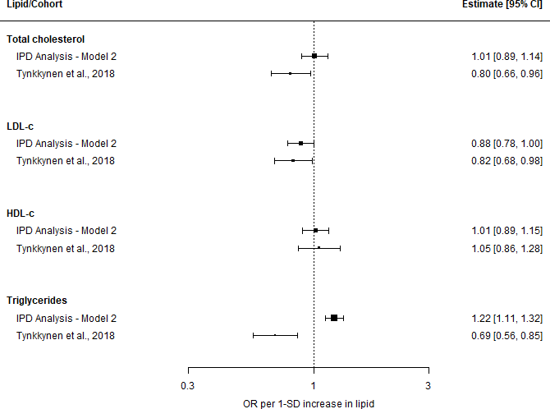

**Figure 6.8:** Comparison of results across the two analyses of the Whitehall II cohort for the all-cause dementia outcome.

*175*

*6.4 - Discussion*

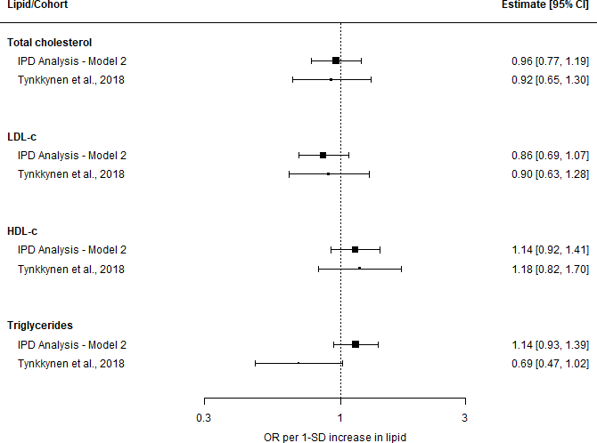

**Figure 6.9:** Comparison of results across the two analyses of the Whitehall II cohort for the Alzheimer’s disease outcome.

Investigation revealed several possible reasons for this discrepancy. The first is that while this analysis uses multiple imputation to address missing data, the Tynkkynen *et al.* analysis does not describe how missing data was handled. However, the reduced precision in the reported estimates suggest a complete case analysis. This interpretation is supported by a comparison of summary statistics, which illustrated that my analysis had substantially more dementia events (N =287 in this analysis vs. n=114 in Tynkkynen *et al.*), suggesting that incomplete records were discarded in the previous analysis. Finally, the covariates adjusted for in each analysis were similar, though the previous analysis had access to genetic data allowing it to adjust for *ApoE* 4 status. However, given that *ApoE* 4 is a risk factor for increased LDL-c

*176*

*6.4 - Discussion*

rather than triglycerides,321 it seems unlikely that additional adjustment for this variable is responsible for the discrepancy in findings observed.

* + 1. Strengths

While this analysis did not manage to obtain and analyse a large proportion of identified data, a central strength of this analysis is the use of a systematic approach to identify and attempt to contact relevant cohorts. Further, it also enabled incorporation of two previously unanalysed datasets - the CaPS and EPIC Norfolk cohorts - thus providing additional evidence that is used in the triangulation exercise reported in Chapter 7.

A further strength is the ability of this analysis to investigate the effect of participant characteristics (namely age and sex) on the association of blood lipids and dementia outcomes. To the best of my knowledge, no previous review has examined the interaction of these factors with the observed associations.

Finally, this analysis provides new evidence on a previously unexplored outcome (vascular dementia), adding to the extremely small evidence base for this outcome identified by the systematic review presented in Chapters 3 & 4. This is relevant even in the previously analysed WhiteHall II cohort, as the previous analysis by Tynkkynen *et al.* did not report on this outcome.

* + 1. Reflections on the process

In hindsight, attempting to undertake a large-scale IPD meta-analysis as part of a larger PhD project may have been overly ambitious. Data harmonization between cohorts in an IPD analysis is an often under-appreciated challenge,327 and in line with this, data cleaning for this analysis took substantially longer than expected. While the cohort response rate was substantially lower that expected, given the

*177*

*6.4 - Discussion*

time and resources required for the cleaning and harmonisation of data from just three cohorts, a situation in which all 37 cohorts responded positively would have been logistically challenging within the scope of a PhD.

* + 1. Future work

While it is tempting to suggest that an IPD analysis of lipid levels be reattempted, without empirically guided approaches to increase the response rate, this may just result in a similarly small set of studies as described here. In line with the limitations considered earlier in this chapter, future methodological work could formally consider the effect of requester characteristics (sex, location, career stage) on response rates in IPD analyses.

Additionally, the production of detailed guidance for handling cases where covariates are systematically missing would represent a useful addition to the topic. Much of the literature around IPD analysis is focused on the synthesis of RCTs, where additional covariate information is needed primarily for the assessment of treatment-covariate interactions rather than the adjustment of the effect estimate for confounding. Given the wide availability of non-randomised cohorts, improved guidance on this challenge would support future work.

Finally, a movement towards increased use of unique persistent identification of researchers, through schemes such as the ORCID programme,342 would help with contact issues. Researchers move institutions regularly as their contracts come to an end, and so the institutional contact details provided on publications are frequently out of date.

*178*

### 6.5 Summary

* 1. *- Summary*
     + In this chapter, I performed an IPD meta-analysis to investigate the effect of blood lipid levels on the risk of incident dementia. There was a very low response rate to requests for data access, resulting in the analysis of three relevant cohorts.
     + I found weak evidence for an association of any lipid with either all-cause or vascular dementia, except for an increased risk of vascular dementia associated with raised triglycerides. Similarly, there was weak evidence that the association of blood lipids and dementia outcomes varied by participant age or sex.
     + I discussed potential reasons for the low response rate, and explored other limitations of this analysis. I highlighted the contribution of this work to the wider topic via the analysis of previously unexplored cohorts (CaPS & EPIC) and outcomes (vascular dementia). Finally, I recommended that future research formally investigate the impact of the characteristics of the requesting researcher on data access rates.
     + The new evidence produced by this analysis will be incorporated, along with evidence identified or produced in the previous chapters, into the triangulation analysis presented in the following chapter.

*Next on my list of features to be specially considered I would place the consistency of the observed associ- ation. Has it been repeatedly observed by different persons, in different places, circumstances and times?*

— Austin Bradford Hill, 1965343

# 7

## Aetiological triangulation across new and

existing evidence sources

**Contents**

**Lay summary** **180**

* 1. **Introduction** **180**
  2. **Data sources** **182**
  3. **Qualitative (narrative) triangulation** **184**
  4. **Quantitative triangulation** **187**
  5. **Discussion** **204**
  6. **Summary** **211**

*7.1 - Introduction*

### Lay summary

In epidemiology, triangulation is the practice of using multiple sources of evidence to provide more reliable answers to a research question. Different sources of evidence will have different limitations. If the result from each source points towards the same answer, this improves our confidence in the conclusion. Triangulation can either be *qualitative* or *quantitative*. In qualitative triangulation, the results of each evidence source are discussed. In contrast, quantitative triangulation aims to combine the different results mathematically to obtain one single overall result.

In this chapter, I describe a new approach for quantitative triangulation, which combines two existing methods. For each source of evidence, I assess and account for robustness (do we believe the result, based on the methods/results of the study?) and relevance (does the source provide useful evidence relevant to the question we are interested in?). To showcase the new method, I apply it to two questions of interest. In each case, evidence from each of the previous chapters is combined to give an overall result.

When combined in the new framework, the results produced by previous chapters did not support an effect of low-density lipoprotein cholesterol (LDL-c) on Alzheimer’s disease nor an effect of triglycerides on vascular dementia. I close the chapter by suggesting future work to further develop the new methods presented.

### Introduction

Aetiological triangulation, or simply triangulation, is the process of comparing and contrasting across different sources of evidence. Triangulation is broadly comparable to Bradford-Hill’s criteria of “consistency”, that is the replication of an observed relationship across several different contexts,343 where contexts are assumed to have different underlying bias structures. More formally it can be defined as:

The practice of strengthening causal inferences by integrating results from several different approaches, where each approach has different (and assumed to be largely unrelated) key sources of potential bias.109

*182*

* 1. *- Introduction*

This approach represents a significant step forward from the current practice of synthesising evidence from only one type of study (e.g. randomised controlled trials (RCTs), non-randomised studies of exposures (NRSE) or interventions (NRSI)). The most common implementation of this method to date has been in the form of *qualitative triangulation* - that is the identification and narrative comparison of diverse evidence sources with respect to their underlying bias structures.109

However, qualitative triangulation faces issues at scale. There is a need to include all evidence to avoid potential confirmation bias,344 yet as the number of evidence sources increases, it is not possible to narratively compare and contrast across multiple results in any meaningful way. This fact is illustrated by previous exemplars of triangulation only considering a small number of individual results.109,345 To overcome this limitation, some attempts have considered the output of a meta- analysis of similarly-designed studies to be a single source of evidence, and have assessed bias in relation to this summary result. While this approach keeps the number of individual sources of evidence manageable, it loses useful information on the specific biases inherent to each result contributing to the summary estimate. For example, while it may be true that all non-randomised studies share some minimal level of bias, competing extents and directions of bias in individual results may be masked by the use of summary estimates. In addition, previous attempts at qualitative triangulation have not systematically assessed the indirectness of the results, that is the differences between the question of interest and the question addressed by a study.

Taken together, these limitations to qualitative triangulation detail a need for a more systematic way to integrate across multiple evidence sources as the number of individual results contributing to the exercise increases. One such approach is *quantitative triangulation*, where results from different evidence sources are combined numerically while accounting for the key sources of bias and indirectness in each. This chapter, in addition to providing a narrative comparison of the existing and new evidence identified by this thesis, builds on recent developments in risk-of-bias assessment and methods for bias-/indirectness-adjusted meta-analysis to propose a

*183*

*7.2 - Data sources*

generalised framework for quantitative triangulation. The framework, along with the methodological challenges to its implementation, is illustrated via two case studies examining the causal effect of lipids on dementia outcomes.

### Data sources

The triangulation exercises presented in this chapter draw on the research produced in each of the preceding chapters. More specifically, this chapter builds on the comprehensive systematic review of existing evidence presented in Chapters 3 &

* + - 1. This evidence base is then supplemented by new evidence on the association of statin use with dementia outcomes in the CPRD (Chapter 5) and the association of lipids with dementia outcomes in previously unanalysed datasets accessed via the DPUK (Chapter 6).

Table 7.1 summarises the research question each data source has attempted to address, the exposures and outcomes considered in each case, and the contribution of each chapter to the triangulation exercise presented here.

*184*

**Table 7.1:** Summary of studies included in this thesis and used as evidence sources in this triangulation exercise. Note, Chapter 2 is intentionally not included in this table, as it describes a research tool rather than a research study.

|  |  |  |  |  |
| --- | --- | --- | --- | --- |
| **Chapter** | **Research Question** | **Exposure/ Intervention** | **Outcome** | **Contibution to evidence synthesis framework** |
| Chapter 3/4 | Based on the available evidence; | Lipids (HDL-c, | Dementia, | Provides overview of existing |
|  | (i) are lipid fractions associated with | LDL-c, TC, | stratified by | evidence, including detailed |
|  | subsequent dementia risk, stratified by subtype?  (ii) Are lipid regulating agents | TG),  Lipid regulating | subtype | risk-of-bias assessments for each result |
|  | associated with subsequent dementia | agents (statins, |  |  |
|  | risk, stratified by subtype? | ezetimibe, |  |  |
|  |  | fibrates, etc.) |  |  |
| Chapter 5 | Are lipid regulating agents associated | Seven classes of | Dementia, | Provides additional observational |
|  | with dementia risk in a large scale | lipid regulating | stratified by | data on vascular dementia |
|  | electonic health record database? | agents | subtype | (under-represented in the literature) |
|  |  |  |  | Provides a source of observational |
|  |  |  |  | evidence created using a method |
|  |  |  |  | with distinct sources of bias to those |
|  |  |  |  | identified by the systematic review |
| Chapter 6 | Are lipid levels associated with | Lipids (HDL-c, | All-cause | Provides additional evidence from |
|  | dementia risk in previously unanalysed prospective cohort | LDL-c, TC, TG) | dementia | unanalysed datasets |

studies?

VaD

Provides additional observational data on vascular dementia

(under-represented in the literature)

*7.2 - Data sources*

*185*

*7.3 - Qualitative (narrative) triangulation*

Additionally, both the qualitative and quantitative triangulation exercises used the detailed risk-of-bias assessments performed and presented as part of the systematic review (Chapters 3 & 4). Similarly, risk-of-bias assessments were performed for each new source of evidence presented in this thesis. The risk of bias tools used to assess each result are described in detail in Section 3.2.8, but in summary, RCTs were assessed using the RoB 2 tool;162 NRSI using the ROBINS-I tool;159 NRSE using an early adapted version of the ROBINS-E tool (see Section 3.2.8);163,164 and MR studies using the Mamluk et al. tool.166

### Qualitative (narrative) triangulation

As part of a qualitative triangulation of the new and existing evidence identified by this thesis, all information sources were initially grouped by outcome, and the findings from each source were narratively compared and contrasted. Potential reasons for heterogeneity between study designs were examined with specific reference to the risk-of-bias in each.

All-cause dementia

Analysis of lipid levels across both the systematic review (Chapters 3 & 4) and the IPD analysis (Chapter 6) found extremely weak evidence for an association of any lipid fraction with all-cause dementia (TC - HR: 0.97, 95%CI: 0.88-1.07; LDL

- HR: 0.97, 95%CI: 0.86-1.08; HDL - HR: 1.05, 95%CI: 0.96-1.14; TG - HR: 0.90,

95%CI: 0.74-1.09). Similarly, meta-analysis of studies identified by the review which examined a binary hypercholesterolemia provided weak evidence for an association of this risk factor with Alzheimer’s disease (HR: 1.11, 95%CI: 0.98-1.25). Finally, a meta-analysis of RCTs of statin use (OR: 1.07, 95%CI: 0.70-1.66) and of MR analyses of genetic instruments that mimic statin use (RR: 0.90, 95%CI: 0.29-2.81)

*186*

*7.3 - Qualitative (narrative) triangulation*

found weak evidence of an association, providing indirect evidence on the effect of lipid lowering on this outcome.

In contrast, the meta-analysis of NRSI of statin use found a slight protective effect for the all-cause dementia outcome (HR: 0.77, 95%CI: 0.69-0.87), though many of the studies in this analysis were found to be at risk of immortal time bias, which would be expected to favour the statin use. Finally, analysis of the association of statin use with all-cause dementia in the CPRD (Chapter 5) found evidence of a harmful association (HR:1.16, 95%CI:1.14-1.19), though this is likely to be driven by the substantial confounding by indication identified in the vascular dementia subgroup.

For fibrates, an alternative lipid-regulating agent, there was some evidence of an increased risk of all-cause dementia in the CPRD (HR:1.28, 95%CI:1.08-1.52), though this was not consistent in the meta-analysis of previous studies examining the association of fibrates and all-cause dementia (HR: 0.89, 95%CI: 0.75-1.07).

Alzheimer’s disease

Meta-analysis of lipid levels in the systematic review found extremely weak evidence for an association of any lipid fraction with Alzheimer’s disease (TC - HR: 1.00, 95%CI: 0.94-1.06; LDL - HR: 1.06, 95%CI: 0.98-1.16; HDL - HR: 0.99, 95%CI: 0.91-

1.07; TG - HR: 1.00, 95%CI: 0.84-1.18). Similarly, meta-analysis of studies examining a binary hypercholesterolemia provided weak evidence for an association of this risk factor with Alzheimer’s disease (HR: 0.99, 95%CI: 0.78-1.25). A meta-analysis of MR analyses of genetic instruments that mimic statin use found weak evidence for an association of lipid lowering with Alzheimer’s disease (RR: 0.76, 95%CI: 0.51-1.14).

In contrast, the meta-analysis of NRSI of statin use found a slight protective effect on this outcome (HR: 0.83, 95%CI: 0.69-0.99), though similar to the all-cause dementia outcome, many of the studies in this analysis were found to be at risk of immortal time bias. However, the CPRD analysis, which attempted to account for this potential bias through the use of time-varying treatment indicator, found

*187*

* 1. *- Qualitative (narrative) triangulation*

weak evidence for an effect (HR:0.98, 95%CI:0.94-1.01). The validity of this finding was limited by the potential for differential misclassification on the basis of the exposure in the CPRD analysis.

Finally, only one of the three cohorts included in the IPD analysis (Whitehall II) contained data on Alzheimer’s disease. However, a previously published analysis (Tynkkynen *et al.*245) examining the association of lipid levels with Alzheimer’s disease in the this cohort was identified by the systenatic review. The results of this previous analysis are incorporated into the results of the meta-analysis reported above, and so the IPD analysis provided no new information on this outcome.

Vascular dementia

There was a general absence of existing evidence on vascular dementia outcomes. Meta-analysis of published results was only possible for the total cholesterol lipid fraction (HR: 1.05, 95%CI: 0.79-1.41). A meta-analysis of studies examining hypercholesterolemia also found weak evidence for an association with vascular dementia (HR: 1.20, 95%CI: 1.00-1.44). Similarly, a meta-analysis of statin use found weak evidence for an effect on this outcome (HR: 0.99, 95%CI: 0.79-1.25). The CPRD analysis found evidence for a harmful association of statin use (HR:1.81, 95%CI:1.73- 1.9), though this finding is likely to be the result of severe confounding by indication related to vascular factors, as identified through the use of control outcomes.

The IPD analysis provided supporting evidence for the absence of an effect of any fraction on vascular dementia, with the sole exception of triglycerides. Raised triglycerides were associated with an increased incidence of vascular dementia across two previously unanalysed cohorts (OR: 1.25, 95%CI: 1.01-1.54), though there is the potential for uncontrolled confounding due to the limited information available on important covariates. With respect to evidence on treatments for hypertriglyceridemia, examination of fibrates in the CPRD provided weak evidence of an association with vascular dementia (HR:1.29, 95%CI:0.83-2.02).

*188*

*7.4 - Quantitative triangulation*

### Quantitative triangulation

The qualitative comparison presented above identified no consistent effect of any lipid fraction on any dementia outcome across the evidence sources presented in this thesis. However, it is clear that this qualitative approach faces difficulties in interpretation when the number of individual results available is large, as discussed in the introduction to this chapter. This is true even when using summary estimates from meta-analyses of primary studies, which sacrifice valuable information on the biases inherent to each individual result.

In the following section, I propose and apply a novel quantitative triangulation framework to address these limitations. This approach incorporates recent advance- ments in the way that bias in results is assessed (namely the move to domain-based assessment tools)162 and existing methods for bias-/indirectness-adjusted meta- analysis346 to integrate the numerical results of the multiple approaches. Despite the absence of any clear signals across the evidence base, as detailed in the previous section, I have used the evidence identified and produced by this thesis to illustrate the novel methodological approach.

* + 1. Methods

The proposed framework involves the following steps:

* + - 1. Define the causal question of interest
      2. Identify relevant evidence sources and standardise effect directions
      3. Specify idealised version of each study
      4. Assess the extent and direction of bias/indirectness in each result
      5. Define modifying terms for bias and indirectness in each result

*189*

*7.4 - Quantitative triangulation*

* + - 1. Calculate bias-/indirectness-adjusted results and perform meta-analysis

Each step is described in comprehensive detail in the sections below. To better illustrate the bias-/indirectness adjustment process detailed in the subsequent sections, the process for calculating the adjusted estimate is described in detail for a single result. Following this, the framework is then applied to two case studies.

Definition of the causal questions of interest (case-studies)

Using the ROBINS-E framework,163 I defined the parameters of my causal ques- tions of interest:

*Case study #1: Effect of mid-life LDL-c on Alzheimer’s disease*

* + - *Population of interest*: General population
    - *Exposure of interest*: Low density lipoprotein cholesterol
    - *Exposure window of interest*: Mid-life (45-60)
    - *Summary measure of exposure over time*: Average exposure
    - *Outcome of interest:* Alzheimer’s disease

*Case study #2: Effect of mid-life triglycerides on vascular dementia*

* + - *Population of interest*: General population
    - *Exposure of interest*: Triglycerides
    - *Exposure window of interest*: Mid-life (45-60)
    - *Summary measure of exposure over time*: Average exposure
    - *Outcome of interest:* Vascular dementia

These causal questions were chosen for several reasons. Firstly, the work presented in the previous chapters had identified some evidence for an association in these

*190*

*7.4 - Quantitative triangulation*

exposure/outcome pairs. Secondly, given the long prodomal period between the onset of physiological changes in the brain and presentation of dementia symptoms, it seems likely that conditions during the mid-life period are particularly important. Finally, examining the causal impact of a lipid fraction on a specific outcome (e.g. Alzheimer’s disease), rather than a composite outcome (e.g. all-cause dementia), focuses on an single causal pathway rather than including several conditions in the outcome definition that likely have very different mechanisms of disease. In addition, previous work presented in this thesis illustrated that the component conditions (in this case Alzheimer’s disease and vascular dementia) are likely to be subject to very different confounding structures (see Section 5.4.2), and the use of a composite all-cause outcome in the triangulation framework may mask this.

Identify relevant results

Once the causal question of interest had been defined, relevant individual results were obtained from the data sources described in Section 7.2. In a broad sense, this meant extracting results that examined the relationship between the exposure/outcome pair, either directly (e.g. non-randomised studies of LDL-c levels) or indirectly (e.g. non-randomised studies of statins, or Mendelian randomisation studies using genetic instruments for LDL-c levels).

Effects were standardised to refer to the risk resulting from a “reduction” in the lipid fraction. For both non-randomised studies and Mendelian randomisation analysis of lipid levels, the association is usually reported per 1-SD increase in the lipid fraction. In this case, the effect estimates were inverted to ensure consistency across study designs.

*191*

*7.4 - Quantitative triangulation*

Specify idealised version of each study

Once the set of relevant results have been identified, an idealised study for each is described An idealised study can be viewed as a replicate of the study producing the result of interest but with all sources of bias removed. The risk of bias is then assessed against this idealised study, while the causal question addressed by each idealised study is compared with the target causal question to define the indirectness of each result.

Note that all of the risk-of-bias tools used to assess non-randomised studies required specification of an idealised version of the study, against which bias was assessed. If using a risk-of-bias assessment tool that does not require this step, the idealised version of the study should be defined in advance of risk-of-bias assessment.

Assess risk and direction of bias in each result

The assessment of bias in each result is discussed in Section 7.2 above.For the sake of consistency and ease of computing, I mapped the different acceptable risk-of-bias judgements in each tool to a harmonised set: “Low”, “Moderate”, and “High”. The exact mapping can be seen in Table 7.2. Of note, no mapping was performed for the critical risk-of-bias levels present in the tools for non-randomised studies. This is in accordance with current best practice in evidence synthesis, which is to exclude all studies at critical risk of bias from further quantitative synthesis.159

*192*

*7.4 - Quantitative triangulation*

**Table 7.2: Mapping of risk-of-bias judgements across assessment tools** The different acceptable levels of bias across the risk-of-bias assessment tools used were mapped to a harmonised set. Note that no mapping for “Critical” risk of bias was performed, as best practice recommends that studies at critical risk of bias are excluded from quantitative syntheses.

|  |  |  |  |
| --- | --- | --- | --- |
| **Harmonised** | **RoB2** | **ROBINS-I / ROBINS-E** | **MR** |
| **Low** | Low | Low | Low |
| **Moderate** | Some concerns | Moderate | Moderate |
| **High** | High | Serious | High |
| **-** | - | Critical | - |

In addition to assessing the extent of bias, as defined by the three levels detailed above, I recorded the predicted direction and type of bias in each domain. This was achieved via an additional question at the end of each bias domain, which asked assessors to predict the expected direction of bias in that domain. Note that this question is currently only formally included in two existing tools (ROB2/ROBINS- I), but I employed an identical approach during assessment of non-randomised studies of exposure and Mendelian randomisation studies. Acceptable responses to this question included:

* + - * “Favours experimental”/“Favours comparator” (defines an additive bias)
      * “Towards null”/“Away from null” (defines a proportional bias)
      * “Unpredictable”

As indicated in the options above, the response to this question is also used to determine the predicted type of bias as either additive or proportional. Proportional biases are dependent on the magnitude of the effect, while additive biases are not.346

For additive biases, determining the absolute direction of bias was simply a case of whether the bias is expected to shift the effect estimate to the left or right on an imaginary forest plot. For example, the estimate would be shifted to the right if a bias was predicted to favour the comparator (Figure 7.1).

*193*

*7.4 - Quantitative triangulation*

In contrast, for proportional biases, whether the estimate should be increased or decreased proportionally depends on the current position of the point estimate relative to the null. For example, if the effect estimate represents a protective effect (below the null), then bias towards the null would be adjusted for by moving the effect estimate proportionally to the right. In contrast, if the effect of the intervention is harmful (effect estimate above the null), bias towards the null would be adjusted for by moving the effect estimate proportionally to the left. Both scenarios are illustrated using example data in Figure 7.1.

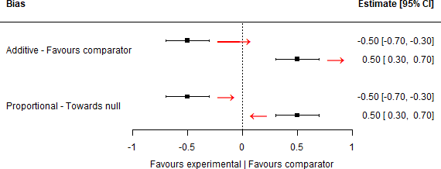

**Figure 7.1: Calculating the absolute direction of biases, based on bias type**

- For additive biases, the direction is consistent regardless of the position of the effect estimate relative to the null - bias “favouring the comparator” will always pull the effect estimate to the right and can induce a change from a protective to harmful effect. In contrast, the position of the effect estimate is accounted for when determining the absolute direction of proportional biases, defined as towards or away from the null.

The predicted direction and type of bias were not recorded for domains at “Low” risk of bias. Finally, for some domains, only one type of bias is allowed. For example, in the confounding domains in the ROBINS-I/ROBINS-E tools, only the “Favours experimental”/“Favours comparator” and “Unpredictable” options are available, meaning that bias in this domain will always be considered additive.

*194*

*7.4 - Quantitative triangulation*

Visualisation of extent and direction of bias

To aid with the quantitative triangulation exercise, I created a new method to visualise the extent, direction and type of bias in each result, enabling detailed comparison across different studies contributing to a synthesis. Similar to the standard paired forest plots introduced in Chapter 3, these “bias direction” plots show the level (or extent) of bias across the domains for each result reported using coloured blocks. However, in contrast to the previous forest plots, symbols are used to illustrate the predicted absolute direction of bias in that domain. Distinct symbol pairs are used to denote additive and proportional biases. Illustrations of these are provided in the Section 7.4.2.

Assign modifying values to risk/direction of bias

Following definition of the extent, type and direction of bias in each domain, I assigned a prior distribution on the log scale to each combination. For example, a “high” additive bias in *j*th domain of the *i*th study is defined as *δ*High and uncertainty around this estimate is given by a distribution with mean *µ* and variance *σ*2:

*i,j*

*δ*High = *f* (*µ*High*, σ*High2) (7.1)

*i,j*

*i,j*

*i,j*

The sign of *µ*High is defined by the absolute direction of the bias. If the bias is

*i,j*

expected to pull the effect to the left, *µ*High is given a negative sign, and if it is expected to pull the effect to the right, it is given a positive sign.

*i,j*

One key feature of the domain-based risk-of-bias tools is that the domains are considered interchangeable - i.e. a “high” judgement in one domain is equivalent to a “high” judgement in any other. As such, for this analysis, I assumed that the distributions assigned to each extent of bias were identical across all values of *j*, that is, were identical for all domains in the risk-of-bias assessment tool. To illustrate for additive biases:

*195*

*7.4 - Quantitative triangulation*

*δ*High = *δ*High = *...* = *δ*High

and similarly

*i,*1

*i,*2

*i,j*

*δ*Moderate = *δ*Moderate = *...* = *δ*Moderate

*i,*1

*i,*2

*i,j*

Reasonable values for the position and spread of the prior distributions were informed by a previously-reported expert bias elicitation exercise.346 Using open data from that study, I calculated the mean values for the mean and variance of the adjustment distributions across all biases considered by that exercise (see Appendix

A.7.1 for more details on how these were calculated). For the purposes of this illustrative analysis and to highlight the generalised nature of the code used to perform the analysis (see Section 7.5.5), I used the calculated values to inform two scenarios of modifying distributions (Table 7.3) for additive biases, and a single set for proportional biases. In the first scenario, the relationship between the position assigned to each additive judgement is linear. In the second scenario, the step from “Moderate” to “High” is twice that from “Low” to “Moderate”. Across both additive and proportional biases, the variance of the “High” judgement distribution was defined to be greater than that of the “Moderate” judgement.

**Table 7.3: Prior distributions mapped to different extents of bias.** Prior values assigned to additive and proportional biases, defined as log-normal distributions with mean *µ* and variance *σ*2 using the notation *N* (*µ, σ*2). For additive biases, two scenarios were defined (see main text). Note that proportional biases are defined on the log scale for ease of calculation, but are exponentiated prior to their use for adjustment.

|  |  |  |
| --- | --- | --- |
| **Bias Level** | **Additive bias** | **Proportional bias** |
| **Low** | - - | - |
| **Moderate** | N(.09, .05) N(.09, .05) | N(.03, .016) |
| **High** | N(.18, .1) N(.27, .1) | N(.06, .032) |

Scenario 1 Scenario 2

*196*

*7.4 - Quantitative triangulation*

Where the direction of bias in a domain was unpredictable for a given result, the mean of the prior distribution for that domain was set to 0 but the appropriate variance for the recorded extent of bias was retained (e.g. for an unpredictable “High” additive bias, the distribution would be *N* (0*,* 0*.*1) under Scenario 1). In other words, adjusting for bias in a domain with an unpredictable direction of bias has no impact on the position of the effect estimate but does increase the uncertainty around it.

Under the method reported in Turner *et al.*,346, total additive bias (denoted using subscript *δ*) in result *i* is then described by mean *µiδ* and variance *σ*2 , which are simply the sum of the mean and variance of all additive biases in the *i*th result. Similarly, the total proportional bias (denoted using subsript *β*) in the *i*th result is described by mean *µiβ* and variance *σiβ*2. This are defined as

*iδ*

*µiβ* = *exp*(*αi* + *ψi*2) (7.2)

*σiβ*2 = {*exp*(*ψi*2) *−* 1 *exp*(2*αi* + *ψi*2) (7.3)

where *αi* and *ψi*2 are the the sum of mean and variance values for all proportional biases in the *i*th result.

Note that the total additive bias is maintained on the log scale, while the total proportional bias has been exponentiated.

Assessing and assigning prior values to indirectness

The indirectness of a result (also termed external bias, external validity, relevance, generalisability, or applicability) is defined here as the discrepancy between the re- search question addressed by the “idealised” study and the causal question of interest.

*197*

*7.4 - Quantitative triangulation*

An identical approach was employed to assess, and assign prior distributions to, the indirectness in each result. The target question for each result was compared against the causal question of interest with respect to three domains, defined as important by the GRADE framework for assessing the certainty of evidence:347 population, intervention/exposure, and outcome. I again used the scale of “Low/”Moderate“/”High" to quantify the extent of indirectness in each domain. All indirectness was defined *a priori* as being proportional in nature (i.e. depending on the magnitude of the effect), in line with previous work on this topic.346,348 As above, data from the previous elicitation exercise were used to inform reasonable prior distributions for each level of indirectness (Table 7.4).

**Table 7.4: Prior distributions mapped to different extents of bias.** Prior values assigned to additive and proportional biases, defined as log-normal distributions with mean *µ* and variance *σ*2 using the notation *N* (*µ, σ*2). For additive biases, two scenarios were defined (see main text). Note that proportional biases are defined on the log scale for ease of calculation, but are exponentiated prior to their use for adjustment.

Bias Level Proportional bias Low -

**Moderate** N(.06, .016)

**High** N(.12, .032)

As an illustrative example, consider the first causal question of the interest in this exercise, the effect of LDL-c in mid-life on Alzheimer’s disease. Here, studies of lipids levels in this time period would require minimal adjustment, whereas studies examining statin use (indirect exposure/intervention) in late-life (indirect population) would be adjusted and down-weighted due to reduced relevance to the causal question.

Once the extent and direction of indirectness has been assessed, total proportional indirectness is then calculated in the same manner as total proportional bias (see Equations (7.2) & (7.3)).

*198*

*7.4 - Quantitative triangulation*

Combining in a bias-adjusted meta-analysis

Using the the method reported in Turner *et al.*,346 once total additive and pro- portional bias and indirectness are calculated, they are used to define an adjusted estimate for each result included in the synthesis.

The adjusted estimate for result *i*,

*θ*ˆ*i*, is defined as:

ˆ = *yi − µ*In*µ*In *− µ*B

(7.4)

*θi iβ iδ iδ*

*µ*B *µ*In

*iβ iβ*

where *µ*B

*iδ*

and *µ*B

refer to the total additive and proportional bias, and *µ*In and

In refer to the total additive and proportional indirectness. Note that in this

*iβ*

*iδ*

*µ*

*iβ*

exercise, the total additive indirectness *µ*In = 1, as all indirectness was defined

*iβ*

*a priori* as being proportional.

The standard error of this estimate is then calculated as:

SE(ˆ) = 1

*θ*

*µ*B *µ*In

2 (

2 +

B 2 +

*µiβ*

B ˆ2

In2 +

*σiβ*

In2 +

B ˆ

In +

In 2 +

B22

*iβ iβ*

*si*

*σiβ*

*θ*

*σiδ*

*σiβ*

*θµiβ*

*µiδ*

*σiδ*

(7.5)

Once each individual result had been adjusted using this approach, I performed a random effects meta-analysis using the unadjusted and adjusted results. I also compared the adjusted results under the two scenarios of additive bias. I extracted the overall effect estimates, along with measures of heterogeneity in each case (*τ* 2, *I*2).349,350

*199*

*7.4 - Quantitative triangulation*

7.4.2 Results

Single study

As an illustrative example of the process using a single result, the bias and indirectness inherent to the estimate of the effect of statin use on Alzheimer’s disease in the CPRD (as analysed in Chapter 5) are considered here. For this result, there were three domains at greater than low risk of bias: Bias due to confounding, Bias due to definition of the outcome, and Bias in the selection of the reported result (Figure 7.2). In Domain 1 (bias due to confounding), the study did not adjust for *ApoE* 4 status, which is predicted to mask any true association between statins and Alzheimer’s disease (see Section 5.4.3 for a fuller discussion). As such, the bias is predicted to *favour the comparator* and so the absolute direction of bias is to the right. In Domain 7 (bias in measurement of the outcome), there was a high risk of differential misclassification on the basis of the exposure. Here, a history of statin use may make a diagnosis of vascular dementia more likely than Alzheimer’s disease, and so for this outcome, this bias is predicted to *favour the experimental* (in this case, an intervention). As such, the absolute direction of bias is to the left. In Domain 7 (bias in selection of the reported result), for consistency with the other NRSI, in the absence of a protocol the bias is assumed to be *away from the null*. Given the position of the effect estimate below the null, the absolute direction of bias in this domain is to the left.

*200*

*7.4 - Quantitative triangulation*

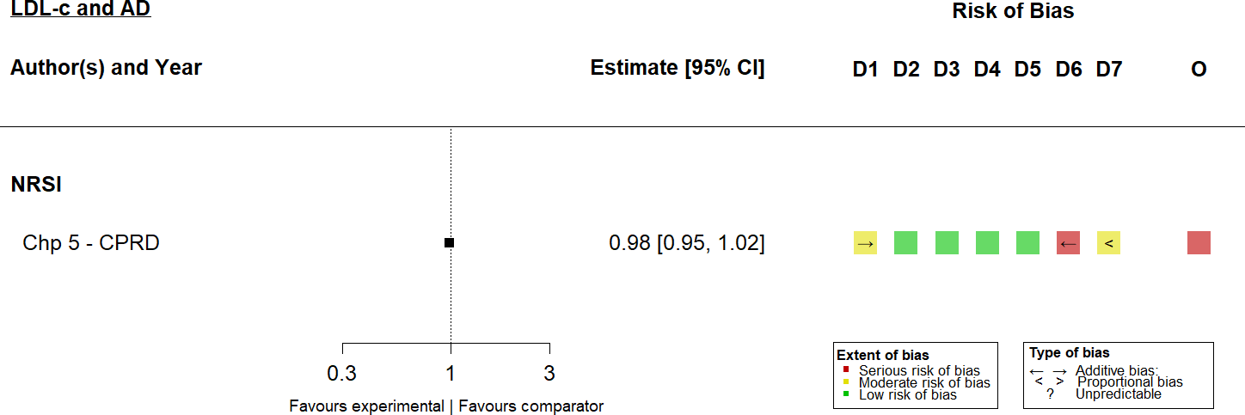

**Figure 7.2:** Bias direction plot for a single study showing the predicted direction of bias in each domain. Additive biases are characterised using arrows, while the proportional biases are denoted using *<* and *>*. A question mark indicates that the direction of bias was unpredictable.

Indirectness was intentionally not displayed in the plot above, as these figures are created using robvis which is focused on creating visualisations of risk-of-bias data. In addition, I found it more useful to articulate the indirectness of a result in tabular format. With respect to this example result, I judged it to be at low risk in the population and outcome domains (Table 7.5). However, the result refers to the effect of statins on Alzheimer’s disease risk, rather than LDL-c levels directly, putting it at high risk of indirectness in the intervention/exposure domain. Overall, assessing the predicted direction of indirectness was more challenging than assessing the predicted direction of bias. In this case, treatment with statins may result in temporary lowering of lipid levels which could thus underestimate the true effect of LDL-c lowering (indirectness towards the null). In contrast, statins may have an effect on Alzheimer’s disease through a mechanism other than their LDL-c lowering effect and so the effect may be overestimated (indirectness away from null). As such, I judged the direction of indirectness in this domain to be unpredictable.

*201*

*7.4 - Quantitative triangulation*

**Table 7.5:** Assessment of indirectness for a single example study.

|  |  |  |  |  |
| --- | --- | --- | --- | --- |
| **Domain** | **Target setting** | **Idealised version** | **Level** | **Direction** |
| Population | General population, | UK general | Low | - |
|  | dementia free at | population, >45 |  |  |
|  | baseline | years of age, |  |  |
|  |  | dementia free at |  |  |
|  |  | baseline |  |  |
| Intervention/ | Average low density | Initiation of statin | High | Unpredictable |
| exposure | lipoprotein | use |  |  |
|  | cholesterol levels at |  |  |  |
|  | midlife (45-60) |  |  |  |
| Outcome | Alzhiemer’s disease, | Alzheimer’s disease | Low | - |
|  | assessed using | cases extracted from |  |  |
|  | recognised clinical | EHR |  |  |
|  | criteria |  |  |  |

of single study

The unadjusted estimate was 0.98 (95%CI: 0.95-1.02). After accounting for the biases and indirectness described, the adjusted result was 1.08 (95%CI: 0.48-2.44).

Case study #1: effect of LDL-c at midlife on Alzheimer’s disease

From the data sources identified in Section 7.2, I identified 18 results relevant to my first causal question of interest. Most (N =17) were identified via the systematic review,54,72,189–191,196,200,204,205,210,212,213,219,245,248 while Chapter 5 provided an additional estimate from the CPRD analysis. The extent, type and direction of predicted bias for each result can be seen in the bias-direction plot presented in Figure 7.3, stratified by study design.

*202*

*7.4 - Quantitative triangulation*

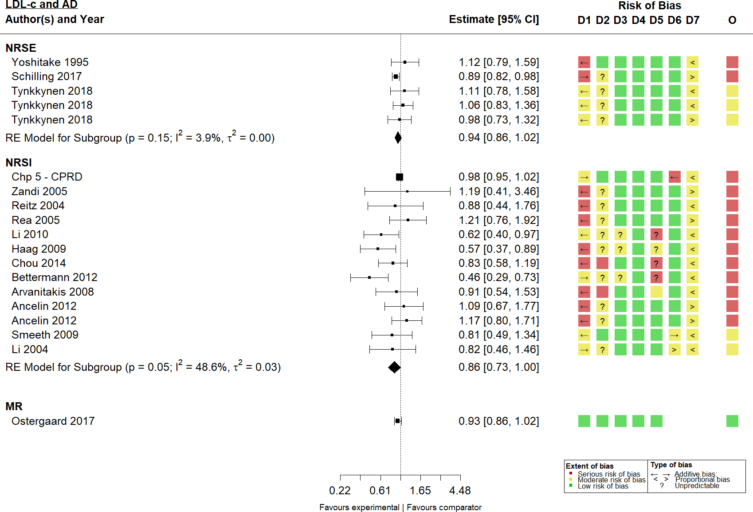

**Figure 7.3:** Bias direction plot, summarising the internal biases related to effect of LDL-c on Alzheimer’s disease, stratified by study design.

The results of the unadjusted and the bias-/indirectness-adjusted (under Scenario 1) are shown in Figure 7.4. Following adjustment for bias and indirectness, the observed effect attenuates to the null (unadjusted 0.94, 95%CI: 0.89-0.99; adjusted 0.95, 95%CI: 0.87-1.04). Additionally, adjustment for bias and indirectness substantially reduced the heterogeneity between studies (unadjusted *τ* 2 = 0.0017, *I*2 = 17; adjusted *τ* 2 = 0.0013569, *I*2 = 1.3037272). However, as can been seen from the right panel in Figure 7.4, this reduction in heterogeneity between studies is largely achieved via a reduction in the precision of each individual result.

*203*

*7.4 - Quantitative triangulation*

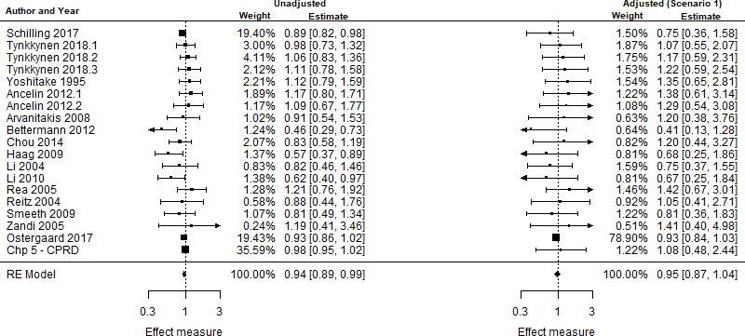

**Figure 7.4:** Random effects meta-analysis of the association of midlife LDL-c with Alzheimer’s disease, using unadjusted and bias-/indirectness-adjusted results.

No substantial differences were observed between the summary estimates obtained under the two scenarios of additive bias (Appendix A.7).

Case study #2: effect of triglycerides at midlife on vascular dementia

From the data sources identified in Section 7.2, I identified 7 results relevant to the causal effect of triglycerides at midlife on vascular dementia. Four were identified via the systematic review,225,237,248 while Chapter 5 provided two additional estimates from unanalysed datasets (CaPS and Whitehall II), and Chapter 6 provides an estimate for the effect of fibrates, a treatment for hypertriglyceridaemia. The extent, type and direction of predicted bias for each result can be seen in the bias-direction plot presented in Figure 7.5, stratified by study design.

*204*

* 1. *- Quantitative triangulation*

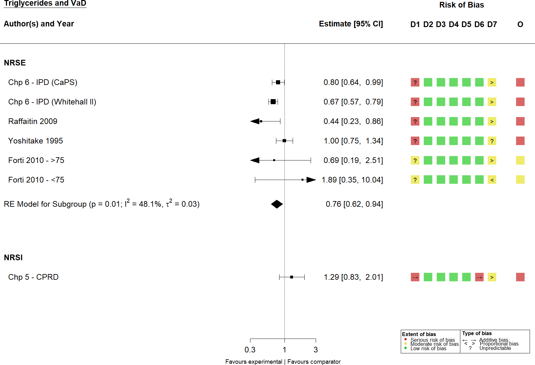

**Figure 7.5:** Bias direction plot, summarising the internal biases related to effect of triglycerides on vascular dementia, stratified by study design.

Comparison of the unadjusted and bias-/indirectness-adjusted results for the effect of triglycerides on vascular dementia did not demonstrate a substantial difference (unadjusted 0.82, 95%CI: 0.64-1.05; adjusted 0.79, 95%CI: 0.58-1.07; Figure 7.6), though again, heterogeneity between the adjusted results was greatly reduced (unadjusted *τ* 2 = 0.054, *I*2 = 65; adjusted *τ* 2 = 0, *I*2 = 0). Similarly there was minimal difference between the results under the two scenarios of bias (Figure

A.6 in Appendix A.7).

*205*

*7.5 - Discussion*

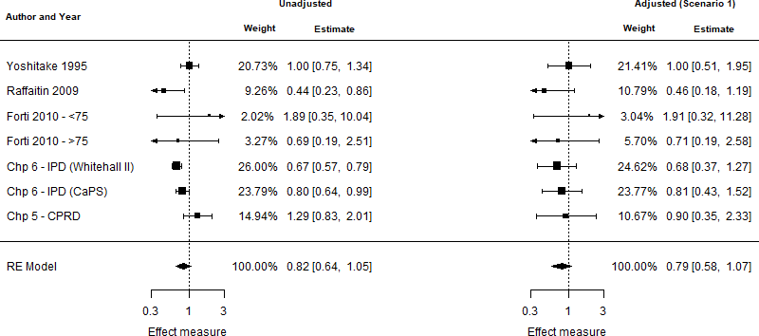

**Figure 7.6:** Random effects meta-analysis of the association of midlife triglycerides and vascular dementia, using unadjusted and bias-/indirectness-adjusted (Scenario 1) results.

### Discussion

* + 1. Summary of findings

This chapter has narratively synthesised the evidence identified and produced by the previous chapters, highlighting the absence of any consistent association between various blood lipid fractions and any dementia outcome.

In addition, it has developed a generalised framework for quantitative triangulation, building on existing methods for systematic domain-based risk of bias assessment and bias-/indirectness-adjusted meta-analysis. To illustrate the method, I considered two causal questions: the effect of LDL-c at mid-life with Alzheimer’s disease and the effect of triglycerides on vascular dementia. In the quantitative triangulation framework, there was weak evidence for an effect in relation to either of the causal questions considered. The heterogeneity between results produced by different study designs contributing to the analysis was substantially reduced using this method, though this was largely due to a reduction in the precision of each individual result.

*206*

*7.5 - Discussion*

* + 1. Limitations

The quantitative analysis presented in this chapter is subject to some strong methodological limitations, which are discussed in detail below.

Defining reasonable prior distributions for bias and indirectness

The key limitation of the quantitative synthesis presented in this chapter is the lack of empirical evidence available for the prior distributions of bias and indirectness. While I attempted to address this by informing the prior distributions using data from a previous expert elicitation exercise, the extent of bias/indirectness in that analysis may not generalise to the one presented here.

Ideally, these prior distributions would be based on empirical data on the effect of different domains of bias/indirectness on a result. Most meta-epidemiological studies examining the effect of different methodological issues studied only randomised controlled trials,351,352 and the estimates of bias they produce may not hold for non- randomised study designs. However, the prior distributions defined here are broadly comparable to previously reported estimates of the impact of bias in non-randomised trials. For example, a previous simulation study estimated that, in the absence of true effect of LDL-c, *ApoE* 4 would induce a RR of 1.09 with risk of dementia per 1-SD increase in LDL-c.353 This is comparable to the mean assigned to the prior log- normal distribution mapped to “Moderate” additive bias (*N* (0*.*09*,* 0*.*05), Table 7.3).

A further limitation is the assumption that the distributions of bias are identical across domains of bias. Previous evidence from meta-epidemiological studies of randomised controlled trials that investigated the effects of different biases indicates that this is unlikely to be the case.354 The generalised framework for quantitative triangulation, presented here and available via the triangulate package (see

*207*

*7.5 - Discussion*

Section 7.5.5), allows for domain-specific distributions of bias/indirectness. As more information on the effect of specific sources of bias becomes available, such domain-specific distributions should be used.

Finally, it may in fact be more reasonable for domains such as bias due to confounding to adjust on a per-confounder basis rather than mapping to a “Moderate” or “High” extent of bias. In this approach, prior distributions are assigned to each of the confounders pre-specified as part of the ROBINS-I/ROBINS-E tools.159 Then, rather than assigning a domain level distribution based on an arbitrary judgement of how many important confounders are missing, the result is adjusted for each confounder not accounted for in the original analysis.

Accuracy of bias-/indirectness-assessment

A key issue in this analysis is the accuracy of the assessment of bias and indirectness in each result. It has been widely demonstrated that the inter-rater agreement when using risk-of-bias tools is low with regards to the extent of bias assigned to each domain355–357 Though not previously studied, given the difficulty in assessing the predicted direction of bias, agreement on this aspect of the tools is likely to be lower still.

A further issue in this regard is that the rigour of the tools may not be equivalent. This issue can be illustrated by the Ostergaard *et al.* study72 having low risk of bias across all domains and thus receiving a substantial proportion of the weight in the first case study (Figure 7.4). While the RoB suite of tools (RoB 2.0, ROBINS-I, ROBINS-E) were developed by an expert working group and have been widely used, the Mamluk *et al.* tool166 used to assess risk of bias in Mendelian randomisation studies was designed by the authors for use in their own review. If the Mamluk tool is failing to adequately assess bias in Mendelian randomisation studies, then any analysis based on its assessments is likely to be subject to bias. This observation is

*208*

*7.5 - Discussion*

particularly problematic given the default position of the ROBINS-I and ROBINS- E tool to require a “Moderate” judgement in the confounding domain. Under these conditions, it is possible that a well-performed cohort study (low risk of bias across everything other that bias due to confounding) will be down-weighted versus a potentially poor MR study.

Low and critical risk of bias

As illustrated in Table 7.2, studies at critical risk of bias were not included in the analysis. While this is in line with best practice, there is theoretically no reason why studies with this extent of bias could not be included in the proposed framework. However, the estimation of an appropriate prior distribution for the effect of “Critical” bias would be substantially more challenging, and so was avoided here.

A related issue is the “Low” risk of bias judgement. In this analysis, I assumed that domains at “Low” risk of bias did not require any adjustment. However, “Low” risk of bias is not equivalent to the absence of bias, and potentially should still be adjusted for, if only minimally. In this case, defining the predicted direction of bias would be particularly challenging in the absence of obvious sources of bias.

Combination of different effect measures

A final limitation of this analysis is the synthesis of different effect estimates. As discussed in Section 3.2.9, hazard ratios are not directly comparable to odds ratios, as they inherently account for person time-at-risk.169 As non-randomised studies (NRSI/NRSI) of dementia outcomes report hazard ratios and Mendelian randomisation studies report odds ratios, the resulting synthesis may be biased by the integration of these two different effect measures. This is primarily a concern for common outcomes, as when the outcome is rare, the odds, risk and hazard ratios approximate each other.

*209*

*7.5 - Discussion*

* + 1. Strengths

The core strength of this analysis is that it is based on a comprehensive systematic review, supplemented by two additional primary studies to fill in the identified evidence gaps. In general, triangulation of any sort should be considered a natural extension of evidence synthesis, and therefore should follow best practice in relation to finding and critically assessing all relevant information. Additionally, the approach presented here also builds on recent developments in bias assessment to “explode out” the component results of a meta-analysis, and consider the effects of bias/indirectness in each separately.

A further advantage of this method comes from the ability to specify the prior distributions for each level of bias/indirectness in advance of performing the assessments. Expert elicitation of the extent of bias/indirectness using a panel of methodologists and topic experts is a powerful technique but the point at which it is deployed in the framework is important. In previous attempts at bias-

/indirectness-adjusted meta-analysis, the extent of bias in each study was assessed via an elicitation process,346,348,358 during which experts were aware of the results of each analysis. This approach is potentially subject to differential misclassification of the impact of bias/indirectness on the basis of the results, as there is no way to ensure that results at a similar level of bias for confounding (for example) are being adjusted by the same amount across studies. As an illustrative example, if experts are influenced by the knowledge of the effect estimate in a study, then a result at “Moderate” risk of confounding and demonstrating a stronger protective effect may receive greater adjustment than a study at the same risk of confounding but with a more modest effect. This is likely to be particularly problematic where experts have preconceived ideas about the true effectiveness of the intervention.

Separating the assessment of bias/indirectness from the assignment of modifying values to each judgement will limit the potential for this misclassification. Using

*210*

*7.5 - Discussion*

the framework proposed, reasonable modifying distributions for each level of bias can be defined *a priori* by the study team using the elicitation procedure detailed previously.346 This approach would be similar to how important confounders and co-interventions are defined in advance when performing ROBINS-I/ROBINS-E assessments.159 As an example, expert elicitation could be used to *a priori* define an additive bias distribution of N(0.1,0.7) for “Moderate” risk of bias in Domain 1 of the ROBINS-I tool (bias due to confounding). Risk-of-bias assessments would then be performed, and each result at “Moderate” risk of bias in Domain 1 is adjusted using this pre-specified distribution.

Finally, accounting for bias using an incorrect prior distribution is no less problematic than synthesising and drawing conclusions from effect estimates that are treated as unbiased, a common occurrence in systematic reviews.185 While this analysis may be limited by the absence of empirically-derived adjustment distributions, it at the very least acknowledges the uncertainty of evidence due to bias/indirectness via a reduction in precision.

* + 1. Future research

An obvious avenue for future work in relation to quantitative triangulation is the identification of empirical prior distributions for the effect of bias/indirectness in non-randomised studies using meta-epidemiological approaches. This will be substantially more challenging than examining the effect of bias in RCTs,354 given the absence of an underlying database of meta-analysis of non-randomised studies.

Future development of this framework should also account for bias at the analysis level in terms of missing evidence.168 For example, there is at least one known study relevant to the triglycerides/vascular dementia case study that reported a non-significant result but provided insufficient details to be included in the analysis.223 Ideally, a quantitative triangulation framework would further account for this proportional meta-bias (as bias due to missing evidence is most likely

*211*

* 1. *- Discussion*

to bias away from the null due to publication bias mechanisms), in addition to result-specific biases.

Appreciation that both the risk-of-bias and indirectness of a result should be assessed is growing. Indeed, some existing tools for the assessment of diagnostic test accuracy359 and prediction models360 consider indirectness (termed applicability in these tools) alongside the assessment of bias. Future iterations of the core risk-of- bias tools (RoB 2, ROBINS-I, ROBINS-E) could take this into account, though there is a competing argument that indirectness is already handled via tools such as the GRADE framework.347 In addition, simple steps like harmonising the risk-of- bias judgements across tools and making the direction of bias question mandatory (even if users default to “Unpredictable”) would represent an improvement in the tools and encourage users to think about how the biases assessed affect the corresponding result. Similarly, software that implements a risk-of-bias tool should allow for direction/extent of bias question and carefully consider how this data will be exported.

* + 1. Outputs

There are two key outputs from this project. The first is the triangulate R package. Personal communication with the authors of the original method resulted in the STATA code to implement the bias-/indirectness-adjusted model.346 This has since been generalised as part of the triangulate R package to enable other users to apply the approach detailed here. The package allows for preprocessing of domain- based risk-of-bias data to correctly identify the direction of bias relative to the effect estimate, use of domain-specific prior distributions, production of bias direction plots (via the tool described in Appendix B.2, calculation of bias/indirectness- adjusted estimates for each result, and synthesis of these adjusted results in a standard random-effects meta-analysis.

*212*

*7.6 - Summary*

The second key output is an annotated example dataset for the LDL-c/Alzheimer’s disease causal question addressed in this chapter. Available via the triangulate package, this data will provide developers of new triangulation methods with an example dataset on which to test new tools, something which seriously hindered development of this work.

### Summary

* + - * In this chapter, I narratively described the evidence identified or produced in previous chapters, and highlighted the issues with a qualitative approach to triangulation when there are several sources of evidence.
      * I then illustrated a proposed generalised framework for quantitative triangula- tion, exploiting existing methods in evidence synthesis and recent developments in the assessment of different risks of bias. I illustrated this method using two case studies: the effect of mid-life LDL-c on Alzheimer’s disease, and the effect of mid-life triglycerides on vascular dementia.
      * I discussed the limitations of this proposed method, given the absence of empirically-based priors for the impact of bias/indirectness, and proposed future research (i.e. meta-epidemiological studies) that would address them.
      * In summary, quantitative triangulation is a promising field that should be considered a natural extension of evidence synthesis. The implications of the synthesised evidence presented here to clinical practice, public health and future research is considered in the following chapter.

*Hold*

— Hold

**8**

## Discussion

**Contents**

* 1. **Lay summary** **214**
  2. **Introduction** **214**
  3. **Summary of clinical findings** **215**
  4. **Summary of methodological contributions** **218**
  5. **Overall strengths and limitations** **220**
  6. **Lessons learned** **222**
  7. **Future work** **223**
  8. **Overall conclusions** **226**

*8.2 - Introduction*

**8.1 Lay summary**

In this final chapter, I describe the results of each previous chapter and compare my results with those of two recent large studies. I describe how doctors and those working in public health should use the results of my work, and highlight issues that may limit the usefulness of my findings. Finally, I describe future research that would build on my findings to move the field forward.

### Introduction

The central aim of this thesis was to infer the causal effect of blood lipid levels on dementia outcomes via evidence synthesis methods. In this discussion, I will review the contribution of each chapter to this aim, summarise the principal findings and methodological innovations of the thesis, and discuss the implications of my findings for both clinical and public health practice. I consider the overall strengths and limitations of this thesis as a coherent body of work and suggest avenues for impactful future research that builds on the research presented.

* + 1. Chapter summary

This thesis is comprised of a mix of methodological and applied research chapters.

In **Chapter** **2**, I introduced the core concepts considered in this thesis and framed the research presented in relation to a theoretical framework of evidence synthesis.

In **Chapter** **2**, I presented a new tool for the systematic searching of health-related preprints, and detailed two use cases for preprint metadata beyond the systematic searching of this evidence source.

*216*

*8.3 - Summary of clinical findings*

In **Chapter** **3**, I described the methods of a comprehensive systematic review of all available evidence on the association of both lipids and lipid-regulating agents with dementia outcomes. The results of this analysis are then presented in **Chapter** **4**.

In **Chapter** **5**, I described an analysis of the association of lipid-regulating agent use and dementia outcomes in the CPRD, a large electronic health record database. I make use of positive and negative control outcomes to illustrate insufficiently controlled confounding.

In **Chapter** **6**, I presented an individual participant data meta-analysis of the association of lipid levels and dementia outcomes, using previously unanalysed data accessed via the Dementia Platform UK.

Finally, in **Chapter** **7**, I proposed a new method for the systematic integration of multiple evidence sources as part of quantitative triangulation framework. I illustrated the method using two case studies (the effect of LDL-c on Alzheimer’s disease and the effect of triglycerides on vascular dementia), drawing on the evidence identified or produced by previous chapters.

### Summary of clinical findings

* + 1. Effect of blood lipids on dementia outcomes

As the results of the different components of this thesis are discussed in detail as part of the triangulation analysis (see Section 7.3), here I briefly summarise the key findings.

Overall, I did not identify a consistent effect of any blood lipid fraction (total cholesterol, LDL cholesterol, HDL cholesterol or triglycerides) on any dementia outcome (all-cause dementia, Alzheimer’s disease or vascular dementia). While published non-randomised studies provided evidence for a protective effect of lipid- lowering via statin use on Alzheimer’s disease and the IPD analysis suggested a

*217*

*8.3 - Summary of clinical findings*

harmful effect of raised triglycerides on vascular dementia, these effects were not maintained when incorporated along with other sources of evidence in a quantitative triangulation framework. Similarly, the IPD analysis did not provide evidence for an interaction of patient characteristics with the association of blood lipids on dementia outcomes, though the results are limited by low number of cohorts analysed.

In the published literature, statins were by far the most studied lipid-regulating agent in relation to dementia outcomes. Given the large proportion of patients taking statins as indicated by my analysis of the CPRD data, this finding is unsurprising. Finally, there was a substantial absence of evidence for vascular dementia.

* + 1. Comparison with new evidence

Since the searches underpinning the systematic review described in this thesis were performed (July 2019), further studies on this topic have been performed. Two of these, notable for the analysis of large UK cohorts, are discussed here.

The first is a large-scale analysis of 953,635 patients in the CPRD, followed from their first LDL-c measurement.353 The study found evidence for a slight increased risk of dementia with higher LDL-c levels at mid-life, driven by the finding for the Alzheimer’s disease subgroup. These results are consistent with the findings presented in this thesis, particularly as this study did not have access to *ApoE* 4 status and so could not adjust for confounding by this variable. *ApoE* 4 is a key risk factor for both Alzheimer’s disease and raised LDL-c levels, and so could explain the hamrful association observed. This is supported by a sensitivity analysis reported within this study, which used published information to estimate *ApoE* 4 would induce a RR of 1.09 per 1-SD increase in LDL-c in the absence of a true causal effect.

The second analysis examined 502,226 participants in the UK Biobank, a large population-based prospective cohort study.361,362 The analysis found no association between lipids measured at mid-life and dementia outcomes, comparable to the results of this thesis. However, similar to the study discussed above, this analysis

*218*

* 1. *- Summary of clinical findings*

did not have access to genetic data and so may be subject to residual confounding by *ApoE* 4 genotype.

* + 1. Implications for clinical practice

Given the absence of any consistent signals across the evidence sources analysed, there are no clear indications for clinical practice arising from this thesis. While my research did not provide any strong evidence for an effect of lipid-lowering on dementia outcomes, the cumulative strength of evidence is also insufficient to rule out an effect.

Given this ambiguity, the use of statins should be restricted to their primary and well-understood purpose of lipid-lowering to reduce the risk of cardiovascular events. However, it is important to recognise that even under the scenario that a strong harmful effect of lipid-lowering on dementia outcomes was identified, whether or not to prescribe a statin at mid-life will always be guided by factors other than dementia prevention. Patients must live to a certain age in order to be at risk of dementia (with the exception of familial early-onset dementias), which is substantially less likely if hypercholesterolemia at mid-life is left unchecked.

In summary, clinicians should be aware of the uncertainty of evidence surrounding the effect of lipid-lowering on dementia outcomes and should be prepared to convey the same to patients.

* + 1. Implications for public health

Similarly, given the ambiguity of evidence, there are no clear implications for public health practice. However, the role of public health, and particularly continuous population surveillance, may be important in providing a further source of evidence in relation to the effect of lipid lowering on dementia. Public health practitioners

*219*

*8.4 - Summary of methodological contributions*

could examine summary-level statistics of GP prescription data to attempt to relate lipid-lowering treatment to temporal or geographical trends in dementia incidence. It will be difficult to assess if any observed trends are due to a true effect or to confounding or ecological biases. However, as dementia outcomes will be monitored anyway for incidence/prevalence estimation and planning of services/care, this approach would provide a ready source of further evidence with a distinct bias structure to the evidence considered in this thesis.

### Summary of methodological contributions

In addition to addressing the causal impact of lipids on dementia outcomes, the research described in this thesis represents a number of novel contributions to the field of evidence synthesis methodology.

* + 1. Inclusion of preprinted evidence

Preprints are an important source of evidence, and future information specialists may wish to search health-related preprints as part of a wider systematic review. To support this, I developed a new tool, medrxivr, as discussed more fully in Chapter 2. The tool has been well received by the community, and its use in systematic reviews363–365 and scoping searches128 has been reported. In addition, the preprint metadata provided by the tool has been used in several meta-research studies.126,127,129

*220*

* + 1. Bias
  1. *- Summary of methodological contributions*

One of the central methodological contributions of this thesis has been on the conduct, visualisation, and incorporation of bias assessments as part of an evidence synthesis exercise.

In terms of assessment, I applied domain-based tools to evidence relevant to the effect of lipids on dementia outcomes and highlighted the limitation of the available tools for Mendelian randomisation studies. I also piloted and provided feedback on a forthcoming tool for assessing the risk of bias due to missing evidence. In the primary analysis of data from the CPRD, I used negative control outcomes to assess the potential for bias due to insufficiently controlled confounding by indication.

In terms of visualisation of bias, I have made a number of methodological con- tributions. I created a well-received R package to create paired forest plots (see Appendix B.2), and built on this to enable creation of the bias direction plots illustrated in Chapter 7.

Finally, I made several novel contributions around the incorporation of bias into analyses. These were intended to encourage authors of reviews to actively consider the impact of bias in their synthesis, something that empirical evidence suggests happens infrequently at present.185 The new methods introduced by this thesis range from the forest plots stratified by overall risk of bias level presented in Chapter 4 to the more advanced triangulation framework presented in Chapter 7.

* + 1. Triangulation framework

The proposed quantitative triangulation framework represents the final novel contribution of this thesis to evidence synthesis methodology. Using pre-specified adjustment distributions mapped to the results of the domain-based risk-of-bias and indirectness assessments, this approach provides a systematic way to account for biases/indirectness across studies, reducing the potential for differential adjustment

*221*

*8.5 - Overall strengths and limitations*

based on knowledge of the results. This framework explcitly seeks to include both direct and indirect evidence, and separates the assessment of bias/indirectness in each result from the definition of distribtuions representing the impact of bias/indirectness.

Ideally, this framework should be based on the results of a comprehensive systematic review, which identifies all evidence (both direct and indirect) related to a causal question of interest. This would represent a break from the current practice of limiting review to a single type of evidence, and would result in fewer, more comprehensive reviews. In the current context of concern over research waste, a concentration of effort in fewer reviews may be advantageous. Section 4.5.2 illustrates the duplication of reviews in relation to the topic of this thesis, while an assessment of the COVID-19 literature found that, for a specific clinical question, there were substantially more reviews (25) than available primary studies (17).366

Finally, while the framework proposed here could (fairly) be criticised over the validity of the prior distributions of bias/indirectness chosen, the assumptions made about the impact of bias in this thesis are no stronger than those made when synthesising effect estimates as though they were unbiased. The proposed framework at the very least recognises the uncertainty introduced by bias/indirectness and decreases the precision of the overall effect estimate on this basis.

In summary, the proposed triangulation framework could enable better use of all available evidence to address causal questions.

### Overall strengths and limitations

The strengths and limitations of each aspect of this thesis have been discussed in the respective chapter. Here, I highlight the strengths and weaknesses of this thesis as a body of work.

*222*

* + 1. Strengths
  1. *- Overall strengths and limitations*

There are several strengths to this thesis as a whole. Specifically, the identification and triangulation of evidence across study designs and publication status sets this thesis apart from previous synthesis of the evidence on this topic. Additionally, this thesis has also produced new evidence on the association of blood lipids with demen- tia outcomes in previously unanalysed cohorts and provided additional information on a previously under-studied association (lipids/LRA and vascular dementia).

A further strength of this thesis is the production of software to support the novel evidence synthesis techniques used. Extensive documentation has been written to guide users through usage of the tools and example data is provided for use. Finally, substantial effort has been invested to make the research documented in this thesis as reproducible as possible - this is documented more fully in Appendix A.8.1.

* + 1. Weaknesses

However, there are also several strong limitations to this thesis. In the first instance, as with many studies of dementia outcomes, a limiting factor in the interpretation of the results is the absence of a detailed pathological mechanism. It is possible that statins have a true effect via some pathway other than lipid-regulation, but without knowledge of the mechanism, the plausibility of this relationship cannot be assessed.

Secondly, each analysis presented here makes use of secondary data sources, be it published literature, electronic health records, or existing cohorts. Secondary data can limit the type of analyses performed (for example, in the IPD analysis presented in Chapter 6, absence of time-to-event data prevented the use of hazard ratios to quantify dementia risk) and the validity of the data if collected for purposes other than research (for example, the accuracy of dementia diagnoses in electronic health records is known to be variable).279

*223*

*8.6 - Lessons learned*

Thirdly, missing evidence was a common limitation across this thesis. In Chapters 3 & 4, several studies stated that they did not report the results of an analysis because the results were not significant. This was particularly common among non- randomised studies of exposure examining blood lipids directly. Similarly, an absence of evidence on vascular dementia, potentially due to a publication bias mechanism, limited the analysis of this outcome. Missing evidence was also as an issue in the IPD meta-analysis reported in Chapter 6, in the form of a poor response to data access requests, while the absence of empirically-based distributions of bias/indirectness for use with the triangulation framework limited the credibility of the results produced.

A final weakness stems from the geographical focus of the data analysed in this thesis. All primary analysis presented drew on data from the UK (CPRD, CaPS, EPIC Norfolk, Whitehall II), while the majority of studies identified by the review were based in the Western world (Figure 4.2). This may limit the generalisability of the results presented to different populations.

### Lessons learned

As part of a reflective learning process throughout my PhD, I maintained a catalogue of failures (available in Appendix A.8.2) describing analytical mistakes, failed experiments, and unsuccessful grant applications. However, I found there was one central learning point from this thesis, namely to be slightly less ambitious when planning future research projects.

The proposal for the program of research underpinning this thesis was created in advance of starting my PhD, as a detailed plan was required in order to secure the funding that supported me through my studies. In hindsight, the decision to take a broad approach to the inclusion of dementia outcomes resulted in a larger workload than anticipated, particularly when also considering evidence from multiple different study designs. Additionally, as dementia subtypes likely have very

*224*

*8.7 - Future work*

different aetiological pathways, it may have been better to focus on a single subtype (e.g. Alzheimer’s disease) when considering the causal effects of lipids. Similarly, attempting to undertake a full individual participant data meta-analysis as a single part of a larger program of research was overly ambitious, as data cleaning and harmonisation for just three cohorts was a substantial undertaking.

In the future, armed with the experience gained through conduct of the research projects presented here, I will be better place to scope and design research projects.

### Future work

Several avenues of future research could be pursued, building on the novel work presented here. These are grouped by topic in the following sections.

* + 1. Generation of new RCT evidence

It is customary at this point in the discussion of results based (primarily) on observational data to recommend that a large-scale randomised controlled trial be performed to assess the effect of the proposed intervention. Given the costs and logistical challenges associated with trials examining outcomes with long prodomal periods such as dementia, a more efficient approach is offered by the opportunistic post-trial follow-up of existing RCTs of lipid-regulating agents.

This approach has already been used to assess long-term (11-20 years) safety out- comes of statin use, using participant recontact367 and linkage with electronic health records to identify events.368 A similar approach could be used to assess the impact of randomisation to statins at midlife on subsequent risk of dementia outcomes. Use of data linkage would represent the most cost-efficient approach,369 though as noted in Chapter 5, there is the potential for non-differential misclassification when defining dementia outcomes using EHRs.

*225*

*8.7 - Future work*

* + 1. Evidence on vascular dementia

As highlighted by the results of the systematic review presented in Chapter 4, there is an absence of evidence on vascular dementia across the existing evidence base. While the primary studies presented here go some way towards supplementing this evidence base, future work is needed both to investigate the reasons for this evidence gap (e.g. due to an absence of primary data, challenges in the analysis of this outcome as documented in Chapter 5, or a publication bias mechanism) and to address it.

However, it seems unlikely that further analysis of observational data alone will be sufficient to investigate this outcome, as indicated by the presence of strong confounding by indication in the analysis of statins and vascular dementia (Chapter 5). Even using new methods, such as a target trial emulation approach, previous analyses have not replicated the known protective effect of statins on coronary heart disease identified by RCTs (see Section 5.4.2).316 Similarly, available Mendelian randomisation studies are limited to a single one-sample analysis of HMGCR variants as a proxy for statin treatment. This study suggested a protective effect of lipid-lowering on vascular dementia, though there was a moderate risk of bias in this analysis and the effect was attenuated to the null when including a wider range of lipid-lowering variants.

Taken together, these points reinforce the need for large-scale GWAS of vascular dementia, similar to those current available for Alzheimer’s disease, to identify associated loci that future two-sample Mendelian randomisation studies could exploit. While GWAS of this outcome are likely to be methodologically challenging, given the difficult in diagnosing “pure” vascular dementia, it would be a worthwhile endeavour and allow for the assessment of genetically-driven risk factors beyond those considered in this thesis.

*226*

* + 1. Preprinted evidence
  1. *- Future work*

In terms of evidence synthesis methodology, future work on preprinted evidence could address how to handle discrepancies between the preprinted and published versions of a paper when identifying results for inclusion in a synthesis. This will be particularly important in cases where the results are substantially different between the two versions or if a result available in the preprint manuscript is not presented in the published version.

The medrxivr tool enables programmatic searching of health-related preprints, and future work could incorporate the tool, along with software to search other literature sources, into an automated searching pipeline as part of a living systematic review.370 In addition, the ready access to preprint data afforded by the tool will enable future meta-epidemiological studies to examine factors which may influence eventual publication (e.g. significant result, geographical location/gender/career stage of first author, or some other factor). Finally, the tool will allow future research to assess the impact of peer review and editorial guidelines on manuscripts through comparison of the same paper at two stages (preprinted versus published). This approach was used to explore the impact of editorial polices on open data sharing, as discussed in Chapter 2, but could be applied to other aspects of the publication process.

* + 1. Reviewing Mendelian randomisation studies

As noted in Chapter 4, methods for the inclusion of Mendelian randomisation studies in evidence synthesis exercises are not yet sufficiently developed, particularly in comparison to other study designs. Future work could aim to validate search strategies for this study design, paying particular attention to the range of terms used to define the analytical approach (e.g. genetic instrumental variable analysis). In addition, as discussed in Section 7.5.2, the lack of an established risk-of-bias tool for Mendelian randomisation studies limits subsequent analyses that requires

*227*

*8.8 - Overall conclusions*

systematic assessment of bias, such as the quantitative triangulation framework proposed here. Creation of a domain-based tool for this study design, which accounts for the differences in potential biases between one- and two-sample approaches, should be considered a priority.

Finally, the inclusion of multiple two-sample Mendelian randomisation studies using identical summary statistics can falsely increase the precision of the summary effect estimate if treated as independent results. It would be interesting to examine how this issue has been addressed in existing reviews of Mendelian randomisation studies, and based on this research, develop best practice guidance for future evidence syntheses.

* + 1. Systematic reviews and quantitative triangulation

Quantitative triangulation is an area ripe for future work. The approach presented here will benefit from future meta-epidemiological studies to better define the impact of bias/indirectness, as discussed in detail in Section 7.5.2. Similarly, future work could expand the framework proposed here to account for meta-biases, such as those introduced by missing evidence. Tools such as ROB-ME will enable this, but how to adjust for this synthesis-level - as opposed to study-level - bias will need to be determined. Finally, the application of the framework to other causal questions will help to identify sticking points and may lead to refinement of the process.

### Overall conclusions

To conclude, this thesis has provided new evidence concerning the role of blood lipids as a modifiable risk factor for dementia and highlighted the considerable uncertainty that still remains in relation to this causal question. In addition, it has developed new methods and tools, specifically around the inclusion of preprints in

*228*

*8.8 - Overall conclusions*

systematic reviews and the quantitative triangulation of evidence sources, which will enable future evidence synthesists to better address important causal questions.

*Lasciate ogne speranza, voi ch’intrate. . .*

# 9

## Bibliography

* + 1. Alzheimer, A. Uber eine eigenartige Erkrankung der Hirnrinde. *Zentralbl. Nervenh. Psych.* **18**, 177–179 (1907).
    2. Stelzmann, R. A., Norman Schnitzlein, H. & Reed Murtagh, F. An english translation of alzheimer’s 1907 paper, ‘über eine eigenartige erkankung der hirnrinde’. *Clinical Anatomy* **8**, 429–431 (1995).
    3. Edition, F. & others. Diagnostic and statistical manual of mental disorders.

*Am Psychiatric Assoc* **21**, (2013).

* + 1. Cerejeira, J., Lagarto, L. & Mukaetova-Ladinska, E. B. Behavioral and Psychological Symptoms of Dementia. *Frontiers in Neurology* **3**, (2012).
    2. Kumar, C. S. & Kuriakose, J. R. End-of-life care issues in advanced dementia.

*Mental Health in Family Medicine* **10**, 129–132 (2013).

* + 1. Burns, A. & Iliffe, S. Dementia. *BMJ* **338**, b75 (2009).
    2. Robinson, L., Tang, E. & Taylor, J.-P. Dementia: Timely diagnosis and early intervention. *BMJ* **350**, h3029 (2015).
    3. Iadecola, C. The pathobiology of vascular dementia. *Neuron* **80**, (2013).
    4. Venkat, P., Chopp, M. & Chen, J. Models and Mechanisms of Vascular Dementia. *Experimental neurology* **272**, 97–108 (2015).
    5. Custodio, N. *et al.* Mixed dementia: A review of the evidence. *Dementia & Neuropsychologia* **11**, 364–370 (2017).
    6. Sheehan, B. Assessment scales in dementia. *Therapeutic Advances in Neurological Disorders* **5**, 349–358 (2012).
    7. Dubois, B. *et al.* Research criteria for the diagnosis of Alzheimer’s disease: Revising the NINCDSADRDA criteria. *The Lancet Neurology* **6**, 734–746 (2007).
    8. Román, G. C. *et al.* Vascular dementia: Diagnostic criteria for research studies: Report of the NINDS-AIREN International Workshop. *Neurology* **43**, 250–250 (1993).
    9. Prince, M. *et al.* Recent global trends in the prevalence and incidence of dementia, and survival with dementia. *Alzheimer’s Research & Therapy* **8**, 23 (2016).
    10. Flier, W. M. van der & Scheltens, P. Epidemiology and risk factors of dementia.

*Journal of Neurology, Neurosurgery & Psychiatry* **76**, v2–v7 (2005).

* + 1. Baker, C., Jarrett, T. & Powell, T. *Dementia: Policy, services and statistics overview*. (2019).
    2. Leading causes of death, UK - Office for National Statistics.
    3. Wittenberg, R. *et al.* The costs of dementia in England. *International Journal of Geriatric Psychiatry* **34**, 1095–1103 (2019).
    4. Prince, M., Albanese, E., Guerchet, M., Prina, M. & others. Dementia and risk reduction: An analysis of protective and modifiable factors. *World Alzheimer Report* 66–83 (2014).
    5. Cummings, J., Lee, G., Ritter, A., Sabbagh, M. & Zhong, K. Alzheimer’s dis- ease drug development pipeline: 2020. *Alzheimer’s & Dementia: Translational Research & Clinical Interventions* **6**, e12050 (2020).
    6. Hampel, H. *et al.* The cholinergic system in the pathophysiology and treatment of Alzheimer’s disease. *Brain* **141**, 1917–1933 (2018).
    7. Pariente, A. *et al.* Prevalence of cholinesterase inhibitors in subjects with dementia in Europe. *Pharmacoepidemiology and Drug Safety* **17**, 655–660 (2008).
    8. Marucci, G. *et al.* Efficacy of acetylcholinesterase inhibitors in Alzheimer’s disease. *Neuropharmacology* 108352 (2020). [doi:10.1016/j.neuropharm.2020.108352](https://doi.org/10.1016/j.neuropharm.2020.108352)
    9. Francis, P. T., Ramírez, M. J. & Lai, M. K. Neurochemical basis for symptomatic treatment of Alzheimer’s disease. *Neuropharmacology* **59**, 221– 229 (2010).
    10. Winblad, B. *et al.* Defeating Alzheimer’s disease and other dementias: A priority for European science and society. *The Lancet Neurology* **15**, 455–532 (2016).
    11. Feingold, K. R. Introduction to Lipids and Lipoproteins. in *Endotext* (eds. Feingold, K. R. et al.) (MDText.com, Inc., 2000).
    12. Peters, R. *et al.* Combining modifiable risk factors and risk of dementia: A systematic review and meta-analysis. *BMJ Open* **9**, e022846 (2019).

*232*

1. Anstey, K. J., Ee, N., Eramudugolla, R., Jagger, C. & Peters, R. A Systematic Review of Meta-Analyses that Evaluate Risk Factors for Dementia to Evaluate the Quantity, Quality, and Global Representativeness of Evidence. *Journal of Alzheimer’s Disease* **70**, S165–S186 (2019).
2. Hughes, D. *et al.* Association of blood pressure lowering with incident dementia or cognitive impairment: A systematic review and meta-analysis. *Jama* **323**, 1934–1944 (2020).
3. Norton, S., Matthews, F. E., Barnes, D. E., Yaffe, K. & Brayne, C. Potential for primary prevention of Alzheimer’s disease: An analysis of population-based data. *The Lancet Neurology* **13**, 788–794 (2014).
4. Pushpakom, S. *et al.* Drug repurposing: Progress, challenges and recommen- dations. *Nature Reviews Drug Discovery* **18**, 41–58 (2019).
5. Laufs, U., Parhofer, K. G., Ginsberg, H. N. & Hegele, R. A. Clinical review on triglycerides. *European Heart Journal* **41**, 99–109c (2020).
6. Zampelas, A. & Magriplis, E. New Insights into Cholesterol Functions: A Friend or an Enemy? *Nutrients* **11**, (2019).
7. Friedewald, W. T., Levy, R. I. & Fredrickson, D. S. Estimation of the Concentration of Low-Density Lipoprotein Cholesterol in Plasma, Without Use of the Preparative Ultracentrifuge. *Clinical Chemistry* **18**, 499–502 (1972).
8. Detection, N. C. E. P. (US). E. P. on. *Third report of the National Cholesterol Education Program (NCEP) Expert Panel on detection, evaluation, and treatment of high blood cholesterol in adults (Adult Treatment Panel III)*. (The Program, 2002).
9. Nelson, R. H. Hyperlipidemia as a Risk Factor for Cardiovascular Disease.

*Primary care* **40**, 195–211 (2013).

1. Libby, P. *et al.* Atherosclerosis. *Nature Reviews Disease Primers* **5**, 1–18 (2019).
2. Collins, R. *et al.* Interpretation of the evidence for the efficacy and safety of statin therapy. *The Lancet* **388**, 2532–2561 (2016).
3. Law, M. R., Wald, N. J. & Rudnicka, A. R. Quantifying effect of statins on low density lipoprotein cholesterol, ischaemic heart disease, and stroke: Systematic review and meta-analysis. *BMJ* **326**, 1423 (2003).
4. Schachter, M. Chemical, pharmacokinetic and pharmacodynamic properties of statins: An update. *Fundamental & Clinical Pharmacology* **19**, 117–125 (2005).
5. Sierra, S. *et al.* Statins as neuroprotectants: A comparative in vitro study of lipophilicity, blood-brain-barrier penetration, lowering of brain cholesterol, and decrease of neuron cell death. *Journal of Alzheimer’s disease: JAD* **23**, 307–318 (2011).
6. Kosoglou, T. *et al.* Ezetimibe: A review of its metabolism, pharmacokinetics and drug interactions. *Clinical Pharmacokinetics* **44**, 467–494 (2005).

*233*

1. Genest, J. Combination of statin and ezetimibe for the treatment of dyslipi- demias and the prevention of coronary artery disease. *The Canadian Journal of Cardiology* **22**, 863–867 (2006).
2. Chaudhary, R., Garg, J., Shah, N. & Sumner, A. PCSK9 inhibitors: A new era of lipid lowering therapy. *World Journal of Cardiology* **9**, 76–91 (2017).
3. McKenney, J. New perspectives on the use of niacin in the treatment of lipid disorders. *Archives of internal medicine* **164**, 697–705 (2004).
4. Skulas-Ray Ann C. *et al.* Omega-3 Fatty Acids for the Management of Hypertriglyceridemia: A Science Advisory From the American Heart Association. *Circulation* **140**, e673–e691 (2019).
5. Burns, M. P. *et al.* Co-localization of cholesterol, apolipoprotein E and fibrillar A*β* in amyloid plaques. *Molecular Brain Research* **110**, 119–125 (2003).
6. Mizuno, T. *et al.* Cholesterol-dependent Generation of a Seeding Amyloid *β*- Protein in Cell Culture *. *Journal of Biological Chemistry* **274**, 15110–15114 (1999).
7. Beecham, G. W. *et al.* Genome-Wide Association Meta-analysis of Neu- ropathologic Features of Alzheimer’s Disease and Related Dementias. *PLoS Genetics* **10**, (2014).
8. Harold, D. *et al.* Genome-wide association study identifies variants at CLU and PICALM associated with Alzheimer’s disease, and shows evidence for additional susceptibility genes. *Nature genetics* **41**, 1088–1093 (2009).
9. Meng, Y. *et al.* Association between SORL1 and Alzheimer disease in a genome-wide study. *Neuroreport* **18**, 1761–1764 (2007).
10. Kivipelto, M. *et al.* Apolipoprotein E *E*4 Allele, Elevated Midlife Total Cholesterol Level, and High Midlife Systolic Blood Pressure Are Independent Risk Factors for Late-Life Alzheimer Disease. *Annals of Internal Medicine* **137**, 149–155 (2002).
11. Kivipelto, M. *et al.* Obesity and vascular risk factors at midlife and the risk of dementia and Alzheimer disease. *Archives of Neurology* **62**, 1556–1560 (2005).
12. Schilling, S. *et al.* Differential associations of plasma lipids with incident dementia and dementia subtypes in the 3C Study: A longitudinal, population- based prospective cohort study. *PLoS medicine* **14**, e1002265 (2017).
13. Solomon, A., Kivipelto, M., Wolozin, B., Zhou, J. & Whitmer, R. A. Midlife Serum Cholesterol and Increased Risk of Alzheimer’s and Vascular Dementia Three Decades Later. *Dementia and Geriatric Cognitive Disorders* **28**, 75–80 (2009).
14. Whitmer, R. A., Sidney, S., Selby, J., Johnston, S. C. & Yaffe, K. Midlife cardiovascular risk factors and risk of dementia in late life. *Neurology* **64**, 277–281 (2005).
15. Li, G. *et al.* Serum cholesterol and risk of Alzheimer disease: A community- based cohort study. *Neurology* **65**, 1045–1050 (2005).

*234*

1. Mainous, A. G., Eschenbach, S. L., Wells, B. J., Everett, C. J. & Gill, J.

M. Cholesterol, transferrin saturation, and the development of dementia and Alzheimer’s disease: Results from an 18-year population-based cohort. *Family Medicine* **37**, 36–42 (2005).

1. Mielke, M. M. *et al.* The 32-year relationship between cholesterol and dementia from midlife to late life. *Neurology* **75**, 1888–1895 (2010).
2. Tan, Z. S. *et al.* Plasma Total Cholesterol Level as a Risk Factor for Alzheimer Disease: The Framingham Study. *Archives of Internal Medicine* **163**, 1053 (2003).
3. Mielke, M. M. *et al.* High total cholesterol levels in late life associated with a reduced risk of dementia. *Neurology* **64**, 1689–1695 (2005).
4. Reitz, C., Tang, M.-X., Luchsinger, J. & Mayeux, R. Relation of plasma lipids to Alzheimer disease and vascular dementia. *Archives of Neurology* **61**, 705–714 (2004).
5. Moroney, J. T. Low-Density Lipoprotein Cholesterol and the Risk of Dementia With Stroke. *JAMA* **282**, 254 (1999).
6. Ritchie, C. W., Terrera, G. M. & Quinn, T. J. Dementia trials and dementia tribulations: Methodological and analytical challenges in dementia research. *Alzheimer’s Research & Therapy* **7**, 31 (2015).
7. McGuinness, B., Craig, D., Bullock, R. & Passmore, P. Statins for the prevention of dementia. *The Cochrane Database of Systematic Reviews* CD003160 (2016). [doi:10.1002/14651858.CD003160.pub3](https://doi.org/10.1002/14651858.CD003160.pub3)
8. Trompet, S. *et al.* Pravastatin and cognitive function in the elderly. Results of the PROSPER study. *Journal of Neurology* **257**, 85–90 (2010).
9. MRC/BHF Heart Protection Study of cholesterol lowering with simvastatin in 20 536 high-risk individuals: A randomised placebocontrolled trial. *The Lancet* **360**, 7–22 (2002).
10. Davey Smith, G. & Hemani, G. Mendelian randomization: Genetic anchors for causal inference in epidemiological studies. *Human Molecular Genetics* **23**, R89–R98 (2014).
11. Greenland, S. An introduction to instrumental variables for epidemiologists.

*International Journal of Epidemiology* **29**, 722–729 (2000).

1. Davies, N. M., Holmes, M. V. & Smith, G. D. Reading Mendelian randomisa- tion studies: A guide, glossary, and checklist for clinicians. *BMJ* **362**, k601 (2018).
2. Larsson, S. C. *et al.* Modifiable pathways in Alzheimer’s disease: Mendelian randomisation analysis. *BMJ* **359**, (2017).
3. Østergaard, S. D. *et al.* Associations between Potentially Modifiable Risk Factors and Alzheimer Disease: A Mendelian Randomization Study. *PLOS Medicine* **12**, e1001841 (2015).
4. Kim, J., Basak, J. M. & Holtzman, D. M. The Role of Apolipoprotein E in Alzheimer’s Disease. *Neuron* **63**, 287–303 (2009).

*235*

1. Benn, M., Nordestgaard, B. G., Frikke-Schmidt, R. & Tybjærg-Hansen, A. Low LDL cholesterol, PCSK9 and HMGCR genetic variation, and risk of Alzheimer’s disease and Parkinson’s disease: Mendelian randomisation study. *BMJ* **357**, j1648 (2017).
2. Donnelly, C. A. *et al.* Four principles to make evidence synthesis more useful for policy. *Nature* **558**, 361–364 (2018).
3. Chandler, J., Higgins, J., Deeks, J., Davenport, C. & Clarke, M. J. Chapter 1: introduction. in *Cochrane Handbook for Systematic Reviews of Interventions version 6.2 (updated February 2021)* **5**, (Cochrane, 2020).
4. Paez, A. Grey literature: An important resource in systematic reviews.

*Journal of Evidence-Based Medicine* (2017). [doi:10.1111/jebm.12265](https://doi.org/10.1111/jebm.12265)

1. Conn, V. S., Valentine, J. C., Cooper, H. M. & Rantz, M. J. Grey literature in meta-analyses. *Nursing Research* **52**, 256–261 (2003 Jul-Aug).
2. McAuley, L., Pham, B., Tugwell, P. & Moher, D. Does the inclusion of grey literature influence estimates of intervention effectiveness reported in meta-analyses? *Lancet (London, England)* **356**, 1228–1231 (2000).
3. Hopewell, S., McDonald, S., Clarke, M. & Egger, M. Grey liter- ature in meta-analyses of randomized trials of health care interven- tions. *The Cochrane Database of Systematic Reviews* MR000010 (2007). [doi:10.1002/14651858.MR000010.pub3](https://doi.org/10.1002/14651858.MR000010.pub3)
4. Lefebvre, C. *et al.* Chapter 4: Searching for and selecting studies. in *Cochrane Handbook for Systematic Reviews of Interventions version 6.2 (updated February 2021)* 67–107 (Cochrane, 2020).
5. Committee on Publication Ethics (COPE). *Discussion Document: preprints*. (2018).
6. Vale, R. D. & Hyman, A. A. Priority of discovery in the life sciences. *eLife* **5**, e16931 (2016).
7. Fraser, N. *et al.* Preprinting a pandemic: The role of preprints in the COVID-19 pandemic. *bioRxiv* 2020.05.22.111294 (2020). [doi:10.1101/2020.05.22.111294](https://doi.org/10.1101/2020.05.22.111294)
8. Rosenthal, R. The file drawer problem and tolerance for null results. *Psycho- logical Bulletin* **86**, 638–641 (1979).
9. Maslove, D. M. Medical PreprintsA Debate Worth Having. *JAMA* **319**, 443–444 (2018).
10. Schalkwyk, M. C. I. van, Hird, T. R., Maani, N., Petticrew, M. & Gilmore, A.

B. The perils of preprints. *BMJ* **370**, m3111 (2020).

1. Mahood, Q., Eerd, D. V. & Irvin, E. Searching for grey literature for systematic reviews: Challenges and benefits. *Research Synthesis Methods* **5**, 221–234 (2014).
2. Shi, X. *et al.* Assessment of Concordance and Discordance Among Clinical Studies Posted as Preprints and Subsequently Published in High-Impact Journals. *JAMA Network Open* **4**, e212110 (2021).

*236*

1. Klein, M., Broadwell, P., Farb, S. E. & Grappone, T. Comparing published scientific journal articles to their pre-print versions. *International Journal on Digital Libraries* **20**, 335–350 (2019).
2. Nicholson, D. N. *et al.* Linguistic Analysis of the bioRxiv Preprint Landscape.

*bioRxiv* 2021.03.04.433874 (2021). [doi:10.1101/2021.03.04.433874](https://doi.org/10.1101/2021.03.04.433874)

1. Riley, R. D., Lambert, P. C. & Abo-Zaid, G. Meta-analysis of individual participant data: Rationale, conduct, and reporting. *BMJ* **340**, c221 (2010).
2. Stewart, L. A. & Parmar, M. K. B. Meta-analysis of the literature or of individual patient data: Is there a difference? *The Lancet* **341**, 418–422 (1993).
3. Arain, F. A., Kuniyoshi, F. H., Abdalrhim, A. D. & Miller, V. M. Sex/gender medicine. The biological basis for personalized care in cardiovascular medicine. *Circulation Journal: Official Journal of the Japanese Circulation Society* **73**, 1774–1782 (2009).
4. Clayton, J. A. Applying the new SABV (sex as a biological variable) policy to research and clinical care. *Physiology & Behavior* **187**, 2–5 (2018).
5. McCartney, M., Treadwell, J., Maskrey, N. & Lehman, R. Making evidence based medicine work for individual patients. *BMJ* **353**, i2452 (2016).
6. Letenneur, L. *et al.* Are sex and educational level independent predictors of dementia and Alzheimer’s disease? Incidence data from the PAQUID project. *Journal of Neurology, Neurosurgery & Psychiatry* **66**, 177–183 (1999).
7. Riley, R. D. *et al.* Individual participant data meta-analysis to examine interactions between treatment effect and participant-level covariates: Statis- tical recommendations for conduct and planning. *Statistics in Medicine* **39**, 2115–2137 (2020).
8. Stewart, L. A. & Tierney, J. F. To IPD or not to IPD?: Advantages and Disadvantages of Systematic Reviews Using Individual Patient Data. *Evaluation & the Health Professions* **25**, 76–97 (2002).
9. Tugwell, P. & Knottnerus, J. A. Advantages of individual patient data analysis in systematic reviews. *Journal of Clinical Epidemiology* **63**, 233–234 (2010).
10. Nevitt, S. J. *et al.* Exploring changes over time and characteristics associ- ated with data retrieval across individual participant data meta-analyses: Systematic review. *BMJ* **357**, j1390 (2017).
11. Ventresca, M. *et al.* Obtaining and managing data sets for individual participant data meta-analysis: Scoping review and practical guide. *BMC Medical Research Methodology* **20**, 113 (2020).
12. Alsheikh-Ali, A. A., Qureshi, W., Al-Mallah, M. H. & Ioannidis, J. P. A. Public Availability of Published Research Data in High-Impact Journals. *PLoS ONE* **6**, e24357 (2011).
13. Federer, L. M. *et al.* Data sharing in PLOS ONE: An analysis of Data Availability Statements. *PLOS ONE* **13**, e0194768 (2018).

*237*

1. Vines, T. H. *et al.* The Availability of Research Data Declines Rapidly with Article Age. *Current Biology* **24**, 94–97 (2014).
2. van Panhuis, W. G. *et al.* A systematic review of barriers to data sharing in public health. *BMC Public Health* **14**, 1144 (2014).
3. Wartenberg, D. & Thompson, W. D. Privacy Versus Public Health: The Impact of Current Confidentiality Rules. *American Journal of Public Health* **100**, 407–412 (2010).
4. Bauermeister, S. *et al.* The Dementias Platform UK (DPUK) Data Portal.

*European Journal of Epidemiology* **35**, 601–611 (2020).

1. Lawlor, D. A., Tilling, K. & Davey Smith, G. Triangulation in aetiological epidemiology. *International Journal of Epidemiology* **45**, 1866–1886 (2016).
2. Munafò, M. R. & Smith, G. D. Robust research needs many lines of evidence.

*Nature* **553**, 399–401 (2018).

1. Rawlinson, C. & Bloom, T. New preprint server for medical research. *BMJ*

**365**, (2019).

1. Sever, R. *et al. bioRxiv: The preprint server for biology*. (Scientific Communication and Education, 2019). [doi:10.1101/833400](https://doi.org/10.1101/833400)
2. Bealy, C. R Programming Humour. *Stack Exchange* (2013).
3. Bramer, W. M., de Jonge, G. B., Rethlefsen, M. L., Mast, F. & Kleijnen,

J. A systematic approach to searching: An efficient and complete method to develop literature searches. *Journal of the Medical Library Association : JMLA* **106**, 531–541 (2018).

1. Gusenbauer, M. & Haddaway, N. R. Which academic search systems are suitable for systematic reviews or meta-analyses? Evaluating retrieval qualities of Google Scholar, PubMed, and 26 other resources. *Research Synthesis Methods* **11**, 181–217 (2020).
2. Ropensci/medrxivr: Access and search medRxiv and bioRxiv preprint data.
3. Wateridge, J. IT projects: A basis for success. *International Journal of Project Management* **13**, 169–172 (1995).
4. Abdill, R. J. & Blekhman, R. Rxivist.org: Sorting biology preprints using social media and readership metrics. *PLOS Biology* **17**, e3000269 (2019).
5. Rxivist: Explore popular biology preprints.
6. Iwema, C. L., LaDue, J., Zack, A. & Chattopadhyay, A. Search.bioPreprint: A discovery tool for cutting edge, preprint biomedical research articles. *F1000Research* **5**, 1396 (2016).
7. Shaw, M. "Self-healing": Softening precision to avoid brittleness: Position paper for WOSS ’02: Workshop on self-healing systems. *Proceedings of the first workshop on Self-healing systems* 111–114 (2002). [doi:10.1145/582128.582152](https://doi.org/10.1145/582128.582152)

*238*

1. Laprie, J. C. Dependability: Basic Concepts and Terminology. in *Dependabil- ity: Basic Concepts and Terminology: In English, French, German, Italian and Japanese* (ed. Laprie, J. C.) 3–245 (Springer, 1992).
2. R Core Team. *R: A language and environment for statistical computing*. (R Foundation for Statistical Computing, 2019).
3. Git scraping: Track changes over time by scraping to a Git repository.
4. Rethlefsen, M. L. *et al.* PRISMA-S: An extension to the PRISMA statement for reporting literature searches in systematic reviews. *Systematic reviews* **10**, 1–19 (2021).
5. Kodvanj, I., Homolak, J., Virag, D. & Trkulja, V. Publishing of COVID-19 Preprints in Peer-reviewed Journals, Preprinting Trends, Pub- lic Discussion and Quality Issues. *bioRxiv* 2020.11.23.394577 (2020). [doi:10.1101/2020.11.23.394577](https://doi.org/10.1101/2020.11.23.394577)
6. Noone, C. *et al.* Investigating and evaluating evidence of the behavioural determinants of adherence to social distancing measures A protocol for a scoping review of COVID-19 research. *HRB Open Research* **3**, 46 (2020).
7. Grassly, N. C. *et al.* Comparison of molecular testing strategies for COVID-19 control: A mathematical modelling study. *The Lancet Infectious Diseases* **20**, 1381–1389 (2020).
8. McGuinness, L. A. & Sheppard, A. L. A descriptive analysis of the data avail- ability statements accompanying medRxiv preprints and a comparison with their published counterparts. *MetaArXiv* (2020). [doi:10.31222/osf.io/p75xe](https://doi.org/10.31222/osf.io/p75xe)
9. Boettiger, C., Chamberlain, S., Hart, E. & Ram, K. Building Software, Building Community: Lessons from the rOpenSci Project. *Journal of Open Research Software* **3**, e8 (2015).
10. McGuinness, L. & Schmidt, L. Medrxivr: Accessing and searching medRxiv and bioRxiv preprint data in R. *Journal of Open Source Software* **5**, 2651 (2020).
11. Issue #380 - medrxivr: Accessing and searching medRxiv preprint data in R

*· ·* ropensci/software-review *·* GitHub. *GitHub · ropensci/software-review*

1. Abdill, R. J. & Blekhman, R. Tracking the popularity and outcomes of all bioRxiv preprints. *eLife* **8**, e45133 (2019).
2. Bong, S. M., McKay, J. L., Factor, S. A. & Ting, L. H. *Perception of whole-body motion during balance perturbations is impaired in Parkinson’s disease and is associated with balance impairment*. (Neurology, 2019). [doi:10.1101/19000265](https://doi.org/10.1101/19000265)
3. Song, F. *et al.* Dissemination and publication of research findings: An updated review of related biases. *Health Technology Assessment* **14**, (2010).
4. Goldacre, B., Morton, C. E. & DeVito, N. J. Why researchers should share their analytic code. *BMJ* l6365 (2019). [doi:10.1136/bmj.l6365](https://doi.org/10.1136/bmj.l6365)
5. McKiernan, E. C. *et al.* How open science helps researchers succeed. *eLife* **5**, e16800 (2016).

*239*

1. Fraser, N. *Rbiorxiv: Client for the ’bioRxiv’ API*. (2020).
2. Vuorre, M. & Crump, M. J. C. Sharing and organizing research products as R packages. *Behavior Research Methods* (2020). [doi:10.3758/s13428-020-01436-x](https://doi.org/10.3758/s13428-020-01436-x)
3. Cochrane, A. L. 1931-1971: A critical review, with particular reference to the medical profession. *Medicines for the year 2000* (1979).
4. McGuinness, L., Higgins, J., Ben-Shlomo, Yoav, Coulthard, L. & Smith, G. The relationship between blood lipid levels and dementia: Protocol for a systematic review and triangulation of all available evidence. *OSF* (2020). [doi:10.17605/OSF.IO/VTW5Y](https://doi.org/10.17605/OSF.IO/VTW5Y)
5. Organization(WHO), W. H. *The ICD-10 classification of mental and be- havioural disorders: Diagnostic criteria for research*. (World Health Organi- zation, 1993).
6. Tennant, P. W. G., Arnold, K. F., Ellison, G. T. H. & Gilthorpe, M. S. Analyses of “change scores” do not estimate causal effects in observational data. *International Journal of Epidemiology* (2021). [doi:10.1093/ije/dyab050](https://doi.org/10.1093/ije/dyab050)
7. Greenhalgh, T. & Peacock, R. Effectiveness and efficiency of search methods in systematic reviews of complex evidence: Audit of primary sources. *BMJ : British Medical Journal* **331**, 1064–1065 (2005).
8. Wohlin, C. Guidelines for snowballing in systematic literature studies and a replication in software engineering. in *Proceedings of the 18th International Conference on Evaluation and Assessment in Software Engineering - EASE ’14* 1–10 (ACM Press, 2014). [doi:10.1145/2601248.2601268](https://doi.org/10.1145/2601248.2601268)
9. Bramer, W. M., Giustini, D., de Jonge, G. B., Holland, L. & Bekhuis, T. De-duplication of database search results for systematic reviews in EndNote. *Journal of the Medical Library Association : JMLA* **104**, 240–243 (2016).
10. Hupe, M. EndNote X9. *Journal of Electronic Resources in Medical Libraries*

**16**, 117–119 (2019).

1. Ouzzani, M., Hammady, H., Fedorowicz, Z. & Elmagarmid, A. Rayyan-a web and mobile app for systematic reviews. *Systematic Reviews* **5**, 210 (2016).
2. Page, M. J. *et al.* The PRISMA 2020 statement: An updated guideline for reporting systematic reviews. *BMJ* **372**, n71 (2021).
3. Gwet, K. L. Computing inter-rater reliability and its variance in the presence of high agreement. *British Journal of Mathematical and Statistical Psychology* **61**, 29–48 (2008).
4. Cohen, J. A Coefficient of Agreement for Nominal Scales. *Educational and Psychological Measurement* **20**, 37–46 (1960).
5. Wongpakaran, N., Wongpakaran, T., Wedding, D. & Gwet, K. L. A comparison of Cohen’s Kappa and Gwet’s AC1 when calculating inter-rater reliability coefficients: A study conducted with personality disorder samples. *BMC Medical Research Methodology* **13**, 61 (2013).

*240*

1. Brennan, P. & Silman, A. Statistical methods for assessing observer variability in clinical measures. *BMJ : British Medical Journal* **304**, 1491–1494 (1992).
2. McHugh, M. L. Interrater reliability: The kappa statistic. *Biochemia Medica*

**22**, 276–282 (2012).

1. Higgins, J. P., Li, T. & Deeks, J. J. Section 6.5.2.10 : Combining groups. in *Cochrane Handbook for Systematic Reviews of Interventions version 6.0 (updated August 2019)* (eds. Higgins, J. P. T. et al.) (Cochrane, 2019).
2. Rugge, B. *et al.* Appendix A: Lipid Conversion Factors. in *Screening and Treatment of Subclinical Hypothyroidism or Hyperthyroidism* (Agency for Healthcare Research and Quality (US), 2011).
3. Reynders, R. M., Ladu, L. & Girolamo, N. D. Contacting of authors modified crucial outcomes of systematic reviews but was poorly reported, not systematic, and produced conflicting results. *Journal of Clinical Epidemiology* **115**, 64–76 (2019).
4. McGuinness, L. A., Higgins, J. P. T. & Sterne, J. A. C. Assessing the Credibility of Findings From Nonrandomized Studies of Interventions. *JAMA Cardiology* **3**, 905–906 (2018).
5. Sterne, J. A. *et al.* ROBINS-I: A tool for assessing risk of bias in non- randomised studies of interventions. *BMJ* **355**, i4919 (2016).
6. Campbell, D. T. Factors relevant to the validity of experiments in social settings. *Psychological Bulletin* **54**, 297–312 (1957).
7. Jüni, P., Altman, D. G. & Egger, M. Assessing the quality of controlled clinical trials. *BMJ* **323**, 42–46 (2001).
8. Sterne, J. A. C. *et al.* RoB 2: A revised tool for assessing risk of bias in randomised trials. *BMJ* **366**, (2019).
9. Morgan R *et al.* A tool to assess Risk Of Bias In Non-randomised Studies - of Exposures (ROBINS-E). in *Advances in Evidence Synthesis: Special issue, Cochrane Database of Systematic Reviews* **9 Supp 1**, 320 (2020).
10. French, C. E. *et al.* Cannabis use and the risk of tuberculosis: A systematic review. *BMC Public Health* **19**, 1006 (2019).
11. Wells, G. A. *et al.* The Newcastle-Ottawa Scale (NOS) for assessing the quality of nonrandomised studies in meta-analyses. (2000).
12. Mamluk, L. *et al.* Evidence of detrimental effects of prenatal alcohol exposure on offspring birthweight and neurodevelopment from a systematic review of quasi-experimental studies. *International Journal of Epidemiology* **49**, 1972–1995 (2020).
13. Spiga, F. *et al.* Tools for the assessment of quality and risk of bias in Mendelian randomization studies: A systematic review. *medRxiv* 2021.10.21.21265126 (2021). [doi:10.1101/2021.10.21.21265126](https://doi.org/10.1101/2021.10.21.21265126)
14. Matthew J Page *et al. Risk Of Bias due to Missing Evidence (ROB-ME): A new tool for assessing risk of non-reporting biases in evidence syntheses - Detailed guidance*.

*241*

1. McKenzie, J. E. & Brennan, S. E. Section 12.1: Why a meta-analysis of effect estimates may not be possible. in *Cochrane Handbook for Systematic Reviews of Interventions version 6.0 (updated August 2019)* (eds. Higgins, J. P. T. et al.) (Cochrane, 2019).
2. VanderWeele, T. J. Optimal approximate conversions of odds ratios and hazard ratios to risk ratios. *Biometrics* **76**, 746–752 (2020).
3. Hedges, L. V. & Vevea, J. L. Fixed-and random-effects models in meta-analysis.

*Psychological methods* **3**, 486 (1998).

1. DerSimonian, R. & Laird, N. Meta-analysis in clinical trials. *Controlled Clinical Trials* **7**, 177–188 (1986).
2. Deeks, J. J., Altman, D. G. & Higgins, J. P. T. Section 10.11.4: Meta- regression. in *Cochrane Handbook for Systematic Reviews of Interventions version 6.0 (updated August 2019)* (eds. Higgins, J. P. T. et al.) (Cochrane, 2019).
3. Viechtbauer, W. *Metafor: Meta-analysis package for r*. (2021).
4. Greenland, S. & Longnecker, M. P. Methods for Trend Estimation from Summarized Dose-Response Data, with Applications to Meta-Analysis. *American Journal of Epidemiology* **135**, 1301–1309 (1992).
5. Durrleman, S. & Simon, R. Flexible regression models with cubic splines.

*Statistics in Medicine* **8**, 551–561 (1989).

1. Liu, Q., Cook, N. R., Bergström, A. & Hsieh, C.-C. A two-stage hierarchical regression model for meta-analysis of epidemiologic nonlinear doseresponse data. *Computational Statistics & Data Analysis* **53**, 4157–4167 (2009).
2. Gauthier, J., Wu, Q. V. & Gooley, T. A. Cubic splines to model relationships between continuous variables and outcomes: A guide for clinicians. *Bone Marrow Transplantation* **55**, 675–680 (2020).
3. White, I. R. Multivariate random-effects meta-analysis. *The Stata Journal* **9**, 40–56 (2009).
4. Gasparrini, A., Armstrong, B. & Kenward, M. G. Multivariate meta-analysis for non-linear and other multi-parameter associations. *Statistics in Medicine* **31**, 3821–3839 (2012).
5. Crippa, A. & Orsini, N. Multivariate dose-response meta-analysis: The dosresmeta R package. *Journal of Statistical Software, Code Snippets* **72**, 1–15 (2016).
6. Sterne, J. A. C. *et al.* Recommendations for examining and interpreting funnel plot asymmetry in meta-analyses of randomised controlled trials. *BMJ* **343**, d4002 (2011).
7. Saran, A. & White, H. Evidence and gap maps: A comparison of different approaches. *Campbell Systematic Reviews* **14**, 1–38 (2018).

*242*

1. Marušić, M. F. *et al.* Methodological tools and sensitivity analysis for assessing quality or risk of bias used in systematic reviews published in the high-impact anesthesiology journals. *BMC Medical Research Methodology* **20**, 121 (2020).
2. Katikireddi, S. V., Egan, M. & Petticrew, M. How do systematic reviews incorporate risk of bias assessments into the synthesis of evidence? A methodological study. *Journal of Epidemiology and Community Health* **69**, 189–195 (2015).
3. McGuinness, L. A. & Higgins, J. P. T. Risk-of-bias VISualization (robvis): An R package and Shiny web app for visualizing risk-of-bias assessments. *Research Synthesis Methods* **12**, 55–61 (2021).
4. Feinstein, A. R. & Cicchetti, D. V. High agreement but low kappa: I. The problems of two paradoxes. *Journal of Clinical Epidemiology* **43**, 543–549 (1990).
5. Ridker, P. M. *et al.* Rosuvastatin to Prevent Vascular Events in Men and Women with Elevated C-Reactive Protein. *New England Journal of Medicine* **359**, 2195–2207 (2008).
6. Ancelin, M.-L. *et al.* Lipid lowering agents, cognitive decline, and dementia: The three-city study. *Journal of Alzheimer’s Disease* **30**, 629–637 (2012).
7. Arvanitakis, Z. *et al.* Statins, incident Alzheimer disease, change in cognitive function, and neuropathology. *Neurology* **70**, 1795–1802 (2008).
8. Bettermann, K. *et al.* Statins, Risk of Dementia, and Cognitive Function: Secondary Analysis of the Ginkgo Evaluation of Memory Study. *Journal of Stroke and Cerebrovascular Diseases* **21**, 436–444 (2012).
9. Beydoun, M. A. *et al.* Statins and serum cholesterol’s associations with incident dementia and mild cognitive impairment. *Journal of Epidemiology & Community Health* **65**, 949–957 (2011).
10. Chao, T.-F. *et al.* Statins and the risk of dementia in patients with atrial fibrillation: A nationwide population-based cohort study. *International Journal of Cardiology* **196**, 91–97 (2015).
11. Chen, J. M. *et al.* Effects of statins on incident dementia in patients with type 2 DM: A population-based retrospective cohort study in Taiwan. *PLoS ONE [Electronic Resource]* **9**, e88434 (2014).
12. Chitnis, A. S. *et al.* Use of statins and risk of dementia in heart failure: A retrospective cohort study. *Drugs & Aging* **32**, 743–754 (2015).
13. Chou, C.-Y., Chou, Y.-C., Chou, Y.-J., Yang, Y.-F. & Huang, N. Statin use and incident dementia: A nationwide cohort study of Taiwan. *International Journal of Cardiology* **173**, 305–310 (2014).
14. Chuang, C. S., Lin, C. L., Lin, M. C., Sung, F. C. & Kao, C. H. Decreased prevalence of dementia associated with statins: A national population-based study. *European Journal of Neurology* **22**, 912–918 (2015).

*243*

1. Cramer, C., Haan, M. N., Galea, S., Langa, K. M. & Kalbfleisch, J. D. Use of statins and incidence of dementia and cognitive impairment without dementia in a cohort study. *Neurology* **71**, 344–350 (2008).
2. Gnjidic, D. *et al.* STATIN THERAPY AND DEMENTIA IN OLDER ADULTS: ROLE OF DISEASE SEVERITY AND MULTIMORBIDITY. *Journal of the American Geriatrics Society* **64**, 223–224 (2016).
3. Haag, M. D., Hofman, A., Koudstaal, P. J., Stricker, B. H. & Breteler, M. M. Statins are associated with a reduced risk of Alzheimer disease regardless of lipophilicity. The Rotterdam Study. *Journal of Neurology, Neurosurgery & Psychiatry* **80**, 13–17 (2009).
4. Hendrie, H. C. *et al.* Statin use, incident dementia and alzheimer disease in elderly african americans. *Ethnicity & Disease* **25**, 345–354 (2015).
5. Hippisley-Cox, J. & Coupland, C. Unintended effects of statins in men and women in England and Wales: Population based cohort study using the QResearch database. *BMJ* **340**, (2010).
6. Jick, H., Zornberg, G. L., Jick, S. S., Seshadri, S. & Drachman, D. A. Statins and the risk of dementia. *Lancet (London, England)* **356**, 1627–1631 (2000).
7. Li, G. *et al.* Statin therapy and risk of dementia in the elderly: A community- based prospective cohort study. *Neurology* **63**, 1624–1628 (2004).
8. Li, G. *et al.* Age-varying association between statin use and incident Alzheimer’s disease. *Journal of the American Geriatrics Society* **58**, 1311–1317 (2010).
9. Liao, M. T., Tsai, C. T. & Lin, J. L. Statins reduce the incidence of dementia in patients with atrial fibrillation: A nationwide cohort study. *European Heart Journal* **34**, 740–741 (2013).
10. Liu, D. *et al.* Incentive schemes to increase dementia diagnoses in primary care in England: A retrospective cohort study of unintended consequences. *British Journal of General Practice* **69**, e154–e163 (2019).
11. Pan, M. L., Hsu, C. C., Chen, Y. M., Yu, H. K. & Hu, G. C. Statin use and the risk of dementia in patients with stroke: A nationwide population-based cohort study. *Journal of Stroke & Cerebrovascular Diseases* **27**, 3001–3007 (2018).
12. Parikh, N. M. *et al.* Risk factors for dementia in patients over 65 with diabetes.

*International Journal of Geriatric Psychiatry* **26**, 749–757 (2011).

1. Rea, T. D. *et al.* Statin Use and the Risk of Incident Dementia: The Cardiovascular Health Study. *Archives of Neurology* **62**, 1047–1051 (2005).
2. Redelmeier, D. A., Manzoor, F. & Thiruchelvam, D. Association between statin use and risk of dementia after a concussion. *JAMA Neurology* **20**, 20 (2019).
3. Reitz, C. *et al.* Association of higher levels of high-density lipoprotein cholesterol in elderly individuals and lower risk of late-onset Alzheimer disease. *Archives of Neurology* **67**, 1491–1497 (2010).

*244*

1. Smeeth, L., Douglas, I., Hall, A. J., Hubbard, R. & Evans, S. Effect of statins on a wide range of health outcomes: A cohort study validated by comparison with randomized trials. *British Journal of Clinical Pharmacology* **67**, 99–109 (2009).
2. Solomon, A. *et al.* Serum cholesterol changes after midlife and late-life cognition: Twenty-one-year follow-up study. *Neurology* **68**, 751–756 (2007).
3. Sparks, D. L. *et al.* Reduced risk of incident AD with elective statin use in a clinical trial cohort. *Current alzheimer research* **5**, 416–421 (2008).
4. Szwast, S. J. *et al.* Association of statin use with cognitive decline in elderly African Americans. *Neurology* **69**, 1873–1880 (2007).
5. Yang, Y. H. *et al.* Statins reduces the risk of dementia in patients with late-onset depression: A retrospective cohort study. *PLoS ONE [Electronic Resource]* **10**, e0137914 (2015).
6. Zamrini, E., McGwin, G. & Roseman, J. M. Association between statin use and Alzheimer’s disease. *Neuroepidemiology* **23**, 94–98 (2004).
7. Zandi, P. P. *et al.* Do statins reduce risk of incident dementia and Alzheimer disease? The Cache County Study. *Archives of General Psychiatry* **62**, 217–224 (2005).
8. Ancelin, M. L. *et al.* Sex differences in the associations between lipid levels and incident dementia. *Journal of Alzheimer’s Disease* **34**, 519–528 (2013).
9. Batty, G. D., Russ, T. C., Starr, J. M., Stamatakis, E. & Kivimaki, M. Modifiable cardiovascular disease risk factors as predictors of dementia death: Pooling of ten general population-based cohort studies. *Journal of Negative Results in Biomedicine* **13**, 8 (2014).
10. Bruce, D. G., Davis, W. A. & Davis, T. M. E. Low serum HDL-cholesterol concentrations in mid-life predict late-life cognitive impairment in type

2 diabetes: The Fremantle diabetes study. *Journal of Diabetes & its Complications* **31**, 945–947 (2017).

1. Chiang, C. J. *et al.* Midlife risk factors for subtypes of dementia: A nested case-control study in Taiwan. *American Journal of Geriatric Psychiatry* **15**, 762–771 (2007).
2. Dodge, H. H., Chang, C. C. H., Kamboh, I. M. & Ganguli, M. Risk of Alzheimer’s disease incidence attributable to vascular disease in the population. *Alzheimer’s and Dementia* **7**, 356–360 (2011).
3. Forti, P. *et al.* Metabolic syndrome and risk of dementia in older adults.

*Journal of the American Geriatrics Society* **58**, 487–492 (2010).

1. Gottesman, R. F. *et al.* Associations between midlife vascular risk factors and 25-Year incident dementia in the atherosclerosis risk in communities (ARIC) cohort. *JAMA Neurology* **74**, 1246–1254 (2017).
2. Gustafson, D. R. *et al.* Epidemiological evidence for lipid-based dementia prevention: The Lipididiet approach. *Journal of Molecular Neuroscience* **1)**, S45 (2012).

*245*

1. Hayden, K. M. *et al.* Vascular risk factors for incident Alzheimer disease and vascular dementia - The Cache County study. *Alzheimer Disease & Associated Disorders* **20**, 93–100 (2006).
2. Kimm, H. *et al.* Mid-life and late-life vascular risk factors and dementia in Korean men and women. *Archives of Gerontology & Geriatrics* **52**, e117–122 (2011).
3. Kivipelto, M. *et al.* Midlife vascular risk factors and Alzheimer’s disease in later life: Longitudinal, population based study. *BMJ (Clinical research ed.)* **322**, 1447–1451 (2001).
4. Kuo, S. C. *et al.* Association between comorbidities and dementia in diabetes mellitus patients: Population-based retrospective cohort study. *Journal of Diabetes & its Complications* **29**, 1071–1076 (2015).
5. Mielke, M. *et al.* Serum ceramides predict incident alzheimer’s disease: The women’s health and aging study (whas) II. *Alzheimer’s and Dementia* **1)**, S607 (2011).
6. Muller, M. *et al.* Metabolic syndrome and dementia risk in a multiethnic elderly cohort. *Dementia & Geriatric Cognitive Disorders* **24**, 185–192 (2007).
7. Noale, M. *et al.* Incidence of dementia: Evidence for an effect modification by gender. The ILSA Study. *International Psychogeriatrics* **25**, 1867–1876 (2013).
8. Notkola, I. L. *et al.* Serum total cholesterol, apolipoprotein E epsilon 4 allele, and Alzheimer’s disease. *Neuroepidemiology* **17**, 14–20 (1998).
9. Peters, R. *et al.* Cardiovascular and biochemical risk factors for incident dementia in the Hypertension in the Very Elderly Trial. *Journal of Hypertension* **27**, 2055–2062 (2009).
10. Raffaitin, C. *et al.* Metabolic syndrome and risk for incident Alzheimer’s disease or vascular dementia: The Three-City Study. *Diabetes Care* **32**, 169–174 (2009).
11. Rantanen, K. *et al.* Cardiovascular risk factors and glucose tolerance in midlife and risk of cognitive disorders in old age up to a 49-year follow-up of the Helsinki businessmen study. *Annals of Medicine* **49**, 462–469 (2017).
12. Ronnemaa, E., Zethelius, B., Lannfelt, L. & Kilander, L. Vascular risk factors and dementia: 40-year follow-up of a population-based cohort. *Dementia & Geriatric Cognitive Disorders* **31**, 460–466 (2011).
13. Solomon, A. *et al.* Lipid-lowering treatment is related to decreased risk of dementia: A population-based study (FINRISK). *Neurodegenerative Diseases* **7**, 180–182 (2010).
14. Strand, B. H. *et al.* Midlife vascular risk factors and their association with dementia deaths: Results from a Norwegian prospective study followed up for 35 years. *Journal of the Neurological Sciences* **324**, 124–130 (2013).

*246*

1. Su, B. *et al.* [P3]: EXPLORING LATE-LIFE RISK FACTORS OF ALZHEIMER’s DISEASE AND OTHER AGE-RELATED DEMENTIAS IN CPRD. *Alzheimer’s & Dementia* **13**, P1178–P1179 (2017).
2. Svensson, T. *et al.* The association between midlife serum high-density lipoprotein and mild cognitive impairment and dementia after 19 years of follow-up. *Transl Psychiatry Psychiatry* **9**, 26 (2019).
3. Tynkkynen, J. *et al.* Apolipoproteins and HDL cholesterol do not associate with the risk of future dementia and Alzheimer’s disease: The National Finnish population study (FINRISK). *Age (Melbourne, Vic.)* **38**, 465–473 (2016).
4. Tynkkynen, J. *et al.* Association of branched-chain amino acids and other circulating metabolites with risk of incident dementia and Alzheimer’s disease: A prospective study in eight cohorts. *Alzheimer’s & Dementia* **14**, 723–733 (2018).
5. Wang, K.-C. *et al.* Risk of Alzheimer’s disease in relation to diabetes: A population-based cohort study. *Neuroepidemiology* **38**, 237–244 (2012).
6. Yamada, M. *et al.* Incidence and risks of dementia in Japanese women: Radiation Effects Research Foundation Adult Health Study. *Journal of the Neurological Sciences* **283**, 57–61 (2009).
7. Yoshitake, T. *et al.* Incidence and risk factors of vascular dementia and Alzheimer’s disease in a defined elderly Japanese population: The Hisayama Study. *Neurology* **45**, 1161–1168 (1995).
8. Zimetbaum, P. *et al.* Plasma lipids and lipoproteins and the incidence of cardiovascular disease in the very elderly. The Bronx Aging Study. *Arteriosclerosis & Thrombosis* **12**, 416–423 (1992).
9. Andrews, S. J. *et al.* Causal Associations Between Modifiable Risk Factors and the Alzheimer’s Phenome. *Annals of Neurology* **89**, 54–65 (2021).
10. Burgess, S. & Davey Smith, G. Mendelian randomization implicates high- density lipoprotein cholesterol-associated mechanisms in etiology of age-related macular degeneration. *Ophthalmology* **124**, 1165–1174 (2017).
11. Mukherjee, S. *et al.* Vascular disease, vascular risk factors and risk of late- onset Alzheimer’s disease: Mendelian randomization analyses in the combined adgc dataset. *Alzheimer’s and Dementia* **1)**, P694 (2013).
12. So, H.-C., Chau, C. K. & Zhao, K. Exploring repositioning opportunities and side-effects of statins: A Mendelian randomization study of HMG-CoA reduc- tase inhibition with 55 complex traits. 170241 (2017). [doi:10.1101/170241](https://doi.org/10.1101/170241)
13. Zhu, Z. *et al.* Causal associations between risk factors and common diseases inferred from GWAS summary data. *Nature Communications* **9**, 224 (2018).
14. Andrews, S. J. *et al.* Causal associations between potentially modifiable risk factors and the Alzheimer’s disease phenome: A Mendelian randomization study. *bioRxiv* (2019). [doi:10.1101/689752](https://doi.org/10.1101/689752)
15. Zhu, H. *kableExtra: Construct complex table with ’kable’ and pipe syntax*. (2020).

*247*

1. Zhu, Z. *et al.* Causal associations between risk factors and common diseases inferred from GWAS summary data. *bioRxiv* (2017). [doi:10.1101/168674](https://doi.org/10.1101/168674)
2. Shepherd, J. *et al.* Pravastatin in elderly individuals at risk of vascular disease (PROSPER): A randomised controlled trial. *Lancet (London, England)* **360**, 1623–1630 (2002).
3. Yamada, M. *et al.* Incidence and risks of dementia in Japanese women: The adult health study. *Journal of the Neurological Sciences* **283**, 306 (2009).
4. Chu, C.-S. *et al.* Use of statins and the risk of dementia and mild cognitive impairment: A systematic review and meta-analysis. *Scientific Reports* **8**, 5804 (2018).
5. Yang, Z. *et al.* Association of blood lipids, atherosclerosis and statin use with dementia and cognitive impairment after stroke: A systematic review and meta-analysis. *Ageing Research Reviews* **57**, 100962 (2020).
6. Muangpaisan, W., Brayne, C. & the Alzheimer’s Society Vascular Dementia Systematic Review Group. Systematic review of statins for the prevention of vascular dementia or dementia. *Geriatrics & Gerontology International* (2010). [doi:10.1111/j.1447-0594.2009.00579.x](https://doi.org/10.1111/j.1447-0594.2009.00579.x)
7. Poly, T. N. *et al.* Association between Use of Statin and Risk of Dementia: A Meta-Analysis of Observational Studies. *Neuroepidemiology* **54**, 214–226 (2020).
8. Kuźma, E. *et al.* Stroke and dementia risk: A systematic review and meta- analysis. *Alzheimer’s & dementia : the journal of the Alzheimer’s Association* **14**, 1416–1426 (2018).
9. Kuźma, E. *et al.* Which Risk Factors Causally Influence Dementia? A Sys- tematic Review of Mendelian Randomization Studies. *Journal of Alzheimer’s disease: JAD* **64**, 181–193 (2018).
10. Power, M. C., Weuve, J., Sharrett, A. R., Blacker, D. & Gottesman, R.

F. Statins, cognition, and dementiasystematic review and methodological commentary. *Nature reviews. Neurology* **11**, 220–229 (2015).

1. Aromataris, E. *et al.* Summarizing systematic reviews: Methodological devel- opment, conduct and reporting of an umbrella review approach. *International Journal of Evidence-Based Healthcare* **13**, 132–140 (2015).
2. Smith, V., Devane, D., Begley, C. M. & Clarke, M. Methodology in conducting a systematic review of systematic reviews of healthcare interventions. *BMC Medical Research Methodology* **11**, 15 (2011).
3. Skrivankova, V. W. *et al.* Strengthening the reporting of observational studies in epidemiology using mendelian randomisation (STROBE-MR): Explanation and elaboration. *BMJ* **375**, n2233 (2021).
4. Sohani, Z. N. *et al.* Assessing the quality of published genetic association studies in meta-analyses: The quality of genetic studies (Q-Genie) tool. *BMC Genetics* **16**, 50 (2015).

*248*

1. Waffenschmidt, S. *et al.* Development and validation of study filters for identifying controlled non-randomized studies in PubMed and Ovid MEDLINE. *Research Synthesis Methods* **11**, 617–626 (2020).
2. Wagner, M., Rosumeck, S., Küffmeier, C., Döring, K. & Euler, U. A validation study revealed differences in design and performance of MEDLINE search filters for qualitative research. *Journal of Clinical Epidemiology* **120**, 17–24 (2020).
3. Benn, M. Re: Low LDL cholesterol, PCSK9 and HMGCR genetic varia- tion, and risk of Alzheimer’s disease and Parkinson’s disease: Mendelian randomisation study. *BMJ* (2017).
4. Meursinge Reynders, R., Ladu, L. & Di Girolamo, N. Contacting of authors modified crucial outcomes of systematic reviews but was poorly reported, not systematic, and produced conflicting results. *Journal of Clinical Epidemiology* **115**, 64–76 (2019).
5. Cooper, C., Bou, J. T. & Varley-Campbell, J. Evaluating the effectiveness, efficiency, cost and value of contacting study authors in a systematic review: A case study and worked example. *BMC Medical Research Methodology* **19**, 45 (2019).
6. Hennessy, E. A. *et al.* Ensuring Prevention Science Research is Synthesis- Ready for Immediate and Lasting Scientific Impact. *Prevention Science* (2021). [doi:10.1007/s11121-021-01279-8](https://doi.org/10.1007/s11121-021-01279-8)
7. Hsieh, C.-Y. *et al.* Taiwan’s National Health Insurance Research Database: Past and future. *Clinical Epidemiology* **11**, 349–358 (2019).
8. McGuinness, L. A., Warren-Gash, C., Moorhouse, L. R. & Thomas, S. L. The validity of dementia diagnoses in routinely collected electronic health records in the United Kingdom: A systematic review. *Pharmacoepidemiology and Drug Safety* **28**, 244–255 (2019).
9. Wilkinson, T. *et al.* Identifying dementia cases with routinely collected health data: A systematic review. *Alzheimer’s & Dementia* **14**, 1038–1051 (2018).
10. Jeyaraman, M. M. *et al.* Methodologically rigorous risk of bias tools for nonrandomized studies had low reliability and high evaluator burden. *Journal of Clinical Epidemiology* **128**, 140–147 (2020).
11. Dorn, H. F. Philosophy of Inferences from Retrospective Studies. *American Journal of Public Health and the Nations Health* **43**, 677–683 (1953).
12. Suissa, S. Immortal Time Bias in Pharmacoepidemiology. *American Journal of Epidemiology* **167**, 492–499 (2008).
13. Walker, V. M., Davies, N. M., Jones, T., Kehoe, P. G. & Martin, R.

M. Can commonly prescribed drugs be repurposed for the prevention or treatment of Alzheimer’s and other neurodegenerative diseases? Protocol for an observational cohort study in the UK Clinical Practice Research Datalink. *BMJ Open* **6**, (2016).

*249*

1. Herrett, E. *et al.* Data Resource Profile: Clinical Practice Research Datalink (CPRD). *International Journal of Epidemiology* **44**, 827–836 (2015).
2. Williams, T., van Staa, T., Puri, S. & Eaton, S. Recent advances in the utility and use of the General Practice Research Database as an example of a UK Primary Care Data resource. *Therapeutic Advances in Drug Safety* **3**, 89–99 (2012).
3. Wood, L. & Coulson, R. Revitalizing the general practice research database: Plans, challenges, and opportunities. *Pharmacoepidemiology and drug safety* **10**, 379–383 (2001).
4. Mathur, R. *et al.* Completeness and usability of ethnicity data in UK-based primary care and hospital databases. *Journal of Public Health (Oxford, England)* **36**, 684–692 (2014).
5. Booth, N. What are the Read Codes? *Health Libraries Review* **11**, 177–182 (1994).
6. Wolf, A. *et al.* Data resource profile: Clinical Practice Research Datalink (CPRD) Aurum. *International Journal of Epidemiology* **48**, 1740–1740g (2019).
7. Wishart, D. S. *et al.* DrugBank 5.0: A major update to the DrugBank database for 2018. *Nucleic Acids Research* **46**, D1074–D1082 (2017).
8. Walker, V. M., Davies, N. M., Martin, R. M. & Kehoe, P. G. Comparison of Antihypertensive Drug Classes for Dementia Prevention. *Epidemiology* **31**, 852–859 (2020).
9. Khan, N. F., Perera, R., Harper, S. & Rose, P. W. Adaptation and validation of the Charlson Index for Read/OXMIS coded databases. *BMC Family Practice* **11**, 1 (2010).
10. Taylor, G. M. J. *et al.* Effectiveness of varenicline versus nicotine replacement therapy on long-term smoking cessation in primary care: A prospective, cohort study of electronic medical records. *The Lancet* **388**, S107 (2016).
11. Wright, A. K. *et al.* Life Expectancy and Cause-Specific Mortality in Type 2 Diabetes: A Population-Based Cohort Study Quantifying Relationships in Ethnic Subgroups. *Diabetes Care* **40**, 338–345 (2017).
12. Charlson, M. E., Pompei, P., Ales, K. L. & MacKenzie, C. R. A new method of classifying prognostic comorbidity in longitudinal studies: Development and validation. *Journal of chronic diseases* **40**, 373–383 (1987).
13. Wells, B. J., Chagin, K. M., Nowacki, A. S. & Kattan, M. W. Strategies for handling missing data in electronic health record derived data. *Egems* **1**, (2013).
14. Sterne, J. A. C. *et al.* Multiple imputation for missing data in epidemiological and clinical research: Potential and pitfalls. *BMJ* **338**, b2393 (2009).
15. Moons, K. G., Donders, R. A., Stijnen, T. & Harrell Jr, F. E. Using the outcome for imputation of missing predictor values was preferred. *Journal of clinical epidemiology* **59**, 1092–1101 (2006).

*250*

1. Lévesque, L. E., Hanley, J. A., Kezouh, A. & Suissa, S. Problem of immortal time bias in cohort studies: Example using statins for preventing progression of diabetes. *BMJ* **340**, b5087 (2010).
2. Lamarca, R., Alonso, J., Gomez, G. & Munoz, A. Left-truncated Data With Age as Time Scale: An Alternative for Survival Analysis in the Elderly Population. *The Journals of Gerontology Series A: Biological Sciences and Medical Sciences* **53A**, M337–M343 (1998).
3. Gail, M. H., Graubard, B., Williamson, D. F. & Flegal, K. M. Comments on “Choice of time scale and its effect on significance of predictors in longitudinal studies” by Michael J. Pencina, Martin G. Larson and Ralph B. D’Agostino, *Statistics in Medicine* 2007; **26** :1343-1359. *Statistics in Medicine* **28**, 1315– 1317 (2009).
4. Pencina, M. J., Larson, M. G. & D’Agostino, R. B. Choice of time scale and its effect on significance of predictors in longitudinal studies. *Statistics in Medicine* **26**, 1343–1359 (2007).
5. Pigott, T. D. A review of methods for missing data. *Educational research and evaluation* **7**, 353–383 (2001).
6. Hughes, R. A., Heron, J., Sterne, J. A. C. & Tilling, K. Accounting for missing data in statistical analyses: Multiple imputation is not always the answer. *International Journal of Epidemiology* **48**, 1294–1304 (2019).
7. Lipsitch, M., Tchetgen, E. T. & Cohen, T. Negative Controls: A Tool for Detecting Confounding and Bias in Observational Studies. *Epidemiology (Cambridge, Mass.)* **21**, 383–388 (2010).
8. Selva-O’Callaghan, A. *et al.* Statin-induced myalgia and myositis: An update on pathogenesis and clinical recommendations. *Expert review of clinical immunology* **14**, 215–224 (2018).
9. Herrett, E. *et al.* Statin treatment and muscle symptoms: Series of randomised, placebo controlled n-of-1 trials. *BMJ* **372**, n135 (2021).
10. Macedo, A. F., Douglas, I., Smeeth, L., Forbes, H. & Ebrahim, S. Statins and the risk of type 2 diabetes mellitus: Cohort study using the UK clinical practice pesearch datalink. *BMC Cardiovascular Disorders* **14**, 85 (2014).
11. Smit, R. A. J. *et al.* Statin-induced LDL cholesterol response and type 2 diabetes: A bidirectional two-sample Mendelian randomization study. *The Pharmacogenomics Journal* **20**, 462–470 (2020).
12. Karalis, D. G., Hill, A. N., Clifton, S. & Wild, R. A. The risks of statin use in pregnancy: A systematic review. *Journal of Clinical Lipidology* **10**, 1081–1090 (2016 Sep-Oct).
13. Carbonari, D. M. *et al.* Use of demographic and pharmacy data to identify patients included within both the Clinical Practice Research Datalink (CPRD) and The Health Improvement Network (THIN). *Pharmacoepidemiology and Drug Safety* **24**, 999–1003 (2015).

*251*

1. Salas, M., Hotman, A. & Stricker, B. H. Confounding by Indication: An Example of Variation in the Use of Epidemiologic Terminology. *American Journal of Epidemiology* **149**, 981–983 (1999).
2. Suttorp, M. M., Siegerink, B., Jager, K. J., Zoccali, C. & Dekker, F. W. Graphical presentation of confounding in directed acyclic graphs. *Nephrology Dialysis Transplantation* **30**, 1418–1423 (2015).
3. Boruzs, K., Juhász, A., Nagy, C., Ádány, R. & Bíró, K. Relationship between Statin Utilization and Socioeconomic Deprivation in Hungary. *Frontiers in Pharmacology* **7**, 66 (2016).
4. Ikeda, T. *et al.* Socioeconomic inequalities in low back pain among older people: The JAGES cross-sectional study. *International Journal for Equity in Health* **18**, 15 (2019).
5. Danaei, G., Rodríguez, L. A. G., Cantero, O. F., Logan, R. & Hernán, M. A. Observational data for comparative effectiveness research: An emulation of randomised trials of statins and primary prevention of coronary heart disease. *Statistical Methods in Medical Research* **22**, 70–96 (2013).
6. Taylor, F. *et al.* Statins for the primary prevention of cardiovascular disease.

*The Cochrane Database of Systematic Reviews* **2013**, CD004816 (2013).

1. Newman, C. B. *et al.* Statin Safety and Associated Adverse Events: A Scientific Statement From the American Heart Association. *Arteriosclerosis, Thrombosis, and Vascular Biology* **39**, e38–e81 (2019).
2. Shepardson, N. E. Cholesterol Level and Statin Use in Alzheimer Disease: II. Review of Human Trials and Recommendations. *Archives of Neurology* **68**, 1385 (2011).
3. Porta, M. *A dictionary of epidemiology*. (Oxford University Press, 2014).
4. Bennet, A. M. *et al.* Association of apolipoprotein E genotypes with lipid levels and coronary risk. *JAMA* **298**, 1300–1311 (2007).
5. Chalmers, I. The Cochrane collaboration: Preparing, maintaining, and disseminating systematic reviews of the effects of health care. *Annals of the New York Academy of Sciences* **703**, 156-163; discussion 163-165 (1993).
6. Thompson, S. G. & Higgins, J. P. T. Treating individuals 4: Can meta-analysis help target interventions at individuals most likely to benefit? *Lancet (London, England)* **365**, 341–346 (2005).
7. Hingorani, A. D. *et al.* Prognosis research strategy (PROGRESS) 4: Stratified medicine research. *The BMJ* **346**, e5793 (2013).
8. Ensor, J., Burke, D. L., Snell, K. I. E., Hemming, K. & Riley, R. D. Simulation- based power calculations for planning a two-stage individual participant data meta-analysis. *BMC Medical Research Methodology* **18**, 41 (2018).
9. Wickham, H. & Grolemund, G. *Chapter 21: Iteration | R for data science: Import, tidy, transform, visualize, and model data*. (O’Reilly, 2016).

*252*

1. Levis, B., Hattle, M. & Riley, R. D. PRIME-IPD SERIES Part 2. Retrieving, checking, and harmonizing data are underappreciated challenges in individual participant data meta-analyses. *Journal of Clinical Epidemiology* **136**, 221– 223 (2021).
2. Fibrinogen Studies Collaboration. Systematically missing confounders in individual participant data meta-analysis of observational cohort studies. *Statistics in Medicine* **28**, 1218–1237 (2009).
3. Abo-Zaid, G. *et al.* Individual participant data meta-analyses should not ignore clustering. *Journal of Clinical Epidemiology* **66**, 865–873.e4 (2013).
4. Burke, D. L., Ensor, J. & Riley, R. D. Meta-analysis using individual participant data: One-stage and two-stage approaches, and why they may differ. *Statistics in Medicine* **36**, 855–875 (2017).
5. Fisher, D. J., Carpenter, J. R., Morris, T. P., Freeman, S. C. & Tierney, J.

F. Meta-analytical methods to identify who benefits most from treatments: Daft, deluded, or deft approach? *BMJ* **356**, j573 (2017).

1. Caerphilly Prospective Study - About.
2. Elwood, P. *et al.* Healthy Lifestyles Reduce the Incidence of Chronic Diseases and Dementia: Evidence from the Caerphilly Cohort Study. *PLOS ONE* **8**, e81877 (2013).
3. Riboli, E. The EPIC Project: Rationale and study design. European Prospective Investigation into Cancer and Nutrition. *International Journal of Epidemiology* **26**, 6S–14 (1997).
4. Riboli, E. *et al.* European Prospective Investigation into Cancer and Nutrition (EPIC): Study populations and data collection. *Public Health Nutrition* **5**, 1113–1124 (2002).
5. Marmot, M. & Brunner, E. Cohort Profile: The Whitehall II study. *Interna- tional Journal of Epidemiology* **34**, 251–256 (2005).
6. Hospital Episode Statistics (HES). *NHS Digital*
7. Ahmed, I., Sutton, A. J. & Riley, R. D. Assessment of publication bias, selection bias, and unavailable data in meta-analyses using individual participant data: A database survey. *BMJ* **344**, d7762 (2012).
8. Jaspers, G. J. & Degraeuwe, P. L. A failed attempt to conduct an individual patient data meta-analysis. *Systematic Reviews* **3**, 97 (2014).
9. Danko, K. J., Dahabreh, I. J., Ivers, N. M., Moher, D. & Grimshaw,

J. M. Contacting authors by telephone increased response proportions compared with emailing: Results of a randomized study. *Journal of Clinical Epidemiology* **115**, 150–159 (2019).

1. Safieh, M., Korczyn, A. D. & Michaelson, D. M. ApoE4: An emerging therapeutic target for Alzheimer’s disease. *BMC Medicine* **17**, 64 (2019).
2. Credit where credit is due. *Nature* **462**, 825–825 (2009).

*253*

1. Hill, A. B. The Environment and Disease: Association or Causation?

*Proceedings of the Royal Society of Medicine* **58**, 295–300 (1965).

1. DuBroff, R. Confirmation bias, conflicts of interest and cholesterol guidance: Can we trust expert opinions? *QJM: An International Journal of Medicine* **111**, 687–689 (2018).
2. Ference, B. A. *et al.* Clinical effect of naturally random allocation to lower systolic blood pressure beginning before the development of hypertension. *Hypertension (Dallas, Tex.: 1979)* **63**, 1182–1188 (2014).
3. Turner, R. M., Spiegelhalter, D. J., Smith, G. C. S. & Thompson, S. G. Bias modelling in evidence synthesis. *Journal of the Royal Statistical Society. Series A, (Statistics in Society)* **172**, 21–47 (2009).
4. Guyatt, G. H. *et al.* GRADE guidelines: 9. Rating up the quality of evidence

- indirectness. *Journal of Clinical Epidemiology* **64**, 1311–1316 (2011).

1. Thompson, S. *et al.* A proposed method of bias adjustment for meta-analyses of published observational studies. *International Journal of Epidemiology* **40**, 765–777 (2011).
2. Higgins, J. P. T., Thompson, S. G., Deeks, J. J. & Altman, D. G. Measuring inconsistency in meta-analyses. *BMJ : British Medical Journal* **327**, 557–560 (2003).
3. Higgins, J. P. T. Commentary: Heterogeneity in meta-analysis should be expected and appropriately quantified. *International Journal of Epidemiology* **37**, 1158–1160 (2008).
4. Amer, M. A. *et al.* A meta-epidemiological study of bias in randomized clinical trials of open and laparoscopic surgery. *British Journal of Surgery* **108**, 477–483 (2021).
5. Page, M. J. *et al.* Empirical Evidence of Study Design Biases in Randomized Trials: Systematic Review of Meta-Epidemiological Studies. *PLOS ONE* **11**, e0159267 (2016).
6. Iwagami, M. *et al.* Blood cholesterol and risk of dementia in more than 1 8 million people over two decades: A retrospective cohort study. *The Lancet Healthy Longevity* **2**, e498–e506 (2021).

*·*

1. Savović, J. *et al.* Association Between Risk-of-Bias Assessments and Results of Randomized Trials in Cochrane Reviews: The ROBES Meta-Epidemiologic Study. *American Journal of Epidemiology* **187**, 1113–1122 (2018).
2. Hartling, L. *et al.* Applying the Risk of Bias Tool in a Systematic Review of Combination Long-Acting Beta-Agonists and Inhaled Corticosteroids for Persistent Asthma. *PLOS ONE* **6**, e17242 (2011).
3. Minozzi, S. *et al.* Risk of bias in nonrandomized studies of interventions showed low inter-rater reliability and challenges in its application. *Journal of Clinical Epidemiology* **112**, 28–35 (2019).

*254*

1. Minozzi, S., Cinquini, M., Gianola, S., Gonzalez-Lorenzo, M. & Banzi, R. The revised Cochrane risk of bias tool for randomized trials (RoB 2) showed low interrater reliability and challenges in its application. *Journal of Clinical Epidemiology* **126**, 37–44 (2020).
2. Wilks, D. C. *et al.* Objectively Measured Physical Activity and Fat Mass in Children: A Bias-Adjusted Meta-Analysis of Prospective Studies. *PLOS ONE* **6**, e17205 (2011).
3. Whiting, P. F. *et al.* QUADAS-2: A revised tool for the quality assessment of diagnostic accuracy studies. *Annals of Internal Medicine* **155**, 529–536 (2011).
4. Moons, K. G. M. *et al.* PROBAST: A Tool to Assess Risk of Bias and Applicability of Prediction Model Studies: Explanation and Elaboration. *Annals of Internal Medicine* **170**, W1–W33 (2019).
5. Gong, J., Harris, K., Peters, S. A. E. & Woodward, M. Sex differences in the association between major cardiovascular risk factors in midlife and dementia: A cohort study using data from the UK Biobank. *BMC Medicine* **19**, 110 (2021).
6. Sudlow, C. *et al.* UK Biobank: An Open Access Resource for Identifying the Causes of a Wide Range of Complex Diseases of Middle and Old Age. *PLOS Medicine* **12**, e1001779 (2015).
7. Imai, N. *et al.* Interpreting estimates of coronavirus disease 2019 (COVID- 19) vaccine efficacy and effectiveness to inform simulation studies of vaccine impact: A systematic review. *Wellcome Open Research* **6**, 185 (2021).
8. Rojoa, D., Raheman, F., Rassam, J. & Wade, R. G. Meta-analysis of the normal diffusion tensor imaging values of the median nerve and how they change in carpal tunnel syndrome. *Scientific Reports* **11**, 20935 (2021).
9. Hamilton, D. G. *et al.* Rates and predictors of data and code sharing in the medical and health sciences: Protocol for a systematic review and individual participant data meta-analysis. *F1000Research* **10**, 491 (2021).
10. Pérez-Gaxiola, G., Verdugo-Paiva, F., Rada, G. & Flórez, I. D. Assessment of Duplicate Evidence in Systematic Reviews of Imaging Findings of Children With COVID-19. *JAMA Network Open* **4**, e2032690 (2021).
11. Group, H. P. S. C. Effects on 11-year mortality and morbidity of lowering LDL cholesterol with simvastatin for about 5 years in 20 536 high-risk individuals: A randomised controlled trial. *The Lancet* **378**, 2013–2020 (2011).
12. Ford, I., Murray, H., McCowan, C. & Packard, C. J. Long-Term Safety and Efficacy of Lowering Low-Density Lipoprotein Cholesterol With Statin Therapy. *Circulation* **133**, 1073–1080 (2016).
13. Llewellyn-Bennett, R. *et al.* Post-trial follow-up methodology in large randomised controlled trials: A systematic review. *Trials* **19**, 298 (2018).
14. Elliott, J. H. *et al.* Living Systematic Reviews: An Emerging Opportunity to Narrow the Evidence-Practice Gap. *PLOS Medicine* **11**, e1001603 (2014).

*255*

1. Sterne, J. A. Why the Cochrane Risk of Bias Tool Should not Include Funding Source as a Standard Item. *Cochrane Database of Systematic Reviews* (2013). [doi:10.1002/14651858.ED000076](https://doi.org/10.1002/14651858.ED000076)
2. Russ, T. C., Kivimäki, M., Starr, J. M., Stamatakis, E. & Batty, G. D. Height in relation to dementia death: Individual participant meta-analysis of 18 UK prospective cohort studies. *The British Journal of Psychiatry* **205**, 348–354 (2014).
3. Wilson, G. *et al.* Best Practices for Scientific Computing. *PLOS Biology* **12**, e1001745 (2014).
4. Wilson, G. *et al.* Good enough practices in scientific computing. *PLOS Computational Biology* **13**, e1005510 (2017).
5. R Core Team. *R: A language and environment for statistical computing*. (R Foundation for Statistical Computing, 2019).
6. Xie, Y. *Bookdown: Authoring books and technical documents with r markdown*. (2021).
7. Textor, J., der Zander, B. van & Ankan, A. *Dagitty: Graphical analysis of structural causal models*. (2021).
8. Dowle, M. & Srinivasan, A. *Data.table: Extension of ‘data.frame‘*. (2021).
9. Iannone, R. *DiagrammeR: Graph/Network visualization*. (2020).
10. Wickham, H., François, R., Henry, L. & Müller, K. *Dplyr: A grammar of data manipulation*. (2021).
11. Gohel, D. *Flextable: Functions for tabular reporting*. (2021).
12. Barrett, M. *Ggdag: Analyze and create elegant directed acyclic graphs*. (2021).
13. Wickham, H. *et al. Ggplot2: Create elegant data visualisations using the grammar of graphics*. (2021).
14. Zhu, H. *kableExtra: Construct complex table with kable and pipe syntax*. (2020).
15. Xie, Y. *Knitr: A general-purpose package for dynamic report generation in r*. (2021).
16. Bache, S. M. & Wickham, H. *Magrittr: A forward-pipe operator for r*. (2020).
17. Bates, D. & Maechler, M. *Matrix: Sparse and dense matrix classes and methods*. (2019).
18. McGuinness, L. & Schmidt, L. *Medrxivr: Access and search MedRxiv and BioRxiv preprint data*. (2021).
19. Allaire, J. J., Gandrud, C., Russell, K. & Yetman, C. *networkD3: D3 JavaScript network graphs from r*. (2017).
20. Pedersen, T. L. *Patchwork: The composer of plots*. (2020).

*256*

1. Urbanek, S. *Png: Read and write PNG images*. (2013).
2. Wickham, H. & Bryan, J. *Readxl: Read excel files*. (2019).
3. McGuinness, L. *Robvis: Visualize the results of risk-of-bias (ROB) assessments*. (2021).
4. Pebesma, E. *Sf: Simple features for r*. (2021).
5. Xie, Y. *Bookdown: Authoring books and technical documents with R markdown*. (Chapman and Hall/CRC, 2016).
6. Textor, J., der Zander, B. van, Gilthorpe, M. S., Liśkiewicz, M. & Ellison,

G. T. Robust causal inference using directed acyclic graphs: The R package ’dagitty’. *International Journal of Epidemiology* **45**, 1887–1894 (2016).

1. Wickham, H. *Ggplot2: Elegant graphics for data analysis*. (Springer-Verlag New York, 2016).
2. Xie, Y. *Dynamic documents with R and knitr*. (Chapman and Hall/CRC, 2015).
3. Xie, Y. Knitr: A comprehensive tool for reproducible research in R. in

*Implementing reproducible computational research* (eds. Stodden, V., Leisch,

F. & Peng, R. D.) (Chapman and Hall/CRC, 2014).

1. McGuinness, L. A. & Schmidt, L. Medrxivr: Accessing and searching medRxiv and bioRxiv preprint data in R. *Journal of Open Source Software* **5**, 2651 (2020).
2. Viechtbauer, W. Conducting meta-analyses in R with the metafor package.

*Journal of Statistical Software* **36**, 1–48 (2010).

1. McGuinness, L. A. & Higgins, J. P. Risk-of-bias VISualization (robvis): An R package and Shiny web app for visualizing risk-of-bias assessments. *Research Synthesis Methods* (2020). [doi:10.1002/jrsm.1411](https://doi.org/10.1002/jrsm.1411)
2. Pebesma, E. Simple features for r: Standardized support for spatial vector data. *The R Journal* **10**, 439–446 (2018).

**Appendices**

# A

## Appendices by Chapter

**Contents**

* 1. **Chapter 1** **260**
  2. **Chapter 2** **262**
  3. **Chapter 3** **264**
  4. **Chapter 4** **283**
  5. **Chapter 5** **291**
  6. **Chapter 6** **293**
  7. **Chapter 7** **295**
  8. **Chapter 8** **300**

### A.1 Chapter 1

* 1. *- Chapter 1*
     1. Publications beyond the scope of this thesis

In addition to publications arising directly from this thesis (described in Section

* + 1. & included in Appendix B.3), I have been involved in a number of external research projects. Taken together, these additional projects provided extensive experience in evidence synthesis methods and in collaborating across large teams.

During 2020, I was involved in the updating of the Preferred Reporting Items for Systematic reviews and Meta-Analyses (PRISMA) statement. My contributions were focused on the data sharing aspects of the guidelines and on building an interactive web application that would allow users to complete the PRISMA checklist. Publications arising from this work are listed below:

* + - * *Page, M.J., Moher, D., Bossuyt, P., Boutron, I., Hoffmann, T., Mulrow, C., Shamseer, L., Tetzlaff, J., Akl, E., Brennan, S.E., Chou, R., Glanville, J., Grimshaw, J., Hróbjartsson, A., Lalu, M.M., Li, T., Loder, E., Mayo-Wilson, E., McDonald, S.,* ***McGuinness, L.A.****, Stewart, L., Thomas, J., Tricco, A., Welch, V.A., Whiting, P., McKenzie, J. (2021). PRISMA 2020 statement: updated guidelines for reporting systematic reviews and meta-analyses. BMJ 372:n71. DOI:* [*10.1136/bmj.n71*](https://doi.org/10.1136/bmj.n71)
      * *Page, M.J., Moher, D., Bossuyt, P., Boutron, I., Hoffmann, T., Mulrow, C., Shamseer, L., Tetzlaff, J., Akl, E., Brennan, S.E., Chou, R., Glanville, J., Grimshaw, J., Hróbjartsson, A., Lalu, M.M., Li, T., Loder, E., Mayo-Wilson, E., McDonald, S.,* ***McGuinness, L.A.****, Stewart, L., Thomas, J., Tricco, A., Welch, V.A., Whiting, P., McKenzie, J. (2021). PRISMA 2020 explanation and elaboration: updated guidance and exemplars for reporting systematic reviews. BMJ 372:n160. DOI:* [*10.1136/bmj.n160*](https://doi.org/10.1136/bmj.n160)

*262*

* 1. *- Chapter 1*
     + - * *Haddaway, N. R., Page, M. J., Pritchard, C. C., & McGuinness, L. A. (2021). PRISMA2020: An R package and Shiny app for producing PRISMA 2020- compliant flow diagrams, with interactivity for optimised digital transparency and Open Synthesis. MedRxiv, DOI:* [*10.1101/2021.07.14.21260492*](https://doi.org/10.1101/2021.07.14.21260492)

In response to the COVID-19 pandemic, I worked with a team of evidence synthesists to develop a literature searching/screening pipeline. This work underpinned a living systematic review on impact of the COVID-19 pandemic on self-harm and suicidal behaviour. Subsequently, the pipeline enabled rapid reviews of related topics, such as an analysis of the available evidence by population.

* + - * + *John, A., Okolie, C., Eyles, E., Webb, R.T., Schmidt, L.,* ***McGuinness, L.A.****, Olorisade, B.K., Arensman, E., Hawton, K., Kapur, N. and Moran, P., 2020. The impact of the COVID-19 pandemic on self-harm and suici- dal behaviour: a living systematic review. F1000Research, 9(1097). DOI:* [*10.12688/f1000research.25522.2*](https://doi.org/10.12688/f1000research.25522.2)
        + *John, A., Eyles, E.,* ***McGuinness, L.A.****, Okolie, C., Olorisade, B.K., Schmidt, L., Webb, R.T., Arensman, E., Hawton, K., Kapur, N. and Moran, P., 2020. The impact of the COVID-19 pandemic on self-harm and suicidal behaviour: protocol for a living systematic review. F1000Research, 9(644), p.644. DOI:* [*10.12688/f1000research.24274.1*](https://doi.org/10.12688/f1000research.24274.1)
        + *Eyles, E., Moran, P., Okolie, C., Dekel, D., Macleod-Hall, C., Webb, R. T., Schmidt, L., Knipe, D., Sinyor, M.,* ***McGuinness, L. A.****, Arensman, E., Hawton, K., O’Connor, R. C., Kapur, N., O’Neill, S., Olorisade, B., Cheng, H.-Y., Higgins, J. P. T., John, A., & Gunnell, D. (2021). Systematic review of the impact of the COVID-19 pandemic on suicidal behaviour amongst health and social care workers across the world. Journal of Affective Disorders Reports, 6, 100271. DOI:* [*10.1016/j.jadr.2021.100271*](https://doi.org/10.1016/j.jadr.2021.100271)

*263*

*A.2 - Chapter 2*

Finally, I have acted as part of a large review team for a number of other evidence synthesis exercises:

* + - * *Grant, M. C., Geoghegan, L., Arbyn, M., Mohammed, Z.,* ***McGuinness, L.A.****, Clarke, E. L., & Wade, R. (2020). The Prevalence of Symptoms in 24,410 Adults Infected by the Novel Coronavirus (SARS-CoV-2; COVID-19): A Systematic Review and Meta-Analysis of 148 Studies from 9 Countries. PLOS ONE. DOI:* [*10.1371/journal.pone.0234765*](https://doi.org/10.1371/journal.pone.0234765)
      * *Cheng, H.Y.,* ***McGuinness, L.A.****, Elbers, R.G., MacArthur, G.J., Taylor, A., McAleenan, A., Dawson, S., López-López, J.A., Higgins, J.P., Cowlishaw,*

*S. and Lingford-Hughes, A. (2020). Treatment interventions to maintain abstinence from alcohol in primary care: systematic review and network meta- analysis. BMJ, 371. DOI:* [*10.1136/bmj.m3934*](https://doi.org/10.1136/bmj.m3934)

* + - * *Schmidt, L., Olorisade, B.K.,* ***McGuinness, L.A.****, Thomas, J. and Higgins,*

*J.P. (2020). Data extraction methods for systematic review (semi) automation. F1000Research, 10:401. DOI:* [*10.12688/f1000research.51117.1*](https://doi.org/10.12688/f1000research.51117.1)

### Chapter 2

* + 1. Code for publication rate analysis

medRxiv automatically links preprints to their published counterparts, and provides the DOI of the published article as part of the metadata on a given preprint. Using medrxivr to access this data, I could assess the two-year publication rate of preprints originally posted to medRxiv in July 2019. The code used for this analysis is presented below:

*264*

* 1. *- Chapter 2*

*# Load relevant packages*

library(medrxivr) library(dplyr)

*# Use snapshot of published status from July 2021*

mx_search( mx_snapshot("ccedfb8a44304b9fba4e3ba518a8ce4ed2294770"), query = "*",

*# Limit to those 129 records published in July 2019*

from_date = "2019-07-01",

to_date = "2019-08-01"

) %>%

*# Create indicator to show which records have been published*

mutate(Status = ifelse(published == "NA",

"Not published", "Published")) %>%

*# Group by indicator variable ("Published"/"Not published")*

group_by(Status) %>%

*# Get total number per group, and percentage of total (N=129)*

summarise(N = n(),

Percent = comma(n() / 129 * 100))

As shown in Table A.1, two-thirds of preprints were published within two years of their submission to medRxiv.

*265*

*A.3 - Chapter 3*

**Table A.1:** Publication status of medRxiv preprints deposited in July 2019, allowing for a two-year lag

Status N Percent

Not published 42 33%

Published 87 67%

### Chapter 3

* + 1. Deviations from protocol

There were a number of deviations from the pre-registered protocol for the systematic review reported in Chapters 3 & 4:141

* + - * I had originally intended to examine both dementia and mild cognitive impairment (MCI) as outcomes of interest. However, given the large number of relevant records for the dementia outcomes, I did not include MCI as an outcome.
      * For Mendelian randomisation analyses, I had originally intended to use a panel of experts to assess he risk of bias in this study design. However, through private correspondence with the authors of a review of risk-of-bias assessment tools for Mendelian randomisation studies (since published167), I became aware of the Mamluk *et al* tool. Given this tool was considered to be the best available for assessing Mendelian randomisation studies and that it followed a domain-based approach, enabling comparison with tools for other study designs, I decided to use it in the review.
      * I performed an additional assessment of the risk of bias due to missing evidence using the ROB-ME tool. This analysis was not planned because the tool did not exist when the protocol was written.

*266*

*A.3 - Chapter 3*

* + - * + I had originally intended to assess sources of funding alongside bias. However, on further reading,371 I learned that any bias introduced by sources of funding would operate through one of the existing domains of the risk-of-bias tools. As such, I did not consider funding sources seperately.
        + Finally, I performed a dose response meta-analysis to assess the evidence for a non-linear realtionship between lipids and dementia outcomes. This marked a departure from the published protocol, as I had not expected the number of studies reporting dementia risk across lipid sub-categories to be sufficient for a dose response analysis.
    1. Web of Science databases searched

**Table A.2:** Summary of Web of Science databases searched. The contents of the Web of Science core collection can vary depending on an institution’s subscription, and so detailing the exact databases and ranges searched is important.

|  |  |  |
| --- | --- | --- |
| **Database** | **Abbreviation** | **Years** |
| Science Citation Index Expanded | SCI-EXPANDED | 1900-present |
| Social Sciences Citation Index | SSCI | 1956-present |
| Arts & Humanities Citation Index | A&HCI | 1975-present |
| Conference Proceedings Citation Index - | CPCI-S | 1990-present |
| Conference Proceedings Citation Index - | CPCI-SSH | 1990-present |
| Emerging Sources Citation Index | ESCI | 2015-present |

Science

Social Science & Humanities

* + 1. Search strategy

An overview of the number of hits per database, in addition to the full line-by-line search results for the each database, are presented below.

*267*

*A.3 - Chapter 3*

**Table A.3:** Summary of number of records identified in each database searched

|  |  |
| --- | --- |
| **Step** | **Hits** |
| Medline | 6045 |
| EMBASE | 10255 |
| PyscINFO | 800 |
| CENTRAL | 1473 |
| Web of Science | 4874 |
| **Total (pre-deduplication)** | **23447** |
| Duplicates | -7338 |
| **Total (post-deduplication)** | **16109** |

**Table A.4:** Overview of the full Medline search strategy.

**# Search term Hits**

1 dement*.ti,ab. 103404

1. alzheimer*.ti,ab. 132832
2. exp Dementia/ 154234
3. exp Alzheimer Disease/ 87346
4. Pick* disease.ti,ab 2794
5. globular glial tauopathy.ti,ab 24
6. primary progressive aphasia.ti,ab 1051
7. logopaenic aphasia.ti,ab 0
8. posterior cortical atrophy.ti,ab 381
9. (age-associated) adj2 (memory decline).ti,ab 11
10. ((mild or slight) adj2 (cognitive or cognition) adj2 (disorder* or defect* or deficit* or disabilit* or dysfunction or impair*)).ti,ab.
11. ((cognit$ or memory or cerebr$ or mental$) adj3 (declin$ or impair$ or los$ or deteriorat$ or degenerat$ or complain$ or disturb$ or disorder$)).ti,ab.

14883

182141

|  |  |
| --- | --- |
| 13 (MCI or aMCI or CIND or non-aMCI).ti,ab | 16893 |
| 14 (cognitive impair*).ti,ab | 56411 |
| 15 Cognition Disorders/ | 62602 |
| 16 Cognitive Dysfunction/ | 11999 |
| 17 Mild Cognitive Impairment/ | 11999 |
| 18 or/1-17 | 407352 |
| 19 lipid*.ti,ab. | 462968 |
| 20 lipoprotein*.ti,ab. | 140438 |
| 21 cholesterol.ti,ab. | 227679 |
| 22 hypercholesterol*.ti,ab. | 33093 |
| 23 hypocholesterol*.ti,ab. | 3347 |
| 24 triacylglycerol.ti,ab. | 11077 |
| 25 lipemia*.ti,ab. | 1836 |
| 26 dyslipid?emia.ti,ab. | 29128 |
| 27 hyperlipid?emia*.ti,ab. | 25134 |
| 28 hypolipid?emia.ti,ab. | 271 |
| 29 HDL.ti,ab. | 61231 |
| 30 LDL.ti,ab. | 71176 |
| 31 VLDL.ti,ab. | 12485 |
| 32 triglyceride*.ti,ab. | 104904 |
| 33 exp Dyslipidemias/ | 76480 |

*268*

*A.3 - Chapter 3*

**Table A.4:** Overview of the full Medline search strategy. *(continued)*

|  |  |  |
| --- | --- | --- |
| **#** | **Search term** | **Hits** |
| 34 | exp Cholesterol/ | 155339 |
| 35 | exp Lipoproteins/ | 141558 |
| 36 | or/19-35 | 777210 |
| 37 | statin*.ti,ab. | 39998 |
| 38 | atorvastatin.ti,ab. | 7994 |
| 39 | cerivastatin.ti,ab | 646 |
| 40 | fluvastatin.ti,ab. | 1795 |
| 41 | pravastatin.ti,ab. | 3940 |
| 42 | rosuvastatin.ti,ab. | 3175 |
| 43 | simvastatin.ti,ab. | 8933 |
| 44 | pitavastatin.ti,ab | 816 |
| 45 | lovastatin.ti,ab. | 3667 |
| 46 | fibrat*.ti,ab. | 3135 |
| 47 | ("fibric acid" adj3 derivat*).ti,ab. | 341 |
| 48 | bezafibrate.ti,ab | 1523 |
| 49 | fenofibrate.ti,ab | 3109 |
| 50 | gemfibrozil.ti,ab | 1802 |
| 51 | clofenapate.ti,ab | 39 |
| 52 | clofibrate.ti,ab | 3035 |
| 53 | ciprofibrate.ti,ab | 481 |
| 54 | (bile adj3 sequest*).ti,ab. | 816 |
| 55 | colestyramine.ti,ab | 60 |
| 56 | colestipol hydrochloride.ti,ab | 52 |
| 57 | colesevelam hydrochloride.ti,ab | 71 |
| 58 | nicotinic acid*.ti,ab. | 5854 |
| 59 | inositol nicotinate.ti,ab | 30 |
| 60 | niacin.ti,ab | 4631 |
| 61 | ezetimibe.ti,ab. | 2766 |
| 62 | acipimox.ti,ab | 292 |
| 63 | evolocumab.ti,ab | 394 |
| 64 | alirocumab.ti,ab | 350 |
| 65 | lomitapide.ti,ab | 150 |
| 66 | (omega-3-acid adj2 ethyl ester*).ti,ab | 85 |
| 67 | meglutol.ti,ab | 2 |
| 68 | Meglutol/ | 134 |
| 69 | exp Anticholesteremic Agents/ | 71609 |
| 70 | exp Fibric Acids/ | 9523 |
| 71 | exp Ezetimibe/ | 1954 |
| 72 | exp Nicotinic Acids/ | 36409 |
| 73 | or/37-72 | 138108 |
| 74 | 18 and 36 | 19659 |
| 75 | 18 and 73 | 2287 |
| 76 | 74 or 75 | 21029 |
| 77 | Animals/ not (Animals/ and Humans/) | 4552498 |
| 78 | 76 not 77 | 18226 |
| 79 | epidemiologic studies/ or case-control studies/ or cross-sectional studies/ or | 2299133 |
|  | cohort studies/ or follow-up studies/ or longitudinal studies/ or prospective |  |

studies/ or retrospective studies/

* 1. ((epidemiologic or prospective or retrospective or cross-sectional or case control* or cohort or longitudinal or followup or follow-up) adj3 (study or studies)).ti,ab,kf.
  2. (case control* or cross-sectional or cohort? or follow-up or followup or longitudinal or prospective or retrospective or observational or population).ti.

1043484

656500

* 1. (cohort? adj2 (analys* or compar* or data or study or studies)).ab. 184866
  2. (population adj2 (based or data* or study or studies or register? or survey? or surveillance)).ab.

200506

84 or/79-83 2933516

*269*

*A.3 - Chapter 3*

**Table A.4:** Overview of the full Medline search strategy. *(continued)*

|  |  |  |
| --- | --- | --- |
| **#** | **Search term** | **Hits** |
| 85 | controlled clinical trial.pt. | 93095 |
| 86 | randomized controlled trial.pt. | 483099 |
| 87 | clinical trials as topic/ | 187183 |
| 88 | (randomi#ed or randomi#ation or randomi#ing).ti,ab,kf. | 585795 |
| 89 | (RCT or "at random" or (random* adj3 (administ* or allocat* or assign* or class* | 512675 |
|  | or cluster or crossover or cross-over or control* or determine* or divide* or |  |
|  | division or distribut* or expose* or fashion or number* or place* or pragmatic or |  |
| 90 placebo.ab,ti,kf. | | 203773 |
| 91 trial.ti. | | 199586 |
| 92 (control* adj3 group*).ab. | | 498141 |
| 93 (control* and (trial or study or group*) and (waitlist* or wait* list* or | | 19035 |
|  | ((treatment or care) adj2 usual))).ti,ab,kf. |  |
| 94 ((single or double or triple or treble) adj2 (blind* or mask* or dummy)).ti,ab,kf. | | 165010 |
| 95 double-blind method/ or random allocation/ or single-blind method/ | | 266392 |
| 96 or/85-95 | | 1616814 |
| 97 84 or 96 | | 4175140 |
| 98 MENDELIAN RANDOMIZATION ANALYSIS/ | | 736 |
| 99 Mendelian randomi*.ti,ab,kf. | | 1647 |
| 100 98 or 99 | | 1738 |
| 101 RANDOMIZED CONTROLLED TRIALS AS TOPIC/ | | 124147 |
| 102 (RCT? or (randomi#ed adj2 (control* or intervention* or experiment* or trial* or | | 405207 |

quasi or recruit* or split or subsitut* or treat*))).ti,ab,kf.

study or studies))).ti,ab,kf.

1. ((random* or comparative or intervention? or treatment?) adj3 (efficacy or effect*)).ti,ab,kf.

435773

1. (clinical adj (intervention? or trial?)).ti,ab,kf. 346211
2. CLINICAL TRIALS AS TOPIC/ or CONTROLLED CLINICAL TRIALS AS TOPIC/

|  |  |
| --- | --- |
| 106 TREATMENT EFFECT/ | 904484 |
| 107 or/101-106 | 1894420 |
| 108 100 AND 107 | 313 |
| 109 instrument* variab*.ti,ab,kf. | 2380 |
| 110 ((causal* or causative) adj3 (associat* or infer* or implicat* or effect* or predict* | 54710 |

192430

or factor? or risk? or relat*)).ti,ab,kf.

111 ((gene* adj2 (associat* or risk? or varia* or determinant?)) or risk variant?).ti,ab,kf.

234808

|  |  |
| --- | --- |
| 112 (disease* adj3 (expos* or associat* or etiolog* or pathogenesis or risk?)).ti,ab,kf. | 304605 |
| 113 risk factor?.mp. | 1045594 |
| 114 exp CAUSALITY/ | 782487 |
| 115 "confounding factors (epidemiology)"/ | 9873 |
| 116 (confound* or nonconfound* or non-confound*).ti,ab,kf. | 113902 |
| 117 (statistics or epidemiolog* or ((genetic* or molecular) and medicine)).jw. | 205082 |
| 118 or/109 -117 | 1768577 |
| 119 108 and 118 | 273 |
| 120 98 and 101 | 27 |
| 121 119 or 120 | 277 |
| 122 97 or 121 | 4175143 |
| 123 78 and 122 | 6045 |

*270*

*A.3 - Chapter 3*

**Table A.5:** Overview of the full Embase search strategy.

**# Search term Hits**

1 dement*.ti,ab. 150297

1. alzheimer*.ti,ab. 182305
2. exp Dementia/ 332818
3. exp Alzheimer Disease/ 184019
4. Pick* disease.ti,ab 3399
5. globular glial tauopathy.ti,ab 52
6. primary progressive aphasia.ti,ab 1877
7. logopaenic aphasia.ti,ab 0
8. posterior cortical atrophy.ti,ab 714
9. (age-associated) adj2 (memory decline).ti,ab 17
10. ((mild or slight) adj2 (cognitive or cognition) adj2 (disorder* or defect* or deficit* or disabilit* or dysfunction or impair*)).ti,ab.
11. ((cognit$ or memory or cerebr$ or mental$) adj3 (declin$ or impair$ or los$ or deteriorat$ or degenerat$ or complain$ or disturb$ or disorder$)).ti,ab.

24705

259650

|  |  |
| --- | --- |
| 13 (MCI or aMCI or CIND or non-aMCI).ti,ab | 31158 |
| 14 (cognitive impair*).ti,ab | 88915 |
| 15 Cognition Disorders/ | 35208 |
| 16 Cognitive Dysfunction/ | 80947 |
| 17 Mild Cognitive Impairment/ | 23295 |
| 18 or/1-17 | 613530 |
| 19 lipid*.ti,ab. | 568453 |
| 20 lipoprotein*.ti,ab. | 168172 |
| 21 cholesterol.ti,ab. | 295493 |
| 22 hypercholesterol*.ti,ab. | 45908 |
| 23 hypocholesterol*.ti,ab. | 3985 |
| 24 triacylglycerol.ti,ab. | 12534 |
| 25 lipemia*.ti,ab. | 2013 |
| 26 dyslipid?emia.ti,ab. | 51477 |
| 27 hyperlipid?emia*.ti,ab. | 40531 |
| 28 hypolipid?emia.ti,ab. | 318 |
| 29 HDL.ti,ab. | 95530 |
| 30 LDL.ti,ab. | 108193 |
| 31 VLDL.ti,ab. | 16654 |
| 32 triglyceride*.ti,ab. | 147716 |
| 33 exp Dyslipidemias/ | 64190 |
| 34 exp Cholesterol/ | 286092 |
| 35 exp Lipoproteins/ | 242167 |
| 36 or/19-35 | 1045396 |
| 37 statin*.ti,ab. | 65212 |
| 38 atorvastatin.ti,ab. | 13401 |
| 39 cerivastatin.ti,ab | 848 |
| 40 fluvastatin.ti,ab. | 2551 |
| 41 pravastatin.ti,ab. | 5573 |
| 42 rosuvastatin.ti,ab. | 5706 |
| 43 simvastatin.ti,ab. | 13858 |
| 44 pitavastatin.ti,ab | 1417 |
| 45 lovastatin.ti,ab. | 4742 |
| 46 fibrat*.ti,ab. | 4434 |
| 47 ("fibric acid" adj3 derivat*).ti,ab. | 407 |
| 48 bezafibrate.ti,ab | 1996 |
| 49 fenofibrate.ti,ab | 4540 |
| 50 gemfibrozil.ti,ab | 2309 |
| 51 clofenapate.ti,ab | 32 |
| 52 clofibrate.ti,ab | 3346 |
| 53 ciprofibrate.ti,ab | 545 |
| 54 (bile adj3 sequest*).ti,ab. | 1092 |

*271*

*A.3 - Chapter 3*

**Table A.5:** Overview of the full Embase search strategy. *(continued)*

|  |  |  |
| --- | --- | --- |
| **#** | **Search term** | **Hits** |
| 55 | colestyramine.ti,ab | 133 |
| 56 | colestipol hydrochloride.ti,ab | 59 |
| 57 | colesevelam hydrochloride.ti,ab | 80 |
| 58 | nicotinic acid*.ti,ab. | 5159 |
| 59 | inositol nicotinate.ti,ab | 46 |
| 60 | niacin.ti,ab | 5622 |
| 61 | ezetimibe.ti,ab. | 4636 |
| 62 | acipimox.ti,ab | 394 |
| 63 | evolocumab.ti,ab | 707 |
| 64 | alirocumab.ti,ab | 648 |
| 65 | lomitapide.ti,ab | 239 |
| 66 | (omega-3-acid adj2 ethyl ester*).ti,ab | 141 |
| 67 | meglutol.ti,ab | 3 |
| 68 | Meglutol/ | 219 |
| 69 | exp Anticholesteremic Agents/ | 178271 |
| 70 | exp Fibric Acids/ | 33072 |
| 71 | exp Ezetimibe/ | 9146 |
| 72 | exp Nicotinic Acids/ | 1946 |
| 73 | or/37-72 | 204136 |
| 74 | 18 and 36 | 36463 |
| 75 | 18 and 73 | 6013 |
| 76 | 74 or 75 | 40002 |
| 77 | Animals/ not (Animals/ and Humans/) | 952788 |
| 78 | 76 not 77 | 39778 |
| 79 | Clinical study/ OR Case control study/ OR Longitudinal study/ OR | 2034044 |
|  | Retrospective study/ OR Prospective study/ OR Cohort analysis/ OR |  |

cross-sectional studies/

1. ((epidemiologic or prospective or retrospective or cross-sectional or case control* or cohort or longitudinal or followup or follow-up) adj3 (study or studies)).ti,ab,kw.
2. (case control* or cross-sectional or cohort? or follow-up or followup or longitudinal or prospective or retrospective or observational or population).ti.

1493506

860479

1. (cohort? adj2 (analys* or compar* or data or study or studies)).ab. 280187
2. (population adj2 (based or data* or study or studies or register? or survey? or surveillance)).ab.

286930

84 or/79-83 3106288

1. randomized controlled trial/ 551164
2. randomization.de. 82502
3. controlled clinical trial/ 462715
4. *clinical trial/ 17542
5. placebo.de. 334642
6. placebo.ti,ab. 287949

91 trial.ti. 270940

1. (randomi#ed or randomi#ation or randomi#ing).ti,ab,kw. 836677
2. (RCT or "at random" or (random* adj3 (administ* or allocat* or assign* or class* or control* or determine* or divide* or division or distribut* or expose* or fashion or number* or place* or recruit* or split or subsitut* or treat*))).ti,ab,kw.

667211

1. ((singl$ or doubl$ or trebl$ or tripl$) adj3 (blind$ or mask$ or dummy)).mp. 290312
2. (control* and (trial or study or group*) and (waitlist* or wait* list* or ((treatment or care) adj2 usual))).ti,ab,kw.

25934

|  |  |
| --- | --- |
| 96 or/85-95 | 1682845 |
| 97 84 or 96 | 4464235 |
| 98 MENDELIAN RANDOMIZATION ANALYSIS/ | 1856 |
| 99 Mendelian randomi*.ti,ab. | 2066 |
| 100 98 or 99 | 2447 |
| 101 RANDOMIZED CONTROLLED TRIALS AS TOPIC/ | 95688 |

*272*

*A.3 - Chapter 3*

**Table A.5:** Overview of the full Embase search strategy. *(continued)*

**# Search term Hits**

* 1. (RCT? or (randomi#ed adj2 (control* or intervention* or experiment* or trial* or study or studies))).ti,ab.
  2. ((random* or comparative or intervention? or treatment?) adj3 (efficacy or effect*)).ti,ab.

557079

611431

* 1. (clinical adj (intervention? or trial?)).ti,ab. 479774
  2. CLINICAL TRIALS AS TOPIC/ or CONTROLLED CLINICAL TRIALS AS 79666

|  |  |
| --- | --- |
| TOPIC/  106 TREATMENT EFFECT/ | 1167457 |
| 107 or/101-106 | 2561978 |
| 108 100 AND 107 | 499 |
| 109 instrument* variab*.ti,ab. | 2809 |
| 110 ((causal* or causative) adj3 (associat* or infer* or implicat* or effect* or predict* | 69566 |
| or factor? or risk? or relat*)).ti,ab.  111 ((gene* adj2 (associat* or risk? or varia* or determinant?)) or risk variant?).ti,ab. | 302507 |
| 112 (disease* adj3 (expos* or associat* or etiolog* or pathogenesis or risk?)).ti,ab. | 420445 |
| 113 risk factor?.mp. | 1243497 |
| 114 exp CAUSALITY/ | 2038 |
| 115 "confounding factors (epidemiology)"/ | 203764 |
| 116 (confound* or nonconfound* or non-confound*).ti,ab. | 157400 |
| 117 (statistics or epidemiolog* or ((genetic* or molecular) and medicine)).jx. | 210731 |
| 118 or/108-117 | 2325782 |
| 119 108 and 118 | 499 |
| 120 98 and 101 | 147 |
| 121 119 or 120 | 499 |
| 122 97 or 121 | 4464264 |
| 123 78 and 122 | 10255 |

**Table A.6:** Overview of the full PyscINFO search strategy.

**# Search term Hits**

1. dement*.ti,ab. 62001
2. alzheimer*.ti,ab. 56133
3. exp Dementia/ 72554
4. exp Alzheimer Disease/ 44097
5. Pick* disease.ti,ab 595
6. globular glial tauopathy.ti,ab 13
7. primary progressive aphasia.ti,ab 791
8. logopaenic aphasia.ti,ab 0
9. posterior cortical atrophy.ti,ab 270
10. (age-associated) adj2 (memory decline).ti,ab 8
11. ((mild or slight) adj2 (cognitive or cognition) adj2 (disorder* or defect* or deficit* or disabilit* or dysfunction or impair*)).ti,ab.
12. ((cognit$ or memory or cerebr$ or mental$) adj3 (declin$ or impair$ or los$ or deteriorat$ or degenerat$ or complain$ or disturb$ or disorder$)).ti,ab.

9577

139004

|  |  |
| --- | --- |
| 13 (MCI or aMCI or CIND or non-aMCI).ti,ab | 7092 |
| 14 (cognitive impair*).ti,ab | 33109 |
| 15 Cognitive Dysfunction/ | 34042 |
| 16 or/1-15 | 215471 |
| 17 lipid*.ti,ab. | 9083 |
| 18 lipoprotein*.ti,ab. | 3102 |
| 19 cholesterol.ti,ab. | 7650 |
| 20 hypercholesterol*.ti,ab. | 826 |

*273*

*A.3 - Chapter 3*

**Table A.6:** Overview of the full PyscINFO search strategy. *(continued)*

|  |  |  |
| --- | --- | --- |
| **#** | **Search term** | **Hits** |
| 21 | hypocholesterol*.ti,ab. | 30 |
| 22 | triacylglycerol.ti,ab. | 70 |
| 23 | lipemia*.ti,ab. | 9 |
| 24 | dyslipid?emia.ti,ab. | 1224 |
| 25 | hyperlipid?emia*.ti,ab. | 1027 |
| 26 | hypolipid?emia.ti,ab. | 2 |
| 27 | HDL.ti,ab. | 1628 |
| 28 | LDL.ti,ab. | 1364 |
| 29 | VLDL.ti,ab. | 100 |
| 30 | triglyceride*.ti,ab. | 2874 |
| 31 | exp Cholesterol/ | 2081 |
| 32 | exp Lipoproteins/ | 971 |
| 33 | or/17-32 | 18467 |
| 34 | statin*.ti,ab. | 5057 |
| 35 | atorvastatin.ti,ab. | 222 |
| 36 | cerivastatin.ti,ab | 11 |
| 37 | fluvastatin.ti,ab. | 17 |
| 38 | pravastatin.ti,ab. | 90 |
| 39 | rosuvastatin.ti,ab. | 55 |
| 40 | simvastatin.ti,ab. | 280 |
| 41 | lovastatin.ti,ab. | 85 |
| 42 | pitavastatin.ti,ab | 20 |
| 43 | fibrat*.ti,ab. | 45 |
| 44 | ("fibric acid" adj3 derivat*).ti,ab. | 1 |
| 45 | bezafibrate.ti,ab | 22 |
| 46 | fenofibrate.ti,ab | 40 |
| 47 | gemfibrozil.ti,ab | 22 |
| 48 | clofenapate.ti,ab | 0 |
| 49 | clofibrate.ti,ab | 12 |
| 50 | ciprofibrate.ti,ab | 0 |
| 51 | (bile adj3 sequest*).ti,ab. | 2 |
| 52 | colestyramine.ti,ab | 0 |
| 53 | colestipol hydrochloride.ti,ab | 0 |
| 54 | colesevelam hydrochloride.ti,ab | 0 |
| 55 | nicotinic acid*.ti,ab. | 154 |
| 56 | inositol nicotinate.ti,ab | 1 |
| 57 | niacin.ti,ab | 173 |
| 58 | ezetimibe.ti,ab. | 19 |
| 59 | acipimox.ti,ab | 1 |
| 60 | evolocumab.ti,ab | 3 |
| 61 | alirocumab.ti,ab | 1 |
| 62 | lomitapide.ti,ab | 1 |
| 63 | (omega-3-acid adj2 ethyl ester*).ti,ab | 1 |
| 64 | meglutol.ti,ab | 0 |
| 65 | or/34-64 | 5782 |
| 66 | 16 and 33 | 3318 |
| 67 | 16 and 65 | 585 |
| 68 | 66 or 67 | 3682 |
| 69 | Animals/ not (Animals/ and Humans/) | 7175 |
| 70 | 68 not 69 | 3680 |
| 71 | Clinical study/ OR Case control study/ OR Longitudinal study/ OR | 1317 |
|  | Retrospective study/ OR Prospective study/ OR Cohort analysis/ OR |  |

cross-sectional studies/

72 ((epidemiologic or prospective or retrospective or cross-sectional or case control* or cohort or longitudinal or followup or follow-up) adj3 (study or studies)).ti,ab,hw.

173681

*274*

*A.3 - Chapter 3*

**Table A.6:** Overview of the full PyscINFO search strategy. *(continued)*

**# Search term Hits**

1. (case control* or cross-sectional or cohort? or follow-up or followup or longitudinal or prospective or retrospective or observational or population).ti.

104744

1. (cohort? adj2 (analys* or compar* or data or study or studies)).ti,ab. 23369
2. (population adj2 (based or data* or study or studies or register? or survey? or surveillance)).ab.

48659

76 or/71-75 261952

1. randomization.de. 0
2. *clinical trial/ 7000
3. placebo.de. 5253
4. placebo.ti,ab. 38285

81 trial.ti. 27967

1. (randomi#ed or randomi#ation or randomi#ing).ti,ab,hw. 78840
2. (RCT or "at random" or (random* adj3 (administ* or allocat* or assign* or class* or control* or determine* or divide* or division or distribut* or expose* or fashion or number* or place* or recruit* or split or subsitut* or treat*))).ti,ab,hw.

93430

1. ((singl$ or doubl$ or trebl$ or tripl$) adj3 (blind$ or mask$ or dummy)).mp. 25258
2. (control* and (trial or study or group*) and (waitlist* or wait* list* or ((treatment or care) adj2 usual))).ti,ab,hw.

9382

86 or/77-85 159116

87 76 or 86 408627

1. Mendelian randomi*.ti,ab. 106
2. (RCT? or (randomi#ed adj2 (control* or intervention* or experiment* or trial* or study or studies))).ti,ab.
3. ((random* or comparative or intervention? or treatment?) adj3 (efficacy or effect*)).ti,ab.

57324

104711

|  |  |
| --- | --- |
| 91 (clinical adj (intervention? or trial?)).ti,ab. | 34390 |
| 92 TREATMENT EFFECT/ | 22971 |
| 93 or/89-92 | 181514 |
| 94 88 AND 93 | 12 |
| 95 instrument* variab*.ti,ab. | 1088 |
| 96 ((causal* or causative) adj3 (associat* or infer* or implicat* or effect* or predict* | 20424 |
| or factor? or risk? or relat*)).ti,ab.  97 ((gene* adj2 (associat* or risk? or varia* or determinant?)) or risk variant?).ti,ab. | 28699 |
| 98 (disease* adj3 (expos* or associat* or etiolog* or pathogenesis or risk?)).ti,ab. | 23709 |
| 99 risk factor?.mp. | 118075 |
| 100 exp CAUSALITY/ | 4201 |
| 101 "confounding factors (epidemiology)"/ | 0 |
| 102 (confound* or nonconfound* or non-confound*).ti,ab. | 28253 |
| 103 (statistics or epidemiolog* or ((genetic* or molecular) and medicine)).jw. | 9677 |
| 104 or/95-103 | 211022 |
| 105 94 and 104 | 11 |
| 106 87 or 105 | 408627 |
| 107 70 and 106 | 800 |

**Table A.7:** Overview of the full CENTRAL search strategy.

|  |  |  |  |
| --- | --- | --- | --- |
| **#** | **Search term** |  | **Hits** |
| 1 | dement* |  | 21445 |
| 2 | alzheimer* |  | 11448 |
| 3 | [mh Dementia] |  | 5224 |
| 4 | [mh "Alzheimer Disease"] |  | 3015 |
| 5 | Pick* disease |  | 1059 |
|  |  | *275* |  |

*A.3 - Chapter 3*

**Table A.7:** Overview of the full CENTRAL search strategy. *(continued)*

|  |  |  |
| --- | --- | --- |
| **#** | **Search term** | **Hits** |
| 6 | globular glial tauopathy | 0 |
| 7 | primary progressive aphasia | 115 |
| 8 | logopaenic aphasia | 0 |
| 9 | posterior cortical atrophy | 68 |
| 10 | (age-associated) NEAR2 (memory decline) | 2696 |
| 11 | ((mild or slight) NEAR2 (cognitive or cognition) NEAR2 (disorder* or defect* or | 136 |

deficit* or disabilit* or dysfunction or impair*))

12 ((cognit$ or memory or cerebr$ or mental$) NEAR3 (declin$ or impair$ or los$ or 45 deteriorat$ or degenerat$ or complain$ or disturb$ or disorder$))

|  |  |
| --- | --- |
| 13 (MCI or aMCI or CIND or non-aMCI) | 2288 |
| 14 cognitive impair* | 14935 |
| 15 [mh "Mild Cognitive Impairment"] | 922 |
| 16 [mh "cognition disorders"] | 4475 |
| 17 [mh "cognitive dysfunction"] | 922 |
| 18 #1 OR #2 OR #3 OR #4 OR #5 OR #6 or #7 or #8 or #9 or #10 or #11 OR | 38448 |
| #12 OR #13 OR #14 OR #15 OR #16 OR #17  19 lipid* | 41298 |
| 20 lipoprotein* | 22336 |
| 21 cholesterol | 34213 |
| 22 hypercholesterol* | 7724 |
| 23 hypocholesterol* | 445 |
| 24 triacylglycerol | 8029 |
| 25 lipemia* | 375 |
| 26 dyslipid?emia | 4929 |
| 27 hyperlipid?emia* | 4667 |
| 28 hypolipid?emia | 10 |
| 29 HDL | 15420 |
| 30 LDL | 18892 |
| 31 VLDL | 1944 |
| 32 triglyceride* | 20436 |
| 33 [mh Dyslipidemias] | 6753 |
| 34 [mh Cholesterol] | 9862 |
| 35 [mh Lipoproteins] | 9416 |
| 36 #19 OR #20 OR #21 OR #22 OR #23 OR #24 OR #25 OR #26 OR #27 OR | 69284 |
| #28 OR #29 OR #30 OR #31 OR #32 OR #33 OR #34 OR #35  37 statin* | 9615 |
| 38 atorvastatin | 4999 |
| 39 cerivastatin | 196 |
| 40 fluvastatin | 725 |
| 41 pravastatin | 1954 |
| 42 rosuvastatin | 2260 |
| 43 simvastatin | 3698 |
| 44 lovastatin | 950 |
| 45 pitavastatin | 470 |
| 46 fibrat* | 503 |
| 47 ("fibric acid" NEAR/3 derivat*) | 161 |
| 48 bezafibrate | 458 |
| 49 fenofibrate | 993 |
| 50 gemfibrozil | 552 |
| 51 clofenapate | 5 |
| 52 clofibrate | 370 |
| 53 ciprofibrate | 48 |
| 54 (bile NEAR/3 sequest*) | 172 |
| 55 colestyramine | 88 |
| 56 colestipol hydrochloride | 29 |
| 57 colesevelam hydrochloride | 104 |

*276*

*A.3 - Chapter 3*

**Table A.7:** Overview of the full CENTRAL search strategy. *(continued)*

|  |  |  |
| --- | --- | --- |
| **#** | **Search term** | **Hits** |
| 58 | nicotinic acid* | 1183 |
| 59 | inositol nicotinate | 22 |
| 60 | niacin | 1084 |
| 61 | ezetimibe | 1541 |
| 62 | acipimox | 176 |
| 63 | evolocumab | 227 |
| 64 | alirocumab | 254 |
| 65 | lomitapide | 23 |
| 66 | ("omega-3-acid" NEAR/2 "ethyl ester*") | 95 |
| 67 | meglutol | 21 |
| 68 | [mh meglutol] | 2 |
| 69 | [mh "Anticholesteremic Agents"] | 5124 |
| 70 | [mh "Fibric Acids"] | 1251 |
| 71 | [mh Ezetimibe] | 635 |
| 72 | [mh "Nicotinic Acids"] | 1951 |
| 73 | #37 OR #38 OR #39 OR #40 OR #41 OR #42 OR #43 OR #44 OR #45 OR | 21694 |
|  | #46 OR #47 OR #48 OR #49 OR #50 OR #51 OR #52 OR #53 OR #54 OR |  |
|  | #55 OR #56 OR #57 OR #58 OR #59 OR #60 OR #61 OR #62 OR #63 OR |  |
| 74 #18 and #36 | | 1605 |
| 75 #18 and #73 | | 727 |
| 76 #74 and #75 | | 2025 |
| Limiting to trials rather than reviews/protcols | | 1473 |

#64 OR #65 OR #66 OR #67 OR #68 OR #69 OR #70 OR #71 OR #72

**Table A.8:** Overview of the full Web of Science search strategy.

|  |  |  |
| --- | --- | --- |
| **#** | **Search term** | **Hits** |
| 1 | TS=dement* | 154301 |
| 2 | TS=alzheimer* | 230302 |
| 3 | TS=Pick* disease | 8119 |
| 4 | TS=globular glial tauopathy | 39 |
| 5 | TS=primary progressive aphasia | 1992 |
| 6 | TS=logopaenic aphasia | 4 |
| 7 | TS=posterior cortical atrophy | 1271 |
| 8 | TS=(age-associated NEAR/2 memory decline) | 16 |
| 9 | TS = ((mild or slight) NEAR/2 (cognitive or cognition) NEAR/2 (disorder* or |  |

defect* or deficit* or disabilit* or dysfunction or impair*))

1. TS = ((cognit$ or memory or cerebr$ or mental$) NEAR/3 (declin$ or impair$ or los$ or deteriorat$ or degenerat$ or complain$ or disturb$ or disorder$))
2. TS = (MCI or aMCI or CIND or non-aMCI)
3. TS = "cognitive impair*"

|  |  |
| --- | --- |
| 13 Y | 313381 |
| 14 TS=lipid* | 623475 |
| 15 TS=lipoprotein* | 188675 |
| 16 TS=cholesterol | 268455 |
| 17 TS=hypercholesterol* | 46269 |
| 18 TS=hypocholesterol* | 4146 |
| 19 TS=triacylglycerol | 15348 |
| 20 TS=lipemia* | 2882 |
| 21 TS=dyslipid?emia | 4881 |
| 22 TS=hyperlipid?emia* | 3324 |
| 23 TS=hypolipid?emia | 45 |

*277*

*A.3 - Chapter 3*

**Table A.8:** Overview of the full Web of Science search strategy. *(continued)*

|  |  |  |
| --- | --- | --- |
| **#** | **Search term** | **Hits** |
| 24 | TS=HDL | 63203 |
| 25 | TS=LDL | 76399 |
| 26 | TS=VLDL | 10962 |
| 27 | TS=triglyceride* | 108266 |
| 28 | #14 OR #15 OR #16 OR #17 OR #18 OR #19 OR #20 OR #21 OR #22 OR | 920847 |
| 29 TS=statin* | | 54504 |
| 30 TS=atorvastatin | | 14422 |
| 31 TS=fluvastatin | | 2547 |
| 32 TS=pravastatin | | 8327 |
| 33 TS=rosuvastatin | | 5171 |
| 34 TS=simvastatin | | 15753 |
| 35 TS=lovastatin | | 6299 |
| 36 TS=fibrat* | | 6972 |
| 37 TS=("fibric acid" NEAR/3 derivat*) | | 313 |
| 38 TS=bezafibrate | | 1926 |
| 39 TS=fenofibrate | | 4194 |
| 40 TS=gemfibrozil | | 2606 |
| 41 TS=clofenapate | | 31 |
| 42 TS=clofibrate | | 3037 |
| 43 TS=ciprofibrate | | 608 |
| 44 TS=(bile NEAR/3 sequest*) | | 790 |
| 45 TS=colestyramine | | 64 |
| 46 TS=colestipol hydrochloride | | 73 |
| 47 TS=colesevelam hydrochloride | | 190 |
| 48 TS=nicotinic acid* | | 11925 |
| 49 TS=inositol nicotinate | | 49 |
| 50 TS=niacin | | 6199 |
| 51 TS=ezetimibe | | 3875 |
| 52 TS=acipimox | | 372 |
| 53 TS=evolocumab | | 723 |
| 54 TS=alirocumab | | 551 |
| 55 TS=lomitapide | | 179 |
| 56 TS=(omega-3-acid NEAR/2 "ethyl ester*") | | 112 |
| 57 #29 OR #30 OR #31 OR #32 OR #33 OR #34 OR #35 OR #36 OR #37 OR | | 108179 |
| #38 OR #39 OR #40 OR #41 OR #42 OR #43 OR #44 OR #45 OR #46 OR | |  |
| #47 OR #48 OR #49 OR #50 OR #51 OR #52 OR # 53 OR # 54 OR # 55 | |  |
|  | OR # 56 |  |
| 58 #13 and #28 | | 18165 |
| 59 #13 and #57 | | 2038 |
| 60 #58 or #59 | | 19123 |
| 61 TS=((epidemiologic or prospective or retrospective or cross-sectional or "case | | 1065411 |
| control*" or cohort or longitudinal or followup or follow-up) NEAR/3 (study or | |  |

#23 OR #24 OR #25 OR #26 OR #27

studies))

1. TS=(case control* or cross-sectional or cohort? or follow-up or followup or longitudinal or prospective or retrospective or observational or population)

4896813

1. TS=(cohort* NEAR/2 (analys* or compar* or data or study or studies)) 235118
2. TS=(population NEAR/2 (based or data* or study or studies or register? or survey? or surveillance))

326505

|  |  |
| --- | --- |
| 65 #61 OR #62 OR #63 OR #64 | 4948637 |
| 66 TS=controlled clinical trial | 267207 |
| 67 TS=randomized controlled trial | 412461 |
| 68 TS=(randomi?ed or randomi?ation or randomi?ing) | 843224 |

*278*

*A.3 - Chapter 3*

**Table A.8:** Overview of the full Web of Science search strategy. *(continued)*

**# Search term Hits**

69 TS=(RCT or "at random" or (random* NEAR/3 (administ* or allocat* or assign* or class* or cluster or crossover or cross-over or control* or determine* or divide* or division or distribut* or expose* or fashion or number* or place* or pragmatic

|  |  |
| --- | --- |
| or quasi or recruit* or split or subsitut* or treat*)))  70 TS=placebo | 240446 |
| 71 TS=trial | 1533550 |
| 72 TS=(control* NEAR/3 group*) | 462747 |
| 73 TS=(control* and (trial or study or group*) and (waitlist* or wait* list* or | 20886 |
| ((treatment or care) NEAR/2 usual)))  74 TS=((single or double or triple or treble) NEAR/2 (blind* or mask* or dummy)) | 268471 |
| 75 #66 OR #67 OR #68 OR #69 OR #70 OR #71 OR #72 OR #73 OR #74 | 2393217 |
| 76 #65 or #75 | 6616705 |
| 77 TS=Mendelian randomisat* | 273 |
| 78 TS=(RCT? or (randomi?ed NEAR/2 (control* or intervention* or experiment* or | 654068 |

706888

trial* or study or studies)))

1. TS=((random* or comparative or intervention? or treatment?) NEAR/3 (efficacy or effect*))

196151

1. TS=(clinical NEAR/0 (intervention? or trial?)) 242109

81 #78 OR #79 OR #80 975661

82 #77 AND #81 40

1. TS=instrument* variab* 55089
2. TS=((causal* or causative) NEAR/3 (associat* or infer* or implicat* or effect* or predict* or factor? or risk? or relat*))
3. TS=((gene* NEAR/2 (associat* or risk? or varia* or determinant?)) or risk variant?)

67811

394086

|  |  |
| --- | --- |
| 86 TS=(disease* NEAR/3 (expos* or associat* or etiolog* or pathogenesis or risk?)) | 257979 |
| 87 TS=risk factor? | 841646 |
| 88 TS=(confound* or nonconfound* or non-confound*) | 116352 |
| 89 TS=(statistics or epidemiolog* or ((genetic* or molecular) and medicine)) | 898995 |
| 90 #83 OR #84 OR #85 OR #86 OR #87 OR #88 OR #89 | 2342704 |
| 91 #82 and #90 | 36 |
| 92 #76 or #91 | 6616705 |
| 93 #60 and #92 | 4874 |

* + 1. Code to search preprints

As detailed extensively in the main text, the inclusion of preprinted literature was a key aspect of the review presented in Chapters 3 & 4. Using the medrxivr tool presented in Chapter 2.

Given the relatively small number of records contained in the preprint server, no study design filters were employed. For the same reason, the number of search terms is smaller compared with the main database searches, as terms returning no records have been removed.

*279*

*A.3 - Chapter 3*

library(medrxivr)

*# Define exposure search terms*

topic1 <- c(mx_caps("statin"),

mx_caps("ldl"),

mx_caps("hdl"),

mx_caps("TG"), mx_caps("triglycer"), paste0("\\b",mx_caps("TC"),"\\b"), mx_caps("ezetim"), mx_caps("fibrate"),

mx_caps("bile acid"), mx_caps("lipoprotein"), mx_caps("lipid"), mx_caps("cholesterol"))

*# Define outcome search terms*

topic2 <- c(mx_caps("dementia"),

mx_caps("alzheim"), mx_caps("MCI"), mx_caps("mild cognitive"))

*# Combine search topics using Boolean AND*

query <- list(topic1, topic2)

*# Run search in bioRxiv*

bx_data <- mx_api_content(server = "biorxiv",

to_date = "2019-08-01") bx_results <- mx_search(bx_data, query)

*280*

* 1. *- Chapter 3*

*# Run search in medRxiv*

mx_data <- mx_api_content(server = "medrxiv",

to_date = "2019-08-01") mx_results <- mx_search(mx_data, query)

* + 1. Calculating Gwet’s AC1

Gwet’s agreement coefficient, *AC*1 is defined as:

*AC*1 = *observed agreement − chance agreement*

1 *− chance agreement*

(A.1)

In reference to a two-by-two table with cells A, B, C and D, it is calculated using the following:

*AC*1 =

*A*+*D*

*N − e*(*γ*)

1 *− e*(*γ*)

(A.2)

where *e*(*γ*) is the chance agreement between raters, given as 2*q*(1 *− q*), where

(*A* + *C*) + (*A* + *B*)

*q* = 2*N* (A.3)

*281*

*A.3 - Chapter 3*

*282*

* + 1. Risk-of-bias assessment tool for Mendelian randomisation studies

A copy of the risk of bias tool used to assess Mendelian randomisation studies is presented in Table **??**, below.

**Table A.9:** Tool used to assess risk of bias in Mendelian randomisation studies, adapted from that developed by Mamluk et al.166

Risk of bias judgement

|  |  |  |  |  |  |
| --- | --- | --- | --- | --- | --- |
| **Bias domain** | **Question** | **High** | **Moderate** | **Low** |  |
| Weak | Strength of | F<10 | F missing or | F»10 |  |
| instrument | association |  | F~10 |  |  |
| bias | between |  |  |  |  |
|  | instrument |  |  |  |  |
|  | and exposure |  |  |  |  |
|  | F statistic < |  |  |  |  |
|  | 10 in the same |  |  |  |  |
|  | sample (F < |  |  |  |  |
|  | 10 indicating a |  |  |  |  |
|  | weak |  |  |  |  |
|  | instrument) |  |  |  |  |

*A.3 - Chapter 3*

*283*

**Table A.9:** Tool used to assess risk of bias in Mendelian randomisation studies, adapted from that developed by Mamluk et al.166 *(continued)*

Risk of bias judgement

|  |  |  |  |  |  |
| --- | --- | --- | --- | --- | --- |
| **Bias domain** | **Question** | **High** | **Moderate** | **Low** |  |
| Genetic | Reported test | Yes AND | Not presented | Presented and |  |
| confounding | on association | there is an | or Yes | no obvious |  |
| bias | between | obvious | presented | association |  |
|  | confounders | association | AND there is |  |  |
|  | and IV |  | some degree of |  |  |
|  | (testing the |  | association |  |  |
|  | assumption |  |  |  |  |
|  | that the |  |  |  |  |
|  | instrument is |  |  |  |  |
|  | associated |  |  |  |  |
|  | with the |  |  |  |  |
|  | outcome only |  |  |  |  |
|  | via the |  |  |  |  |
|  | exposure) |  |  |  |  |
| ?Other? | Included | Yes |  | No |  |
| confounding | confounders in |  |  |  |  |
| bias | the IV analysis |  |  |  |  |

*A.3 - Chapter 3*

*284*

**Table A.9:** Tool used to assess risk of bias in Mendelian randomisation studies, adapted from that developed by Mamluk et al.166 *(continued)*

**Risk of bias judgement**

|  |  |  |  |  |  |
| --- | --- | --- | --- | --- | --- |
| **Bias domain** | **Question** | **High** | **Moderate** | **Low** |  |
| Additional | Presence of | Genetic IVs | Biologically | Same as |  |
| direct effects | pleiotropy for | with no | plausible | moderate |  |
| between IV | genetic IVs | knowledge of | lipid-specific | AND checks |  |
| and outcome |  | mechanism for | mechanism of | that there is |  |
| (exclusion |  | genetic | association for | no other |  |
| restriction |  | variant-lipid | genetic | known effect |  |
| assumption) |  | association | variant-lipid | of genetic |  |
|  |  | (e.g. GWAS | (e.g. lipid | variants on |  |
|  |  | hit, could be | metabolising | outcome or its |  |
|  |  | acting through | genetic | risk-factors |  |
|  |  | any pathway?) | variants) |  |  |
| Bias due to | Homogenous | Non- | Population | ?Population |  |
| selection of | population or | homogenous | described as | described as |  |
| participants | similar | population | homogenous | homogenous |  |
|  | ancestry? If | (e.g. black and | (e.g. whites | (e.g. whites |  |
|  | no: Stratified | white together, | only) BUT not | only) AND |  |
|  | by ethnicity or | etc.) | corrected for | corrected for |  |
|  | adjusted for |  | ancestry | ancestry |  |
|  | population |  | informative | informative |  |
|  | stratification |  | markers like | markers like |  |
|  | (yes/no)? |  | principal | principal |  |
|  |  |  | components | components |  |
|  |  |  | derived from | derived from |  |
|  |  |  | GWAS | GWAS |  |

### Chapter 4

* + 1. PRISMA Checklist

**Table A.10: PRISMA Checklist**

*A.4 - Chapter 4*

**Topic**

**No. Item**

**Location**

**TITLE**

Title 1 Identify the report as a systematic review.

Page 43

**ABSTRACT**

Abstract 2 See the PRISMA 2020 for Abstracts checklist

**N**

Not applicable

**INTRODUCTIO**

Rationale 3 Describe the rationale for the review in the context of existing knowledge.

Objectives 4 Provide an explicit statement of the objective(s) or question(s) the review addresses.

Section 3.1

Section 3.1

**METHODS**

Eligibility criteria 5 Specify the inclusion and

exclusion criteria for the review and how studies were grouped for the syntheses.

Information sources 6 Specify all databases, registers,

websites, organisations, reference lists and other sources searched or consulted to identify studies. Specify the date when each source was last searched or consulted.

Section 3.2.3

Section 3.2.4

*285*

*A.4 - Chapter 4*

**Table A.10: PRISMA Checklist** *(continued)*

**Topic**

**No. Item**

**Location**

Search strategy 7 Present the full search

strategies for all databases, registers and websites, including any filters and limits used.

Selection process 8 Specify the methods used to

decide whether a study met the inclusion criteria of the review, including how many reviewers screened each record and each report retrieved, whether they worked independently, and if applicable, details of automation tools used in the process.

Tables A.4-A.8

Section 3.2.5

Data collection process

9 Specify the methods used to collect data from reports, including how many reviewers collected data from each report, whether they worked independently, any processes for obtaining or confirming data from study investigators, and if applicable, details of automation tools used in the process.

Section 3.2.7

Data items 10a List and define all outcomes for

which data were sought. Specify whether all results that were compatible with each outcome domain in each study were sought (e.g. for all measures, time points, analyses), and if not, the methods used to decide which results to collect.

Section 3.2.7

*286*

*A.4 - Chapter 4*

**Table A.10: PRISMA Checklist** *(continued)*

**Topic**

**No. Item**

**Location**

Study risk of bias assessment

10b List and define all other variables for which data were sought (e.g. participant and intervention characteristics, funding sources). Describe any assumptions made about any missing or unclear information.

11 Specify the methods used to assess risk of bias in the included studies, including details of the tool(s) used, how many reviewers assessed each study and whether they worked independently, and if applicable, details of automation tools used in the process.

Section 3.2.7

Section 3.2.8

Effect measures 12 Specify for each outcome the

effect measure(s) (e.g. risk ratio, mean difference) used in the synthesis or presentation of results.

Synthesis methods 13a Describe the processes used to

decide which studies were eligible for each synthesis (e.g. tabulating the study intervention characteristics and comparing against the planned groups for each synthesis (item 5)).

13b Describe any methods required to prepare the data for presentation or synthesis, such as handling of missing summary statistics, or data conversions.

Specified in individual forest plots

Section 3.2.9

Section 3.2.8

*287*

*A.4 - Chapter 4*

**Table A.10: PRISMA Checklist** *(continued)*

**Topic**

**No. Item**

**Location**

Reporting bias assessment

Certainty assessment

13c Describe any methods used to tabulate or visually display results of individual studies and syntheses.

13d Describe any methods used to synthesize results and provide a rationale for the choice(s). If meta-analysis was performed, describe the model(s), method(s) to identify the presence and extent of statistical heterogeneity, and software package(s) used.

13e Describe any methods used to explore possible causes of heterogeneity among study results (e.g. subgroup analysis, meta-regression).

13f Describe any sensitivity analyses conducted to assess robustness of the synthesized results.

1. Describe any methods used to assess risk of bias due to missing results in a synthesis (arising from reporting biases).
2. Describe any methods used to assess certainty (or confidence) in the body of evidence for an outcome.

Section 3.2.9

Section 3.2.9

Section 3.2.9

Not applicable

Section 3.2.8

Not applicable

**RESULTS**

Study selection 16a Describe the results of the

search and selection process, from the number of records identified in the search to the number of studies included in the review, ideally using a flow diagram.

Section 4.2.1,

and Figure 4.1

*288*

*A.4 - Chapter 4*

**Table A.10: PRISMA Checklist** *(continued)*

**Topic**

**No. Item**

**Location**

Study characteristics

Risk of bias in studies

Results of individual studies

Results of syntheses

16b Cite studies that might appear to meet the inclusion criteria, but which were excluded, and explain why they were excluded.

* 1. Cite each included study and present its characteristics.
  2. Present assessments of risk of bias for each included study.
  3. For all outcomes, present, for each study: (a) summary statistics for each group (where appropriate) and (b) an effect estimate and its precision (e.g. confidence/credible interval), ideally using structured tables or plots.

20a For each synthesis, briefly summarise the characteristics and risk of bias among contributing studies.

20b Present results of all statistical syntheses conducted. If

meta-analysis was done, present for each the summary estimate and its precision (e.g. confidence/credible interval) and measures of statistical heterogeneity. If comparing groups, describe the direction of the effect.

20c Present results of all investigations of possible causes of heterogeneity among study results.

Section 4.5.1

Table 4.3

Figures 4.3-4.15

Figures 4.3-4.15

Section 4.3

Figures 4.3-4.15

Section 4.4.2

*289*

*A.4 - Chapter 4*

**Table A.10: PRISMA Checklist** *(continued)*

**Topic**

**No. Item**

**Location**

20d Present results of all sensitivity analyses conducted to assess the robustness of the synthesized results.

Reporting biases 21 Present assessments of risk of

bias due to missing results (arising from reporting biases) for each synthesis assessed.

Not applicable

Figures 4.3-4.15

Certainty of evidence

22 Present assessments of certainty (or confidence) in the body of evidence for each outcome assessed.

Not applicable

**DISCUSSION**

Discussion 23a Provide a general interpretation of the results in the context of other evidence.

23b Discuss any limitations of the evidence included in the review.

23c Discuss any limitations of the review processes used.

23d Discuss implications of the results for practice, policy, and future research.

Section 4.5.1

Section 4.5

Section 4.5.6

Section 4.5,

Section 8.3 & 8.4

**OTHER IN- FORMATION**

Registration and protocol

24a Provide registration information for the review, including register name and registration number, or state that the review was not registered.

24b Indicate where the review protocol can be accessed, or state that a protocol was not prepared.

Not applicable

Section 3.2.1

*290*

* 1. *- Chapter 4*

**Table A.10: PRISMA Checklist** *(continued)*

**Topic**

**No. Item**

**Location**

24c Describe and explain any amendments to information provided at registration or in the protocol.

Support 25 Describe sources of financial or non-financial support for the review, and the role of the funders or sponsors in the review.

Appendix A.3.1

Acknowledgements

Competing interests

Availability of data, code and other materials

1. Declare any competing interests of review authors.
2. Report which of the following are publicly available and where they can be found: template data collection forms; data extracted from included studies; data used for all analyses; analytic code; any other materials used in the review.

Acknowledgements Section 4.5.5

* + 1. Dose response plots by fraction

In addition to examining a non-linear relationship between LDL-c and Alzheimer’s disease (see Figure 4.16), I performed a dose response analysis for two other exposure-outcome pairs. The results of these analyses are presented below.

*291*

* 1. *- Chapter 4*

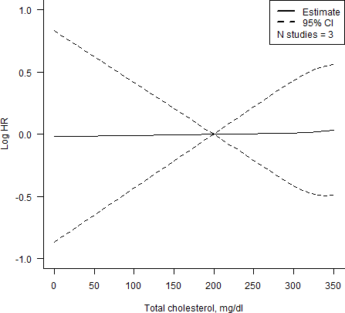

**Figure A.1:** Dose-response meta-analysis of total cholesterol on all-cause dementia

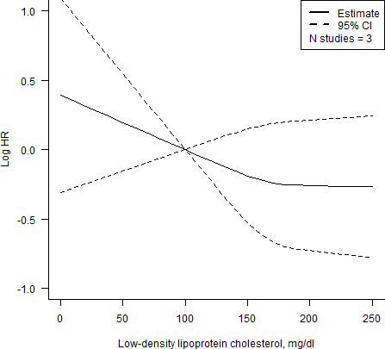

**Figure A.2:** Dose-response meta-analysis of low-density lipoprotein cholesterol on Alzheimer’s disease

*292*

* 1. *- Chapter 5*

### Chapter 5

* + 1. Amendments to protocol

Any changes made to the approved protocol are “Minor amendments” as per the ISAC criteria, specifically falling under the category of “Additional methods to further control for confounding or sensitivity analysis provided these are to be reported as secondary to the main findings”.

Changes include:

* + - * Use of a time-varying treatment indicator, to correctly classify time-at-risk.
      * Inclusion of additional covariates that are adjusted for in the main model.
    1. Minimum follow-up period

Enforcing a minimum period of follow-up is normally used to reduce the risk of reverse causation in an analysis by excluding events occurring within a certain time-frame post-exposure. With respect to dementia outcomes, which have a long prodromal period, enforcing a minimum period of follow-up can add biological validity to an analysis. Incident cases of dementia that occur within a few years of starting a drug may already be beyond effective preventive treatment at the time the drug was started, and so restricting the analysis to those with longer exposure to treatment may provide a more reliable estimate of the effect.

Panel A of Figure A.3 describes a standard analysis of an exposure with a minimum enforced follow-up period (in this case, 10 years). Participants enter the cohort and are classified at that point as either exposed or unexposed, for example, on the basis of a total cholesterol measurement. Participants are followed-up over time, but events occurring before the minimum period of follow-up are discarded.

*293*

* 1. *- Chapter 5*

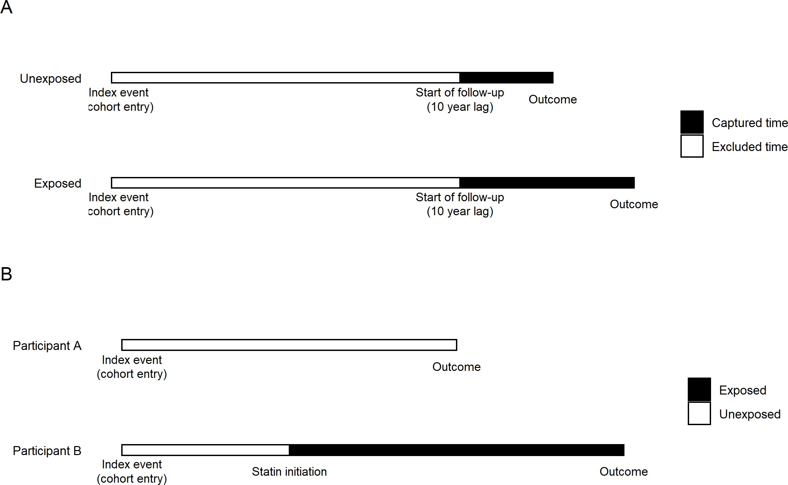

**Figure A.3:** Diagram illustrating the design of two studies. Panel A shows a study in which all participants enter the study and are assinged an exposure group at the same time, making it ease to define a minimum period of follow-up. In contrast, Panel B illustrates the time- varying analysis used in Chapter 5, which makes it challenging to define an unbiased minimum period of follow-up.

However, applying a similar approach to the analysis performed in Chapter 5, illustrated in Panel B of Figure A.3, is challenging. The use of a time updating treatment indicator results in two potential starting points for the 10-year lag: entry into the cohort or initiation of statin therapy. As the purpose of this analysis is to investigate the impact of statin treatment, starting the minimum period of follow-up from cohort entry is not helpful as it does not ensure that participants have been exposed to the drug for 10 years. Alternatively, defining the minimum period of follow-up from statin initiation cause issues around the treatment of time-at-risk before statin initiation and around the start point for the follow- up period in those never prescribed a statin. In summary, either approach is likely to be substantially biased.

With these caveats in mind, below I present a sensitivity analysis of the association

*294*

* 1. *- Chapter 6*

of statins with dementia outcomes, enforcing a minimum 10-year period of follow-up from statin initiation in those prescribed a statin.



**Figure A.4:** Sensitivity analysis showing the results of a re-analysis of the CPRD data enforcing a minimum follow-up period of 10 years in the statin group. Events occurring within 10 years of inititating statins were discarded, but the participant-time-at-risk was maintained. No minimum follow-up period was applied in those never taking a statin, due to the difficulties in defining the start date for the follow-up period, as discussed in the text above.

### Chapter 6

* + 1. Covariate matrix

*295*

* 1. *- Chapter 6*

**Table A.11:** Overview of missing data across covariates (described as N (%)) included in IPD analysis. Note that LDL is missing completely for the Whitehall and CaPS datasets as this measure was derived from the measures for TC, HDL and TG following multiple imputation of missing values in these variables.

|  |  |  |  |
| --- | --- | --- | --- |
| **Variable** | **Whitehall II** | **Epic** | **CaPS** |
| **Age group** | 182 (2.2%) | Complete | Complete |
| **Male** | Complete | Complete | Complete |
| **BMI** | 30 (0.4%) | 60 (5.4%) | X |
| **Education** | Complete | 1 (0.1%%) | X |
| **Smoke ever** | 1454 (17.7%) | 7 (0.6%) | 10 (0.4%) |
| **Alcohol ever** | 1344 (16.4%) | 26 (2.3%) | 129 (5.1%) |
| **Ethnicity** | 30 (0.4%) | 6 (0.5%) | X |
| **IHD** | Complete | 1 (0.1%) | X |
| **Diabetes** | 372 (3.3%) | 1 (0.1%) | 9 (0.4%) |
| **TC** | 82 (1%) | 114 (10.2%) | 55 (2.2%) |
| **LDL-c** | * | 140 (12.6%) | * |
| **HDL-c** | 108 (1.3%) | 141 (12.6%) | 98 (3.9%) |
| **TG** | 82 (1%) | 114 (10.2%) | 115 (4.6%) |

Values shown are N (Percentage) unless otherwise stated. **Key:** Complete - No missing values; X - Variable not recorded/available in this cohort; * - LDL values derived from total cholesterol, HDL and triglycerides.

**Abbreviations:** BMI - Body mass index; IHD - Ischemic heart disease; HDL - Low-density lipoprotein cholesterol; LDL - Low-density lipoprotein cholesterol; TG - Triglyc- erides.

* + 1. Dementia definitions across cohorts

*296*

* 1. *- Chapter 7*

**Table A.12:** Definition of dementia outcomes across cohorts included in the individual participant data meta-analysis. Note the codes used to define dementia and related outcomes in the HES data as part of the Whitehall II cohort were taken from a previously published analysis.372

|  |  |  |  |  |
| --- | --- | --- | --- | --- |
| **Cohort** | **Primary detection** | **Identification of dementia** | **Identification of AD** | **Identification of VaD** |
| CaPS | DPUK derived | Assessment at | NA | Not reported |
|  | variable from | clinic by a |  |  |
|  | Phase V | combination of |  |  |
|  | (2002-2004) | interviewers |  |  |
|  | data | and clinicians. |  |  |
| EPIC | Self-reported | Has your doctor | NA | NA |
| Norfolk | during 5th | ever told you |  |  |
|  | Health Checkup | that you had |  |  |
|  | (2016-2018) | any of the |  |  |
|  |  | following: |  |  |
|  |  | Dementia |  |  |
|  |  | (Alzheimer’s, |  |  |
|  |  | Vascular |  |  |
|  |  | Dementia, |  |  |
|  |  | Lewy Body or |  |  |
|  |  | other)? |  |  |
|  |  | YES/NO |  |  |
| Whitehall | Electronic | ICD-9: | ICD-9: 331.0 | ICD-9: 290.4 |
| II | health records, | 290.0-290.4, | ICD-10: F00, | ICD-10: F01 |
|  | via the Hospital | 331.0- | G30 |  |
|  | Episodes | 331.2,331.82,331.9 |  |  |
|  | Statistics | ICD-10: |  |  |
|  | database | F00,F01,F03,G30,G31 | |  |

**methods**

### Chapter 7

* + 1. Calculation of average adjustment values from pre- vious expert elicitation exercise

The paper describing the bias/indirectness-adjusted meta-analysis method used expert elicitation to define a distribution for bias and indirectness across eight

*297*

*A.7 - Chapter 7*

studies examining the effectiveness of routine anti-D prophylaxis in Rhesus negative women.346 The authors consider five sources of bias (selection bias, performance bias, attrition bias, detection bias and other bias) and four sources of indirectness (population, intervention, control, outcome). For each domain of bias/indirectness, four experts were asked to define the 67% interval around the effect expected due to bias/indirectness in the absence of a true effect. Additive or multiplicative scales were used to capture the intervals for additive and proportional bias/indirectness, respectively. The authors then use assumed log-normality of these distributions to derive a mean and variance for each on the log scale.

The resulting data for two domains of bias (attrition and detection) in one study are shown in Table A.13.

**Table A.13:** Distributions of bias, defined by position and variance terms, assigned by four independent experts to attrition and detection bias in a single study. This data was obtained from a previous publication,346 and represents an illustrative subset of the larger dataset.

|  |  |  |  |  |
| --- | --- | --- | --- | --- |
| **Study** | **Domain** | **Assessor** | **Position** | **Variance** |
| 1 | Attrition bias | 1 | -0.11 | 0.01 |
| 1 | Attrition bias | 2 | -0.08 | 0.01 |
| 1 | Attrition bias | 3 | -0.11 | 0.01 |
| 1 | Attrition bias | 4 | -0.05 | 0.00 |
| 1 | Detection bias | 1 | -0.09 | 0.02 |
| 1 | Detection bias | 2 | -0.32 | 0.14 |
| 1 | Detection bias | 3 | -0.23 | 0.02 |
| 1 | Detection bias | 4 | 0.00 | 0.01 |

In an attempt to inform the prior distributions used in the triangulation exercise presented in Chapter 7, I first averaged the position and variance values across the four experts for each source of bias/indirectness within each study. I took the average of the absolute of the position value, as I wanted to obtain the average

*298*

*A.7 - Chapter 7*

adjustment regardless of direction. The results of this process for the example data presented below are shown in Table A.14.

**Table A.14:** Position and variance values for two example bias domains (attritiona and detection), obtained by averaging the absolute of the values contained in A.15 across the four reviewers.

|  |  |  |  |
| --- | --- | --- | --- |
| **Study** | **Domain** | **Position** | **Variance** |
| 1 | Attrition bias | 0.0875 | 0.0075 |
| 1 | Detection bias | 0.1600 | 0.0475 |

I then took the average and maximum of the expert-averaged position and variance values. The results of this for the example data are presented in Table A.15.

**Table A.15:** Mean and maximum of position and variance values desribed in Table A.15

Mean position Mean variance Max position Max variance

0.12375 0.0275 0.16 0.0475

This two step approach (averaging across assessors before taking the average and maximum across domains/studies) was important. While the final average values will be the same whichever approach is taken, in a one-step process, the maximum value can be artificially inflated by a single expert’s estimate. For example, in the illustrative data subset above, Assessor 2 assigns a distribution of N(-0.32,0.14), which would double the maximum position (0.16) and triple the maximum variance (0.0475) obtained when first averaging across experts.

*299*

* 1. *- Chapter 7*

The distributions arising from this applying this approach to the entire dataset, stratified by bias/indirectness and additive/proportional effects, are presented in Table A.16.

**Table A.16:** Mean and maximum distributions for bias and indirectness obtained from data resulting from the elicitation exercise reported in *Turner et al*346. Note I did not calculate values for additive indirectness, as in my analysis, all indirectness was assumed to be proportional.

Mean Max

**Bias (Additive)** N(0.09, 0.06) N(0.42, 0.29)

**Bias (Proportional)** N(0.03, 0.02) N(0.31, 0.21)

**Indirectness (Proportional)** N(0.07, 0.02) N(0.26, 0.16)

The mean values shown were used to define the distributions assigned to “Moderate” bias/indirectness judgements in my analysis (see Tables 7.3 & 7.4).

* + 1. Comparison of two scenarios of bias

As discussed in the main text, I defined two sets of additive bias distributions as a sensitivity analysis. The results for the two case studies under the two scenarios are presented in the figures below. Under the first, shown on the left of the subsequent forest plot, the difference in the position value between the distributions assigned to “High” and “Moderate” bias levels is the same as between the “Moderate” and “Low” levels. Under the second scenario, the difference in the position value between the distributions assigned to “High” and “Moderate” is twice that between “Moderate” and “Low”.

*300*

* 1. *- Chapter 7*

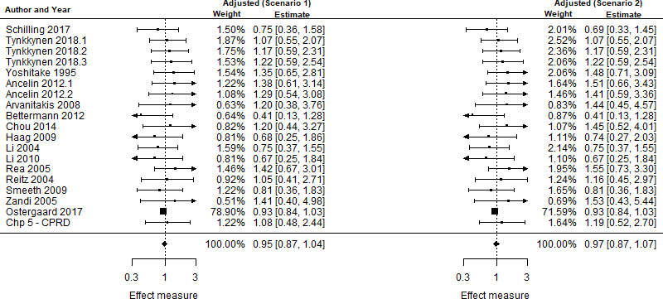

**Figure A.5:** Comparison of bias-/indirectness-adjusted meta-analyses under two different scenarios of prior distributions of bias. Scenario 1: position value between the distributions assigned to “High” and “Moderate” bias levels is the same as between the “Moderate” and “Low” levels. Scenario 2: position value between the distributions assigned to “High” and “Moderate” bias levels is twice that between “Moderate” and “Low” levels

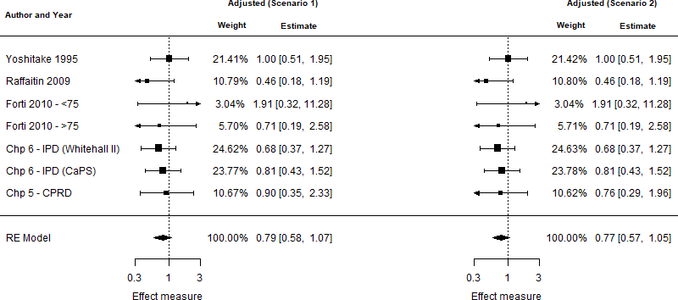

**Figure A.6:** Comparison of bias-/indirectness-adjusted meta-analyses of triglyc- erides/vascular dementia, using two different scenarios for the relationship of levels of bias. Scenario 1: position value between the distributions assigned to “High” and “Moderate” bias levels is the same as between the “Moderate” and “Low” levels. Scenario 2: position value between the distributions assigned to “High” and “Moderate” bias levels is twice that between “Moderate” and “Low” levels

*301*

* 1. *- Chapter 8*

### Chapter 8

* + 1. Reproducible research

Reproducible and science has been a key theme running through this thesis, as reflected by the development of an open source tools to search preprinted literature, create visualisations of risk-of-bias data and to preform quantitative triangulation. In line with this, an open source copy of the code used to produce this thesis is available on GitHub, as is the code used to perform the analysis contained within it.

Unfortunately, given the nature of the data underpinning the CPRD (Chapter 5) and IPD (Chapter 6) analyses, it is not possible to make it publicly available. Access to the CPRD data is dependent on an application to its managing body, while acces to the cohorts within the DPUK requires approval from both the DPUK and inidividual cohort owners. In the absence of data sharing, the best option to enable review and increase transparency is the open sharing of the code used to perform the analysis.136

Finally, all software projects in these thesis attempt to conform to minimal best practices for research computing.373,374

* + 1. Catalogue of failures

OVer the course of my PhD, I kept a record of attempted

Short section detailing the things I tried to do but which did not work:

* + - * Failed to properly scope the literature and correctly estimate the number of studies returned by the search
      * Failed IV analysis of anti-HC drugs because of low numbers of non-statins.
      * Failed to realise that the initial code list used for the positive control outcome of IHD in the CPRD analysis (Chapter 5)

*302*

*A.8 - Chapter 8*

* + - * + Unsuccessful grant application with Andy
        + Unsuccessful grant application with Chris Penfold
        + Unsuccessful grant application with Matt
        + Instrumental variable analysis of lipid regulation use using physicians pre- scribing preference.
        + 2 x unsuccessful conference abstracts

# B

## Other Appendices

**Contents**

* 1. **Software used to create this thesis** **304**
  2. **Producing risk-of-bias visualisations with robvis** **307**
  3. **Copies of papers arising from this thesis** **311**

*B.1 - Software used to create this thesis*

### B.1 Software used to create this thesis

This thesis was written in RMarkdown using the RStudio integrated development environment. Several R packages were used as part of this project.174,375–403 The version number of these packages is shown below:

## R version 3.6.1 (2019-07-05)

## Platform: x86_64-w64-mingw32/x64 (64-bit) ## Running under: Windows 10 x64 (build 19043) ##

## Matrix products: default ##

## locale:

## [1] LC_COLLATE=English_United Kingdom.1252 ## [2] LC_CTYPE=English_United Kingdom.1252

## [3] LC_MONETARY=English_United Kingdom.1252 ## [4] LC_NUMERIC=C

## [5] LC_TIME=English_United Kingdom.1252 ##

## attached base packages:

## [1] stats graphics utils datasets grDevices methods base ##

## other attached packages:

## [1] DiagrammeR_1.0.5 readxl_1.3.1 networkD3_0.4 ## [4] ggdag_0.2.3 dagitty_0.3-1 sf_0.9-8

## [7] flextable_0.6.4 data.table_1.14.0 kableExtra_1.3.1 ## [10] medrxivr_0.0.5.9000 robvis_0.3.0.900 png_0.1-7

## [13] metafor_3.0-2 Matrix_1.2-17 patchwork_1.1.1 ## [16] ggplot2_3.3.5 dplyr_1.0.6 magrittr_2.0.1

*306*

* 1. *- Software used to create this thesis*

##

## loaded via a namespace (and not attached):

|  |  |  |  |  |
| --- | --- | --- | --- | --- |
| ## | [1] | colorspace_1.4-1 | ellipsis_0.3.1 | class_7.3-15 |
| ## | [4] | rio_0.5.16 | rprojroot_2.0.2 | snakecase_0.11.0 |
| ## | [7] | base64enc_0.1-3 | rstudioapi_0.13 | farver_2.0.1 |
| ## | [10] | graphlayouts_0.5.0 | ggrepel_0.9.1 | fansi_0.4.2 |
| ## | [13] | lubridate_1.7.9 | mathjaxr_1.4-0 | xml2_1.3.2 |
| ## | [16] | extrafont_0.17 | cachem_1.0.3 | knitr_1.36 |
| ## | [19] | polyclip_1.10-0 | jsonlite_1.7.2 | Rttf2pt1_1.3.7 |
| ## | [22] | rgeos_0.5-5 | ggforce_0.3.1 | readr_1.3.1 |
| ## | [25] | compiler_3.6.1 | httr_1.4.1 | fastmap_1.0.1 |
| ## | [28] | cli_2.5.0 | tweenr_1.0.1 | visNetwork_2.0.9 |
| ## | [31] | htmltools_0.5.1.1 | tools_3.6.1 | igraph_1.2.6 |
| ## | [34] | gtable_0.3.0 | glue_1.4.2 | rnaturalearthdata_0.1.0 |
| ## | [37] | rsvg_1.3 | V8_3.0.1 | PRISMA2020_0.0.1 |
| ## | [40] | Rcpp_1.0.6 | rbiorxiv_0.2.0 | cellranger_1.1.0 |
| ## | [43] | vctrs_0.3.6 | debugme_1.1.0 | nlme_3.1-140 |
| ## | [46] | extrafontdb_1.0 | DiagrammeRsvg_0.1 | ggraph_2.0.0 |
| ## | [49] | conflicted_1.0.4 | xfun_0.22 | stringr_1.4.0 |
| ## | [52] | ps_1.3.0 | openxlsx_4.1.4 | rvest_0.3.5 |
| ## | [55] | lifecycle_1.0.0 | MASS_7.3-51.6 | scales_1.1.0 |
| ## | [58] | tidygraph_1.1.2 | hms_0.5.2 | RColorBrewer_1.1-2 |
| ## | [61] | yaml_2.2.1 | curl_4.3 | gridExtra_2.3 |
| ## | [64] | gdtools_0.2.3 | stringi_1.5.3 | highr_0.8 |
| ## | [67] | e1071_1.7-3 | boot_1.3-22 | zip_2.1.1 |
| ## | [70] | rlang_0.4.10 | pkgconfig_2.0.3 | systemfonts_1.0.1 |
| ## | [73] | evaluate_0.14 | lattice_0.20-38 | purrr_0.3.4 |
| ## | [76] | htmlwidgets_1.5.1 | labeling_0.3 | processx_3.5.2 |
| ## | [79] | tidyselect_1.1.0 | here_1.0.0 | plyr_1.8.5 |
| ## | [82] | bookdown_0.21.6 | R6_2.5.0  *307* | magick_2.2 |

* 1. *- Software used to create this thesis*

|  |  |  |  |  |
| --- | --- | --- | --- | --- |
| ## | [85] | generics_0.1.0 | DBI_1.1.1 | pillar_1.5.1 |
| ## | [88] | haven_2.3.1 | foreign_0.8-71 | withr_2.3.0 |
| ## | [91] | units_0.6-6 | sp_1.3-2 | tibble_3.1.0 |
| ## | [94] | janitor_2.0.1 | crayon_1.4.1 | uuid_0.1-4 |
| ## | [97] | KernSmooth_2.23-15 | utf8_1.2.1 | rmarkdown_2.7.4 |
| ## | [100] | officer_0.3.17 | viridis_0.5.1 | rnaturalearth_0.1.0 |
| ## | [103] | grid_3.6.1 | callr_3.7.0 | cranlogs_2.1.1 |
| ## | [106] | forcats_0.5.1 | irrCAC_1.0 | digest_0.6.27 |
| ## | [109] | classInt_0.4-2 | webshot_0.5.2 | tidyr_1.1.3 |
| ## | [112] | munsell_0.5.0 | viridisLite_0.3.0 | utilities_0.3.0 |

*308*

* 1. *- Producing risk-of-bias visualisations with robvis*

### Producing risk-of-bias visualisations with robvis

The robvis package provides functions to convert a risk-of-bias assessment summary table into a summary plot or a traffic-light plot, formatted based on the specific risk-of-bias assessment tool used.

* + 1. Templates

robvis currently contains templates for the following tools:

* + - * ROB2
      * ROBINS-I
      * QUADAS-2
      * ROB1
      * General
    1. Data expectations

For the direction bias plots, the data expected by the tools is more comprehensive.

**Table B.1:** First five assessments contained in data_rob2, an example dataset for the Risk of Bias 2 tool for randomised controlled trials available via the robvis package.

|  |  |  |  |  |  |
| --- | --- | --- | --- | --- | --- |
| **Study D1** | **D2** | **D3** | **D4** | **D5** | **Overall** |
| Study 1 Low | Low | Low | Low | Low | Low |
| Study 2 Some concerns | Low | Low | Low | Low | Low |
| Study 3 No information | Low | Some concerns | Low | Low | Some concerns |
| Study 4 Low | Low | High | Low | Some concerns | High |
| Study 5 High | High | Low | Low | Some concerns | Low |

**Table B.2:** Example data illustrating the structure required for bias direction plots. *dij*, *did*, and *dit* define the extent (Serious, Moderate, Low), direction (right or left), and type (additive or proportional) of bias in the *i*th domain. Note that, because of the wide nature of the data, I have abbreviated the data in order to display it. A key for interpreting the data can be found below the table.

**ID yi sei**

1 0.11 0.05

2 0.02 0.15

3 -0.06 0.13

4 -0.11 0.18

5 -0.12 0.18

**d1j d1d d1t**

H R A

M L A

M L A

M L A

H L A

**d2j d2d d2t**

M U A

M U A

M U A

M U A

L - -

**d3j d3d d3t**

L - -

L - -

L - -

L - -

L - -

**d4j d4d d4t**

L - -

L - -

L - -

L - -

L - -

**d5j d5d d5t**

L - -

L - -

L - -

L - -

L - -

**d6j d6d d6t**

L - -

L - -

L - -

L - -

1. - -

**d7j d7d d7t**

1. R P

M R P

M L P

M L P

M L P

**overall**

H M M M H

*B.2 - Producing risk-of-bias visualisations with robvis*

*310*

**Abbreviations:** yi - Effect estimate; sei - Standard error of the effect estimate; H - High risk of bias; M - Moderate risk of bias; L - Low risk of bias; R - Right; L - Left; U - Unpredictable; A - Additive; P - Proportional

* 1. *- Producing risk-of-bias visualisations with robvis*
     1. Simple visualisations

rob_summary(data = data_rob2, tool = "ROB2")

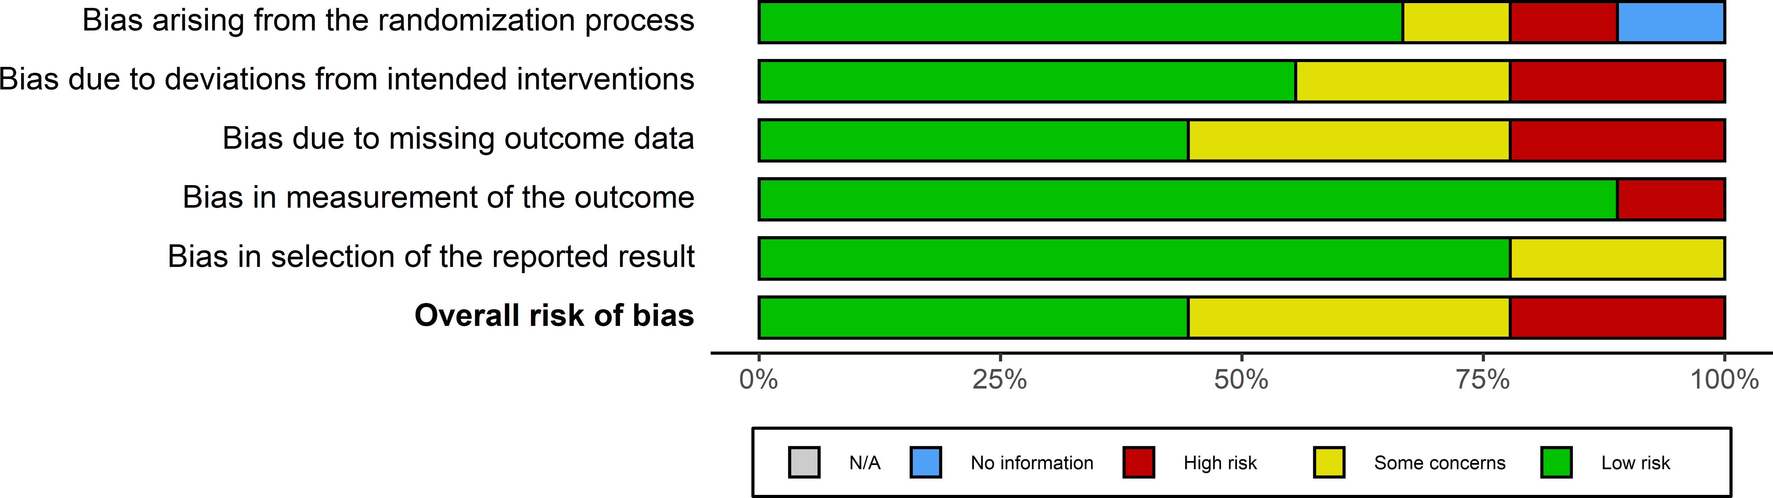

**Figure B.1:** Illustration of a simple summary barplot created using the data_rob example risk-of-bias dataset shown in Table @ef(tab:biasData-table) above. Note that this plot is unweighted and shows the *proportion of studies* at each level of bias, but an option exists with robvis to create a barplot weighted by the *proportion of evidence* at each level of bias.

rob_traffic_light(data = data_rob2,

tool = "ROB2", psize = 10)

* 1. *- Producing risk-of-bias visualisations with robvis*

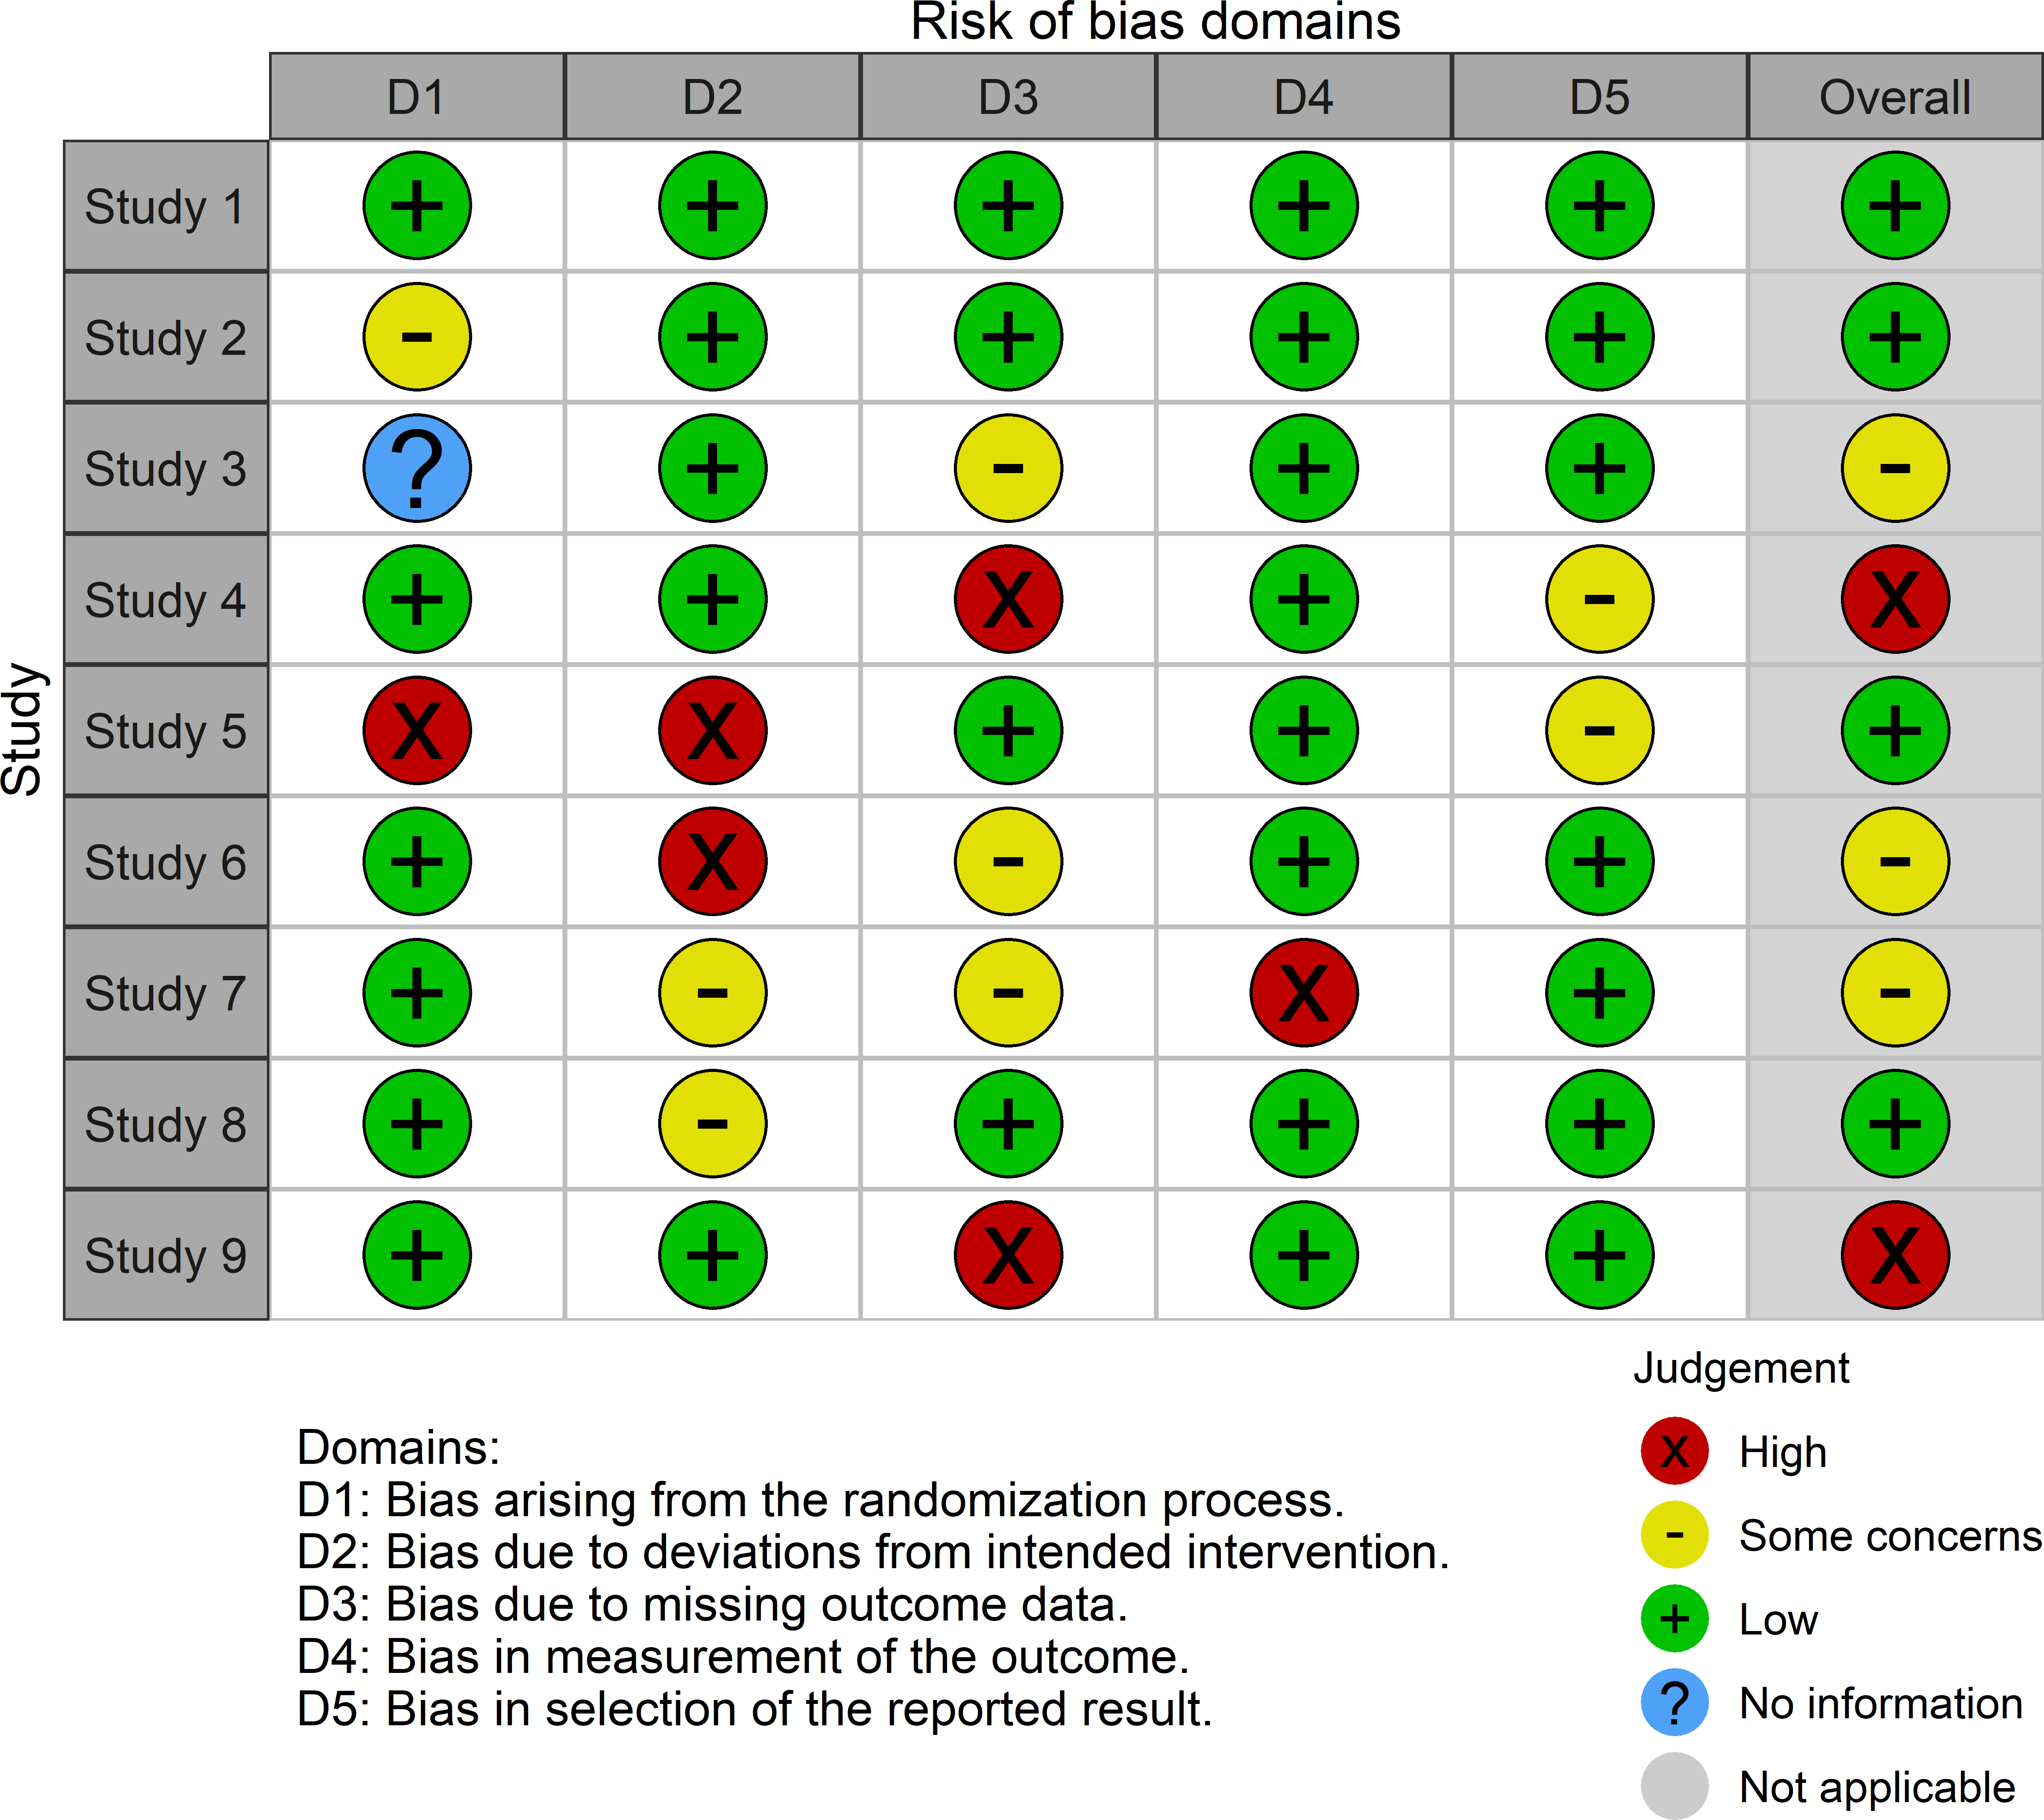

**Figure B.2:** Illustration of a simple traffic light plot created using the data_rob example risk-of-bias dataset shown in Table @ef(tab:biasData-table) above.

*312*

* 1. *- Copies of papers arising from this thesis*

### Copies of papers arising from this thesis

The following pages contain copies of the following publications:

* + - * ***McGuinness L. A.****, Higgins J. P. T., Walker, V. M., Davies, N. M., Martin, R. M., Coulthard, E., Davey-Smith, G., Kehoe, P. G., and Ben- Shlomo, Y. (2021) Association of lipid-regulating drugs with dementia and related conditions: an observational study of data from the Clinical Practice Research Datalink. medRxiv. DOI:* [*10.1101/2021.10.21.21265131*](https://doi.org/10.1101/2021.10.21.21265131)
      * ***McGuinness, L. A.****, and L Schmidt. (2020) medrxivr: Accessing and searching medRxiv and bioRxiv preprint data in R. Journal of Open Source Software 5.54 2651. DOI:* [*10.21105/joss.02651*](https://doi.org/10.21105/joss.02651)
      * ***McGuinness, L. A.****, and Higgins J. P. T. (2020) “Risk-of-bias VISualiza- tion (robvis): An R package and Shiny web app for visualizing risk-of-bias assessments.” Research Synthesis Method). DOI:* [*10.1002/jrsm.1411*](https://doi.org/10.1002/jrsm.1411)
      * ***McGuinness, L. A.****, and Sheppard A. L. 2020. “A Descriptive Analysis of the Data Availability Statements Accompanying Medrxiv Preprints and a Comparison with Their Published Counterparts.” PLOS ONE 16(5): e0250887. DOI:* [*10.1371/journal.pone.0250887*](https://doi.org/10.1371/journal.pone.0250887)
      * *Hennessy, E. A., Acabchuk, R., Arnold, P. A., Dunn, A. G., Foo, Y. Z., Johnson, B. T., Geange, S. R., Haddaway, N. R., Nakagawa, S., Mapanga, W., Mengersen, K., Page, M., Sánchez-Tójar, A. Welch, V.,* ***and McGuinness***

***L. A.*** *(2021). Ensuring Prevention Science Research is Synthesis-Ready for Immediate and Lasting Scientific Impact. Prevention Science . DOI:* [*10.1007/s11121-021-01279-8*](https://doi.org/10.1007/s11121-021-01279-8)

These manuscripts arose from work performed as part of this thesis, as discussed more fully in Section 1.7.1.

*313*

medRxiv preprint doi: https://doi.org/10.1101/2021.10.21.21265131; this version posted October 25, 2021. The copyright holder for this preprint

**(which was not certified by peer review)** is the author/funder, who has granted medRxiv a license to display the preprint in perpetuity.

It is made available under a CC-BY-NC 4.0 International license .

##### Front matter

**Type of manuscript:**

Original Research Article

**Title:**

Association of lipid-regulating drugs with dementia and related conditions: an observational study of data from the Clinical Practice Research Datalink

**Authors and affiliations:**

Luke A McGuinness1,2,*, Julian PT Higgins1,2,3, Venexia M Walker1,2,4, Neil M Davies1,2, Richard M Martin1,2,3, Elizabeth Coulthard5, George Davey-Smith1,2,3, Patrick G Kehoe5 and Yoav Ben-Shlomo2

* 1. MRC University of Bristol Integrative Epidemiology Unit, Bristol, UK
  2. Bristol Medical School: Population Health Sciences, University of Bristol, Bristol, UK
  3. NIHR Biomedical Research Centre at University Hospitals Bristol and Weston NHS Foundation Trust and the University of Bristol.
  4. Department of Surgery, University of Pennsylvania Perelman School of Medicine,

Philadelphia, USA

* 1. Bristol Medical School: Translational Health Sciences, University of Bristol, Bristol, UK

**Corresponding author:**

Luke McGuinness; Bristol Medical School, University of Bristol, Canynge Hall, 39 Whatley Road, Bristol, BS8 2PS, United Kingdom.; [luke.mcguinness@bristol.ac.uk](mailto:luke.mcguinness@bristol.ac.uk)

**Word counts**

* Main text word count (max 4000): 3104
* Abstract word count (max 250): 250

1

medRxiv preprint doi: https://doi.org/10.1101/2021.10.21.21265131; this version posted October 25, 2021. The copyright holder for this preprint

**(which was not certified by peer review)** is the author/funder, who has granted medRxiv a license to display the preprint in perpetuity.

It is made available under a CC-BY-NC 4.0 International license .

##### Abstract

**Background:** There is some evidence that circulating blood lipids play a role in the development of Alzheimer’s disease (AD) and dementia. These modifiable risk factors could be targeted by existing lipid-regulating agents, including statins, for dementia prevention. Here, we test the association between lipid-regulating agents and incidence of dementia and related conditions in the Clinical Practice Research Datalink (CPRD), an United Kingdom-based electronic health record database.

**Methods:** A retrospective cohort study was performed using routinely collected CPRD data (January 1995 and March 2016). Multivariable Cox proportional hazard models, allowing for a time-varying treatment indicator, were used to estimate the association between seven lipid-regulating drug classes (vs. no drug) and five dementia outcomes (all-cause, vascular and other dementias, and probable and possible Alzheimer’s disease).

**Results:** We analyzed 1,684,564 participants with a total follow-up of 10,835,685 patient- years (median: 5.9 years (IQR:2.7-9.7)). We found little evidence that lipid-regulating agents were associated with incidence of Alzheimer’s disease (probable HR:0.98, 95%CI:0.94-1.01; possible HR:0.97, 95%CI:0.93-1.01), but there was evidence of an increased risk of all-cause (HR:1.17, 95%CI:1.14-1.19), vascular (HR:1.81, 95%CI:1.73- 1.89) and other dementias (HR:1.19, 95%CI:1.15-1.24). Evidence from a number of control outcomes indicated the presence of substantial residual confounding by indication (ischaemic heart disease HR: 1.62, 95%CI: 1.59-1.64; backpain HR: 1.04, 95%CI: 1.03-1.05;

and Type 2 diabetes HR: 1.50, 95%CI: 1.48-1.51).

**Conclusion:** Lipid-regulating agents were not associated with reduced Alzheimer’s disease risk. There was some evidence of an increased the risk of all-cause, vascular and other dementias, likely due to residual confounding by indication.

**Keywords:** Dementia; Alzheimer’s disease; Lipids; Statins; Cohort study; Observational study; Electronic health records

medRxiv preprint doi: https://doi.org/10.1101/2021.10.21.21265131; this version posted October 25, 2021. The copyright holder for this preprint

**(which was not certified by peer review)** is the author/funder, who has granted medRxiv a license to display the preprint in perpetuity.

It is made available under a CC-BY-NC 4.0 International license .

##### Key messages

* A large cohort of patients from the Clinical Practice Research Datalink (CPRD) electronic health record database was assembled to examine the association of lipid-regulating agents, such as statins, with dementia outcomes.
* There was little evidence that lipid-regulating agents were associated with

Alzheimer’s disease, but there was some evidence for a harmful association with all- cause, vascular and other dementias. In all cases, the estimated associations were driven by the any statin subgroup, which comprised most participants in our cohort.

* Evidence from the control outcome analyses indicated strong residual confounding by indication, mostly likely related to vascular factors.

medRxiv preprint doi: https://doi.org/10.1101/2021.10.21.21265131; this version posted October 25, 2021. The copyright holder for this preprint

**(which was not certified by peer review)** is the author/funder, who has granted medRxiv a license to display the preprint in perpetuity.

It is made available under a CC-BY-NC 4.0 International license .

##### Introduction

Dementia is a major progressive neurocognitive disorder, the most common types of which are Alzheimer’s disease, vascular dementia and Lewy Body dementia.(1) Despite an increasing number of cases globally and decades of research, there remains much unknown about the pathogenesis and progression of the disease, and, at present, no effective treatment exists to arrest, slow or reverse the cognitive decline associated with the condition.(2) Drug repurposing, the identification of new applications for previously approved drugs, may provide an efficient mechanism to discover new effective preventative and therapeutic treatments for dementia.(3,4)

Several cardiovascular factors have been identified as potential risk factors for dementia,(5) and of these, circulating lipid levels represent a promising target for intervention due to the ready availability of lipid-modifying treatments. In this context, determining whether lipid-regulating agents (LRA) could be repurposed for the prevention of dementia and related diseases would be helpful in the development of evidence-based prevention policy. Several existing prospective studies have examined the association of LRA use with dementia.(6–10) However, many of these studies are small, record few outcomes, and had limited follow-up.

The use of electronic health data for epidemiological research has several advantages.(11) As the data are collected through the routine care of a large cohort, they allow for nested cohort studies using sample sizes and time-scales which would be infeasible using traditional methods. In addition, data are collected for care provision and without a specific research question in mind, providing a holistic picture of a patient and their health experience. While they may not contain information on all potentially important confounders,(12) electronic health records provide routine data on common covariates for millions of participants.

We therefore aimed to test the association between several major classes of LRA and all- cause dementia, Alzheimer’s disease, vascular dementia and other dementias, in the Clinical Practice Research Datalink (CPRD), a large, population-based electronic health record (EHR) database from the United Kingdom.(13)

medRxiv preprint doi: https://doi.org/10.1101/2021.10.21.21265131; this version posted October 25, 2021. The copyright holder for this preprint

**(which was not certified by peer review)** is the author/funder, who has granted medRxiv a license to display the preprint in perpetuity.

It is made available under a CC-BY-NC 4.0 International license .

##### Methods

* 1. Study design and protocol

We defined a longitudinal cohort using data from the CPRD. Our initial sample included all participants registered at a participating practice between 1 January 1995 and 29 February 2016 who had a flag for “research quality” data. Records pre-dating the 1995 cut-off were excluded from the analysis as data quality and reliability are thought to be higher after this date.(14) All events of interest were identified using predetermined code lists, which are available for inspection (see Data/code availability).

An *a priori* protocol for this study was published,(15) and amendments to this are recorded in Supplementary Materials 1. This study was reported in line with the RECORD guidelines (Supplementary Materials 2).(16)

* 1. Study Cohort

Participants were included in our study cohort if their record contained any of the following index events: (a) a code for a diagnosis of hypercholesterolemia or related condition; (b) a code for prescription of a LRA (such as statins); (c) a total cholesterol test result of >4mmol/L; (d) or a low-density lipoprotein cholesterol (LDL-c) test result of

>2mmol/L.

These index events allowed us to define a population of participants who were either at risk of hypercholesterolemia, as indicated by the elevated total or LDL-c test results, or had already been diagnosed with it, as indicated by a diagnostic code or related prescription.

This approach, conditioning entry into the study on being either “at-risk” or already

diagnosed with hypercholesterolemia, was employed to reduce the “confounding by

indication” that we would expect to observe if we had used a general population cohort.

An index date for each participant was defined as the date when the first relevant code or test result (as detailed above) was recorded on their clinical record. Participants were followed up until the earliest of (a) an outcome of interest; (b) death; (c) end of follow-up (29 February 2016); (d) last registration date with their GP practice; or (e) the last CPRD collection date for their practice. Participants were removed from our sample if they were less than 40 years of age at entry (as these patients are less likely to be prescribed a LRA), had less than 12 months of “research quality” data prior to their index date, were simultaneously prescribed more than one LRA (due to the difficulty of assigning these patients to a single exposure group), or were diagnosed with dementia before or on the date of the index event.

medRxiv preprint doi: https://doi.org/10.1101/2021.10.21.21265131; this version posted October 25, 2021. The copyright holder for this preprint

**(which was not certified by peer review)** is the author/funder, who has granted medRxiv a license to display the preprint in perpetuity.

It is made available under a CC-BY-NC 4.0 International license .

* 1. Exposures

We considered seven lipid-regulating drug classes based on groupings in the British National Formulary (BNF)(17), namely: statins, fibrates, bile acid sequestrants, ezetimibe, nicotinic acid groups, ezetimibe and statin (representing one treatment containing both drugs, rather than the two classes being prescribed concurrently), and omega-3 fatty acid groups.

To address the potential for immortal time bias, we employed a time-varying indicator of treatment status to correctly allocate time-at-risk to the exposed and unexposed groups.(18) Under this model, all participants entered the unexposed group on their index date and were moved into the exposed group on the date they were first prescribed an eligible LRA. Participants whose index event was a LRA prescription entered the study and the exposed group on the same day, and so contributed no time-at-risk to the unexposed group.

A participant’s drug class was assigned based on their first recorded prescription, and any drug switching was ignored to mimic an intention-to-treat approach. We did however tabulate how often the initial drug class was stopped (defined as last prescription of the primary class being followed by at least six months of observation), added to (defined as a second drug class being prescribed before the last prescription of the initial class), or switched (defined as a second drug class being prescribed after the last prescription of the initial class).

* 1. Outcomes

We considered five outcomes as part of this analysis: probable Alzheimer’s disease,

possible Alzheimer’s disease, vascular dementia, other dementias, and a composite all- cause dementia outcome. When two or more outcomes were coded in a participant’s clinical record, a decision tree was used to differentiate between them (Supplementary Figure 1). The diagnosis date of the outcome was determined by the first record of a relevant code.

* 1. Covariates

The analysis was adjusted for a range of baseline covariates including sex, grouped year of entry into the cohort (<=2000, 2001-2005, 2006-2010, >2010), Charlson co-morbidity index, Index of Multiple Deprivation (IMD), consultation rate, alcohol use (current, former, never), smoking (current, former, never), BMI, baseline total cholesterol, and history of cardiovascular disease, coronary bypass surgery, coronary artery disease, peripheral arterial disease, hypertension, chronic kidney disease, and Type 1 and Type 2 diabetes.

These variables were selected as potential confounders between dementia outcomes and use of a LRA. All covariates were determined at the index date and definitions for each can be found in Supplementary Table 1.

medRxiv preprint doi: https://doi.org/10.1101/2021.10.21.21265131; this version posted October 25, 2021. The copyright holder for this preprint

**(which was not certified by peer review)** is the author/funder, who has granted medRxiv a license to display the preprint in perpetuity.

It is made available under a CC-BY-NC 4.0 International license .

* 1. Analysis plan

All analyses were performed in STATA (V16, StataCorp LLC, College Station, TX). Cox proportional hazard models with a time-varying treatment indicator were used to estimate the hazard ratio and corresponding 95% confidence intervals, allowing for potential

clustering of outcomes by practice. Participant’s age was used as the time axis for all models.(19–21) To observe the effect of adjusting for additional covariates, we compared models adjusted for age only and age and sex with the fully adjusted model. Additional analyses stratified by outcome and drug class were also performed.

In the case of missing data, we used multiple imputation by chained equations (MICE) in STATA to create 20 imputed datasets.(22) All covariates included in the analytic model were also included in the imputation model.(23) The full imputation model is available for inspection (See Data/Code availability section).

* 1. Sensitivity analyses

We performed several sensitivity analyses. As statins are contraindicated in pregnancy,(24) we ran the models described above but excluding participants below the age of 55. Given the different ability of lipophilic statins to cross the blood-brain barrier,(25) we further stratified the statin exposure group into lipophilic (Atorvastatin, Lovastatin, Simvastatin, Cerivastatin) and hydrophilic (Pravastatin, Rosuvastatin, Fluvastatin) statins. Finally, we included three alternative outcomes with known associations with statin use as positive or negative controls using the fully adjusted model: back pain (negative control), ischaemic heart disease (positive protective control), and Type 2 diabetes (positive harmful control).(26,27)

medRxiv preprint doi: https://doi.org/10.1101/2021.10.21.21265131; this version posted October 25, 2021. The copyright holder for this preprint

**(which was not certified by peer review)** is the author/funder, who has granted medRxiv a license to display the preprint in perpetuity.

It is made available under a CC-BY-NC 4.0 International license .

##### Results

* 1. Patient characteristics

A total of 1,684,564 participants met the inclusion criteria for our cohort (see Supplementary Figure 2 for the attrition flowchart), with a total follow-up of 10,835,685 patient years at risk. Most participants were included in the cohort due to an elevated test result (elevated cholesterol test result: 93%, prescription of LRA: 5.6%, code for hypercholesterolemia: 1%). The median age at the index date was 57 years (inter-quartile range (IQR):48-67) and participants were followed up for a median of 5.9 years (IQR:2.7- 9.7). During follow-up, an all-cause dementia diagnosis was recorded for 41,830 patients (12,647 probable Alzheimer’s disease, 9,954 possible Alzheimer’s disease, 8,466 vascular dementia, 10,763 other dementia).

The number of events, time-at-risk and crude rates for each drug class, tabulated by dementia outcome, are shown in Table 1. Most participants (98.1%) prescribed a lipid- regulating agent were prescribed a statin. We excluded the “Ezetimibe and statins” and “Nicotinic acid groups” drug classes from subsequent subgroup analyses based on the extremely small number of participants in these groups (Table 1). The distribution of

baseline characteristics across the remaining seven drug classes can be seen in Table 2. The stopping, addition and switching of drug classes was common across all exposure groups (Supplementary Table 2).

* 1. Missing data

Full covariate information was available for 450,234 participants (26.7%). Five key variables had some missing data: IMD 2010 score, a proxy for socioeconomic position that is measured as twentiles with 1 indicating the least deprived and 20 indicating the most deprived, was missing for 625,788 participants (37.1%), because it is only recorded for selected English practices; alcohol status was missing for 269,526 participants (16%); smoking status was missing for 84,424 participants (5%); BMI, or a calculated BMI from height and weight measurements, was missing for 266,672 participants (15.8%); baseline total cholesterol was missing for 119,675 participants (7.1%); and baseline LDL cholesterol was missing for 787,289 participants (46.7%).

* 1. Primary analysis

**Alzheimer’s disease**

As shown in Figure 1, our results show little evidence of an association between lipid- regulating agents and probable (HR:0.98, 95%CI:0.94-1.01) or possible (HR:0.97, 95%CI:0.93-1.01) Alzheimer’s disease when compared with no treatment, except for an adverse association between fibrates and probable Alzheimer’s disease (HR:1.52, 95%CI:1.13-2.03).

medRxiv preprint doi: https://doi.org/10.1101/2021.10.21.21265131; this version posted October 25, 2021. The copyright holder for this preprint

**(which was not certified by peer review)** is the author/funder, who has granted medRxiv a license to display the preprint in perpetuity.

It is made available under a CC-BY-NC 4.0 International license .

**Non-Alzheimer’s disease dementias**

In contrast to the findings for Alzheimer’s disease outcomes, lipid-regulating agents were associated with an increased risk of a subsequent diagnosis of vascular dementia (HR:1.81, 95%CI:1.73-1.89) or other dementias (HR:1.19, 95%CI:1.15-1.24). Again, the observed estimate was driven mainly by the any statin subgroup, but there was some evidence that ezetimibe was associated with an increased risk of vascular (HR:2.33, 95%CI:1.11-4.89) and other (HR:1.88, 95%CI:1.01-3.5) dementias.

**All-cause dementia**

For the composite all-cause dementia outcome, we found treatment with a lipid-regulating agent was associated with a slightly increased risk (HR:1.17, 95%CI:1.14-1.19), which lies between the associations for the Alzheimer and non-Alzheimer dementia outcomes as would be expected. There was also some evidence that fibrates were associated with increased risk of all-cause dementia (HR:1.28, 95%CI:1.08-1.52).

* 1. Sensitivity analyses

Adjustment for additional covariates beyond age and sex had a limited impact (Supplementary Figure 3), except for the probable Alzheimer’s disease outcome, where the full adjustment attenuated to the null the protective association observed when adjusting only for age and sex.

Removing participants aged 55 and under at the index date from our analysis had minimal effect on our estimates (Supplementary Figure 4). When stratifying by statin properties, hydrophilic statins were less harmful in relation to the any, vascular and other dementias outcomes compared with lipophilic statins (Supplementary Figure 5). Similarly,

hydrophilic statins were associated with a reduced incidence of Alzheimer’s disease,

compared with the absence of evidence for an association with lipophilic statins.

For our control outcomes (Supplementary Figure 6), there was some evidence that patients prescribed a lipid-regulating agent had an increased risk of back pain (HR: 1.04, 95%CI: 1.03-1.05), ischaemic heart disease (HR: 1.62, 95%CI: 1.59-1.64) and Type 2 diabetes (HR:

1.50, 95%CI: 1.48-1.51).

medRxiv preprint doi: https://doi.org/10.1101/2021.10.21.21265131; this version posted October 25, 2021. The copyright holder for this preprint

**(which was not certified by peer review)** is the author/funder, who has granted medRxiv a license to display the preprint in perpetuity.

It is made available under a CC-BY-NC 4.0 International license .

##### Discussion

* 1. Main findings

There was little evidence for an association between lipid-regulating agents and probable and possible Alzheimer’s when compared with no treatment, but some evidence they were associated with an increased risk of an all-cause dementia, secondary to their association with vascular and other dementias diagnoses. The association observed in each case was driven by the any statin subgroup, which included a substantial majority of participants.

For the other drug classes, there was limited evidence of an association with any outcome, with two exceptions. Ezetimibe was associated with increased risk of vascular and other dementias, while fibrates were associated with increased risk of all-cause dementia and probable Alzheimer’s disease.

* 1. Comparison with other literature

Much of the existing literature focuses on the association of statins alone with neurodegenerative outcomes, with other lipid-regulating agents being grouped as “non- statin cholesterol-lowering drugs,”(8) echoing the distribution of participants in our analysis.

**Statins and all-cause dementia**

A recent Cochrane Review identified two randomized trials comparing treatment with statins versus non-treatment for the prevention of dementia, only one of which presented information on the incidence of dementia.(28) This study (Heart Protection Study) showed no effect of treatment with simvastatin on all-cause dementia risk (OR: 1.00, 95%CI:0.61- 1.65),(29) but concerns were raised over the diagnostic criteria used. A meta-analysis of 30 observational studies found a reduced risk of all-cause dementia was associated with statin treatment (RR 0.83, 95%CI: 0.79–0.87).(30) This conflicts with the findings of our analysis, where statin use was associated with an increased risk of all-cause dementia (HR:1.17, 95%CI:1.14-1.19). Some of the included studies in the meta-analysis specifically exclude vascular dementia from the definition of all-cause dementia,(31) which may limit the ability for comparison with our findings for the all-cause dementia outcome.

Additionally, a previous analysis of the THIN EHR database using a propensity-score matched analysis found a protective effect of statins on all-cause dementia (HR:0.81, 95%CI:0.69-0.96)(32). Differences in the code-lists used to define dementia outcomes, in addition an analytical approach that adjusted for covariates defined after the index date, may go some way to explaining the discrepancy.

**Statins and Alzheimer’s disease**

medRxiv preprint doi: https://doi.org/10.1101/2021.10.21.21265131; this version posted October 25, 2021. The copyright holder for this preprint

**(which was not certified by peer review)** is the author/funder, who has granted medRxiv a license to display the preprint in perpetuity.

It is made available under a CC-BY-NC 4.0 International license .

Our results are broadly in line with the findings of two distinct approaches examining the

effect of statin treatment on subsequent Alzheimer’s disease. No randomized trials of

statins for the prevention of Alzheimer’s disease have been reported, but a recent meta- analysis of 20 observational studies found statins were associated with a reduced risk of Alzheimer’s disease (RR 0.69, 95% CI 0.60–0.80) with stronger evidence than observed in our analysis.(30) This review included case-control studies and analyses likely to be at risk of immortal time bias, which may account for the discrepancy with our findings.

Additionally, a recent Mendelian randomization study examining the effect of genetic

inhibition of HMGCR on Alzheimer’s disease (a genetic proxy for statin treatment) provided

equivocal evidence (OR: 0.91, 95%CI: 0.63-1.31) but was consistent with our results.(33)

Our additional analyses stratified by statin properties found little evidence of differences in associations of lipophilic and hydrophilic statins and incidence of Alzheimer’s disease, consistent with a recent meta-analysis of observational studies.(6)

**Statins and vascular/other dementia**

Far fewer studies have tested the association between lipid-regulating agents and vascular dementia or other dementias. A recent review found four observational studies examining the association of statins and vascular dementia found limited evidence for an effect (RR:0.93, 95% CI 0.74–1.16).(30) This contrasts with the harmful association found in our analysis (HR:1.81, 95%CI:1.73-1.89). When stratifying by lipid properties, lipophilic statins were more harmful than hydrophilic statins in vascular dementia, potentially due to their ability to cross the blood brain barrier.

**Other drug classes**

Apart from statins, few studies examining a lipid-regulating agent have been reported. One of the few classes for which a previous analysis was available were fibrates, which found little evidence of an association with all-cause dementia was identified,(8) inconsistent with our finding that patients prescribed fibrates had higher all-cause dementia risk than those prescribed other lipid lowering agents.

A previous Mendelian randomization study found little evidence that genetic variants that proxy for ezetimibe affect risk of Alzheimer’s disease (OR: 1.17, 95%CI: 0.73-1.87),(33) consistent with our findings. To our knowledge, there is no previous study of the effect of preventative treatment with ezetimibe on risk of vascular dementia.

* 1. Strengths and limitations

A major strength of our analysis is the size of the included cohort and the length of follow- up that the use of electronic health records allowed. In addition, we followed users and non-users from a common index date, using a time-updating treatment indicator to correctly assign time-at-risk to the exposed and unexposed groups.

medRxiv preprint doi: https://doi.org/10.1101/2021.10.21.21265131; this version posted October 25, 2021. The copyright holder for this preprint

**(which was not certified by peer review)** is the author/funder, who has granted medRxiv a license to display the preprint in perpetuity.

It is made available under a CC-BY-NC 4.0 International license .

However, the findings of our analysis are subject to several limitations. Confounding by indication is a major bias in pharmacoepidemiological studies and could provide a potential explanation for the observed increased risk of vascular and other dementias with lipid regulating agent use. Patients with vascular risk factors are more likely to receive a statin prescription and also to be diagnosed with vascular dementia. Supporting evidence for this interpretation comes from a variety of sources, including the results of the control outcome analyses. This would explain the increased risk for the ischaemic heart disease outcome, for which statins are known to be protective, whilst almost no association was observed with the backpain outcome, indicating that most of the uncontrolled confounding is likely to be related to vascular factors. Additionally, we obtained the expected harmful

result for Type 2 diabetes, where statins’ mechanism of action on this outcome is unlikely to be vascular.(26,34,35) Further supporting evidence comes from the increasingly harmful association observed when moving from the probable and possible Alzheimer’s disease outcome to the other dementias outcome, and finally to the vascular dementia outcomes.

This pattern suggests that the strength of the residual confounding by indication increases as the proportion of cases with a vascular component in an outcome definition increases. A review of other available literature suggests that this observation (a harmful effect of lipid regulating agents on vascular-related outcome due to confounding by indication) is not unusual. Using a conventional epidemiological technique, a previous analysis also found an increased risk of coronary heart disease (analogous to the ischaemic heart disease outcome used in our analysis) in those taking statins (HR: 1.31, 95%CI: 1.04-1.66).(36) Controlling for confounding by indication in that study through the use of a trial emulation analysis gave an estimate of 0.89 (95%CI: 0.73-1.09), a comparable though less precise estimate to that observed in RCTs of statin use (0.73, 95%CI: 0.67-0.80).(37)

A secondary limitation is the potential for differential outcome misclassification based on the exposure, as we cannot exclude the possibility that for people with memory complaints, a diagnosis of vascular dementia might be made more frequently than Alzheimer’s disease if their medical records contain prescriptions for lipid-regulating agents. Further, there is also the potential for non-differential misclassification of the outcome, based on the use of electronic health records to identify dementia cases.(38,39)

A further limitation stems from uncontrolled confounding due to genetic factors. Number of ApoE 𝜖4 alleles represents the strongest genetic risk factor for Alzheimer’s disease, but also substantially increases LDL-c levels,(40) potentially prompting treatment with a statin or other lipid regulating agent. We were unable to control for ApoE genotype in this analysis as we did not have access to genetic data on participants. As a result, any

protective association between LRA use and the Alzheimer’s disease outcomes may be

masked by residual negative confounding by ApoE.

Finally, as with many studies of dementia, there is a risk of reverse causation in our analysis. Dementia and associated conditions have a long prodromal period, during which preclinical disease could cause indications for the prescription of a lipid-regulating agent.

medRxiv preprint doi: https://doi.org/10.1101/2021.10.21.21265131; this version posted October 25, 2021. The copyright holder for this preprint

**(which was not certified by peer review)** is the author/funder, who has granted medRxiv a license to display the preprint in perpetuity.

It is made available under a CC-BY-NC 4.0 International license .

##### Conclusions

We have provided new evidence on the association of lipid-regulating agent prescription, predominantly statins, with all-cause dementia, Alzheimer’s disease, vascular dementia, and other dementias. We found limited evidence that use of lipid-regulating agents was associated with incidence of probable or possible Alzheimer’s disease, but they were associated with an increased risk of all-cause, vascular and other dementias. Despite our attempts to account for bias in our analysis, there is a strong potential for residual confounding, misclassification and reverse causation.

This is likely to explain the unexpected increase in risk of vascular dementia associated with statin use. Future research should aim to address these biases using newer methods such as a trial emulation analysis.

medRxiv preprint doi: https://doi.org/10.1101/2021.10.21.21265131; this version posted October 25, 2021. The copyright holder for this preprint

**(which was not certified by peer review)** is the author/funder, who has granted medRxiv a license to display the preprint in perpetuity.

It is made available under a CC-BY-NC 4.0 International license .

##### Declarations

**Ethics approval**

The protocol for this study was approved by the CPRD’s Independent Scientific Advisory Committee (ISAC 15_246R). This study did not directly involve patients, and so further ethical approval was not required.

**Data/code availability**

This analysis used the CPRD-GOLD primary care dataset March 2016 snapshot (ISAC 15_246R), which is available upon application to the CPRD Independent Scientific Advisory Committee. The code lists used to define the outcomes and covariates for this study are available as a supplementary file. The code lists, as well as the scripts used to create the study cohort and perform the analyses, are also available from the GitHub repository for this project (https://github.com/mcguinlu/CPRD-LRA), which was archived at the time of publication on Zenodo (DOI: **TBC**).

**Supplementary data**

Supplementary data are available at IJE online.

**Sources of funding**

LAM is supported by an NIHR Doctoral Research Fellowship (DRF-2018-11-ST2-048). JPTH, RMM and GDS are supported by the NIHR Biomedical Research Centre at University Hospitals Bristol and Weston NHS Foundation Trust and the University of Bristol. The views expressed are those of the author(s) and not necessarily those of the NIHR or the Department of Health and Social Care. YBS and JPTH are supported by the NIHR Applied Research Collaboration West (ARC West) at University Hospitals Bristol NHS Foundation Trust. LAM, VMW, NMD, RMM, JPTH and GDS are members of the MRC Integrative Epidemiology Unit at the University of Bristol (MC_UU_00011/1, MC_UU_00011/4). JPTH is a National Institute for Health Research (NIHR) Senior Investigator (NF-SI-0617-10145).

The views expressed in this article are those of the authors and do not necessarily represent those of the NHS, the NIHR, MRC, or the Department of Health and Social Care. NMD is supported by a Norwegian Research Council Grant number 295989.

**Conflict of interest statement**

None declared.

medRxiv preprint doi: https://doi.org/10.1101/2021.10.21.21265131; this version posted October 25, 2021. The copyright holder for this preprint

**(which was not certified by peer review)** is the author/funder, who has granted medRxiv a license to display the preprint in perpetuity.

It is made available under a CC-BY-NC 4.0 International license .

##### Tables

*Table 1: Summary of number of events, participant-time-at-risk and crude rates by drug class and dementia outcome.*

|  |  |  |  |  |  |  |  |  |  |  |  |  |  |  |  |
| --- | --- | --- | --- | --- | --- | --- | --- | --- | --- | --- | --- | --- | --- | --- | --- |
| **Exposure group** | **Any dementia** | | | **Probable AD** | | **Possible AD** | | | **Vascular dementia Other dementia** | | | | | | |
| **Events** | **PYAR** | **Ratea** | **Events** | **PYAR** | **Ratea** | **Events** | **PYAR** | **Ratea** | **Events** | **PYAR** | **Ratea** | **Events** | **PYAR** | **Ratea** |
| **No LRA**  **(unexposed)**  **By drug class** | 18,608 | 5,872,717 | 317 | 6,368 | 5,818,047 | 109 | 2,637 | 5,800,964 | 45 | 4,813 | 5,811,594 | 83 | 4,790 | 5,808,285 | 82 |
| Statins | 22,920 | 4,871,568 | 470 | 6,190 | 4,758,526 | 130 | 5,773 | 4,753,437 | 121 | 5,871 | 4,755,258 | 123 | 5,086 | 4,747,237 | 107 |
| Omega- 3 FAGs | 19 | 8,034 | 236 | 4 | 7,927 | 50 | 7 | 7,950 | 88 | 4 | 7,938 | 50 | 4 | 7,925 | 50 |
| Fibrates | 141 | 38,003 | 371 | 49 | 37,102 | 132 | 21 | 36,835 | 57 | 36 | 37,001 | 97 | 35 | 36,983 | 95 |
| Ezetimibe | 32 | 6,604 | 485 | 8 | 6,429 | 124 | 7 | 6,425 | 109 | 12 | 6,444 | 186 | 5 | 6,393 | 78 |
| BAS | 106 | 36,370 | 291 | 28 | 35,808 | 78 | 19 | 35,726 | 53 | 26 | 35,768 | 73 | 33 | 35,808 | 92 |
| Ezetimibe  + Statinsb | 0 | 986 | - | 0 | 986 | - | 0 | 986 | - | 0 | 986 | - | 0 | 986 | - |
| NAG | 4 | 1,403 | - | 0 | 1,379 | - | 2 | 1,391 | - | 1 | 1,389 | - | 1 | 1,382 | - |
| **Total** | **41,830** | **10,835,686** | **386** | **12,647** | **10,666,205** | **119** | **8,466** | **10,643,714** | **80** | **10,763** | **10,656,378** | **101** | **9,954** | **10,644,999** | **94** |
| a Crude rate per 100,000 participant-years-at-risk | | | | |  | | |  | | |  | | |  | |
| b One treatment containing both drugs, rather than the two classes being prescribed concurrently  Abbreviations: AD - Alzheimer's disease; BAS - Bile acid sequestrants; LRA - Lipid regulating agent; NAG - Nicotinic acid groups; Omega-3 FAGs - Omega-3 fatty acid groups; PYAR - Participant-years-at-risk. | | | | | | | | | | | | | | | |

medRxiv preprint doi: https://doi.org/10.1101/2021.10.21.21265131; this version posted October 25, 2021. The copyright holder for this preprint

**(which was not certified by peer review)** is the author/funder, who has granted medRxiv a license to display the preprint in perpetuity.

It is made available under a CC-BY-NC 4.0 International license .

*Table 2: Patient characteristics by drug class. Summary statistics are presented as "% (N)" unless otherwise specified in the variable name.*

|  |  |  |  |  |  |  |  |
| --- | --- | --- | --- | --- | --- | --- | --- |
|  | **Whole Sample** | **None** | **Statins** | **Bile acid sequestrants** | **Ezetimibe** | **Fibrates** | **Omega-3 Fatty Acid Groups** |
| **Sample size (N)** | 1,684,564 | 1,087,704 | 585,528 | 5,396 | 763 | 3,889 | 992 |
| **Year of cohort entry (median)** | 2006 | 2007 | 2004 | 2005 | 2004 | 2001 | 2005 |
| **Female** | 53.0%  (893174) | 56.2%  (610950) | 47.1%  (276043) | 66.4% (3585) | 54.5% (416) | 38.6%  (1500) | 52.6% (522) |
| **Age at cohort entry (median)** | 57 | 54 | 62 | 57 | 60 | 58 | 56 |
| **CAD** | 0.4% (7133) | 0.1% (589) | 1.1% (6465) | 0.1% (6) | 0.9% (7) | 1.4% (53) | 1.3% (13) |
| **CBS** | 0.3% (5699) | 0.1% (682) | 0.8% (4926) | 0.1% (4) | 0.4% (3) | 2.0% (78) | 0.6% (6) |
| **CVD** | 2.1% (34899) | 1.1% (11619) | 3.9%  (22977) | 1.6% (86) | 2.6% (20) | 4.4% (170) | 1.7% (17) |
| **Charlson (ever > 0)** | 30.6%  (516135) | 25.1%  (272642) | 40.7%  (238403) | 42.5% (2292) | 41.7% (318) | 50.8%  (1976) | 40.4% (401) |
| **IMD-2010 (median)** | 9 | 8 | 9 | 8 | 9 | 10 | 10 |
| **Consultation rate (mean/SD)** | 5.4 (5.4) | 5.0 (5.0) | 6.2 (6.1) | 8.6 (7.4) | 7.4 (6.6) | 7.1 (6.2) | 8.0 (8.0) |
| **Alcohol (ever)** | 85.9%  (1447151) | 86.6%  (941648) | 84.7%  (496110) | 82.8% (4468) | 84.0% (641) | 82.9%  (3223) | 82.0% (813) |
| **Smoking (ever)** | 51.1%  (861355) | 47.1%  (511826) | 58.6%  (343074) | 55.2% (2978) | 57.5% (439) | 60.2%  (2341) | 53.7% (533) |
| **BMI (mean/SD)** | 27.0 (5.3) | 26.7 (5.2) | 27.7 (5.3) | 26.8 (5.8) | 28.1 (5.7) | 29.0 (5.2) | 26.9 (5.5) |
| **PAD** | 0.7% (12613) | 0.4% (4039) | 1.4% (8424) | 0.9% (47) | 0.9% (7) | 1.9% (75) | 1.0% (10) |
| **Hypertension** | 16.0%  (269804) | 11.5%  (124604) | 24.4%  (143101) | 12.8% (692) | 23.9% (182) | 25.8%  (1002) | 15.7% (156) |
| **Total cholesterol (mean/SD)** | 5.7 (10.1) | 5.5 (6.4) | 6.2 (15.3) | 5.3 (1.3) | 7.1 (26.5) | 6.4 (5.6) | 5.6 (1.6) |
| **LDL cholesterol (mean/SD)** | 3.6 (4.9) | 3.4 (5.3) | 4.0 (3.7) | 3.1 (1.0) | 3.9 (1.1) | 3.3 (1.8) | 3.2 (1.0) |
| **CKD** | 0.1% (1295) | 0.1% (740) | 0.1% (545) | 0.1% (6) | 0.1% (1) | 0.0% (0) | 0.3% (3) |
| **Type 1 Diabetes** | 0.2% (4037) | 0.1% (785) | 0.5% (3196) | 0.3% (14) | 1.0% (8) | 0.8% (31) | 0.1% (1) |
| **Type 2 Diabetes** | 2.9% (48557) | 1.1% (11797) | 6.1%  (35941) | 2.3% (123) | 5.4% (41) | 15.8%  (614) | 2.8% (28) |

Note: The 'Nicotinic acid groups' (n=165) and 'Ezetimibe and Statins' (n=127) subgroups are not shown, but are included in the whole sample column Abbreviations: BMI - Body mass index; CAD - Coronary arterial disease; CBS - Coronary bypass surgery; CKD - Chronic kidney disease; CVD - Cardiovascular disease; IMD - Index of multiple deprivation; LRA - Lipid regulating agent; PAD - Peripheral arterial disease; SD - Standard deviation.

medRxiv preprint doi: https://doi.org/10.1101/2021.10.21.21265131; this version posted October 25, 2021. The copyright holder for this preprint

**(which was not certified by peer review)** is the author/funder, who has granted medRxiv a license to display the preprint in perpetuity.

It is made available under a CC-BY-NC 4.0 International license .

##### Figures

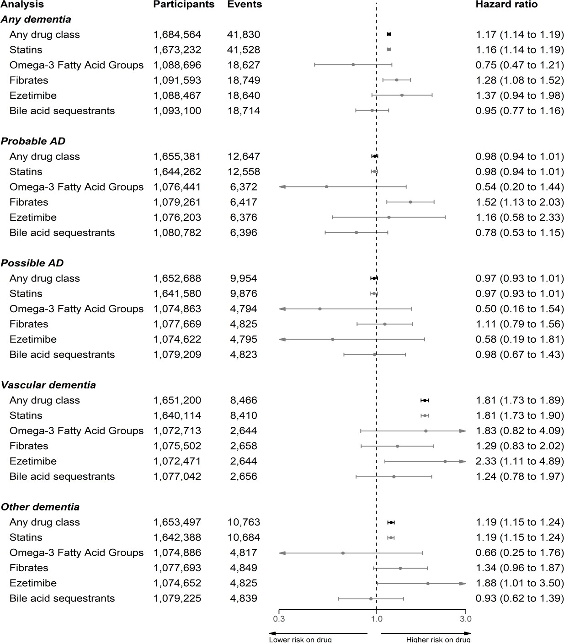

*Figure 1: Results from the primary analyses of CPRD data comparing prescription of an lipid- regulating drug with no prescription, stratified by dementia outcome and drug class. All results were obtained using the fully adjusted model and participant age as the time scale.*

medRxiv preprint doi: https://doi.org/10.1101/2021.10.21.21265131; this version posted October 25, 2021. The copyright holder for this preprint

**(which was not certified by peer review)** is the author/funder, who has granted medRxiv a license to display the preprint in perpetuity.

It is made available under a CC-BY-NC 4.0 International license .

##### Bibliography

1. Prince M, Ali G-C, Guerchet M, Prina AM, Albanese E, Wu Y-T. Recent global trends in the prevalence and incidence of dementia, and survival with dementia. Alzheimer’s Research & Therapy. 2016 Jul;8(1):23.
2. Jobke B, McBride T, Nevin L, Peiperl L, Ross A, Stone C, et al. Setbacks in Alzheimer research demand new strategies, not surrender. PLoS medicine. 2018 Feb;15(2):e1002518.
3. Ashburn TT, Thor KB. Drug repositioning: Identifying and developing new uses for existing drugs. Nature Reviews Drug Discovery. 2004;3(8):673.
4. Pushpakom S, Iorio F, Eyers PA, Escott KJ, Hopper S, Wells A, et al. Drug repurposing: Progress, challenges and recommendations. Nature Reviews Drug Discovery. 2019 Jan;18(1):41–58.
5. Walker VM, Davies NM, Martin RM, Kehoe PG. Comparison of Antihypertensive Drug Classes for Dementia Prevention. Epidemiology. 2020 Nov;31(6):852–9.
6. Chu C-S, Tseng P-T, Stubbs B, Chen T-Y, Tang C-H, Li D-J, et al. Use of statins and the risk of dementia and mild cognitive impairment: A systematic review and meta-analysis. Scientific Reports. 2018 Apr;8(1):5804.
7. Larsson SC, Markus HS. Does Treating Vascular Risk Factors Prevent Dementia and Alzheimer’s Disease? A Systematic Review and Meta-Analysis. Journal of Alzheimer’s Disease. 2018 Jan;64(2):657–68.
8. Ancelin M-L, Carrière I, Barberger-Gateau P, Auriacombe S, Rouaud O, Fourlanos S, et al. Lipid lowering agents, cognitive decline, and dementia: The three-city study. Journal of Alzheimer’s Disease. 2012 Jan;30(3):629–37.
9. Bettermann K, Arnold AM, Williamson J, Rapp S, Sink K, Toole JF, et al. Statins, Risk of Dementia, and Cognitive Function: Secondary Analysis of the Ginkgo Evaluation of Memory Study. Journal of Stroke and Cerebrovascular Diseases. 2012 Aug;21(6):436–44.
10. Rea TD, Breitner JC, Psaty BM, Fitzpatrick AL, Lopez OL, Newman AB, et al. Statin Use and the Risk of Incident Dementia: The Cardiovascular Health Study. Archives of Neurology. 2005 Jul;62(7):1047–51.
11. Casey JA, Schwartz BS, Stewart WF, Adler NE. Using Electronic Health Records for Population Health Research: A Review of Methods and Applications. Annual Review of Public Health. 2016 Mar;37(1):61–81.
12. Farmer R, Mathur R, Bhaskaran K, Eastwood SV, Chaturvedi N, Smeeth L. Promises and pitfalls of electronic health record analysis. Diabetologia. 2018 Jun;61(6):1241–8.
13. Herrett E, Gallagher AM, Bhaskaran K, Forbes H, Mathur R, van Staa T, et al. Data Resource Profile: Clinical Practice Research Datalink (CPRD). International Journal of Epidemiology. 2015 Jun;44(3):827–36.

medRxiv preprint doi: https://doi.org/10.1101/2021.10.21.21265131; this version posted October 25, 2021. The copyright holder for this preprint

**(which was not certified by peer review)** is the author/funder, who has granted medRxiv a license to display the preprint in perpetuity.

It is made available under a CC-BY-NC 4.0 International license .

1. Wolf A, Dedman D, Campbell J, Booth H, Lunn D, Chapman J, et al. Data resource profile: Clinical Practice Research Datalink (CPRD) Aurum. International Journal of Epidemiology. 2019 Dec;48(6):1740–1740g.
2. Walker VM, Davies NM, Jones T, Kehoe PG, Martin RM. Can commonly prescribed drugs be repurposed for the prevention or treatment of Alzheimer’s and other neurodegenerative diseases? Protocol for an observational cohort study in the UK Clinical Practice Research Datalink. BMJ Open. 2016;6(12).
3. Nicholls SG, Langan SM, Sørensen HT, Petersen I, Benchimol EI. The RECORD reporting guidelines: Meeting the methodological and ethical demands of transparency in research using routinely-collected health data. Clinical epidemiology. 2016;8:389.
4. Wishart DS, Feunang YD, Guo AC, Lo EJ, Marcu A, Grant JR, et al. DrugBank 5.0: A major update to the DrugBank database for 2018. Nucleic Acids Research. 2017;46(D1):D1074–82.
5. Lévesque LE, Hanley JA, Kezouh A, Suissa S. Problem of immortal time bias in cohort studies: Example using statins for preventing progression of diabetes. BMJ. 2010 Mar;340:b5087.
6. Lamarca R, Alonso J, Gomez G, Munoz A. Left-truncated Data With Age as Time Scale: An Alternative for Survival Analysis in the Elderly Population. The Journals of Gerontology Series A: Biological Sciences and Medical Sciences. 1998 Sep;53A(5):M337–43.
7. Gail MH, Graubard B, Williamson DF, Flegal KM. Comments on ‘Choice of time scale and its effect on significance of predictors in longitudinal studies’ by Michael J. Pencina, Martin G. Larson and Ralph B. D’Agostino, *Statistics in Medicine* 2007; **26** :1343-1359. Statistics in Medicine. 2009 Apr;28(8):1315–7.
8. Pencina MJ, Larson MG, D’Agostino RB. Choice of time scale and its effect on significance of predictors in longitudinal studies. Statistics in Medicine. 2007 Mar;26(6):1343–59.
9. Sterne JAC, White IR, Carlin JB, Spratt M, Royston P, Kenward MG, et al. Multiple imputation for missing data in epidemiological and clinical research: Potential and pitfalls. BMJ. 2009 Jun;338:b2393.
10. Moons KG, Donders RA, Stijnen T, Harrell Jr FE. Using the outcome for imputation of missing predictor values was preferred. Journal of clinical epidemiology. 2006;59(10):1092–101.
11. National Institute for Health and Care Excellence. Cardiovascular disease: Risk assessment and reduction, including lipid modification. https:[//w](http://www.nice.org.uk/guidance/cg181/ifp/chapter/Drug-treatments-to-lower-your-)ww[.nice.org.uk/guidance/cg181/ifp/chapter/Drug-treatments-to-lower-your-](http://www.nice.org.uk/guidance/cg181/ifp/chapter/Drug-treatments-to-lower-your-) cholesterol; NICE;
12. Sierra S, Ramos MC, Molina P, Esteo C, Vázquez JA, Burgos JS. Statins as neuroprotectants: A comparative in vitro study of lipophilicity, blood-brain-barrier

medRxiv preprint doi: https://doi.org/10.1101/2021.10.21.21265131; this version posted October 25, 2021. The copyright holder for this preprint

**(which was not certified by peer review)** is the author/funder, who has granted medRxiv a license to display the preprint in perpetuity.

It is made available under a CC-BY-NC 4.0 International license .

penetration, lowering of brain cholesterol, and decrease of neuron cell death. Journal of

Alzheimer’s disease: JAD. 2011;23(2):307–18.

1. Collins R, Reith C, Emberson J, Armitage J, Baigent C, Blackwell L, et al. Interpretation of the evidence for the efficacy and safety of statin therapy. The Lancet. 2016 Nov;388(10059):2532–61.
2. Herrett E, Williamson E, Brack K, Beaumont D, Perkins A, Thayne A, et al. Statin treatment and muscle symptoms: Series of randomised, placebo controlled n-of-1 trials. BMJ. 2021 Feb;372:n135.
3. McGuinness B, Craig D, Bullock R, Passmore P. Statins for the prevention of dementia. The Cochrane Database of Systematic Reviews. 2016 Jan;(1):CD003160.
4. MRC/BHF Heart Protection Study of cholesterol lowering with simvastatin in 20 536 high-risk individuals: A randomised placebocontrolled trial. The Lancet. 2002 Jul;360(9326):7–22.
5. Poly TN, Islam MM, Walther BA, Yang H-C, Wu C-C, Lin M-C, et al. Association between Use of Statin and Risk of Dementia: A Meta-Analysis of Observational Studies. Neuroepidemiology. 2020;54(3):214–26.
6. Chao T-F, Liu C-J, Chen S-J, Wang K-L, Lin Y-J, Chang S-L, et al. Statins and the risk of dementia in patients with atrial fibrillation: A nationwide population-based cohort study. International Journal of Cardiology. 2015 Oct;196:91–7.
7. Smeeth L, Douglas I, Hall AJ, Hubbard R, Evans S. Effect of statins on a wide range of health outcomes: A cohort study validated by comparison with randomized trials. British Journal of Clinical Pharmacology. 2009 Jan;67(1):99–109.
8. Williams DM, Finan C, Schmidt AF, Burgess S, Hingorani AD. Lipid lowering and Alzheimer disease risk: A mendelian randomization study. Annals of Neurology. 2020 Jan;87(1):30–9.
9. Macedo AF, Douglas I, Smeeth L, Forbes H, Ebrahim S. Statins and the risk of type 2 diabetes mellitus: Cohort study using the UK clinical practice pesearch datalink. BMC Cardiovascular Disorders. 2014 Jul;14(1):85.
10. Smit RAJ, Trompet S, Leong A, Goodarzi MO, Postmus I, Warren H, et al. Statin- induced LDL cholesterol response and type 2 diabetes: A bidirectional two-sample Mendelian randomization study. The Pharmacogenomics Journal. 2020 Jun;20(3):462–70.
11. Danaei G, García Rodríguez LA, Cantero OF, Logan R, Hernán MA. Observational data for comparative effectiveness research: An emulation of randomised trials to estimate the effect of statins on primary prevention of coronary heart disease. Statistical methods in medical research. 2013 Feb;22(1):70–96.

medRxiv preprint doi: https://doi.org/10.1101/2021.10.21.21265131; this version posted October 25, 2021. The copyright holder for this preprint

**(which was not certified by peer review)** is the author/funder, who has granted medRxiv a license to display the preprint in perpetuity.

It is made available under a CC-BY-NC 4.0 International license .

1. Taylor F, Huffman MD, Macedo AF, Moore TH, Burke M, Davey Smith G, et al. Statins for the primary prevention of cardiovascular disease. The Cochrane Database of Systematic Reviews. 2013 Jan;2013(1):CD004816.
2. Wilkinson T, Ly A, Schnier C, Rannikmäe K, Bush K, Brayne C, et al. Identifying dementia cases with routinely collected health data: A systematic review. Alzheimer’s & Dementia. 2018 Aug;14(8):1038–51.
3. McGuinness LA, Warren-Gash C, Moorhouse LR, Thomas SL. The validity of dementia diagnoses in routinely collected electronic health records in the United Kingdom: A systematic review. Pharmacoepidemiology and Drug Safety. 2019;28(2):244–55.
4. Bennet AM, Di Angelantonio E, Ye Z, Wensley F, Dahlin A, Ahlbom A, et al. Association of apolipoprotein E genotypes with lipid levels and coronary risk. JAMA. 2007 Sep;298(11):1300–11.



**DOI:** 10.21105/joss.02651

**Software**

* Review
* Repository
* Archive

#### medrxivr: Accessing and searching medRxiv and bioRxiv preprint data in R

Luke A McGuinness1, 2 and Lena Schmidt1

**1** Department of Population Health Science, University of Bristol **2** MRC Intergrative Epidemiology Unit, University of Bristol

Summary

An increasingly important source of health-related bibliographic content are preprints: pre-

liminary versions of research articles that have yet to undergo peer review. The two preprint

**Editor:** Daniel S. Katz

**Reviewers:**

* @danielskatz

**Submitted:** 08 September 2020

**Published:** 09 October 2020

**License**

Authors of papers retain copyright and release the work under a Creative Commons Attribution 4.0 International License (CC BY 4.0).

repositories most relevant to health-related sciences are medRxiv and bioRxiv, both of which are operated by the Cold Spring Harbor Laboratory, a not-for-profit research and educational institution (Rawlinson & Bloom, 2019).

The goal of the medrxivr R package is two-fold. In the first instance, it provides program- matic access to the Cold Spring Harbour Laboratory (CSHL) API, allowing users to download medRxiv and bioRxiv preprint metadata (e.g., title, abstract, author list.) This functionality will be of interest to anyone who wishes to import medRxiv and/or bioRxiv preprint metadata into R, for example to explore the distribution of preprints by subject area or by publication year. Examples of this type of usage have already been reported (e.g., by Brierley, 2020).

In the second instance, the package provides functions that allow users to search the down- loaded preprint metadata for relevant preprints using complex search strings, including func- tionality such as search term truncation, Boolean operators (AND, OR, NOT), and term proximity. Helper functions are provided that allow users to export the results of their search to a .bib file for import into a reference manager (e.g., Zotero) and to download the full-text PDFs of preprints matching their search. This aspect of the package will be more relevant to systematic reviewers, health librarians and others performing literature searches, allowing them to perform and document transparent and reproducible searches in these important evidence sources.

Acknowledgements

We acknowledge funding from NIHR (LAM through NIHR Doctoral Research Fellowship (DRF- 2018-11-ST2-048), and LS through NIHR Systematic Reviews Fellowship (RM-SR-2017-09- 028)). LAM is a member of the MRC Integrative Epidemiology Unit at the University of Bristol. The views expressed in this article are those of the authors and do not necessarily represent those of the NHS, the NIHR, MRC, or the Department of Health and Social Care.

References

Brierley, L. (2020). The role of research preprints in the academic response to the COVID-19 epidemic. *Authorea*. doi:10.22541/au.158516578.89167184

Rawlinson, C., & Bloom, T. (2019). New preprint server for medical research. *BMJ*, *365*. doi:10.1136/bmj.l2301

McGuinness et al., (2020). medrxivr: Accessing and searching medRxiv and bioRxiv preprint data in R. *Journal of Open Source Software*, 5(54), 1

2651. https://doi.org/10.21105/joss.02651

Received: 27 February 2020 Revised: 16 April 2020 Accepted: 18 April 2020

DOI: 10.1002/jrsm.1411

SPECIAL I SSUE P AP ER 

Risk-of-bias VISualization (robvis): An R package and Shiny web app for visualizing risk-of-bias assessments

Luke A. McGuinness1,2 | Julian P. T. Higgins1,2

1MRC Integrative Epidemiology Unit at the University of Bristol, Bristol, UK

Despite a major increase in the range and number of software offerings now available to help researchers produce evidence syntheses, there is currently no generic tool for producing figures to display and explore the risk-of-bias assess- ments that routinely take place as part of systematic review. However, tools such as the R programming environment and Shiny (an R package for build- ing interactive web apps) have made it straightforward to produce new tools to help in producing evidence syntheses. We present a new tool, robvis (Risk- Of-Bias VISualization), available as an R package and web app, which facili- tates rapid production of publication-quality risk-of-bias assessment figures. We present a timeline of the tool's development and its key functionality.

KEYWOR DS

data visualization, evidence synthesis, R, risk of bias

2Population Health Sciences, Bristol Medical School, University of Bristol, Bristol, UK

Correspondence

Luke A. McGuinness, Bristol Medical School, University of Bristol, Canynge Hall, 39 Whatley Road, Bristol, BS8 2PS, United Kingdom.

Email: [luke.mcguinness@bristol.ac.uk](mailto:luke.mcguinness@bristol.ac.uk)

Funding information

National Institute for Health Research, Grant/Award Number: NF-SI-

0617-10145Research Trainees Coordinating Centre, Grant/Award Number: DRF-2018-11-ST2-048

1. | INTRODUCTION

Synthesis of evidence from the totality of relevant research is becoming more important than ever in info- rming policy across an increasingly wide range of fields.1 Risk of bias assessment—evaluation of the internal valid- ity of studies included in a systematic review—often forms a key part of the evidence synthesis process, partic- ularly in the health sciences.2 A well-developed family of tools is widely used, which have in common the charac- teristic that they evaluate specific domains of bias rather being constructed as a checklist or a quantitative score.2 These tools include the RoB (Risk of Bias) 2 tool for ran- domized trials,3 the ROBINS-I (Risk Of Bias In Non- randomized Studies—of Interventions) tool,4 the QUADAS 2 (Quality and Applicability of Diagnostic Accuracy Studies) tool,5 and the ROBIS (Risk Of Bias in Systematic Reviews) tool.6 Within each bias domain a judgement is reached about the strength of the study in

that regard: for example, the first domain in the Cochrane RoB 2 tool deals with bias arising from the ran- domization process.3 Accessible graphics summarizing the results of these domain-based risk-of-bias assessments are included in reports of systematic reviews. A conve- nient plot in many reviews is a “traffic light” plot, which tabulates the judgement for each study in each domain. For larger numbers of studies, when such a table becomes unmanageable, a popular alternative is a (possi- bly weighted) bar plot, which shows the proportion of information with each judgement for each domain.7

Researchers can face a number of barriers in creating these plots. While some evidence synthesis platforms, such as Cochrane's Review Manager,8 can produce these visualizations, not all researchers use these systems to conduct their systematic reviews, and copying the risk-of- bias data into these systems solely to produce the plots is inefficient and error prone. On the other hand, creating the figures “by hand,” through software such as MS

This is an open access article under the terms of the Creative Commons Attribution License, which permits use, distribution and reproduction in any medium, provided the original work is properly cited.

© 2020 The Authors. *Research Synthesis Methods* published by John Wiley & Sons Ltd.

*Res Syn Meth.* 2021;12:55–61.

wileyonlinelibrary.com/journal/jrsm

55



56

MCGUINNESS AND HIGGINS

PowerPoint or Adobe Illustrator, may lead to uni- ntentional errors and require the plots to be redrawn when a review is updated. Additionally, while the field of evidence synthesis software has grown rapidly in recent years,9 this growth has not been equally distributed across the different aspects of the systematic review pro- cess. For example, a recent review found several software offerings aimed specifically at the abstract screening stage of the review process,10 but no similar time- and error- reducing tool has been proposed for visualizing the results of risk-of-bias assessments.

It is now straightforward to produce such a tool, thanks to the availability of powerful computing offerings including R, RStudio, and Shiny (an R package for building interactive web apps).11-13 Here, we present robvis (Risk Of Bias VISualization),14 an R package and Shiny web-app that allows users to create publication-ready risk-of-bias plots quickly and easily. While primarily designed for use with the major risk-of- bias assessment tools used in health research (ROB2, ROBINS-I, and QUADAS-2), the tool allows users to visu- alize the results from any domain-based risk-of-bias assessment or quality appraisal tool.

The tool is open-source and available to use free of charge. Users can download a stable version of the R package from CRAN (https://cran.r-project.org/ package=robvis); or access and contribute to the open- source code that powers the package via GitHub (https:// github.com/mcguinlu/robvis). Extended guidance for the tool, including a step-by-step walk-through for those new to the R programming environment, is also available via the “Doing Meta-Analysis in R" online guide.15 Below, we discuss the tool's development and key functionality.

1. | DEVELOPMENT

Development of robvis began in April 2019 at the Evi- dence Synthesis Hackathon (ESH), an event which brings together interested researchers, practitioners, and coders to discuss and develop new open-source evidence synthe- sis technologies. Test versions of both the R package and the web app were made available in early June 2019, with attendees of the ESH and members of the Bristol Appraisal and Review of Research (BARR) group at the University of Bristol being invited to test the tool and pro- vide feedback. This feedback, along with other feature suggestions from the wider evidence synthesis commu- nity captured via GitHub issues, was incorporated and the first release version of the package was uploaded to CRAN in November 2019. The tool has been well received and is beginning to be cited in the evidence syn- thesis literature.16-20

Highlights

* Risk-of-bias assessment is a key element of the systematic review workflow.
* No other tool exists explicitly for the purpose of visualizing risk-of-bias results.
* Here, we present robvis, an open-source R package and Shiny web app for creating publi- cation-ready risk-of-bias assessment figures.
* robvis forms part of the metaverse, a collection of R packages designed to provide an evidence synthesis workflow in R.

1. | FUNCTIONALITY
   1. | R package
      1. | Tool templates and example data sets

At the time of writing, the tool includes templates for three major tools: the Cochrane RoB 2 tool for assessing random- ized trials,3 the ROBINS-I tool for assessing non-randomized studies of interventions,4 and the QUADAS-2 tool for assessing diagnostic accuracy studies.5 These templates auto- matically apply the correct risk-of-bias domain names to the figures, and label the judgement levels appropriately (eg, “Low,” “Some Concerns,” and “High” in the case of the RoB 2 tool). In addition, robvis contains a general template that can be used to visualize the result of any domain-based assessment tool. The generic template has greater flexibility than the tool-specific templates, allowing a user-specified number of domains and custom domain titles to be used. It is suitable for use with the original version of the Cochrane risk-of-bias tool for randomized trials,21 in which flexibility in the specification of domains was permitted. Since users of more recent tools such as RoB 2 and ROBINS-I are not per- mitted to modify the domains, we strongly encourage use of the in-built templates for these.

In order to help users familiarize themselves with the package and its functionality, robvis contains built-in example data-sets for each template. We illustrate the example data for the RoB 2 tool for assessing risk of bias in randomized trials in Table 1.

* + 1. | Data import

robvis expects the risk-of-bias data file to be arranged in a specific way (see Table 1 for an example). The first



MCGUINNESS AND HIGGINS

57

TABLE 1 Example dataset for the ROB 2 tool contained within robvis. Data can be imported to the tool from with an Excel spreadsheet or a CSV file

|  |  |  |  |  |  |  |  |
| --- | --- | --- | --- | --- | --- | --- | --- |
| Study | D1 | D2 | D3 | D4 | D5 | Overall | Weight |
| Study 1 | Low | Low | Low | Low | Low | Low | 33.33 |
| Study 2 | Some concerns | Low | Low | Low | Low | Low | 33.33 |
| Study 3 | Some concerns | Low | Some concerns | Low | Low | Some concerns | 0.14 |
| Study 4 | Low | Low | High | Low | Some concerns | High | 9.09 |
| Study 5 | High | High | Low | Low | Some concerns | Low | 12.5 |
| Study 6 | Low | High | Some concerns | Low | Low | Some concerns | 25 |
| Study 7 | Low | Some concerns | Some concerns | High | Low | Some concerns | 200 |
| Study 8 | Low | Some concerns | Low | Low | Low | Low | 11.11 |
| Study 9 | Low | Low | High | Low | Low | High | 1.11 |

TABLE 2 Description of the arguments available in the two main functions of the robvis R package. “X” indicates that the option is available for the respective function

|  |  |  |  |
| --- | --- | --- | --- |
| Argument | rob_traffic_light() | rob_summary() | Description |
| data | X | X | Defines the data frame containing the summary (domain) level |

risk-of-bias assessments. See the text and Table 1 for the format expected by robvis.

tool

X

X

Defines the risk of bias assessment tool used. The RoB2 (tool = “ROB2”), ROBINS-I (tool = “ROBINS-I"), and

QUADAS-2 (tool = “QUADAS-2”) assessments tools are

currently supported. Other tools can be visualized using the

generic template (tool = “Generic”) [Note 1].

color X X Defines the color scheme for the plot. The default is

colour = “cochrane” which uses the “Cochrane” (red, yellow, green) colors, while a preset option for a color-blind friendly palette is also available

(colour = “colourblind”). Alternatively, users can specify their own color scheme for example, colour = c (“#f442c8,” “#bef441,” “#000000”).

overall

X

Defines whether to include an additional bar showing the distribution of overall risk of bias judgments in the summary

barplot figure. Default is overall = FALSE.

weighted X Defines whether weights should be used to produce the summary barplot figure. Default is weighted = TRUE, in line with current Cochrane Collaboration guidance.

psize

X

Defines the size of the points in the traffic light plot. Default is

psize = 20.

*Note:* This option (tool = “Generic”) reflects the general template name used in the current development version of robvis, which will become the standard for all future iterations of the package. However, in the current CRAN version, the generic template is accessed using tool = “ROB1”.

column should contain the unique study/result identifier. The second-to-last column should contain the overall risk-of-bias judgments. The final column contains some measure of the result's precision (eg, the weight assigned to that result in a meta-analysis, or the sample size of the analysis that produced the result). This weight column is

used to create the summary bar plot, as current guidance recommends dividing the bars to show the proportion of information at each level of risk of bias, determined by the cumulative weight at that level, rather than simply showing the number of studies/results in each category.2 If a measure of precision is not available, or to reproduce



58

MCGUINNESS AND HIGGINS

“equally” weighted bar charts as have traditionally been presented in Cochrane Reviews to date, these weights may all be specified to be 1.

* + 1. | Functions

robvis contains two main functions. The first, rob_- traffic_light(), creates a *traffic light plot*. This displays every risk-of-bias judgement in a matrix, with domains along the horizontal and results/studies down the vertical, similar to the data set. The second func- tion, rob_summary(), creates a *weighted bar plot*. This shows the proportion of information with each

risk-of-bias judgement separately for each domain in the assessment tool specified.

A worked example using these functions is outlined below, illustrating the simple steps involved in creating risk- of-bias plots using robvis. A detailed description of the additional options that can be used with each function is presented in Table 2. All examples produced in this article are created using the stable version available from CRAN.

To install and load the package in R, enter the follow- ing into the console:

install.packages(“robvis”) library(robvis)

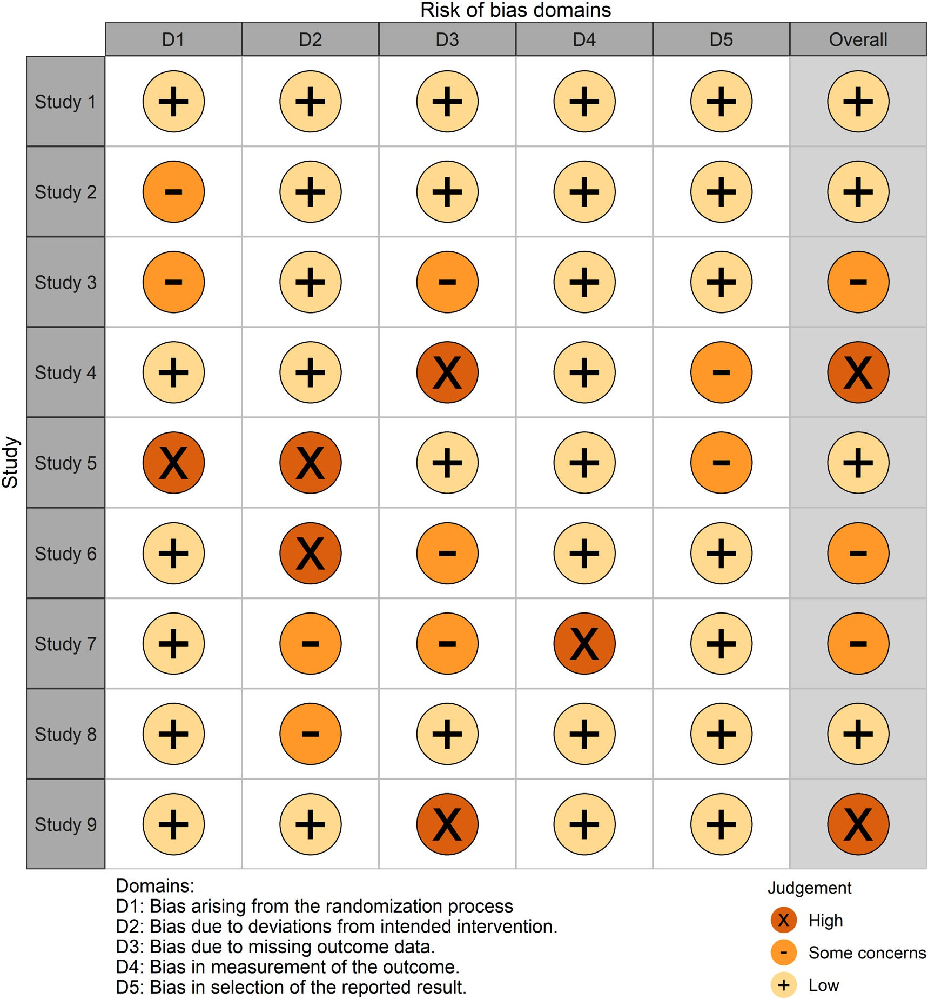

FIGU RE 1 Example risk of bias traffic light plot of ROB2 assessments created using robvis and the colourblind palette [Colour figure can be viewed at wileyonlinelibrary.com]



MCGUINNESS AND HIGGINS

59

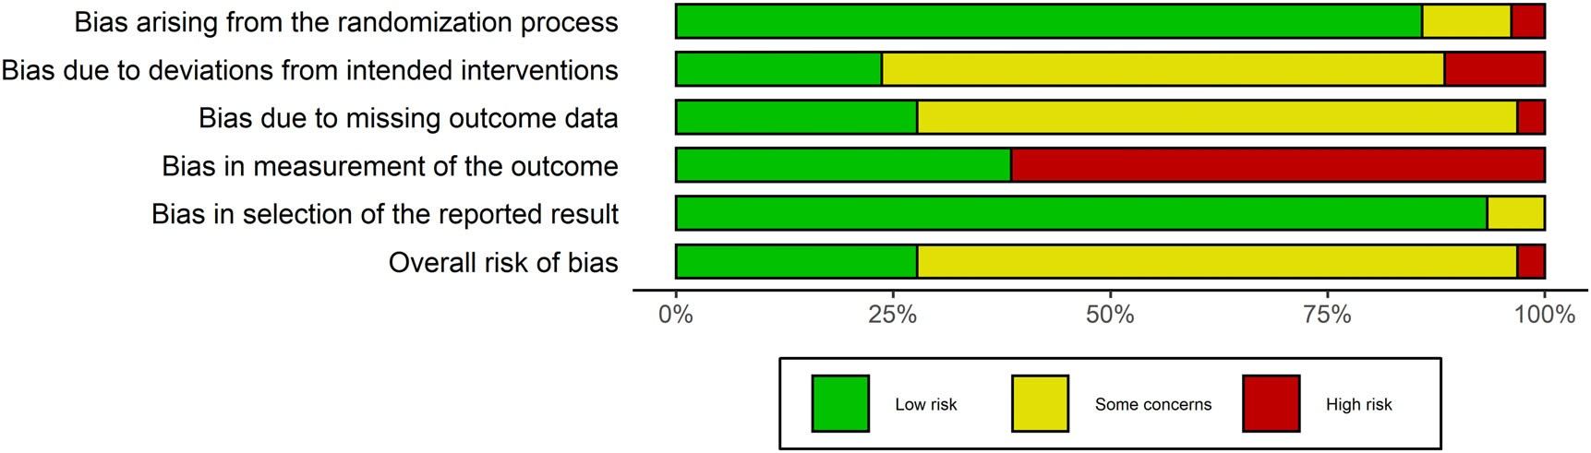

FIGU RE 2 Example risk of bias summary plot of ROB2 assessments created using robvis and the standard Cochrane palette [Colour figure can be viewed at wileyonlinelibrary.com]

Using the example data set (data_rob2) that is built into the package and is presented in Table 1 for refer- ence, the traffic light plot shown in Figure 1 is created using:

rob_traffic_light(data = data_rob2,

tool = “ROB2”,

colour = “colourblind”, psize = 15)

Similarly, using the same data set, the summary barplot shown in Figure 2 is created using:

rob_summary(data = data_rob2,

tool = “ROB2”,

overall = TRUE)

* + 1. | Further customization

The ggplot2 package in R, based on the “The Grammar of Graphics,” allows users to create detailed graphics and was used to create the templates found in robvis.22,23 As a result, both robvis functions return a ggplot object, meaning they can be easily customized further using the ggplot2 framework. For example, to add a title to the summary bar plot:

library(ggplot2)

plot <− rob_summary(data_rob2,

tool = “ROB2”)

plot +

ggtitle(“Summary Bar Plot”)

For a full discussion of the range of post-production modifications that can be made to the plots via the ggplot2 package, we refer the reader to the extensive guidance available.23

* 1. | Shiny web app

Although robvis was originally designed for use in the command-line-based R programming environment, we developed a web app to make the tool accessible to those without knowledge of R. This is available via [www.](http://www/) riskofbias.info.24 The app was built using Shiny,13 an R package which makes it easy to produce interactive web- apps, and provides a graphical user interface (GUI) for the robvis package, allowing users to interact with the func- tions presented above without the need to download R or type any commands. Users can upload their data as either an Excel spreadsheet (recommended) or a comma-separate values (CSV) file, or can manually enter it directly into the app. Uploaded data are passed through a number of quality control checks that ensure the app will work correctly, and users are prevented from producing the plots until any issues identified have been addressed. Finally, users can customize their plots by defining a color scheme and other parameters, all through the online app.

1. | DISCUSSION

robvis facilitates the rapid production of two common risk-of-bias assessment figures at publication quality. By implementing robvis both as an R package and a Shiny web app, its functionality is available to evidence synthesists with varying levels of ability in R. robvis serves as an example of the advantages of “packaging” the R scripts that evidence synthesists often create for personal use.25 It is likely that several other evidence syn- thesists have written scripts to produce similar risk-of- bias plots to those presented here—in fact, we personally know of at least one other research group that has done so. This duplication of time and effort is inefficient, and creating and sharing well-documented R packages repre- sents one way to reduce this inefficiency. Taking this approach one step further, Shiny apps represent a straightforward way to provide a user-friendly GUI for a



60

MCGUINNESS AND HIGGINS

newly created R package within a very short time-frame, expanding the potential pool of users of the package to anyone with an internet connection.

Creating a package using R has a number of particu- lar advantages. R provides access to a range of powerful tools including the ggplot infrastructure as demon- strated above, and RMarkdown, which enables creation of documents that can be rendered in a range of formats such as PDF, HTML, or Word.26 Furthermore, and focus- ing specifically on evidence synthesis, building new tools as packages in R allows for easy integration with the range of existing evidence synthesis packages. Recently, the metaverse project,27 of which robvis is a part, has begun to curate a collection of R packages that cover different aspects of the systematic review and meta-analysis process which, when taken together, form a coherent end- to-end open-source alternative to commercial offerings such as Covidence or Review Manager. Key offerings in this suite of packages include litsearcher, which facili- tates systematic search strategy development, revtools, a package for managing the review process and performing title and abstract screening, metaDigitise, a package for automatic extraction of data from figures in research papers, and metafor, a package for conducting meta- analyses in R.28-31

While robvis is a stable package, a range of addi- tional functionality could be added. At present, the num- ber of tools with a specific template included in robvis is limited—adding additional templates is a priority. For example, a template for ROBIS, the risk-of-bias assess- ment tool for systematic reviews,6 is in development. Additionally, the robvis tool does not yet allow for the production of paired forest plots, where the risk-of-bias judgement is presented alongside each specific result included in the meta-analysis.2 This was initially consid- ered to be beyond the scope of the tool, as it involves the visualization of something other than risk-of-bias assess- ments. However, following user-driven demand, this functionality is in development and will be available in the near future. Finally, we would like to add similar functionality to that provided by the metafor:: reporter() function, which generates a brief para- graph of text describing the results of a meta-analysis. The future robvis::reporter() function would pro- vide a boilerplate description of the assessment tool used and the key domains at risk of bias.

ACKNOWLEDGMENTS

The following people provided valuable feedback that contributed to the development of the robvis tool: Emily Kothe, Eliza Grames, Matthew Page, Alexandra Bannach-Brown, Kyle Hamilton, Charles Gray, Vincent

Cheng, Wouter van Amsterdamn, Neal Haddaway, and Martin Westgate.

LAM is supported by an NIHR Doctoral Research Fel- lowship (DRF-2018-11-ST2-048). Attendance at the Evi- dence Synthesis Hackathon in April 2019 was supported by a grant from the Evidence Synthesis Hackathon itself and the University of Bristol Alumni Foundation. JPTH is a National Institute for Health Research (NIHR) Senior Investigator (NF-SI-0617-10145). JPTH is supported by NIHR Bristol Biomedical Research Centre at University Hospitals Bristol NHS Foundation Trust and the Univer- sity of Bristol. JPTH is supported by the NIHR Applied Research Collaboration West (ARC West) at University Hospitals Bristol NHS Foundation Trust. JPTH is a mem- ber of the MRC Integrative Epidemiology Unit at the University of Bristol. The views expressed in this article are those of the authors and do not necessarily represent those of the NHS, the NIHR, MRC, or the Department of Health and Social Care.

CONFLICT OF INTEREST

The author reported no conflict of interest.

DATA AVAILABILITY STATEMENT

The software and data presented in this paper are freely available on GitHub: https://github.com/mcguinlu/ robvis

ORCID

*Luke A. McGuinness * https://orcid.org/0000-0001-8730- 9761

REFERENCES

1. Donnelly CA, Boyd I, Campbell P, et al. Four principles to make evidence synthesis more useful for policy. *Nature*. 2018; 558(7710):361-364. https://doi.org/10.1038/d41586-018-05414-4.
2. Cochrane Handbook for Systematic Reviews of Interventions Version 6.0 (Updated August 2019)Boutron I, Higgins JP, Altman DG, et al. Chapter 7: considering bias and conflicts of interest among the included studies. In: JPT H, Chandler J, Cumpston M, et al., eds. Cochrane; 2019. Retrieved from. [www.training.cochrane.org/handbook.](http://www.training.cochrane.org/handbook)
3. Sterne JAC, Savovi'c J, Page MJ, et al. RoB 2: a revised tool for

assessing risk of bias in randomised trials. *BMJ*. 2019;366:l4898. https://doi.org/10.1136/bmj.l4898.

1. Sterne JAC, Hernán MA, Reeves BC, et al. ROBINS-I: a tool for assessing risk of bias in non-randomised studies of interven- tions. *BMJ*. 2016;355:i4919. https://doi.org/10.1136/bmj.i4919.
2. Whiting PF, Rutjes AW, Westwood ME, et al. QUADAS-2: a revised tool for the quality assessment of diagnostic accuracy studies. *Ann Intern Med*. 2011;155(8):529-536. https://doi.org/ 10.7326/0003-4819-155-8-201110180-00009.
3. Whiting P, Savovi'c J, Higgins JPT, et al. ROBIS: a new tool to

assess risk of bias in systematic reviews was developed. *J Clin*



MCGUINNESS AND HIGGINS

61

*Epidemiol*. 2016;69:225-234. https://doi.org/10.1016/j.jclinepi.

2015.06.005.

1. Higgins JPT, Altman DG. Chapter 8: Assessing risk of bias in included studies. In: JPT H, Green S, eds. *Cochrane Handbook for Systematic Reviews of Interventions*. Hoboken, New Jersey, United States: Wiley Online Library; 2008:187-241. https://doi. org/10.1002/9780470712184.ch8.
2. Cochrane Collaboration. Review Manager (RevMan) [Com- puter Program]. 2014. https://community.cochrane.org/help/ tools-and-software/revman-5.
3. Marshall C, Brereton P. Systematic review toolbox: a catalogue of tools to support systematic reviews. Paper presented at: Pro- ceedings of the 19th International Conference on Evaluation and Assessment in Software Engineering. EASE'15. Association for Computing Machinery; 2015: Article 23; 1–6. https://doi. org/10.1145/2745802.2745824.
4. Harrison H, Griffin SJ, Kuhn I, Usher-Smith JA. Software tools to support title and abstract screening for systematic reviews in healthcare: an evaluation. *BMC Med Res Methodol*. 2020;20(1): 7. https://doi.org/10.1186/s12874-020-0897-3.
5. R Core Team. R: A Language and Environment for Statistical Computing. Vienna, Austria: R Foundation for Statistical Com- puting; 2019. [https://www.R-project.org/.](http://www.R-project.org/)
6. RStudio Team. *RStudio: Integrated Development Environment for R*. Boston, MA: RStudio, Inc.; 2015.
7. Chang W, Cheng J, Allaire J, Xie Y, McPherson J. Shiny: *Web Application Framework for R*. Boston, MA: RStudio; 2019. Retrieved from https://CRAN.R-project.org/package=shiny.
8. McGuinness LA. Robvis: An R package for visualising risk-of- bias assessments. [Computer Software - v0.3.0]. November 2019. https://doi.org/10.5281/zenodo.3552342.
9. Harrer M, Cuijpers P, Ebert D. *Doing Meta-Analysis in R: A Hands-on Guide*. Erlangen, Germany: Zenodo; 2019.
10. Gibb K, Seeley A, Quinn T, et al. The consistent burden in publi- shed estimates of delirium occurrence in medical inpatients over four decades: a systematic review and meta-analysis study. med- Rxiv. 2019: 19005165. https://doi.org/10.1101/19005165.
11. Habadi MI, Asiri AA, Aloufi SA, et al. Prevalence of panic dis- orders in the primary health care setting: a systematic review and meta-analysis. *EC Micro*. 2019;16(1):1-9.
12. Veloso A, Vicente SG, Filipe MG. Effectiveness of cognitive training for school-aged children and adolescents with atten- tion deficit/hyperactivity disorder: a systematic review. *Front Psych*. 2020;10:2983. https://doi.org/10.3389/fpsyg.2019.02983.
13. Simillis C, Singh HKSI, Afxentiou T, et al. Postoperative che- motherapy improves survival in patients with resected high- risk stage II colorectal cancer: results of a systematic review and meta-analysis. Colorectal Dis. 2020; Published online 30th January. https://doi.org/10.1111/codi.14994.
14. Tanneru K, Gautam S, Norez D, Kumar J., Alam M.U., Koocheckpour S., Balaji K.C., Joseph C. Meta-analysis and sys- tematic review of intermediate-term follow-up of prostatic ure- thral lift for benign prostatic hyperplasia. Int Urol Nephrol February 2020. https://doi.org/10.1007/s11255-020-02408-y. Retrieved on 24 February 2020.
15. Higgins JPT, Altman DG, Gøtzsche PC, et al. The Cochrane Collaboration's tool for assessing risk of bias in randomised tri- als. *BMJ*. 2011;343:d5928. https://doi.org/10.1136/bmj.d5928.
16. Wickham H. *Ggplot2: Elegant Graphics for Data Analysis*. New York, NY: Springer-Verlag; 2016.
17. Wilkinson L. *The Grammar of Graphics*. 2nd ed. New York, NY: Springer-Verlag; 2012.
18. McGuinness L. Robvis web application. 2019. Retrieved on

20 January 2020 from [https://www.riskofbias.info/welcome/](http://www.riskofbias.info/welcome/) robvis-visualization-tool

1. Wickham H. R Packages: Organize, Test, Document, and Share Your Code. First. O'Reilly Media, Inc.; 2015. Retrieved on 20 February 2020 from <http://r-pkgs.had.co.nz/>
2. Xie Y, Allaire JJ, Grolemund G. R Markdown: the Definitive Guide. Chapman and Hall/CRC; 2018. Retrieved on 1 February 2020 from https://bookdown.org/yihui/rmarkdown/
3. Various Authors. Metaverse: an R Ecosystem for Meta- Research. 2020. Retrieved on 24 February 2020 from https:// rmetaverse.github.io/
4. Grames EM, Stillman AN, Tingley MW, Elphick CS. An auto- mated approach to identifying search terms for systematic reviews using keyword co-occurrence networks. *Methods Ecol Evol*. 2019; 10:1645-1654. https://doi.org/10.1111/2041-210X.13268.
5. Viechtbauer W. Conducting meta-analyses in R with the met- afor package. *J Stat Software*. 2010;36(3):1-48. https://doi.org/ 10.18637/jss.v036.i03.
6. Pick JL, Nakagawa S, Noble DWA. Reproducible, flexible and high-throughput data extraction from primary literature: the metaDigitise R package. *Methods Ecol Evol.* 2018;10:426-431. https://doi.org/10.1101/247775.
7. Westgate MJ. Revtools: an R package to support article screen- ing for evidence synthesis. *Res Syn Meth*. 2019;10:606-614. https://doi.org/10.1002/jrsm.1374.

How to cite this article: McGuinness LA, Higgins JPT. Risk-of-bias VISualization (robvis): An R package and Shiny web app for visualizing risk-of-bias assessments. *Res Syn Meth*. 2021;12: 55–61. https://doi.org/10.1002/jrsm.1411

PLOS ONE

RESEARCH ARTICLE

A descriptive analysis of the data availability statements accompanying medRxiv preprints and a comparison with their published counterparts

**Luke A. McGuinness1,2*, Athena L. Sheppard3**

**1** Population Health Sciences, Bristol Medical School, University of Bristol, Bristol, United Kingdom, **2** MRC Integrative Epidemiology Unit at the University of Bristol, Bristol, United Kingdom, **3** Department of Health Sciences, University of Leicester, Leicester, United Kingdom



* [luke.mcguinness@bristol.ac.uk](mailto:luke.mcguinness@bristol.ac.uk)

Abstract

 OPEN ACCESS

**Citation:** McGuinness LA, Sheppard AL (2021) A descriptive analysis of the data availability statements accompanying medRxiv preprints and a comparison with their published counterparts. PLoS ONE 16(5): e0250887. https://doi.org/ 10.1371/journal.pone.0250887

**Editor:** Rafael Sarkis-Onofre, Meridional Faculty IMED, BRAZIL

**Received:** September 21, 2020

**Accepted:** April 15, 2021

**Published:** May 13, 2021

**Peer Review History:** PLOS recognizes the benefits of transparency in the peer review process; therefore, we enable the publication of all of the content of peer review and author responses alongside final, published articles. The editorial history of this article is available here: https://doi.org/10.1371/journal.pone.0250887

**Copyright:** © 2021 McGuinness, Sheppard. This is an open access article distributed under the terms of the Creative Commons Attribution License, which permits unrestricted use, distribution, and reproduction in any medium, provided the original author and source are credited.

**Data Availability Statement:** All materials (data, code and supporting information) are available from GitHub (https://github.com/mcguinlu/data-

**Objective**

To determine whether medRxiv data availability statements describe open or closed data— that is, whether the data used in the study is openly available without restriction—and to examine if this changes on publication based on journal data-sharing policy. Additionally, to examine whether data availability statements are sufficient to capture code availability declarations.

**Design**

Observational study, following a pre-registered protocol, of preprints posted on the medRxiv repository between 25th June 2019 and 1st May 2020 and their published counterparts.

**Main outcome measures**

Distribution of preprinted data availability statements across nine categories, determined by a prespecified classification system. Change in the percentage of data availability state- ments describing open data between the preprinted and published versions of the same record, stratified by journal sharing policy. Number of code availability declarations reported in the full-text preprint which were not captured in the corresponding data availability statement.

**Results**

3938 medRxiv preprints with an applicable data availability statement were included in our sample, of which 911 (23.1%) were categorized as describing open data. 379 (9.6%) pre- prints were subsequently published, and of these published articles, only 155 contained an applicable data availability statement. Similar to the preprint stage, a minority (59 (38.1%)) of these published data availability statements described open data. Of the 151 records eli- gible for the comparison between preprinted and published stages, 57 (37.7%) were

PLOS ONE Data availability in medRxiv preprints and their published counterparts

availability-impact), archived at time of submission on Zenodo (DOI: 10.5281/zenodo.3968301).

**Funding:** LAM is supported by an National Institute for Health Research (NIHR; https://[www.nihr.ac.uk/](http://www.nihr.ac.uk/)

) Doctoral Research Fellowship (DRF-2018-11- ST2-048). The funders had no role in study design, data collection and analysis, decision to publish, or preparation of the manuscript. The views expressed in this article are those of the authors and do not necessarily represent those of the NHS, the NIHR, MRC, or the Department of Health and Social Care.

**Competing interests:** The authors have declared that no competing interests exist.

published in journals which mandated open data sharing. Data availability statements more frequently described open data on publication when the journal mandated data sharing (open at preprint: 33.3%, open at publication: 61.4%) compared to when the journal did not mandate data sharing (open at preprint: 20.2%, open at publication: 22.3%).

**Conclusion**

Requiring that authors submit a data availability statement is a good first step, but is insuffi- cient to ensure data availability. Strict editorial policies that mandate data sharing (where appropriate) as a condition of publication appear to be effective in making research data available. We would strongly encourage all journal editors to examine whether their data availability policies are sufficiently stringent and consistently enforced.

**1 Introduction**

The sharing of data generated by a study is becoming an increasingly important aspect of sci- entific research [1, 2]. Without access to the data, it is harder for other researchers to examine, verify and build on the results of that study [3]. As a result, many journals now mandate data availability statements. These are dedicated sections of research articles, which are intended to provide readers with important information about whether the data described by the study are available and if so, where they can be obtained [4].

While requiring data availability statements is an admirable first step for journals to take, and as such is viewed favorably by journal evaluation rubrics such as the Transparency and Openness Promotion [TOP] Guidelines [5], a lack of review of the contents of these statements often leads to issues. Many authors claim that their data can be made “available on request”, despite previous work establishing that these statements are demonstrably untrue in the majority of cases—that when data is requested, it is not actually made available [6–8]. Addi- tionally, previous work found that the availability of data “available on request” declines with article age, indicating that this approach is not a valid long term option for data sharing [9].

This suggests that requiring data availability statements without a corresponding editorial or peer review of their contents, in line with a strictly enforced data-sharing policy, does not achieve the intended aim of making research data more openly available. However, few jour- nals actually mandate data sharing as a condition of publication. Of a sample of 318 biomedical journals, only ~20% had a data-sharing policy that mandated data sharing [10].

Several previous studies have examined the data availability statements of published articles [4, 11–13], but to date, none have examined the statements accompanying preprinted manu- scripts, including those hosted on medRxiv, the preprint repository for manuscripts in the medical, clinical, and related health sciences [14]. Given that preprints, particularly those on medRxiv, have impacted the academic discourse around the recent (and ongoing) COVID-19 pandemic to a similar, if not greater, extent than published manuscripts [15], assessing whether these studies make their underlying data available without restriction (i.e. “open”), and adequately describe how to access it in their data availability statements, is worthwhile. In addition, by comparing the preprint and published versions of the data availability statements for the same paper, the potential impact of different journal data-sharing policies on data avail- ability can be examined. This study aimed to explore the distribution of data availability state- ments’ description of the underlying data across a number of categories of “openness” and to

PLOS ONE Data availability in medRxiv preprints and their published counterparts

assess the change between preprint and journal-published data availability statements, strati- fied by journal data-sharing policy. We also intended to examine whether authors planning to make the data available upon publication actually do so, and whether data availability state- ments are sufficient to capture code availability declarations.

1. **Methods**
   1. **Protocol and ethics**

A protocol for this analysis was registered in advance and followed at all stages of the study [16]. Any deviations from the protocol are described. Ethical approval was not required for this study.

* 1. **Data extraction**

The data availability statements of preprints posted on the medRxiv preprint repository between 25th June 2019 (the date of first publication of a preprint on medRxiv) and 1st May 2020 were extracted using the medrxivr and rvest R packages [17, 18]. Completing a data avail- ability statement is required as part of the medRxiv submission process, and so a statement was available for all eligible preprints. Information on the journal in which preprints were sub- sequently published was extracted using the published DOI provided by medRxiv and rcross- ref [19]. Several other R packages were used for data cleaning and analysis [20–33].

To extract the data availability statements for published articles and the journals data-shar- ing policies, we browsed to the article or publication website and manually copied the relevant material (where available) into an Excel file. The extracted data are available for inspection (see Material availability section).

* 1. **Categorization**

A pre-specified classification system was developed to categorize each data availability state- ment as describing either open or closed data, with additional ordered sub-categories indicat- ing the degree of openness (see Table 1). The system was based on the “Findability” and “Accessibility” elements of the FAIR framework [34], the categories used by previous effort to categorize published data availability statements [4, 11], our own experience of medRxiv data availability statements, and discussion with colleagues. Illustrative examples of each category were taken from preprints included in our sample [35–43].

The data availability statement for each preprinted record were categorized by two indepen- dent researchers, using the groups presented in Table 1, while the statements for published articles were categorized using all groups barring Category 3 and 4 (“Available in the future”). Records for which the data availability statement was categorized as “Not applicable” (Cate- gory 1 from Table 1) at either the preprint or published stage were excluded from further anal- yses. Researchers were provided only with the data availability statement, and as a result, were blind to the associated preprint metadata (e.g. title, authors, corresponding author institution) in case this could affect their assessments. Any disagreements were resolved through discussion.

Due to our large sample, if authors claimed that all data were available in the manuscript or as a S1 File, or that their study did not make use of any data, we took them at their word.

Where a data availability statement met multiple categories or contained multiple data sources with varying levels of openness, we took a conservative approach and categorized it on the basis of the most restrictive aspect (see S1 File for some illustrative examples). We plotted the

PLOS ONE Data availability in medRxiv preprints and their published counterparts

**Table 1. Categories used to classify the data availability statements.**

|  |  |  |  |
| --- | --- | --- | --- |
| **Key** | **Main category** | **Sub-category** | **Example** |
| **0** | Not applicable (protocol for a review, commentary, etc) |  | "Data sharing not applicable to this article as no datasets were generated or analysed during the current study." [35] |
| **1** | "Closed" | Data not made available | "Not available for public" [36] |
| **2** | "Closed" | Data available on request to authors | "Data can be available upon reasonable request to the corresponding author." [37] |
| **3** | "Closed" | Data will be made available in the future (link provided) | "The protocol and full dataset will be available at Open Science Framework upon peer review publication (https://osf.io/rvbuy/)."  [38] |
| **4** | "Closed" | Data will be made available in the future (no link provided) | "Data will be deposited in Dryad upon publication" [39] |
| **5** | "Closed" | Data available from central repository (access-controlled or open access), but insufficient detail available to find specific dataset | "Data were obtained from the international MSBase cohort study. Information regarding data availability can be obtained at https:// [www.msbase.org/."](http://www.msbase.org/) OR Daily diagnosis number of countries outside China is download from WHO situation reports (https:// [www.who.int/emergencies/diseases/novel-coronavirus-2019/](http://www.who.int/emergencies/diseases/novel-coronavirus-2019/) situation-reports). [https://www.who.int/emergencies/diseas](http://www.who.int/emergencies/diseases/)es/  novel-coronavirus-2019/situation-reports [40] |
| **6** | "Closed" | Data available from central access-controlled repository, and sufficient details included to identify specific dataset e.g. via extract or accession ID or date stamp | "This research has been conducted using the UK Biobank Resource under application number 24494. All bona fide researchers can apply to use the UK Biobank resource for health  related research that is in the public interest." [41] |
| **7** | "Open" | Data available in the manuscript/S1 File | "All data related to this study are present in the paper or the S1 File." [42] |
| **8** | "Open" | Data available via a online repository that is not access- controlled e.g. Dryad, Zenodo | "Extracted data used in this meta-analysis and analysis code are available at [www.doi.org/10.5281/zenodo.3149365."](http://www.doi.org/10.5281/zenodo.3149365) [43] |

Illustrative examples of each category were taken from preprints included in our sample (see "Data extraction").

https://doi.org/10.1371/journal.pone.0250887.t001

distribution of preprint and published data availability statements across the nine categories presented in Table 1.

Similarly, the extracted data-sharing policies were classified by two independent reviewers according to whether the journal mandated data sharing (1) or not (0). Where the journal had no obvious data sharing policy, these were classified as not mandating data sharing.

* 1. **Changes between preprinted and published statements**

To assess if data availability statements change between preprint and published articles, we examined whether a discrepancy existed between the categories assigned to the preprinted and published statements, and the direction of the discrepancy (“more closed” or “more open”).

Records were deemed to become “more open” if their data availability statement was catego- rized as “closed” at the preprint stage and “open” at the published stage. Conversely, records described as “more closed” were those moving from “open” at preprint to “closed” on publication.

We declare a minor deviation from our protocol for this analysis [16]. Rather than investi- gating the data-sharing policy only for journals with the largest change in openness as intended, which involved setting an arbitrary cut-off when defining “largest change”, we sys- tematically extracted and categorized the data-sharing policies for all journals in which pre- prints had subsequently been published using two categories (1: “requiring/mandating data sharing” and, 2: “not requiring/mandating data sharing”), and compared the change in open- ness between these two categories. Note that Category 2 includes journals that encourage data sharing, but do not make it a condition of publication.

PLOS ONE Data availability in medRxiv preprints and their published counterparts

To assess claims that data will be provided on publication, the data availability statements accompanying the published articles for all records in Category 3 (“Data available on publica- tion (link provided)”) or Category 4 (“Data available on publication (no link provided)”) from Table 1 were assessed, and any difference between the two categories examined.

* 1. **Code availability**

Finally, to assess whether data availability statements also capture the availability of program- ming code, such as STATA do files or R scripts, the data availability statement and full text PDF for a random sample of 400 preprinted records were assessed for code availability (1: “code availability described” and 2: “code availability not described”).

1. **Results**

The data availability statements accompanying 4101 preprints registered between 25th June 2019 and 1st May 2020 were extracted from the medRxiv preprint repository on the 26th May 2020 and were coded by two independent researchers according to the categories in Table 1. During this process, agreement between the raters was high (Cohen’s Kappa = 0.98; “almost perfect agreement”) [44].

Of the 4101 preprints, 163 (4.0%) in Category 0 (“Not applicable”) were excluded following coding, leaving 3938 remaining records. Of these, 911 (23.1%) had made their data open as per the criteria in Table 1. The distribution of data availability statements across the categories can be seen in Fig 1. A total of 379 (9.6%) preprints had been subsequently published, and of these, only 159 (42.0%) had data availability statements that we could categorize. 4 (2.5%) records in

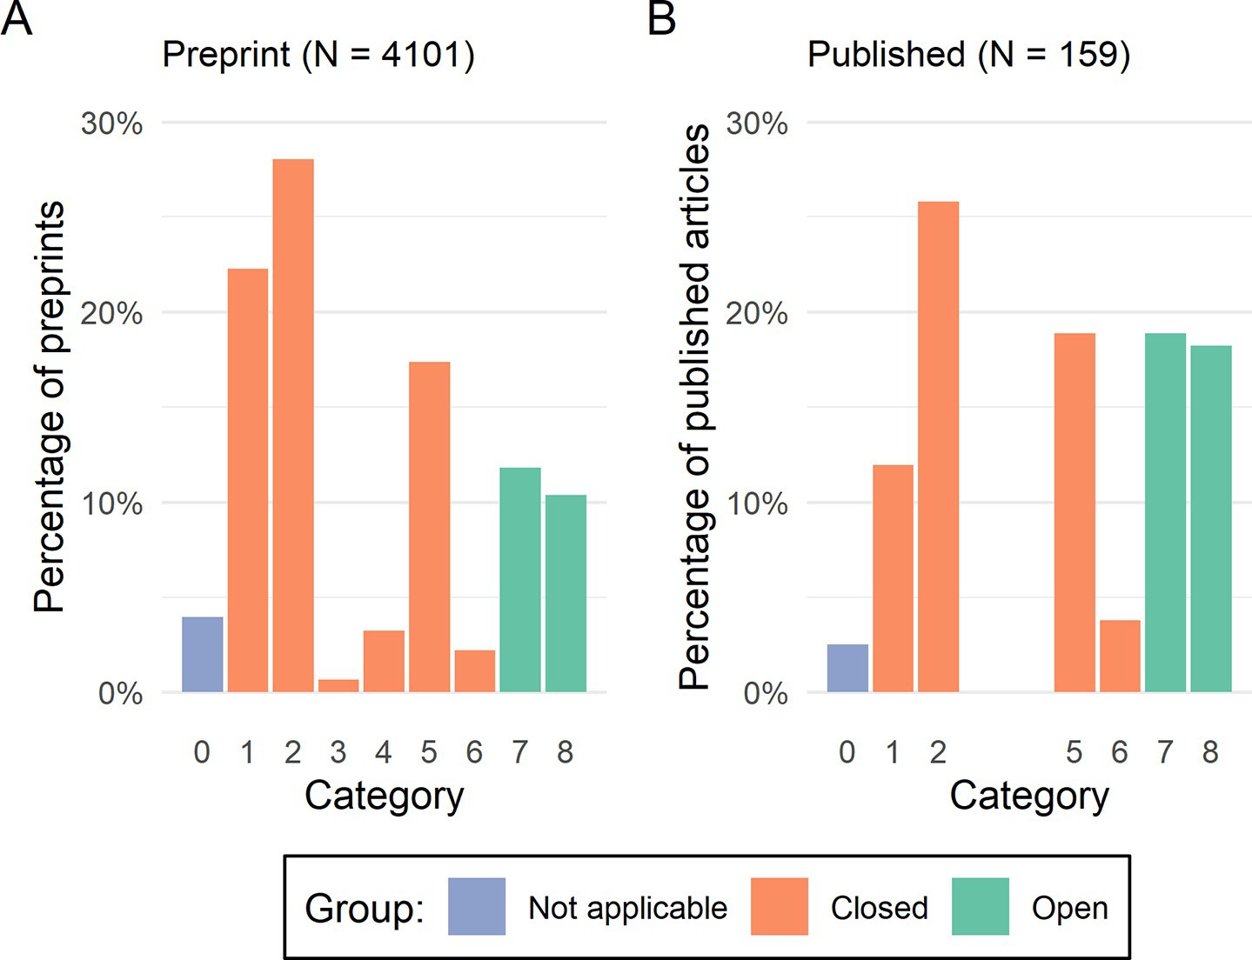

**Fig 1. Distribution of the data availability statements of preprinted (Panel A) and published (Panel B) records by category from Table 1.**

https://doi.org/10.1371/journal.pone.0250887.g001

PLOS ONE Data availability in medRxiv preprints and their published counterparts

**Table 2. Change in openness of data availability statements from preprint to published article, grouped by journal data-sharing policy.**

|  |  |  |  |  |  |  |
| --- | --- | --- | --- | --- | --- | --- |
| **Journal data sharing policy** | **Preprinted records subsequently published (N)** | **Open DAS in preprinted version % (N)** | **Open DAS in published version % (N)** | **Change in DAS from preprint to publication** | | |
| **More open (N)** | **More closed (N)** | **No change (N)** |
| **Does not mandate open data** | 94 | 20.2% (19) | 22.3% (21) | 10 | 8 | 76 |
| **Mandates open data** | 57 | 33.3% (19) | 61.4% (35) | 16 | 0 | 41 |

https://doi.org/10.1371/journal.pone.0250887.t002

Category 0 (“Not applicable”) were excluded, and of the 155 remaining, 59 (38.1%) had made their data open as per our criteria.

For the comparison of preprinted data availability statements with their published counter- parts, we excluded records that were not published, that did not have a published data avail- ability statement or that were labeled as “Not applicable” at either the preprint or published stage, leaving 151 records (3.7% of the total sample of 4101 records) records.

Data availability statements more frequently described open data on publication compared to the preprinted record when the journal mandated data sharing (Table 2). Moreover, the data availability statements for 8 articles published in journals that did not mandate open data sharing became less open on publication. The change in openness for preprints grouped by category and stratified by journal policy is shown in S1 Table in S1 File, while the change for each individual journal included in our analysis is shown in S2 Table in S1 File.

Interestingly, 22 records published in a journal mandating open data sharing did not have an open data availability statement. The majority of these records described data that was avail- able from a central access-controlled repository (Category 5 or 6), while in others, legal restric- tions were cited as the reason for lack of data sharing. However, in some cases, data was either insufficiently described or was only available on request (S3 Table in S1 File), indicating that journal policies which mandate data sharing may not always be consistently applied allowing some records may slip through the gaps.

161 (4.1%) preprints stated that data would be available on publication, but only 10 of these had subsequently been published (Table 3) and the number describing open data on publica- tion did not seem to vary based on whether the preprinted data availability statements include a link to an embargoed repository or not, though the sample size is small.

Of the 400 records for which code availability was assessed, 75 mentioned code availability in the preprinted full-text manuscript. However, only 22 (29.3%) of these also described code availability in the corresponding data availability statement (S4 Table in S1 File).

**Table 3. Assessment of whether researchers promising to make data available on publication actually do so, and whether this differs if researchers included a link to an embargoed repository or not.**

|  |  |  |  |
| --- | --- | --- | --- |
| **Preprint Category** | **Number of preprints** | **Published Category** | **Number of published studies** |
| **Data available in the future, with a link to an embargoed repository provided** | 3 | 1. Data not made available | 1 (33.3%) |
| 5. Data available from central repository (access-controlled or open access), but insufficient detail available to find specific dataset | 1 (33.3%) |
| 8. Data available via a online repository that is not access-controlled e.g. Dryad, Zenodo | 1 (33.3%) |
| **Data available in the future, with no details of embargoed repository given** | 7 | 1. Data not made available | 1 (14.3%) |
| 2. Data available on request to authors | 1 (14.3%) |
| 7. Data available in the manuscript/S1 File | 1 (14.3%) |
| 8. Data available via a online repository that is not access-controlled e.g. Dryad, Zenodo | 4 (57.1%) |

https://doi.org/10.1371/journal.pone.0250887.t003

PLOS ONE Data availability in medRxiv preprints and their published counterparts

1. **Discussion**
   1. **Principal findings and comparison with other studies**

We have reviewed 4101 preprinted and 159 published data availability statements, coding them as “open” or “closed” according to a predefined classification system. During this labor- intensive process, we appreciated statements that reflected the authors’ enthusiasm for data sharing (“YES”) [45], their bluntness (“Data is not available on request.”) [46], and their efforts to endear themselves to the reader (“I promise all data referred to in the manuscript are avail- able.”) [47]. Of the preprinted statements, almost three-quarters were categorized as “closed”, with the largest individual category being “available on request”. In light of the substantial impact that studies published as preprints on medRxiv have had on real-time decision making during the current COVID-19 pandemic [15], it is concerning that data for these preprints is so infrequently readily available for inspection.

A minority of published records we examined contained a data availability statement

(n = 159 (42.0%)). This lack of availability statement at publication results in a loss of useful information. For at least one published article, we identified relevant information in the pre- printed statement that did not appear anywhere in the published article, due to it not contain- ing a data availability statement [48, 49].

We provide initial descriptive evidence that strict data-sharing policies, which mandate that data be made openly available (where appropriate) as a condition of publication, appear to suc- ceed in making research data more open than those that do not. Our findings, though based on a relatively small number of observations, agree with other studies on the effect of journal policies on author behavior. Recent work has shown that “requiring” a data availability state- ment was effective in ensuring that this element was completed [4], while “encouraging” authors to follow a reporting checklist (the ARRIVE checklist) had no effect on compliance [50, 51].

Finally, we also provide evidence that data availability statements alone are insufficient to capture code availability declarations. Even when researchers wish to share their code, as evi- denced by a description of code availability in the main paper, they frequently do not include this information in the data availability statement. Code sharing has been advocated strongly elsewhere [52–54], as it provides an insight into the analytic decisions made by the research team, and there are few, if any, circumstances in which it is not possible to share the analytic code underpinning an analysis. Similar to data availability statements, a dedicated code avail- ability statement which is critically assessed against a clear code-sharing policy as part of the editorial and peer review processes will help researchers to appraise published results.

* 1. **Strengths and limitations**

A particular strength of this analysis is that the design allows us to compare what is essentially the same paper (same design, findings and authorship team) under two different data-sharing polices, and assess the change in the openness of the statement between them. To our knowl- edge this is the first study to use this approach to examine the potential impact of journal edito- rial policies. This approach also allows us to address the issue of self-selection. When looking at published articles alone, it is not possible to tell whether authors always intended to make their data available and chose a given journal due to its reputation for data sharing. In addition, we have examined all available preprints within our study period and all corresponding pub- lished articles, rather than taking a sub-sample. Finally, categorization of the statements was carried out by two independent researchers using predefined categories, reducing the risk of misclassification.

PLOS ONE Data availability in medRxiv preprints and their published counterparts

However, our analysis is subject to a number of potential limitations. The primary one is that manuscripts (at both the preprint and published stages) may have included links to the data, or more information that uniquely identifies the dataset from a data portal, within the text (for example, in the Methods section). While this might be the case, if readers are expected to piece together the relevant information from different locations in the manuscript, it throws into question what having a dedicated data availability statement adds. A second limitation is that we do not assess the veracity of any data availability statements, which may introduce some misclassification bias into our categorization. For example, we do not check whether all relevant data can actually be found in the manuscript/S1 File (Category 7) or the linked reposi- tory (Category 8), meaning our results provide a conservative estimate of the scale of the issue, asprevious work has suggested that this is unlikely to be the case [12]. A further consideration is that for Categories 1 (“No data available”) and 2 (“Available on request”), there will be situa- tions where making research data available is not feasible, for example, due to cost or concerns about patient re-identifiability [55, 56]. This situation is perfectly reasonable, as long as state- ments are explicit in justifying the lack of open data.

* 1. **Implications for policy**

Data availability statements are an important tool in the fight to make studies more reproduc- ible. However, without critical review of these statements in line with strict data-sharing poli- cies, authors default to not sharing their data or making it “available on request”. Based on our analysis, there is a greater change towards describing open data between preprinted and pub- lished data availability statements in journals that mandate data sharing as a condition of pub- lication. This would suggest that data sharing could be immediately improved by journals becoming more stringent in their data availability policies. Similarly, introduction of a related code availability section (or composite “material” availability section) will aid in reproducibil- ity by capturing whether analytic code is available in a standardized manuscript section.

It would be unfair to expect all editors and reviewers to be able to effectively review the code and data provided with a submission. As proposed elsewhere [57], a possible solution is to assign an editor or reviewer whose sole responsibility in the review process is to examine the data and code provided. They would also be responsible for judging, when data and code are absent, whether the argument presented by the authors for not sharing these materials is valid.

However, while this study focuses primarily on the role of journals, some responsibility for enacting change rests with the research community at large. If researchers regularly shared our data, strict journal data-sharing policies would not be needed. As such, we would encourage authors to consider sharing the data underlying future publications, regardless of whether the journal actually mandates it.

1. **Conclusion**

Requiring that authors submit a data availability statement is a good first step, but is insuffi- cient to ensure data availability, as our work shows that authors most commonly use them to state that data is only available on request. However, strict editorial policies that mandate data sharing (where appropriate) as a condition of publication appear to be effective in making research data available. In addition to the introduction of a dedicated code availability state- ment, a move towards mandated data sharing will help to ensure that future research is readily reproducible. We would strongly encourage all journal editors to examine whether their data availability policies are sufficiently stringent and consistently enforced.

PLOS ONE Data availability in medRxiv preprints and their published counterparts

**Supporting information**

**S1 File.**

(DOCX)

**Acknowledgments**

We must acknowledge the input of several people, without whom the quality of this work would have been diminished: Matthew Grainger and Neal Haddaway for their insightful com- ments on the subject of data availability statements; Phil Gooch and Sarah Nevitt for their skill in identifying missing published papers based on the vaguest of descriptions; Antica Culina, Julian Higgins and Alfredo Sa´nchez-To´jar for their comments on the preprinted version of this article; and Ciara Gardiner, for proof-reading this manuscript.

**Author Contributions Conceptualization:** Luke A. McGuinness. **Data curation:** Luke A. McGuinness.

**Formal analysis:** Luke A. McGuinness, Athena L. Sheppard.

**Investigation:** Luke A. McGuinness, Athena L. Sheppard. **Methodology:** Luke A. McGuinness, Athena L. Sheppard. **Project administration:** Luke A. McGuinness.

**Software:** Luke A. McGuinness.

**Supervision:** Luke A. McGuinness.

**Validation:** Luke A. McGuinness, Athena L. Sheppard.

**Visualization:** Luke A. McGuinness.

**Writing – original draft:** Luke A. McGuinness.

**Writing – review & editing:** Luke A. McGuinness, Athena L. Sheppard.

**References**

1. Packer M. Data sharing in medical research. *BMJ* 2018; k510. https://doi.org/10.1136/bmj.k510 PMID: 29444885
2. Taichman DB, Backus J, Baethge C, et al. Sharing clinical trial data. *BMJ* 2016; i255. https://doi.org/10. 1136/bmj.i255 PMID: 26790902
3. Krumholz HM. Why data sharing should be the expected norm. *BMJ (Clinical research ed)* 2015; 350: h599. https://doi.org/10.1136/bmj.h599 PMID: 25655137
4. Federer LM, Belter CW, Joubert DJ, et al. Data sharing in PLOS ONE: An analysis of Data Availability Statements. *PLOS ONE* 2018; 13:e0194768. https://doi.org/10.1371/journal.pone.0194768 PMID: 29719004
5. Nosek BA, Alter G, Banks GC, et al. Promoting an open research culture. *Science* 2015; 348:1422–5. https://doi.org/10.1126/science.aab2374 PMID: 26113702
6. Naudet F, Sakarovitch C, Janiaud P, et al. Data sharing and reanalysis of randomized controlled trials in leading biomedical journals with a full data sharing policy: Survey of studies published in *The BMJ* and *PLOS Medicine*. *BMJ* 2018; k400. https://doi.org/10.1136/bmj.k400 PMID: 29440066
7. Miyakawa T. No raw data, no science: Another possible source of the reproducibility crisis. *Molecular Brain* 2020; 13:24. https://doi.org/10.1186/s13041-020-0552-2 PMID: 32079532

PLOS ONE Data availability in medRxiv preprints and their published counterparts

1. Krawczyk M, Reuben E. (Un)Available upon Request: Field Experiment on Researchers’ Willingness to Share Supplementary Materials. *Accountability in Research* 2012; 19:175–86. https://doi.org/10.1080/ 08989621.2012.678688 PMID: 22686633
2. Vines TH, Albert AYK, Andrew RL, et al. The Availability of Research Data Declines Rapidly with Article Age. *Current Biology* 2014; 24:94–7. https://doi.org/10.1016/j.cub.2013.11.014 PMID: 24361065
3. Vasilevsky NA, Minnier J, Haendel MA, et al. Reproducible and reusable research: Are journal data sharing policies meeting the mark? *PeerJ* 2017; 5. https://doi.org/10.7717/peerj.3208 PMID: 28462024
4. Colavizza G, Hrynaszkiewicz I, Staden I, et al. The citation advantage of linking publications to research data. *PLOS ONE* 2020; 15:e0230416. https://doi.org/10.1371/journal.pone.0230416 PMID: 32320428
5. Roche DG, Kruuk LEB, Lanfear R, et al. Public Data Archiving in Ecology and Evolution: How Well Are We Doing? *PLOS Biology* 2015; 13:e1002295. https://doi.org/10.1371/journal.pbio.1002295 PMID: 26556502
6. Tan SC, Flanagan D, Morris E, et al. Research data repositories chosen by researchers across broad range of disciplines, from an analysis of 145,000 data availability statements. *Authorea* Published Online First: July 2020. https://doi.org/10.22541/au.159422974.49069472
7. Rawlinson C, Bloom T. New preprint server for medical research. *BMJ* 2019; 365. https://doi.org/10. 1136/bmj.l2301 PMID: 31167753
8. Fraser N, Brierley L, Dey G, et al. Preprinting a pandemic: The role of preprints in the COVID-19 pan- demic. *bioRxiv* 2020;2020.05.22.111294. https://doi.org/10.1101/2020.05.22.111294
9. McGuinness LA, Sheppard AL. Protocol for a descriptive analysis of the data availability statements accompanying medRxiv preprints. 2020.
10. McGuinness L, Schmidt L. Medrxivr: Accessing and searching medRxiv and bioRxiv preprint data in R.

*Journal of Open Source Software* 2020; 5:2651. https://doi.org/10.21105/joss.02651

1. Wickham H. *Rvest: Easily harvest (scrape) web pages*. 2019. https://CRAN.R-project.org/package= rvest
2. Chamberlain S, Zhu H, Jahn N, et al. *Rcrossref: Client for various ‘CrossRef’ ‘APIs’*. 2020. https:// CRAN.R-project.org/package=rcrossref
3. R Core Team. *R*: *A language and environment for statistical computing*. Vienna, Austria:: R Foundation for Statistical Computing 2019. [https://www.R-project.o](http://www.R-project.org/)rg/
4. Wickham H, Hester J, Chang W. *Devtools*: *Tools to make developing r packages easier*. 2019. https:// CRAN.R-project.org/package=devtools
5. Wickham H, Franc¸ois R, Henry L, et al. *Dplyr*: *A grammar of data manipulation*. 2019. https://CRAN.R- project.org/package=dplyr
6. Gohel D. *Flextable*: *Functions for tabular reporting*. 2020. https://CRAN.R-project.org/package= flextable
7. Wickham H. ggplot2: Elegant *graphics for data analysis*. Springer-Verlag New York 2016. https:// ggplot2.tidyverse.org
8. Rodriguez-Sanchez F. *Grateful*: *Facilitate citation of r packages*. 2018. https://github.com/Pakillo/ grateful
9. Mu¨ ller K. *Here*: *A simpler way to find your files*. 2017. https://CRAN.R-project.org/package=here
10. Gamer M, Lemon J, Fellows I, et al. *Irr*: *Various coefficients of interrater reliability and agreement*. 2019. https://CRAN.R-project.org/package=irr
11. Gohel D. *Officer*: *Manipulation of microsoft word and PowerPoint documents*. 2020. https://CRAN.R- project.org/package=officer
12. Pedersen TL. *Patchwork*: *The composer of plots*. 2019. https://CRAN.R-project.org/package= patchwork
13. Neuwirth E. *RColorBrewer*: *ColorBrewer palettes*. 2014. https://CRAN.R-project.org/package= RColorBrewer
14. Chan C, Chan GC, Leeper TJ, et al. *Rio*: *A swiss-army knife for data* file i/o. 2018.
15. Wickham H. *Stringr: Simple, consistent wrappers for common string operations*. 2019. https://CRAN.R- project.org/package=stringr
16. Mu¨ ller K, Wickham H. *Tibble*: *Simple data frames*. 2019. https://CRAN.R-project.org/package=tibble
17. Wilkinson MD, Dumontier M, Aalbersberg IjJ, et al. The FAIR Guiding Principles for scientific data man- agement and stewardship. *Scientific Data* 2016; 3:160018. https://doi.org/10.1038/sdata.2016.18 PMID: 26978244

PLOS ONE Data availability in medRxiv preprints and their published counterparts

1. Ehrlich OG, Testaverde J, Heller C, et al. Crohns disease and ulcerative colitis patient perspectives on clinical trials and participation. *medRxiv* 2019;19000273. https://doi.org/10.1101/19000273
2. Septiandri AA, Aditiawarman A, Tjiong R, et al. Cost-Sensitive Machine Learning Classification for Mass Tuberculosis Screening. *medRxiv* 2019;19000190. https://doi.org/10.1101/19000190
3. Solis JCA, Storvoll I, Vanbelle S, et al. Impact of spectrograms on the classification of wheezes and crackles in an educational setting. An interrater study. *medRxiv* 2019;19005504. https://doi.org/10. 1101/19005504
4. Ebbeling CB, Bielak L, Lakin PR, et al. Higher energy requirement during weight-loss maintenance on a low- versus high-carbohydrate diet: Secondary analyses from a randomized controlled feeding study. *medRxiv* Published Online First: July 2019. https://doi.org/10.1101/19001248
5. Barry A, Bradley J, Stone W, et al. Increased gametocyte production and mosquito infectivity in chronic versus incident Plasmodium falciparum infections. *medRxiv* 2020;2020.04.08.20057927. https://doi. org/10.1101/2020.04.08.20057927
6. Malpas CB, Ali Manouchehrinia A, Sharmin S, et al. Early clinical markers of aggressive multiple sclero- sis. *medRxiv* Published Online First: July 2019. https://doi.org/10.1101/19002063
7. Knuppel A, Papier K, Fensom GK, et al. Meat intake and cancer risk: Prospective analyses in UK Bio- bank. *medRxiv* 2019;19003822. https://doi.org/10.1101/19003822
8. Thompson ER, Bates L, Ibrahim IK, et al. Novel delivery of cellular therapy to reduce ischaemia reperfu- sion injury in kidney transplantation. *medRxiv* 2019;19005546. https://doi.org/10.1101/19005546
9. Moriarty F, Ebell MH. A comparison of contemporary versus older studies of aspirin for primary preven- tion. *medRxiv* 2019;19004267. https://doi.org/10.1101/19004267
10. McHugh ML. Interrater reliability: The kappa statistic. *Biochemia Medica* 2012; 22:276–82. PMID: 23092060
11. Chen L, Du X, Liu Y, et al. Comparison of the Clinical Implications among Two Different Nutritional Indi- ces in Hospitalized Patients with COVID-19. *medRxiv* Published Online First: May 2020. https://doi.org/ 10.1101/2020.04.28.20082644
12. Hashmi M, Taqi A, Memon MI, et al. A national landscaping survey of critical care services in hospitals accredited for training in a lower-middle income country: Pakistan. *medRxiv* Published Online First: April 2020. https://doi.org/10.1101/2020.04.22.20071555
13. Peng L, Liu J, Xu W, et al. 2019 Novel Coronavirus can be detected in urine, blood, anal swabs and oro- pharyngeal swabs samples. *medRxiv* Published Online First: February 2020. https://doi.org/10.1101/ 2020.02.21.20026179
14. Martin J, Hosking G, Wadon M, et al. A brief report: De novo copy number variants in children with atten- tion deficit hyperactivity disorder. *medRxiv* Published Online First: December 2019. https://doi.org/10. 1101/2019.12.12.19014555
15. Martin J, Hosking G, Wadon M, et al. A brief report: De novo copy number variants in children with atten- tion deficit hyperactivity disorder. *Translational Psychiatry* 2020; 10:135. https://doi.org/10.1038/ s41398-020-0821-y PMID: 32398668
16. Hair K, Macleod MR, Sena ES, et al. A randomised controlled trial of an Intervention to Improve Compli- ance with the ARRIVE guidelines (IICARus). *Research Integrity and Peer Review* 2019; 4:12. https:// doi.org/10.1186/s41073-019-0069-3 PMID: 31205756
17. Kilkenny C, Browne WJ, Cuthill IC, et al. Improving Bioscience Research Reporting: The ARRIVE Guidelines for Reporting Animal Research. *PLOS Biology* 2010; 8:e1000412. https://doi.org/10.1371/ journal.pbio.1000412 PMID: 20613859
18. Goldacre B, Morton CE, DeVito NJ. Why researchers should share their analytic code. *BMJ* 2019; l6365. https://doi.org/10.1136/bmj.l6365 PMID: 31753846
19. Eglen SJ, Marwick B, Halchenko YO, et al. Towards standard practices for sharing computer code and programs in neuroscience. *Nature neuroscience* 2017; 20:770–3. https://doi.org/10.1038/nn.4550 PMID: 28542156
20. Culina A, van den Berg I, Evans S, et al. Low availability of code in ecology: A call for urgent action.

*PLOS Biology* 2020; 18:e3000763. https://doi.org/10.1371/journal.pbio.3000763 PMID: 32722681

1. Goodhill GJ. Practical costs of data sharing. *Nature* 2014; 509:33–3. https://doi.org/10.1038/509033b PMID: 24784208
2. Courbier S, Dimond R, Bros-Facer V. Share and protect our health data: An evidence based approach to rare disease patients’ perspectives on data sharing and data protection—quantitative survey and rec- ommendations. *Orphanet Journal of Rare Diseases* 2019; 14:175. https://doi.org/10.1186/s13023-019- 1123-4 PMID: 31300010
3. Sa´nchez-To´jar A, Lagisz M, Moran NP, et al. The jury is still out regarding the generality of adaptive “transgenerational” effects. *Ecology Letters*;n/a. https://doi.org/10.1111/ele.13479 PMID: 32844521

Prevention Science https://doi.org/10.1007/s11121-021-01279-8



**Ensuring Prevention Science Research is Synthesis‑Ready for Immediate and Lasting Scientific Impact**

**Emily A. Hennessy1 · Rebecca L. Acabchuk2 · Pieter A. Arnold3 · Adam G. Dunn4 · Yong Zhi Foo5 ·**

**Blair T. Johnson6 · Sonya R. Geange3,7 · Neal R. Haddaway8,9,10 · Shinichi Nakagawa5 · Witness Mapanga11 · Kerrie Mengersen12 · Matthew J. Page13 · Alfredo Sánchez‑Tójar14 · Vivian Welch15 · Luke A. McGuinness16**

Accepted: 23 June 2021

© Society for Prevention Research 2021

**Abstract**

When seeking to inform and improve prevention efforts and policy, it is important to be able to robustly synthesize all avail- able evidence. But evidence sources are often large and heterogeneous, so understanding what works, for whom, and in what contexts can only be achieved through a systematic and comprehensive synthesis of evidence. Many barriers impede comprehensive evidence synthesis, which leads to uncertainty about the generalizability of intervention effectiveness, includ- ing inaccurate titles/abstracts/keywords terminology (hampering literature search efforts), ambiguous reporting of study meth- ods (resulting in inaccurate assessments of study rigor), and poorly reported participant characteristics, outcomes, and key variables (obstructing the calculation of an overall effect or the examination of effect modifiers). To address these issues and improve the reach of primary studies through their inclusion in evidence syntheses, we provide a set of practical guidelines to help prevention scientists prepare synthesis-ready research. We use a recent mindfulness trial as an empirical example to ground the discussion and demonstrate ways to ensure the following: (1) primary studies are discoverable; (2) the types of data needed for synthesis are present; and (3) these data are readily synthesizable. We highlight several tools and practices that can aid authors in these efforts, such as using a data-driven approach for crafting titles, abstracts, and keywords or by creating a repository for each project to host all study-related data files. We also provide step-by-step guidance and software suggestions for standardizing data design and public archiving to facilitate synthesis-ready research.

**Keywords** Evidence synthesis · Meta-data · Reporting · Reproducibility · Synthesis-ready research · Transparency

Systematic reviews are an important tool for informing policy and practice. When done well, they provide a robust synthesis of available evidence, account for risks of bias in individual studies, and address problems associated with the volume of primary research being published (Johnson & Hennessy, 2019; Wilson & Tanner-Smith, 2014).

To conduct a comprehensive evidence synthesis, such as a systematic review and meta-analysis, primary studies related to the research aim must be identifiable and report relevant study and outcome data. Those who conduct evi- dence syntheses — hereafter referred to as *evidence synthe- sists* — often need information about study processes and measured variables aside from a manuscripts’ primary out- come of interest to explore why there are differences (i.e.,

  Emily A. Hennessy [ehennessy@mgh.harvard.edu](mailto:ehennessy@mgh.harvard.edu)

Extended author information available on the last page of the article

statistical heterogeneity) between studies examining the same intervention. This information is often missing, which leads to uncertainty about the generalizability of interven- tion effectiveness across different groups (e.g., race/ethnic- ity, gender, age) and can make these efforts slower and less accurate (Borah et al., 2017; Haddaway & Westgate, 2019; Nakagawa et al., 2020; Nuijten et al., 2016). Even when stud- ies report their statistical data and results in detail, there is often still important information missing about other factors that require further attention before they can be accurately synthesized (e.g., description of the intervention, population, or outcome measures). Data and meta-data may be missing from a primary study for many reasons, including article length restrictions, a lack of detailed reporting standards or awareness of the importance of open data, or a desire to retain control of analyses, amongst others.

Given the potential impact of their work on human health and behaviors, prevention scientists should be at the

###### Logo Description automatically generated1 3

forefront of ensuring primary research is transparent, repro- ducible, and furthermore, we argue, synthesis-ready. *Syn- thesis-ready research* is our term to describe a study (e.g., randomized controlled trial (RCT), quasi-experimental study (QED), or observational study), its *meta-data* (i.e., descrip- tive information about the study’s data, including protocols, tools, algorithms, so that one could replicate the study), and *data* (information collected while conducting the study) that can be readily and accurately used in evidence syntheses.

Resources are available to enable authors to share detailed data and meta-data associated with a study; yet, these resources are often not directly connected to scien- tific journal practices. Some of these options make it much easier to discover, use, and cite authors’ research, substan- tially increasing the impact and legacy of their work. Thus, our aim was to draw on resources from across disciplines (Grant et al., 2018; Montgomery et al., 2018; Schulz et al., 2010; Wilkinson et al., 2016) to produce a guide to report- ing primary research that is open, accessible, and synthesis- ready. To illustrate synthesis-ready research principles and streamline this process for prevention scientists, we briefly present an empirical example from a mindfulness meditation RCT to improve college student well-being (“Introduction to Empirical Example”), followed by a demonstration of the application of best practices for synthesis-ready research to this example (“Evidence Synthesis Process Applied to Our Empirical Example” and “How to Make Research Synthesis- Ready: Steps from Study Design to Completion”).

From Primary Study Research to Evidence Synthesis

Primary study conduct and reporting guidelines now advocate for reporting enough information for research to be transparent and reproducible and also provide specific information on how to do so (Chan et al., 2013; Grant et al., 2018; Schulz et al., 2010). Similarly, efforts have focused on improving the degree of FAIRness of primary studies, by making research Findable, Accessible, Interoperable, and Reusable (Wilkinson et al., 2016).1

*Findable* indicates research is identifiable to anyone searching for it; data and meta-data and their locations clearly described. Data and meta-data that are retrievable by their identifier (e.g., a digital object identifier, DOI) and are freely obtainable in full without barriers to access (e.g.,

1 Although FAIR principles primarily refer to enhancing the ability of machines to find and use data, these recommendations also enhance data reuse by individuals. Where appropriate, we have adapted the FAIR components to more directly apply to human-readability efforts for the purposes of this manuscript.

###### 1 3

Prevention Science

without needing to register with an external website or contacting study authors) are considered *Accessible*. Data and meta-data that are understandable across humans or machines without the need for specialized tools or trans- lation and include linkage to their relevant data/meta-data are *Interoperable*. Finally, *Resuable* refers to the degree to which information can be appropriately repurposed (e.g., integrated/built upon). Thus, research data and meta-data should have a data usage license, detailed records of data origins, and be clearly and richly described in their accom- panying materials. By following Open Science recommenda- tions and addressing FAIR principles (Frankenhuis & Nettle, 2018; Vicente-Saez & Martinez-Fuentes, 2018), prevention scientists can provide synthesis-ready research that improves the translation of research into practice.

Evidence syntheses rely on the data reported in research studies and by the researchers themselves. Similar to the con- duct of primary research, there are best practices for conducting and reporting of evidence syntheses, including the following: problem formulation, systematically identifying and selecting studies for inclusion, coding studies for key features, calculating effect sizes (if synthesizing quantitative data, such as by con- ducting a meta-analysis), analyzing the data (assess quality and risk of bias, synthesize coded information from studies), and interpreting and communicating results (Online, Fig. 1). The content and the comprehensiveness of the review (if the review authors follow best practice guidelines) are a direct result of the available information reported in primary studies.

Potential Advantages of Synthesis‑Ready Research

Synthesis-ready research can increase the transparency, integrity, and reproducibility of research, ultimately leading to improved scientific evidence (Beugelsdijk et al., 2020). Pre-registration and subsequent data sharing practices should reduce the prevalence of post hoc hypothesis (HARKing; Forstmeier et al., 2017; Kerr, 1998) and falsifying or mis- representing data in results (Banks et al., 2019; Miyakawa, 2020). Doing so can reduce duplication of effort and intro- duce findings to the research community sooner and ensure that all findings (beneficial and adverse) are reported, results that can prevent costly mistakes and accelerate the impact of prevention scientists (Gupta et al., 2015; Pasquetto et al., 2019). Indeed, synthesis-ready data can be used repeat- edly and for multiple purposes, ultimately informing more research questions: thus it is more cost-effective when com- pared to data that is only used by the team that collected it.

Primary researchers who make their work synthesis- ready should also benefit from these efforts. Synthesis-ready research is more likely to be identified and used in evidence synthesis (Christensen et al., 2019; Gerstner et al., 2017).

Prevention Science

For example, a recent study showed that hosting data in a repository resulted in 25% more citations than merely stat- ing data were available by request (Colavizza et al., 2020). Additionally, depending on the organization of the meta- data and the data repository used, the dataset may be cited directly, as may other study materials such as the analytical code, further enhancing the profile of the work and those who conducted it (Crosas, 2013).

Because synthesis-ready research is also more identifiable, there will be increased opportunities for future collaborations (Popkin, 2019), which potentially improves future resource- sharing and reduces costs. Producing synthesis-ready research can also increase the recognition of an individual study team to an international audience. Many funding sources require data sharing of their grantees and necessitate the inclusion of such plans in grant proposals (e.g., Wellcome Trust, the UK Medical Research Council, and the US National Institutes of Health: Gaba et al., 2020; NIH Data Sharing Policy & Guid- ance, 2003; Wellcome Trust Public Health Research Data Forum, 2012). Thus, researchers who prepare and deliver grant-funded research findings with synthesis-ready consid- erations are considered responsive to funders while potentially attaining these other discussed benefits.

Introduction to Empirical Example

Our empirical example is a RCT (*N* = 140 participants; regis- tered in Clinical Trials, NCT03402009) conducted across two university semesters in the 2018 academic year (Acabchuk et al., 2021). The study evaluated two active treatment condi- tions to determine what tools best assist university students in developing a personal meditation practice to self-manage symptoms of depression, anxiety, and stress. One group was assigned to the *10% Happier* meditation phone app (labeled the “App Group”; Ten Percent Happier: Mindfulness Medita- tion Courses, 2020), which provides guided meditations, and the other was assigned to the *10% Happier* meditation phone app in combination with a Muse EEG neurofeedback device (labeled the “Muse Group”; Choose Muse, 2018). The study included a baseline assessment, randomization to one of two groups, an orientation session for both groups, collection of salivary biomarkers, and follow-up survey assessments on a variety of well-being and behavior outcomes throughout the study (Study Timeline: Online, Fig. 2).

Evidence Synthesis Process Applied to Our Empirical Example

Drawing from our empirical example, if one sought to con- duct a systematic review of all types of mindfulness inter- ventions for college students on health-related outcomes

(*Problem Formulation*), they would first need to be able to identify all primary research matching their inclusion criteria (*Finding and Selecting Studies*). Clearly delineat- ing the research problem is a foundational step in a review, as it drives the search strategy and ability to accurately identify and synthesize primary study research. Research questions in an evidence synthesis should address all the main elements of the studies to be included; many draw on the PICOS framework with its focus on the population(s), intervention(s), comparator(s), outcome(s), and study design(s) elements of a research problem (Stern et al., 2014). Once the relevant literature is identified, data are extracted from the studies (*Code Studies for Relevant Features*) so that the analysis can commence by synthesizing coded data (*Analyze the Systematic Review Database*).

Within this broader process, the types of data and meta- data that need to be reported in a primary study depend on the task and/or type of evidence synthesis. For example, research methods need to be fully reported to assess risk of bias. If the review aimed to measure the effectiveness of mindfulness interventions on depression symptoms using a meta-analysis, then primary studies should report the data necessary to calculate an effect size from their depres- sive symptom assessment for all participants (e.g., means, standard deviations, and sample sizes for each group). To address relevant potential effect modifiers (e.g., age, year in school, gender, intervention fidelity), any data collected during the primary study on participant characteristics and the study methods (e.g., description of groups, duration of intervention) needs to be transparently reported. To exam- ine geographic and temporal effect modifiers, key informa- tion about the study location and timing should be provided (Johnson et al., 2017). Additionally, if the synthesis focuses on participants’ perspectives on why interventions are more or less effective, they would need access to any qualitative data collected as part of the study (e.g., interviews, focus groups). Given this variability in the type of questions that could be addressed in a synthesis, it is important for investi- gators to transparently and comprehensively report a variety of information about their research.

How to Make Research Synthesis‑Ready: Steps from Study Design to Completion

Approaching every step of a research project with data shar- ing in mind is useful and often necessary to ensure that data sharing is possible. This approach has the added benefit of encouraging better overall project management, including clearer workflows and comprehensive documentation of the analytical process. We now illustrate each step of these sug- gestions from study design to sharing with examples from our mindfulness trial (Fig. 1).

###### 1 3

Prevention Science

Study Design

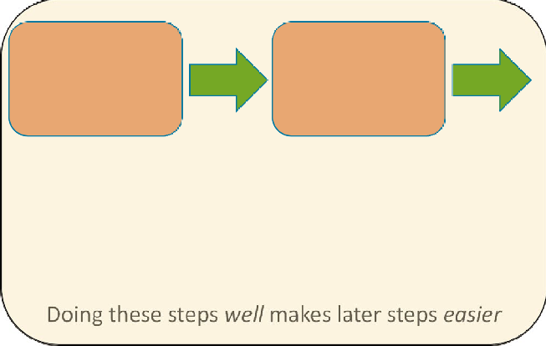

①Register study

②Prepare protocol

Study Conduct

Use transparent and reproducible workflows

Study Dissemination

③Unique permanent identifier (authors, data, metadata)

④Include DAS with manuscript

Archiving and Sharing

⑫ Choose appropriate location for sharing data

⑬ Share data

Doing these steps *well* makes later steps *easier*

Doing these steps *well* makes later steps *easier*

Mindfulness Trial

CD Pre-registered on clinicaltrials.gov

C£ Protocol developed using SPIRIT guidelines (Online, Figure 2)

® ORCID used for authors; Data and metadata archived in Zenodo, given DOI (Figure 2)

® DAS (Manuscript, p. 12)

� Tags used include: phone application, randomized controlled trial, smartphone app, quality of life, mental health, mindfulness meditation, stress reduction

0 litsearchr generates title, abstract, key terms (Online Table 3)

® CC-BY-4.0 license; allows reuse of data provided researchers are credited

Figure 2, Zenodo

Figure 2, Zenodo

⑪ Figure 2, Zenodo

⑫ Github repository, archived with Zenodo

Individual participant data shared via excel files; metadata provided

⑬ for other key study elements

⑤Use archiving repository ‘Tags’

⑥Use consistent author usernames

⑦Craft title, abstract, keywords to increase Findability

⑧License data Files to Prepare

⑨ README

⑩Data dictionary

⑪Variable crosswalks

**Fig. 1** Best practices in generating synthesis-ready research applied to mindfulness trial. DAS, data availability statement

**Study Design**

Preparing research for sharing can be a resource-intensive process, and so planning and provisioning for this task are vital to consider when submitting funding applications and considering funders’ reporting requirements. When con- ducting research with human participants, advance planning for data sharing is essential because it ensures appropriate documentation is prepared. Any potential ethical concerns with data sharing should be addressed during the review of study materials by the governing Institutional Review Board, which ensures that participant consent documents include the correct language to ensure participants can consent to anonymized data sharing (Ohmann et al., 2017; Thorogood & Knoppers, 2017). The Inter-university Consortium for Political and Social Research (ICPSR) recommends carefully constructing these sections and provides sample text to use to ensure that participants are informed about the potential use of their anonymized data in future research (Inter-university Consortium for Political and Social Research, 2010).

###### 1 3

The study protocol is the foundation of the study, detail- ing all the processes, procedures, and materials planned for a research project. Best practice for primary studies and secondary data analysis is to register a study protocol that includes primary questions and/or hypotheses, methodology, and planned analyses. With careful attention to developing a comprehensive protocol using a standard structure, this docu- ment can increase the synthesis-readiness of the research. The information provided in a study protocol includes impor- tant meta-data that may not be available in a single published manuscript but that can be used by evidence synthesists to address a variety of research questions, including using it to assess study quality and risk of bias due to selection of reported results or “outcome switching” (Falk Delgado & Falk Delgado, 2017; Kahan & Jairath, 2018). We recom- mend that authors review published guidelines for the best tool for the study design in question: The EQUATOR net- work provides an online resource to compare these tools (https://[www.equator-network.org/).](http://www.equator-network.org/)) Online Tables 1 and 2 present a mapping of critical elements for a study *protocol*

Prevention Science

(using the Standard Protocol Items: Recommendations for Interventional Trials (SPIRIT); Chan et al., 2013) and for a study *manuscript* (using the Consolidated Standards of Reporting Trials for social and psychological interventions (CONSORT); Grant et al., 2018)) and indicate how study information provided following these guidelines could be used in an evidence synthesis. Table 1

The protocol for our mindfulness trial uses the SPIRIT guidelines (Chan et al., 2013) and is archived in a Zenodo repository (DOI: https://doi.org/10.5281/zenodo.4011716).

**Study Conduct**

To facilitate data sharing and to distribute the workload across the projects’ lifecycle, transparent and reproducible data management workflows should be employed throughout the research process, including (1) defining data file con- tents; (2) clearly describing variable names, definitions, units, and formats; (3) implementing consistent data organization and file structure; (4) performing basic quality assurance to ensure that values fall within expected ranges; and (5) pro- viding documentation including the analytical steps taken (crosswalks), data dictionaries (i.e., codebooks), and meta- data (Barton et al., 2010; Strasser, 2012; Yenni et al., 2019)*.* Building in these meta-data collection steps into the analysis process makes it easier to create items like variable cross- walks and data dictionaries to accompany shared research.

**Study Dissemination**

The most labor-intensive stage of making data synthesis- ready within a FAIR perspective occurs during preparation for study dissemination as it involves several steps. To ensure their research is *Findable* and *Accessible*, authors should (1) ensure all authors have a unique permanent identifier such as an ORCID iD (Open Researcher and Contributor ID, 2009) and include this identifier with manuscript and data submis- sion (because institutional emails are often impermanent);

(2) include a detailed data availability statement with manu- script submission; (3) assign data and meta-data a globally unique and persistent identifier (e.g., DOI), which ensures long-term discoverability; (4) use available data ‘tags’ in the archiving repository; (5) use consistent names/usernames across the different journal and archiving platforms; and (6) craft the title and abstract and select keywords that will opti- mize the chances of research being identified via the most

**Data Availability Statements to Ensure Findability** A data availability statement (DAS; also known as “data access statements” or “availability of materials”) provides informa- tion about how and where other researchers can access the study data and is often required when submitting a manu- script for publication (Federer et al., 2018; Graf et al., 2020). In some closed-access journals, DAS are treated as article meta-data, so they are accessible even if the article is behind a paywall, ensuring the data are findable. Thus, the DAS should be as explicit as possible, even if some information that is in the manuscript is repeated in the DAS.

The DAS for our mindfulness trial example states: “Both the full raw dataset and the finalized analytical dataset used in this analysis are available from Zenodo (DOI: https://doi. org/10.5281/zenodo.4011716), along with comprehensive data dictionaries and crosswalks.”

**Creating Titles, Abstracts, and Keywords to Optimize Findabil‑ ity** Carefully crafting titles and abstracts, in addition to choos- ing appropriate keywords, is essential to help other researchers find your research. As much as possible given word limits, these should describe the condition, exposure, and settings of a study (Grant et al., 2018; Montgomery et al., 2018). These pieces of the submission are often the last to be created but are the main pieces of information indexed and displayed in electronic data- bases and are used to identify relevant research for an evidence synthesis. As a result of their ability to increase the findability of research, we suggest a data-driven approach to crafting these sections. The litsearchr package for the R programming environment offers a systematic approach to generate a list of words likely to improve the identifiability of the study manuscript (Grames et al., 2019; R Core Team, 2019).

Using our mindfulness trial example, we began with a set of keywords we thought likely to capture a set of relevant pub- lished articles from which we could draw the most highly used keywords. We conducted a search using these keywords in Pub- Med on August 24, 2020 and used litsearchr to systemati- cally generate a list of important terms. The results suggest that several terms could be strategically incorporated in the title, abstract, and keywords to increase the findability of the trial (Online, Table 3 provides further details using our example).

**Data Licenses** Assigning a license to the data being shared is important to govern how the data can be reused and, more importantly, to help ensure that the study team is credited.2 For our mindfulness trial example, we chose the CC-BY-4.0 license, which allows the reuse of the data provided the origi-

nal researchers are credited with the creation of the dataset.

typical evidence synthesis method of searching for research

(i.e., electronic database searches). To ensure their data is also *Interoperable* and *Reusable*, researchers need to attend to licensing, data file structures and formats, and detailed meta-data when preparing their data for sharing.

2 Comparing the full suite of licenses available is beyond the scope of this article; online resources such as ChooseALicence (https:// choosealicense.com/non-software/) and Creative Commons (https:// creativecommons.org/licenses/) provide detailed descriptions of the range of licenses available for data sharing.

**Table 1** Comparison of the options for sharing data

Location Examples Advantages Disadvantages Examples

Non-affiliated repositories Zenodo; Dryad; Figshare;

Open Science Framework

Institutional repositories data.bris;

Harvard Dataverse; Inter-university Consortium for Political and Social Research; UK Data Service

Free (except Dryad)

Self-archiving. DOI assigned.

Long-term storage. Can blind repositories for double-blind peer- review (Anonymous Github; OSF “Anonymous” Links)

Supported by institution

DOI assigned. Often can get help from staff when uploading data

Some have a Data Publishing Charge (e.g., Dryad charges $120). No review of files uploaded

Not as well known as other repositories—limits findability

Repository for Abbott et al., 2019, contains raw dataset, analysis data- set, cleaning code, analysis code. Available from https://doi.org/10. 5281/zenodo.3529382

Pescosolido et al., 2020, contains scripts and data to replicate all fig- ures/analyses found in the original manuscript

Supplemental files attached to the online version of the published article

Many file types (.txt,.xlsx,.doc,.pdf) with data or metadata

Likely relatively less work to prepare compared to the other options

No DOI (for supplemental files)

Can be closed- access. Potential for data to be lost. Least findable of the other options

Slep et al., 2020, contains mPLUS code and data

Tomczyk et al., 2020, open access, includes data in manuscript and sup- plemental files

Prevention Science

1 3

Prevention Science

**Data File Structures and Formats** Sharing individual partici- pant data, i.e., data on each variable collected for each par- ticipant, affords those wishing to reuse or synthesize these data a range of advantages. Access to data on all variables collected, rather than just those used in the primary study’s analysis, allows synthesists to ensure that an estimate from a primary study is adjusted for a common set of variables when it is included in a meta-analysis, even if the published effect estimate for that study was not (Riley et al., 2010). Even among individual participant data, different levels of granularity exist.

It may not be possible to share each individual partici- pant data point, especially when participant confidential- ity is at risk, for example, when studying a rare disease or among participants of specialized programs. In these cases, there are several options for sharing individual participant data. The first is to generate a “synthetic” dataset that mim- ics the individual-level data by preserving statistical proper- ties and the relationships between variables. Software, for example, the synthpop R package, can help users gener- ate a synthetic dataset (Quintana, 2020, provides a tuto- rial on using this package). A second option is to remove some individual characteristics that might give away participants’ identities, such as age, sex, and location of recruitment source, but provide the rest of the variables as individual data points. Finally, if it is not possible to share any individual participant data, then at the very minimum, summary-level data (e.g., means and standard deviations or percentages which describe the distribution of all variables between intervention/exposure groups) should be provided for all variables included in the paper and, if possible, the dataset, not solely those thought by the primary study team to be relevant. Of course, for investigators conducting years of longitudinal studies examining numerous questions for which they are not ready to share data, we advise authors to explicitly state in their DAS the reasons for not sharing data. By beginning to capture the true reasons for not shar- ing data, data availability statements can then begin to be used as support for introducing better protection for and citation of data producers.

To illustrate the distinction in the level of data shared,

for our mindfulness trial, we shared the raw data exported from the survey instrument, which contains each partici- pant’s answer to each individual question, and the processed individual participant data, which include scale score sum- maries (i.e., total DASS-21 score, comprised of 21 indi- vidual questions). To explore these different datasets, see the “REDCAP_data.xlsx” and “combined_data.xlsx” files in our Github repository which is archived by Zenodo (DOI: https://doi.org/10.5281/zenodo.4011716).

Study data can be shared as machine-readable (e.g., unformatted Excel/CSV files and raw DNA microarray

sequences) or human-readable formats (e.g., formatted PDF tables, figures, and data contained in text such as “There was evidence of an association (Odds ratio: 0.91, 95%CI: 0.85–0.96)”). Although tools are being developed to extract data automatically from human-readable sources for evi- dence syntheses (Marshall et al., 2020), it is often challeng- ing to import these data into statistical analysis software, reducing interoperability and synthesis-readiness.

For our mindfulness trial example, all study data are shared via Excel files in our Github repository which is archived by Zenodo (DOI: https://doi.org/10.5281/zenodo. 4011716). This includes the mindfulness trial’s quantitative survey data. It also includes qualitative data, which were generated from in-person, semi-structured interviews and coded to examine adherence and problems with using the tools. To demonstrate synthesis-readiness, the relevant responses for qualitative coding are included in the data file rather than the full interview notes.

**Meta‑data** Providing a README, a plain text file that contains useful information about data or software, can help ensure that data are correctly accessed, interpreted, and reused by other researchers. The README file should include a (1) definition of the primary research aims using a relevant alternative framework that addresses the main com- ponents of the research which will help others identify and use the research (e.g., PICOTS, TOPICS + M; Haynes, 2006; Johnson & Hennessy, 2019; Stern et al., 2014); (2) a short description of all the data files included in the project reposi- tory; (3) signposts to the detailed data dictionaries for each data file which contain definitions of all variables, including coded (e.g., “CRP_t2”) and interpretable (e.g., “C-Reactive Protein levels at 2 months post-baseline”) variable names, the values that each variable is allowed to take, and include missing data indicators and units of measurement; (4) a sum- mary of data processing steps that were used to produce the final analytic datasets from the raw data files; (5) a descrip- tion of each data file’s relationship to other data files in the repository, and relevant linkage variables, such as participant ID; (6) permanent author contact details; and (7) details of the license, including the full name of the license holder, the year, and where the full text of the license can be found. The README for our mindfulness trial contains the seven main elements necessary for a comprehensive meta- data file; see Fig. 2 for a snapshot of these pieces and visit Zenodo to view and download all files: https://doi.org/10.

5281/zenodo.4011716.

**Archiving and Sharing Research Data**

Research data sharing can be done via institutional and non- institutional repositories or alongside published articles

Prevention Science

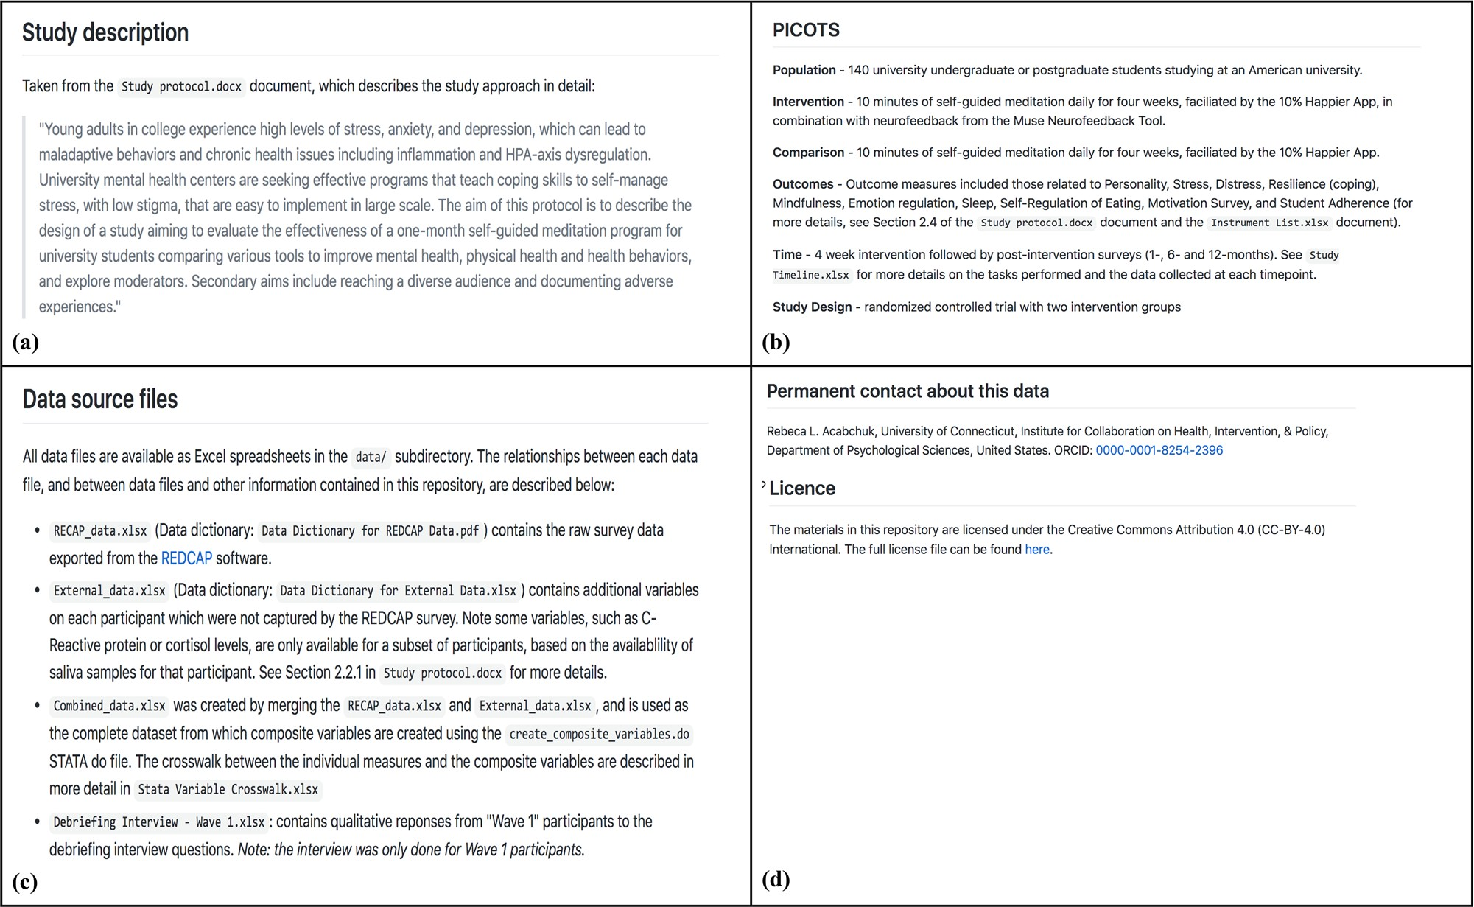

**Fig. 2** Mindfulness trial metadata included in the README file. Panels **a** and **b** provide the study description according to the PICOTS framework; **c** provides data source files, locations, and rela-

(Table 1). We have ordered these sharing options from best practice (most likely to be synthesis-ready) to good practice (still synthesis-ready but may require additional effort to prepare for synthesis).

**Non‑affiliated Repositories** Non-affiliated repositories are commercial or charity repositories that allow researchers to self-archive, and assign a DOI to, their research data. Exam- ples include Dryad, Open Science Framework, and Zenodo (Dryad, 2020; Open Science Framework, 2020; Zenodo— Research Shared, 2020). The main limitation of these reposi- tories is that there are often conditions on how much data can be stored; some charge fees for storage.

For our mindfulness trial example, the repository was created in GitHub and archived using Zenodo, as GitHub deposition is non-permanent and does not assign a DOI to the uploaded data. Repositories of this type can be embar- goed prior to publication to prevent “scooping,” and some repositories also provide services to help prevent scooping. For example, projects hosted in the Open Science Frame- work can have “anonymous” links to remove identifying meta-data as part of double-blind peer-review requirements.

tionships between the files; **d** provides permanent author information and licensing information

**Institutional Repositories** An institutional repository is one hosted by an academic institution, such as the ICPSR (ICSPR, 2021). An advantage of affiliated repositories is that some provide staff to guide researchers who are new to data sharing. These repositories are less well-known, which may limit the findability of data when compared to other options. The terms of deposition should be reviewed to ensure that authors retain data ownership and copyright over the deposited materials.

**Supplemental Files** A common option for sharing research data is as a supplementary file to the published manuscript. However, this method has several major limitations. This approach reduces data findability because datasets shared as supplementary material are grouped under the publica- tion’s DOI and are not uniquely identifiable. There is also the potential for supplementary files to become disassoci- ated with their respective publications, for example, dur- ing a website redesign. If the published article is behind a paywall, then data attached to it as supplementary files may also be blocked and so data shared as supplemental files may not be fully accessible. Sharing data as supplementary files to an open-access publication should be considered the minimum level of data sharing needed to make research synthesis-ready.

###### 1 3

Prevention Science

Potential Challenges and Future Considerations

In this article, we have outlined the benefits of synthesis- ready research and provided guidelines on how to follow best practice and produce synthesis-ready research. Yet, we appreciate that there are many perceived and actual chal- lenges to doing so, including costs to data sharing, lack of incentives, lack of awareness or training, not wanting to “give away” data or get “scooped” on findings, and the necessity of ensuring participant confidentiality (Evans, 2016; Tennant et al., 2019; Tenopir et al., 2011, 2015; van

Panhuis et al., 2014; Walters, 2020).

To address the lack of knowledge and training, we have provided information, workflows, and a full demonstration using an empirical example, in addition to signposting to fur- ther literature, to help researchers plan for the resources needed for making research synthesis-ready at project conceptualiza- tion. Many funders have recognized the value of data sharing and will provide funds to do so based on investigator budgets which can offset the tangible (platform sharing fees) and intan- gible (time spent preparing data) costs of this process.

Researchers have valid concerns about having their research scooped, and yet, several measures can help pre- vent scooping including pre-registering study analysis plans and depositing preprints while awaiting publica- tion, all core practices of open science. An additional solution is to license data at the point of publication or archival (“How to Make Research Synthesis-Ready: Steps from Study Design to Completion”). Finally, some journals have implemented “scoop-protection” policies for research, a system-level solution we hope more jour- nals will implement to address this challenge (Transpose, 2020). Ensuring that all types of research data are reused appropriately is a warranted concern (Bishop, 2009; Yardley et al., 2014); yet, evidence suggests that indi- viduals reusing data seek to collaborate with the original data creators to harness their knowledge about the data, rather than using it to scoop findings or to disprove the original publication’s findings, resulting in improved and more accurate data reuse and increased opportunities for publication (Pasquetto et al., 2019). As well, providing clearly detailed documentation in the data and meta-data files (“How to Make Research Synthesis-Ready: Steps from Study Design to Completion” and Fig. 2) should reduce inappropriate use of shared data. Finally, we have provided several different options for maintaining the confidentiality of participants while attending to synthe- sis-readiness (“How to Make Research Synthesis-Ready: Steps from Study Design to Completion”).

Conclusions

Despite the importance of making research available and synthesis-ready, not all scientific disciplines have embraced data/meta-data sharing and transparency at the same rate (Graf et al., 2020; Hardwicke et al., 2020; Sholler et al., 2019; Vasilevsky et al., 2017). If prevention scientists share research in synthesis-ready forms, the field would see improvements, especially in terms of impact on policy and practice. We presented methods for managing data sharing processes that should make it easier to produce synthesis- ready research. Changes in research practice that focus on synthesizability will reduce the delay between implementing effective primary study approaches (Nakagawa et al., 2020) and should have a positive impact on translation of preven- tion science into policy and practice.

**Supplementary Information** The online version contains supplemen- tary material available at https://doi.org/10.1007/s11121-021-01279-8.

**Acknowledgements** The paper was first developed during the 2019 Evidence Synthesis Hackathon.

**Author Contribution** Project administration (EAH; LAM), roles/writing

— original draft (EAH; LAM), visualization (EAH; LAM); data curation (RLA; LAM); resources (LAM); funding acquisition (NRH); investiga- tion (EAH; LAM; RLA), methodology (EAH; LAM); software (EAH; LAM); conceptualization (All authors), writing — review and editing (all authors).

**Funding** The Fenner School of Environment & Society (ANU), the University of New South Wales, and the Faculty of Humanities at the University of Johannesburg funded the Evidence Synthesis Hackathon 2019. EAH has support from NIAAA (K01 AA028536-01). MJP has support from an Australian Research Council Discovery Early Career Researcher Award (DE200101618). LAM has support by an NIHR Doctoral Research Fellowship (DRF-2018–11-ST2-048).

**Declarations**

**Conflict of Interest** The authors declare no competing interests.

**Disclaimer** The views expressed in this article are those of the authors and do not necessarily represent those of the NIAAA, NHS, the NIHR, or the Department of Health and Social Care.

References

Abbott, S., Christensen, H., Welton, N. J., & Brooks-Pollock, E. (2019). Estimating the effect of the 2005 change in BCG policy in England: A retrospective cohort study, 2000 to 2015. *Eurosur- veillance*, *24*(49), 1,900,220. https://doi.org/10/gg9nqk

Acabchuk, R. L., Simon, M. A., Low, S., Brisson, J. M., & Johnson, B.

T. (2021). Measuring meditation progress with a consumer-grade EEG device: Caution from a randomized controlled trial. *Mind- fulness, 12*, 68–81. https://doi.org/10.1007/s12671-020-01497-1

###### 1 3

Banks, G. C., Field, J. G., Oswald, F. L., O’Boyle, E. H., Landis, R. S., Rupp, D. E., & Rogelberg, S. G. (2019). Answers to 18 questions about open science practices. *Journal of Business and Psychology, 34*, 257–270. https://doi.org/10.1007/s10869-018-9547-8

Barton, C., Smith, R., & Weaver, R. (2010). Data practices, policy, and rewards in the information era demand a new paradigm. *Data Science Journal, 9*, IGY95–IGY99. https://doi.org/10.2481/dsj. SS_IGY-003

Beugelsdijk, S., van Witteloostuijn, A., & Meyer, K. E. (2020). A new approach to data access and research transparency (DART). *Journal of International Business Studies, 51*, 887–905. https://doi.org/10. 1057/s41267-020-00323-z

Bishop, L. (2009). Ethical sharing and reuse of qualitative data. *Australian Journal of Social Issues*, *44*(3), 255-272.

Borah, R., Brown, A. W., Capers, P. L., & Kaiser, K. A. (2017). Analysis of the time and workers needed to conduct systematic reviews of medical interventions using data from the PROSPERO registry. *BMJ Open, 7*, e012545. https://doi.org/10.1136/bmjopen-2016-012545

Chan, A. W., Tetzlaff, J. M., Altman, D. G., Laupacis, A., Gøtzsche,

P. C., Krleža-Jerić, K., .& Doré, C. J. (2013). *SPIRIT 2013 state- ment: Defining standard protocol items for clinical trials*. Annals of Internal Medicine; Ann Intern Med. https://doi.org/10.7326/ 0003-4819-158-3-201302050-00583

Choose Muse. (2018, June 25). *A deep dive into brainwaves: Brainwave frequencies explained*. Muse. https://choosemuse.com/blog/a-deep- dive-into-brainwaves-brainwave-frequencies-explained-2/

Christensen, G., Dafoe, A., Miguel, E., Moore, D. A., & Rose,

1. K. (2019). A study of the impact of data sharing on arti- cle citations using journal policies as a natural experiment. *PLoS One, 14*, e0225883. https://doi.org/10.1371/journal. pone.0225883

Colavizza, G., Hrynaszkiewicz, I., Staden, I., Whitaker, K., & McGillivray, B. (2020). The citation advantage of linking publica- tions to research data. *PLoS One, 15*, 023–0416. https://doi.org/ 10.1371/journal.pone.0230416

Crosas, M. (2013, October 30). *Joint Declaration of Data Cita- tion Principles—FINAL*. FORCE11. https://[www.force11.org/](http://www.force11.org/) datacitationprinciples

Dryad. (2020). https://datadryad.org/stash/our_mission

Evans, S. R. (2016). Gauging the purported costs of public data archiving for long-term population studies. *PLoS Biology, 14*, e1002432. https:// doi.org/10.1371/journal.pbio.1002432

Falk Delgado, A., & Falk Delgado, A. (2017). Outcome switching in randomized controlled oncology trials reporting on surrogate end- points: A cross-sectional analysis. *Scientific Reports*, *7*. https://doi. org/10.1038/s41598-017-09553-y

Federer, L. M., Belter, C. W., Joubert, D. J., Livinski, A., Lu, Y. L., Snyders, L. N., & Thompson, H. (2018). Data sharing in PLOS ONE: An analysis of Data Availability Statements. *PLoS One*, 13, e0194768. https://doi.org/10/gdhb7j

Forstmeier, W., Wagenmakers, E. J., & Parker, T. H. (2017). Detect- ing and avoiding likely false-positive findings – a practical guide. *Biological Reviews, 92*, 1941–1968. https://doi.org/10.1111/brv.

12315

Frankenhuis, W. E., & Nettle, D. (2018). Open science is liberating and can foster creativity. *Perspectives on Psychological Science, 13*, 439–447. https://doi.org/10.1177/1745691618767878

Gaba, J. F., Siebert, M., Dupuy, A., Moher, D., & Naudet, F. (2020). Funders’ data-sharing policies in therapeutic research: A sur- vey of commercial and non-commercial funders. *PloS One, 15*, e0237464. https://doi.org/10.1371/journal.pone.0237464

Gerstner, K., Moreno-Mateos, D., Gurevitch, J., Beckmann, M., Kambach, S., Jones, H. P., & Seppelt, R. (2017). Will your paper be used in a meta-analysis? Make the reach of your research broader and longer lasting. *Methods in Ecology and Evolution, 8*, 777–784. https://doi.org/10.1111/2041-210X.12758

Prevention Science

Graf, C., Flanagan, D., Wylie, L., & Silver, D. (2020). The open data challenge: An analysis of 124,000 data availability statements and an ironic lesson about data management plans. *Data Intelligence*, 1–15. https://doi.org/10.1162/dint_a_00061

Grames, E. M., Stillman, A. N., Tingley, M. W., & Elphick, C. S. (2019). An automated approach to identifying search terms for systematic reviews using keyword co-occurrence networks. *Meth- ods in Ecology and Evolution, 10*, 1645–1654.

Grant, S., Mayo-Wilson, E., Montgomery, P., Macdonald, G., Michie, S., Hopewell, S., Moher, D., Aber, J. L., Altman, D., Bhui, K., Booth, A., Clark, D., Craig, P., Eisner, M., Fraser, M. W., Gardner, F., Grant, S., Hedges, L., Hollon, S., & CONSORT-SPI 2018. (2018). CONSORT-SPI 2018 explanation and elaboration: Guid- ance for reporting social and psychological intervention trials. *Trials, 19*, 406. https://doi.org/10.1186/s13063-018-2735-z

Gupta, Y. K., Meenu, M., & Mohan, P. (2015). The Tamiflu fiasco and lessons learnt. *Indian Journal of Pharmacology, 47*, 11–16. https://doi.org/10.4103/0253-7613.150308

Haddaway, N. R., & Westgate, M. J. (2019). Predicting the time needed for environmental systematic reviews and systematic maps. *Conser- vation Biology, 33*(2), 434–443. https://doi.org/10.1111/cobi.13231 Hardwicke, T. E., Wallach, J. D., Kidwell, M. C., Bendixen, T.,

Crüwell, S., & Ioannidis, J. P. A. (2020). An empirical assessment of transparency and reproducibility-related research practices in the social sciences (2014–2017). *Royal Society Open Science, 7*, 1908706. https://doi.org/10.1098/rsos.190806

Haynes, R. B. (2006). Forming research questions. *Journal of Clini- cal Epidemiology, 59*, 881–886. https://doi.org/10.1016/j.jclinepi.

2006.06.006

ICPSR. (2021). Retrieved February 24, 2021, from https://www.icpsr. umich.edu/web/pages/

Inter-university Consortium for Political and Social Research (2010). Guide to social science data preparation and archiving best prac- tice throughout the data life cycle. *ICPSR Institute for Social Research University of Michigan*.

Johnson, B. T., & Hennessy, E. A. (2019). Systematic reviews and meta-analyses in the health sciences: Best practice methods for research syntheses. *Social Science & Medicine, 233*, 237–251. https://doi.org/10.1016/j.socscimed.2019.05.035

Johnson, B. T., Cromley, E. K., & Marrouch, N. (2017) Spatiotemporal meta-analysis: Reviewing health psychology phenomena over space and time. *Health Psychology Review, 11,* 280–291.

Kahan, B. C., & Jairath, V. (2018). Outcome pre-specification requires sufficient detail to guard against outcome switching in clinical trials: A case study. *Trials, 19*, 265. https://doi.org/10.1186/ s13063-018-2654-z

Kerr, N. L. (1998). HARKing: Hypothesizing after the results are known. *Personality and Social Psychology Review, 2*, 196–217.

Marshall, I. J., Johnson, B. T., Wang, Z., Rajasekaran, S., & Wallace,

1. C. (2020). Semi-Automated evidence synthesis in health psy- chology: Current methods and future prospects. *Health Psychol- ogy Review, 14*, 145–158. https://doi.org/10.1080/17437199.2020. 1716198

Miyakawa, T. (2020). No raw data, no science: Another possible source of the reproducibility crisis. *Molecular Brain, 13*, 24. https://doi. org/10.1186/s13041-020-0552-2

Montgomery, P., Grant, S., Mayo-Wilson, E., Macdonald, G., Michie, S., Hopewell, S., Moher, D., Lawrence Aber, J., Altman, D., Bhui, K., Booth, A., Clark, D., Craig, P., Eisner, M., Fraser, M. W., Gardner, F., Grant, S., Hedges, L., Hollon, S., & CONSORT-SPI Group. (2018). Reporting randomised trials of social and psy- chological interventions: The CONSORT-SPI 2018 Extension. *Trials, 19*, 407–407. https://doi.org/10.1186/s13063-018-2733-1

Nakagawa, S., Dunn, A. G., Lagisz, M., Bannach-Brown, A., Grames,

E. M., Sánchez-Tójar, A., O’Dea, R. E., Noble, D. W. A., Westgate,

###### 1 3

Prevention Science

M. J., Arnold, P. A., Barrow, S., Bethel, A., Cooper, E., Foo,

Y. Z., Geange, S. R., Hennessy, E., Mapanga, W., Mengersen, K., Munera, C., & Hackathon, E. S. (2020). A new ecosystem for evidence synthesis. *Nature Ecology & Evolution, 4*, 498–501. https://doi.org/10.1038/s41559-020-1153-2

NIH data sharing policy and guidance. (2003). National Institutes of Health. https://grants.nih.gov/grants/policy/data_sharing/data_ sharing_guidance.htm

Nuijten, M. B., Hartgerink, C. H. J., van Assen, M. A. L. M., Epskamp, S., & Wicherts, J. M. (2016). The prevalence of statistical reporting errors in psychology (1985–2013). *Behavior Research Methods, 48*, 1205–1226. https://doi.org/10.3758/s13428-015-0664-2

Ohmann, C., Banzi, R., Canham, S., Battaglia, S., Matei, M., Ariyo, C., Becnel, L., Bierer, B., Bowers, S., Clivio, L., Dias, M., Druml, C., Faure, H., Fenner, M., Galvez, J., Ghersi, D., Gluud, C., Groves, T., Houston, P., & Demotes-Mainard, J. (2017). Sharing and reuse of individual participant data from clinical trials: Principles and recommendations. *BMJ Open, 7*, e018647. https://doi.org/10. 1136/bmjopen-2017-018647

Open Science Framework. (2020). https://osf.io/

ORCID iD. (2009). "ORCID website". orcid.org. Retrieved 18 April 2021.

Pasquetto, I. V., Borgman, C. L., & Wofford, M. F. (2019). Uses and reuses of scientific data: The data creators’ advantage. *Harvard Data Science Review*, *1*. https://doi.org/10.1162/99608f92.fc14bf2d Pescosolido, B., Lee, B., & Kafadar, K. (2020). Replication data for: Socio-demographic similarity at the contextual level alters indi- vidual risk for completed suicide [Data set]. Harvard Dataverse.

https://doi.org/10.7910/DVN/35IV23

Popkin, G. (2019). Data sharing and how it can benefit your scientific career. *Nature, 569*, 445–447.

Quintana, D. S. (2020). A synthetic dataset primer for the biobehav- ioural sciences to promote reproducibility and hypothesis genera- tion. *Elife, 9*, e53275.

R Core Team. (2019). *R: A language and environment for statistical computing*. https://[www.R-project.org/](http://www.R-project.org/)

Riley, R. D., Lambert, P. C., & Abo-Zaid, G. (2010). Meta-analysis of individual participant data: Rationale, conduct, and reporting. *BMJ*, *340*. https://doi.org/10.1136/bmj.c221

Schulz, K. F., Altman, D. G., Moher, D., & CONSORT Group. (2010). CONSORT 2010 statement: Updated guidelines for reporting parallel group randomised trials. *BMJ (clinical Research Ed.), 340*, c332. https://doi.org/10.1136/bmj.c332

Sholler, D., Ram, K., Boettiger, C., & Katz, D. S. (2019). Enforcing public data archiving policies in academic publishing: A study of ecology journals. *Big Data & Society*, *6*, epub. https://doi.org/10. 1177/2053951719836258

Slep, A. M. S., Heyman, R. E., Lorber, M. F., Baucom, K. J. W., & Linkh, D. J. (2020). Evaluating the Effectiveness of NORTH STAR: A Community-Based Framework to Reduce Adult Substance Misuse, Intimate Partner Violence, Child Abuse, Suicidality, and Cumulative Risk. Prevention Science. https://doi.org/10/gg898m

Stern, C., Jordan, Z., & McArthur, A. (2014). Developing the review question and inclusion criteria. *AJN the American Journal of Nursing, 114*, 53–56.

Strasser, C. (2012). *Primer on data management: What you always wanted to know.*

Ten Percent Happier: Mindfulness Meditation Courses. (2020). Ten per- cent happier. https://[www.tenpercent.com](http://www.tenpercent.com/)

Tennant, J. P., Crane, H., Crick, T., Davila, J., Enkhbayar, A., Havemann, J., Kramer, B., Martin, R., Masuzzo, P., Nobes, A., Rice, C., Rivera-López, B., Ross-Hellauer, T., Sattler, S., Thacker, P. D., & Vanholsbeeck, M. (2019). Ten hot topics around schol- arly publishing. *Publications, 7*, 34. https://doi.org/10.3390/ publications7020034

Tenopir, C., Allard, S., Douglass, K., Aydinoglu, A. U., Wu, L., Read, E., Manoff, M., & Frame, M. (2011). Data sharing by scientists: Prac- tices and perceptions. *PLoS One, 6*, e21101. https://doi.org/10.1371/ journal.pone.0021101

Tenopir, C., Dalton, E. D., Allard, S., Frame, M., Pjesivac, I., Birch, B., Pollock, D., & Dorsett, K. (2015). Changes in data sharing and data reuse practices and perceptions among scientists worldwide. *PLoS One, 10*, e0134826. https://doi.org/10.1371/journal.pone. 0134826

Thorogood, A., & Knoppers, B. M. (2017). Can research ethics com- mittees enable clinical trial data sharing? *Ethics, Medicine and Public Health, 3*, 56–63.

Tomczyk, S., Schomerus, G., Stolzenburg, S., Muehlan, H., & Schmidt,

S. (2020). Ready, willing and able? An investigation of the theory of planned behaviour in help-seeking for a community sample with current untreated depressive symptoms. *Prevention Science*, *21*(6), 749–760. https://doi.org/10/gg898n

Transpose. (2020). *Transpose Database: A database of journal policies on peer review, co-reviewing, and preprinting*. https:// transpose-publishing.github.io/#/

van Panhuis, W. G., Paul, P., Emerson, C., Grefenstette, J., Wilder, R., Herbst, A. J., Heymann, D., & Burke, D. S. (2014). A systematic review of barriers to data sharing in public health. *BMC Public Health, 14*, 1144. https://doi.org/10.1186/1471-2458-14-1144

Vasilevsky, N. A., Minnier, J., Haendel, M. A., & Champieux, R. E. (2017). Reproducible and reusable research: Are journal data sharing policies meeting the mark? *PeerJ*, *5*.

Vicente-Saez, R., & Martinez-Fuentes, C. (2018). Open Science now: A systematic literature review for an integrated definition. *Jour- nal of Business Research, 88*, 428–436. https://doi.org/10.1016/j. jbusres.2017.12.043

Walters, W. H. (2020). Data journals: Incentivizing data access and documentation within the scholarly communication system. *Insights, 33*, 18. https://doi.org/10.1629/uksg.510

Wellcome Trust Public Health Research Data Forum. (2012). *Summary of Funders’ data sharing policies*. https://wellcome.ac.uk/sites/ default/files/summary-of-phrdf-funder-data-sharing-policies.pdf Wilkinson, M. D., Dumontier, M., Aalbersberg, I. J., Appleton, G., Axton, M., Baak, A., Blomberg, N., Boiten, J. W., da Silva Santos,

L. B., Bourne, P. E., Bouwman, J., Brookes, A. J., Clark, T., Crosas,

M., Dillo, I., Dumon, O., Edmunds, S., Evelo, C. T., Finkers, R., & Mons, B. (2016). The FAIR guiding principles for scientific data management and stewardship. *Scientific Data, 3*, 160018. https://doi.org/10.1038/sdata.2016.18

Wilson, S. J., & Tanner-Smith, E. E. (2014). Meta-analysis in preven- tion science. In Z. Sloboda & H. Petras (Eds.), *Defining preven- tion science* (pp. 431–452). Springer US. https://doi.org/10.1007/ 978-1-4899-7424-2_19

Yardley, S. J., Watts, K. M., Pearson, J., & Richardson, J. C. (2014). Ethical issues in the reuse of qualitative data: Perspectives from literature, practice, and participants. *Qualitative Health Research*, *24*(1), 102-113.

Yenni, G. M., Christensen, E. M., Bledsoe, E. K., Supp, S. R., Diaz, R. M., White, E. P., & Ernest, S. K. M. (2019). Developing a mod- ern data workflow for regularly updated data. *PLoS Biology, 17*, e3000125. https://doi.org/10.1371/journal.pbio.3000125

Zenodo—Research Shared. (2020). https://about.zenodo.org/

**Publisher’s Note** Springer Nature remains neutral with regard to jurisdictional claims in published maps and institutional affiliations.

###### 1 3

Authors and Affiliations

Prevention Science

**Emily A. Hennessy1 · Rebecca L. Acabchuk2 · Pieter A. Arnold3 · Adam G. Dunn4 · Yong Zhi Foo5 ·**

**Blair T. Johnson6 · Sonya R. Geange3,7 · Neal R. Haddaway8,9,10 · Shinichi Nakagawa5 · Witness Mapanga11 · Kerrie Mengersen12 · Matthew J. Page13 · Alfredo Sánchez‑Tójar14 · Vivian Welch15 · Luke A. McGuinness16**

1 Center for Addiction Medicine, Recovery Research Institute, Massachusetts General Hospital & Harvard Medical School, Boston, MA, USA

2 Institute for Collaboration On Health, Intervention, Department of Psychological Sciences, University of Connecticut & Policy, Mansfield, USA

3 Research School of Biology, The Australian National University, Canberra, Australia

4 Biomedical Informatics and Digital Health, School

of Medical Sciences, Faculty of Medicine and Health, The University of Sydney, Sydney, Australia

5 Evolution & Ecology Research Centre and School

of Biological, Earth and Environmental Sciences, University of New South Wales, Sydney, NSW 2052, Australia

6 Department of Psychological Sciences, University

of Connecticut, 406 Babbidge Road, Unit 1020, Storrs, CT 06269-1020, USA

7 Department of Biological Sciences, University of Bergen, Bergen, Norway

8 Stockholm Environment Institute, Stockholm, Sweden

9 Mercator Research Institute On Global Commons and Climate Change, Berlin, Germany

10 Africa Centre for Evidence, Johannesburg, South Africa

11 Faculty of Health Sciences, Non-Communicable Diseases Research Division of the Wits Health Consortium, University of the Witwatersrand, Johannesburg, South Africa

12 School of Mathematical Sciences, Queensland University of Technology, Brisbane, Australia

13 School of Public Health and Preventive Medicine, Monash University, Melbourne, Australia

14 Department of Evolutionary Biology, Bielefeld University, Bielefeld, Germany

15 School of Epidemiology and Public Health, Bruyere Research Institute, University of Ottawa, Ottawa, Canada

16 Department of Population Health Sciences, University of Bristol, Bristol, UK

1 3